This lab is to complete the implementation of the Min-Heap data structure. After doing this, read a file that have numbers separated by commas and heapsort it, then print out.

The code have two parts, main and Heap.

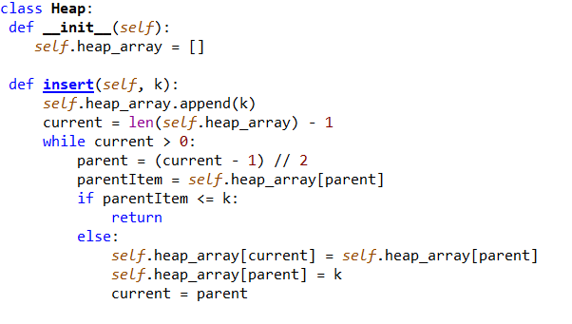

The goal is to find the right place for the new element in the heap and insert it:

1. First insert the element at the bottom of the heap. In the array implementation, this is the position after the last element in the array.
2. Then, into a loop, as long as the value of the new element is less than the value of its parent, the loop lets the new element "go" up the heap and exchange the new element with its parent. When the process stops (either the new element is greater than or equal to its parent or the top node), the new element is in its proper location.

O(logN)

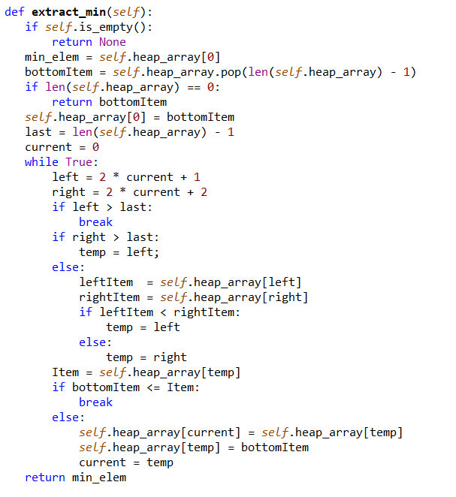

The goal is to return the elements in the node after the root node is deleted and adjust the location of the other nodes to maintain the heap properties:

1. First, save the pointer to the top and bottom elements in the heap and move the element from the bottom of the heap to the top.

2. Go down from top of the heap and move the smallest element up one level until it reaches the bottom of the heap.

O(logN)

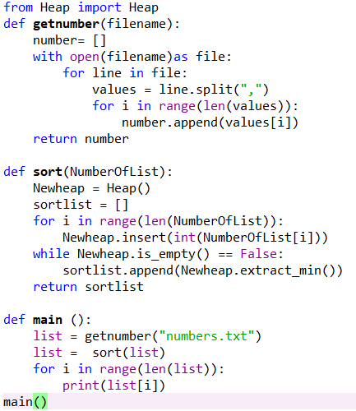

The getnumber is to read the txt file and save the numbers in the list.

The sort is to create a new heap to insert the list. Then extract the min and save the numbers in to a list, then print out.

Test:



