Supplementary Equation Table. Equation summary of the Bayesian inference model, includes the formulas, the meaning of the corresponding elements, and the priori information used in the model.
 | Equation | Elements | Prior distribution
Rt estimation | 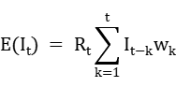 | —the number of infections at time t, which is inferred by the reported cases by removing the time lag t’ from exposure to reporting. This time lag t' is the sum of the incubation period (t_{c}') and the reporting delay (t_{r}').  —the infectivity profile which depends on the serial interval  —the instantaneous reproduction number at time t  —is the incidence at time t-k | Serial interval:  Original: Gamma(5.80, 3.20)  Alpha: Gammal(5.80, 3.20)  Delta: Gamma(5.80, 3.20)  Omicron: Gamma(5.80, 3.20)  Incubation period (t_{c}'):  Original: Lognormal(1.78,0.52)  Alpha: Lognormal(1.50,0.46)  Delta: Lognormal(1.25,0.34)  Omicron: Lognormal(1.02,0.45)  Report delay (t_{r}'):  Before mass screening: Lognormal(0.82,0.84)  After mass screening: Binomial(1,0.3)
NPIs effect estimation | 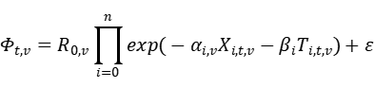 | —the basic reproduction number of variant v  —each individual NPI i under variant v on day t  —the control variable, i.e. air temperature, population density and practical vaccination rate  —the coefficient of the covariate X across different variants v  —the coefficient of the control variable  —the instantaneous reproduction number at time t of variant v  the variance of | :  Original: gamma(3.32,0.1)  Alpha: gamma(4.28,0.1)  Delta: gamma(4.90,0.1)  Omicron: gamma(9.05,0.1)  ~ gamma(1/6,1) - log(1.05/6)  ~ normal(0,0.5)

