**STEP 1**

**Mehtod 1: ./ googleSearchByKeywords.ps1 [enter]**

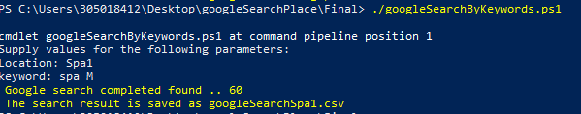

**STEP 2**

**Mehtod 2(position pararmeter): ./ googleSearchByKeywords.ps1 Spa2 “spa T” [enter]**



Method 1 and 2 generate 2 files



**STEP 3**

**.\MergeRefernceDifferernce.ps1 .\googleSearchSpa1.csv .\googleSearchSpa2.Csv**

Merge both files of Spa1.csv and Spa2.csv , duplicate records will not be copied .The result of 32 records found in Spa2.csv is copy and inserted into Spa1.csv.

