Below is a screen capture from the Chrome browser. The bottom portion of the picture shows the web developer section of the browser which is where changes to the HTML document were made. There are a few ways to access the web developer tool in the browser but the easiest way is to press the F12 key on the keyboard.

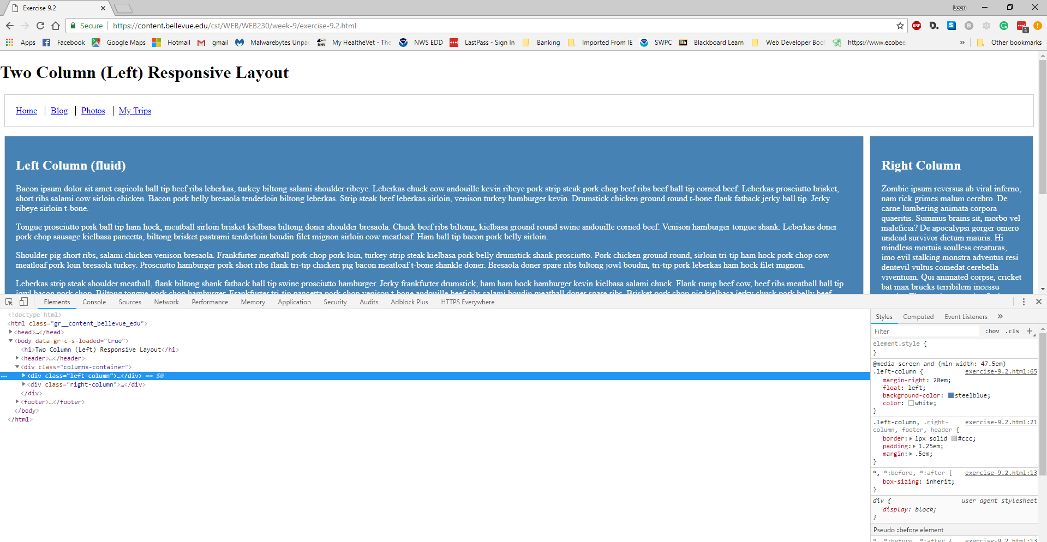

**3.**

**4.**

**2.**

**1.**

With the webpage loaded in the Chrome browser, and the F12 key pressed, follow the next steps to change the Left Column and Right Column backgrounds to steelblue and the text in both columns white:

1. Locate and select the Elements section of toolbar at highlighted number one.
2. Select the arrow next to body to expand that section. Next, select the arrow next to the “<div class=’columns-container’>” and highlight the left column class. The CSS code for the .left-column
3. Place your cursor under float: left; in the .left-column as indicated by the highlighted number three. When you place your cursor below float, “: ;” will automatically appear. When you type background, a dropdown list will appear. Select the background-color option. Press the tab key on the keyboard and it will advance you to the property section, where you can type steelblue. Next, press the tab key and it will automatically insert a new line under background-color. Type “color” and press the tab key, and then type “white”. The left column background will now be blue with white letters.
4. Next, select the right column by clicking on the div class highlighted above by number four. The CSS code at location highlighted by the number three above will now show the code for the “.right-column”. Place your cursor under float: left; in the right-column as you did in step three and follow the same instructions to enter the background-color and text color. The right column background will now be blue with white letters.