Below is a screen capture from the Firefox browser. The bottom portion of the picture shows the web developer section of the browser, which is where changes to the HTML document were made. There are a few ways to access the web developer tool in the browser but the easiest way is to press the F12 key on the keyboard.

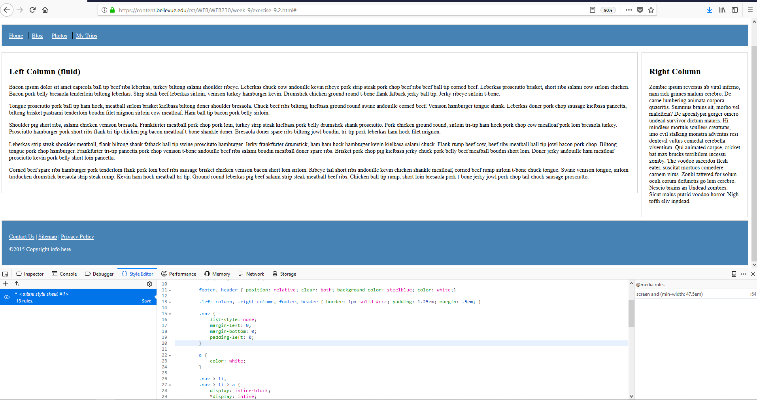

**3.**

**2.**

**1.**

With the webpage loaded in the Firefox browser, and the F12 key pressed, follow the next steps to change the header and footer backgrounds to steelblue and the links and text in the header and footer to white:

1. Locate and select the {} Style Editor section of toolbar at highlighted number one.
2. Insert a CSS rule that changes all of the anchor elements on the page to the color white.
3. Within the footer and header CSS rule, insert “background-color: steelblue;” and “color: white;” in the rule. This will change the background color to blue and all of the remaining text that is in the header and footer will also be turned to white.