  - AI Art Production Workflow Guide Version 1.0
September 25, 2025
This workflow is a reference. Explore, compare, and share other tools and methods when they produce better results.
Availability of these services varies by region. Check each service's current access requirements and terms.
Contents
1. Creating image assets
2. Creating video assets
3. Creating WAV audio assets
4. Organizing deliverable files
5. Preparing layered image assets
1. Creating image assets
Step 1. Refine the prompt. Many image models respond well to English prompts, but try both English and your preferred language.
Tool: ChatGPT. Website: https://chatgpt.com/
Example
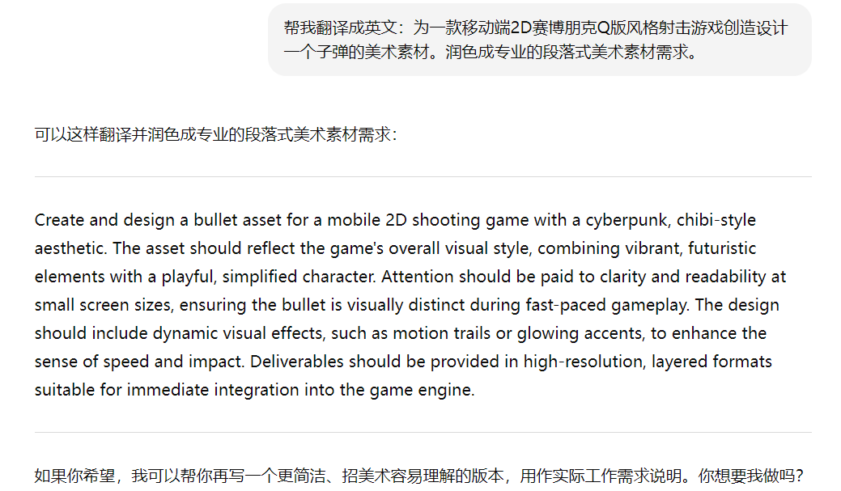
Step 2. Generate the image. Compare other image models when useful.
- Image tool: ImageFX. Website: https://labs.google/fx
Kling AI is another option, described in the video section below.
Example
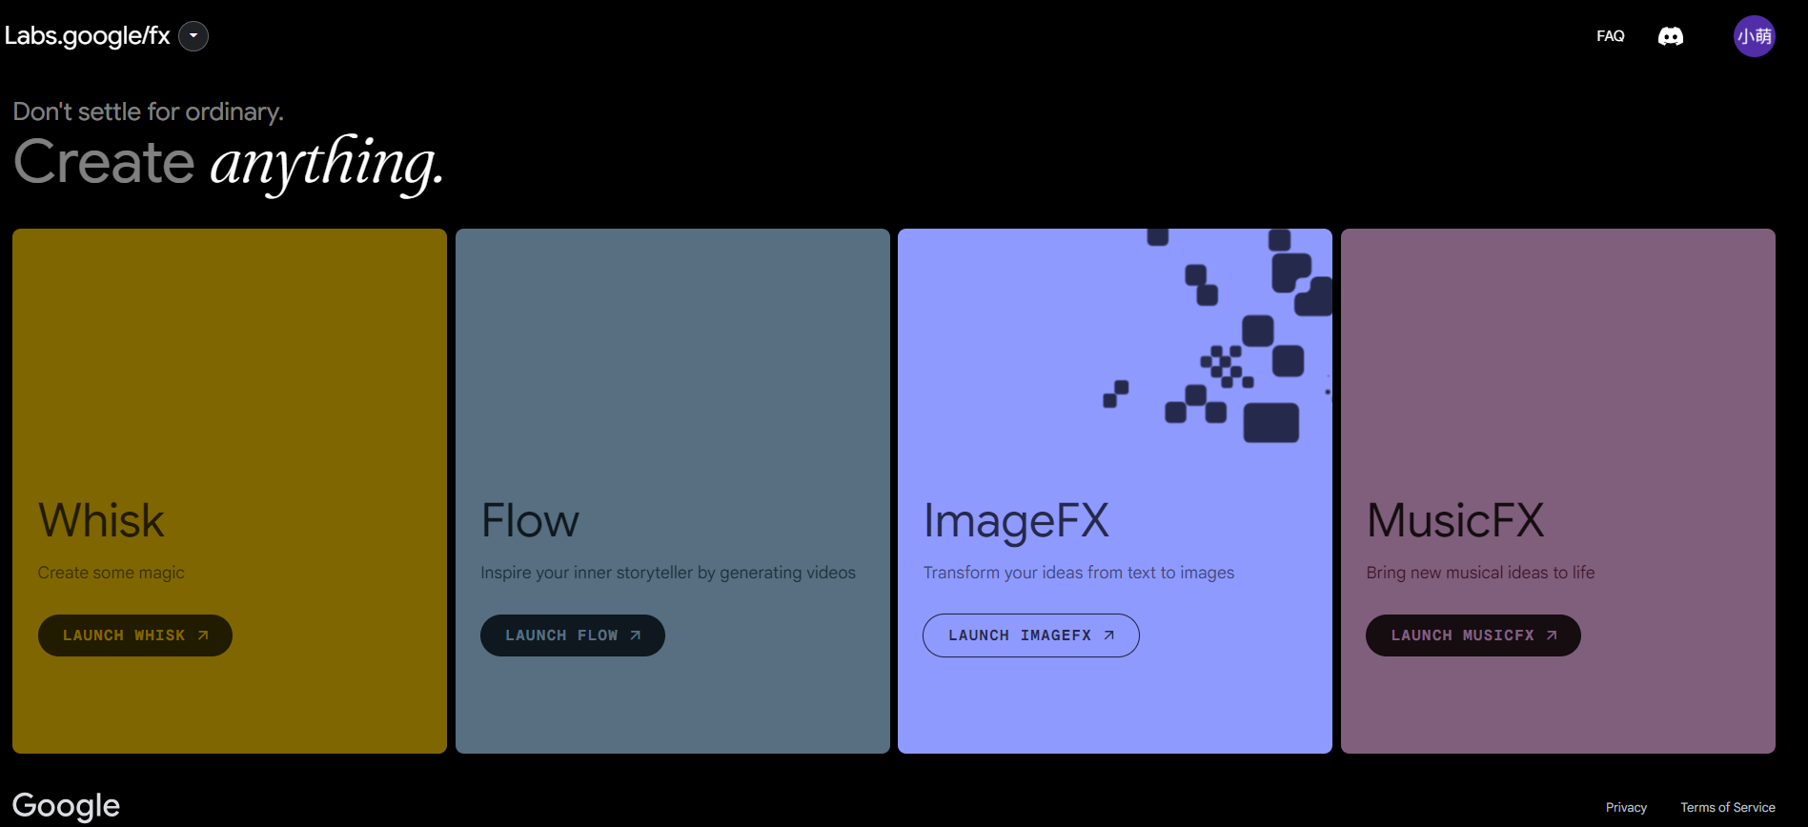
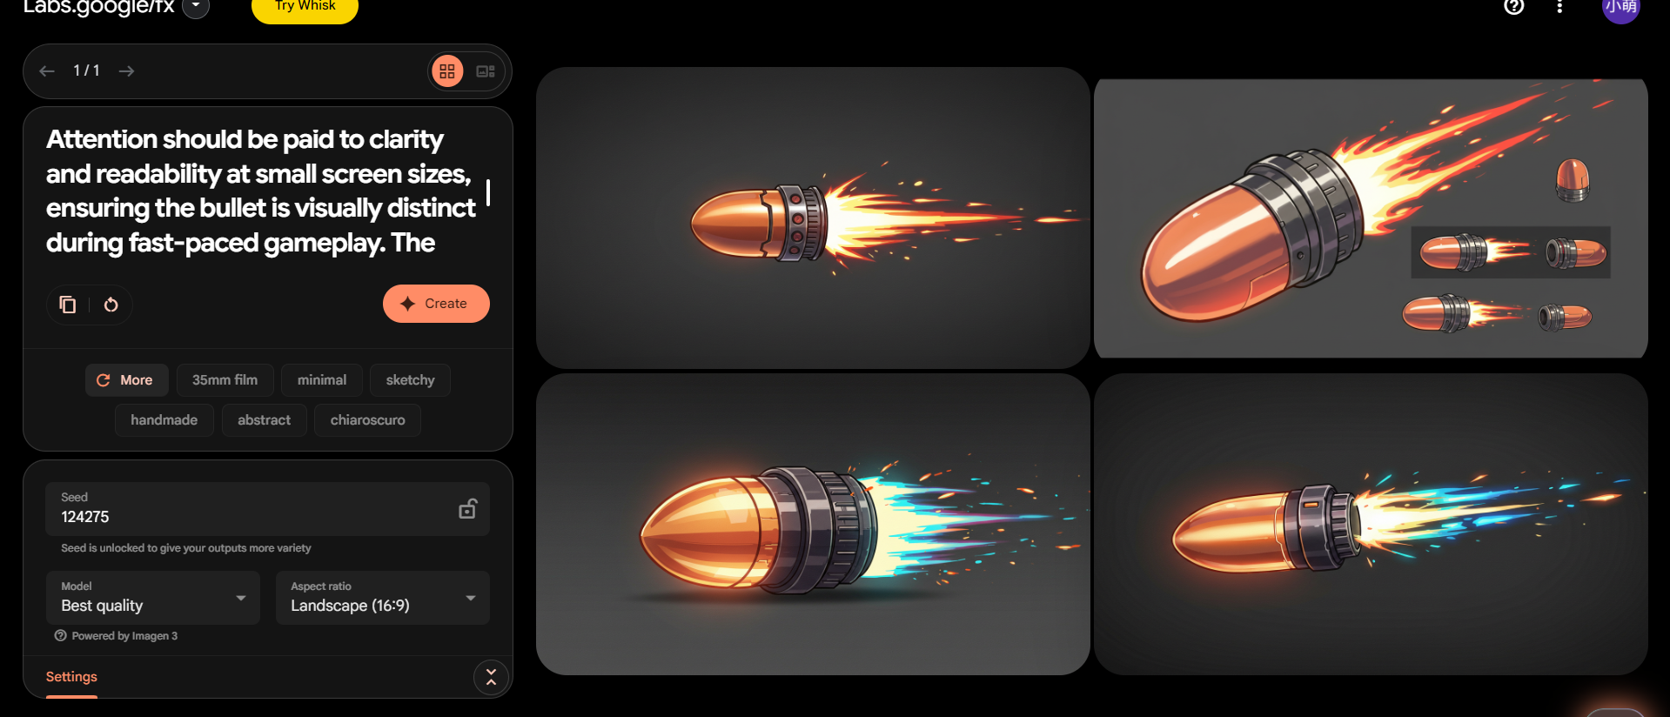
Step 3. Remove the background so the exported asset has transparency.
Tool: Pixian. Website: https://pixian.ai/free. It can process several images in one batch.
Example
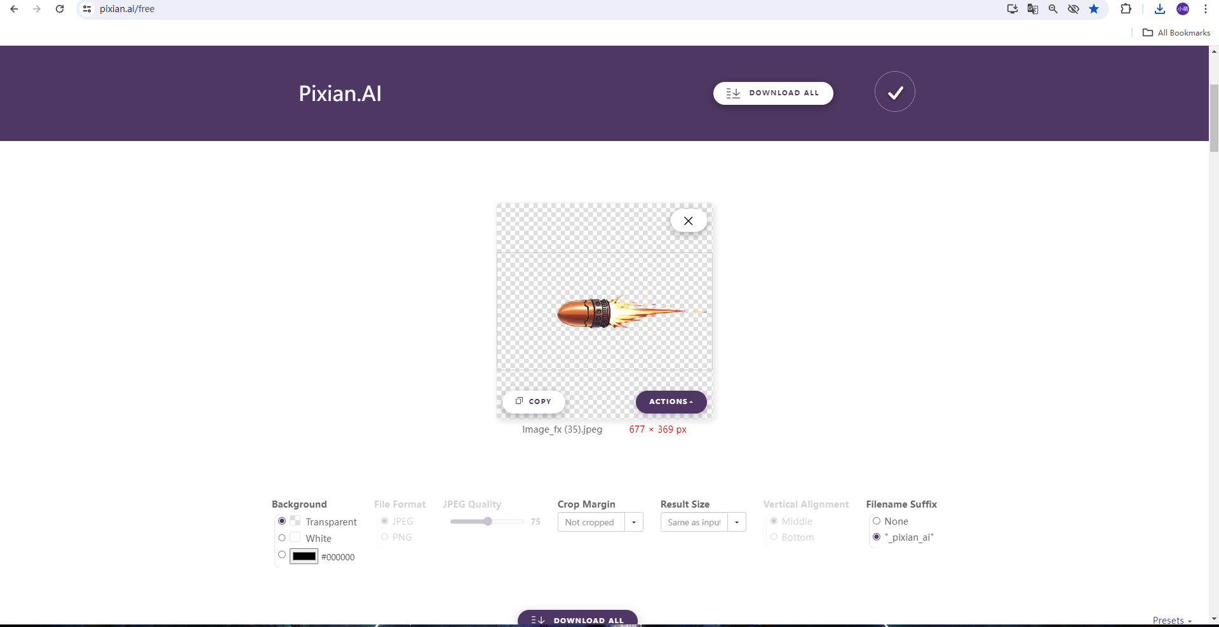
2. Creating video assets
Step 1. Refine the prompt as described in the image workflow.
Step 2. Generate video with Kling AI.
Website: https://app.klingai.com/cn/
Refine the prompt before generating video because video creation can consume substantial credits.
For more consistent style, first generate an image, then use suitable images as the opening and ending frames of the video. This can give better control than generating the video directly from text.
Example
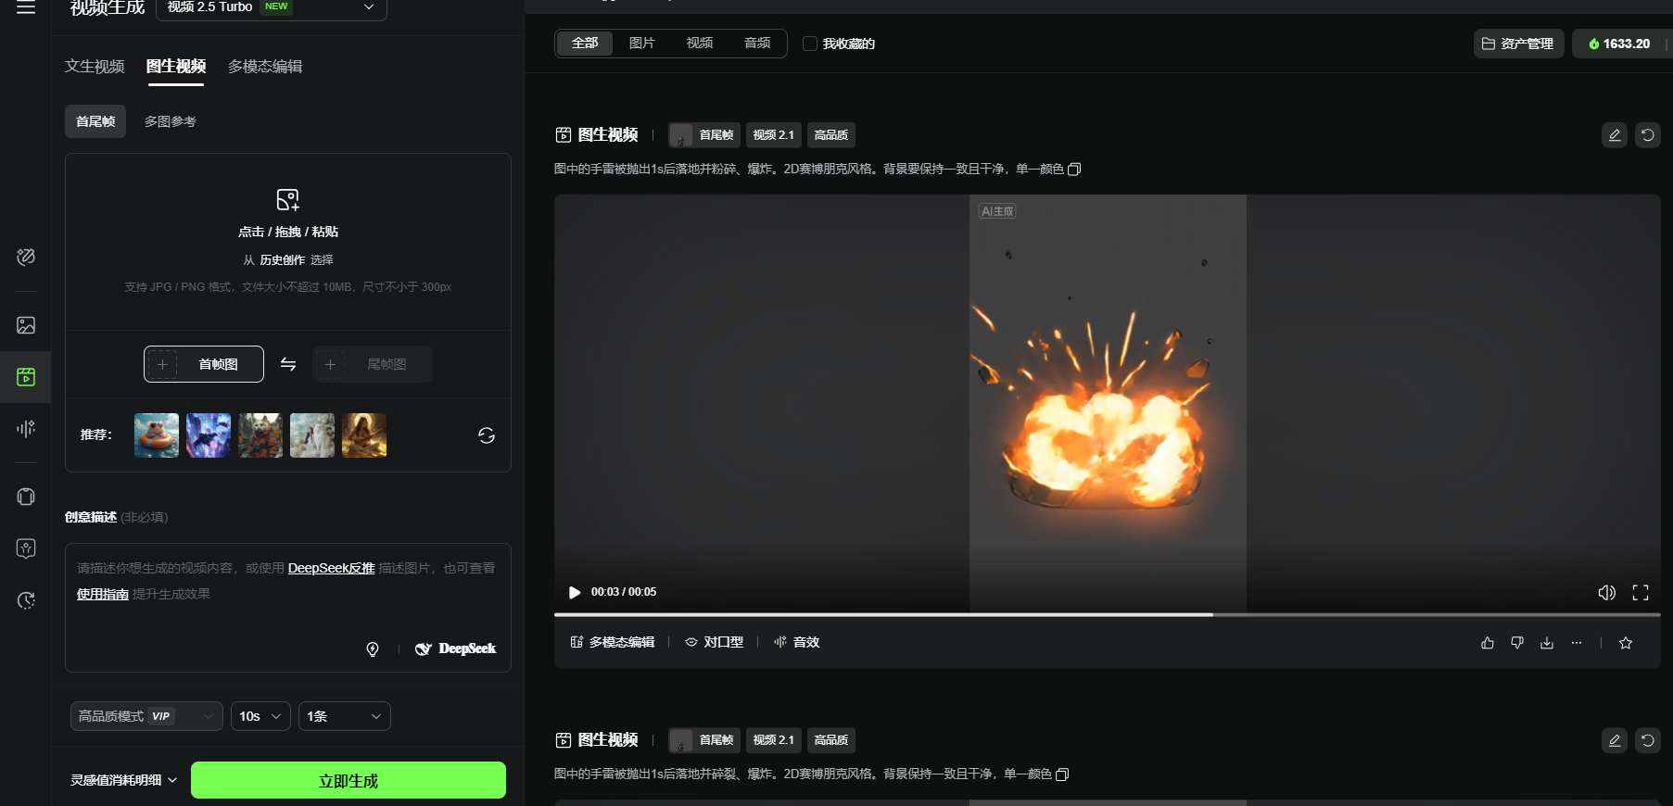
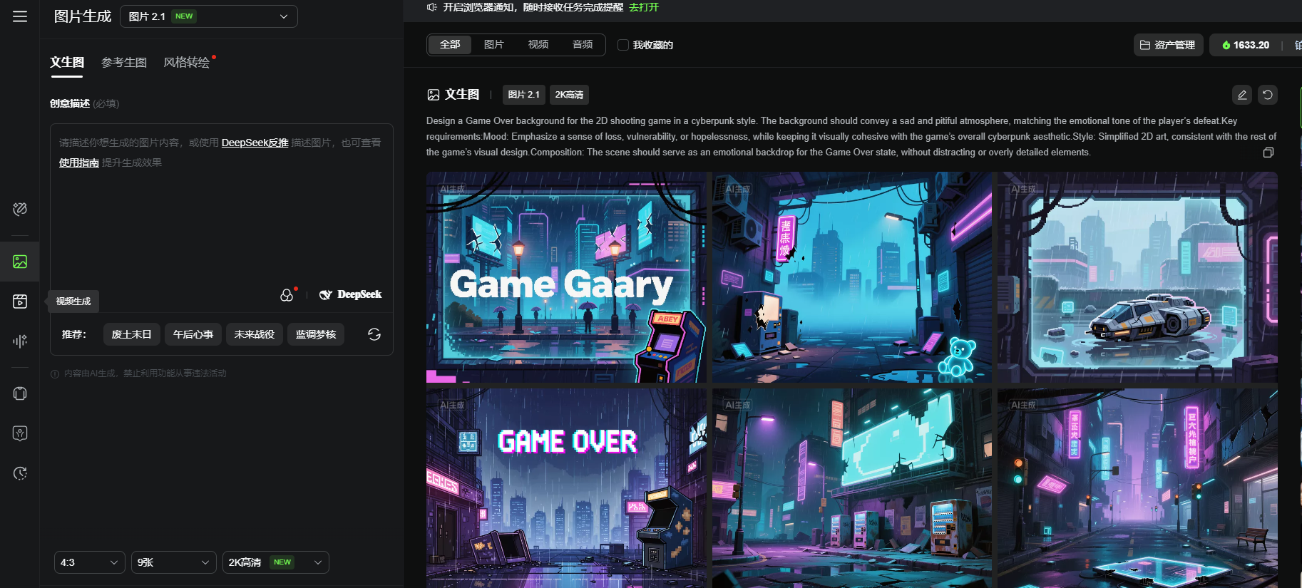
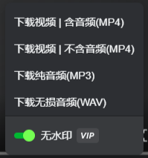The tool provides several generation options: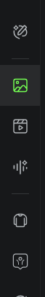
At the time this workflow was written, generated clips were limited to about 10 seconds. Check the current limit if you need longer footage.
Step 3. Convert the video to a GIF.
Website: https://ezgif.com/ (Video to GIF)
Example: Upload the video, wait for it to load, select a suitable frame rate, and generate the GIF.
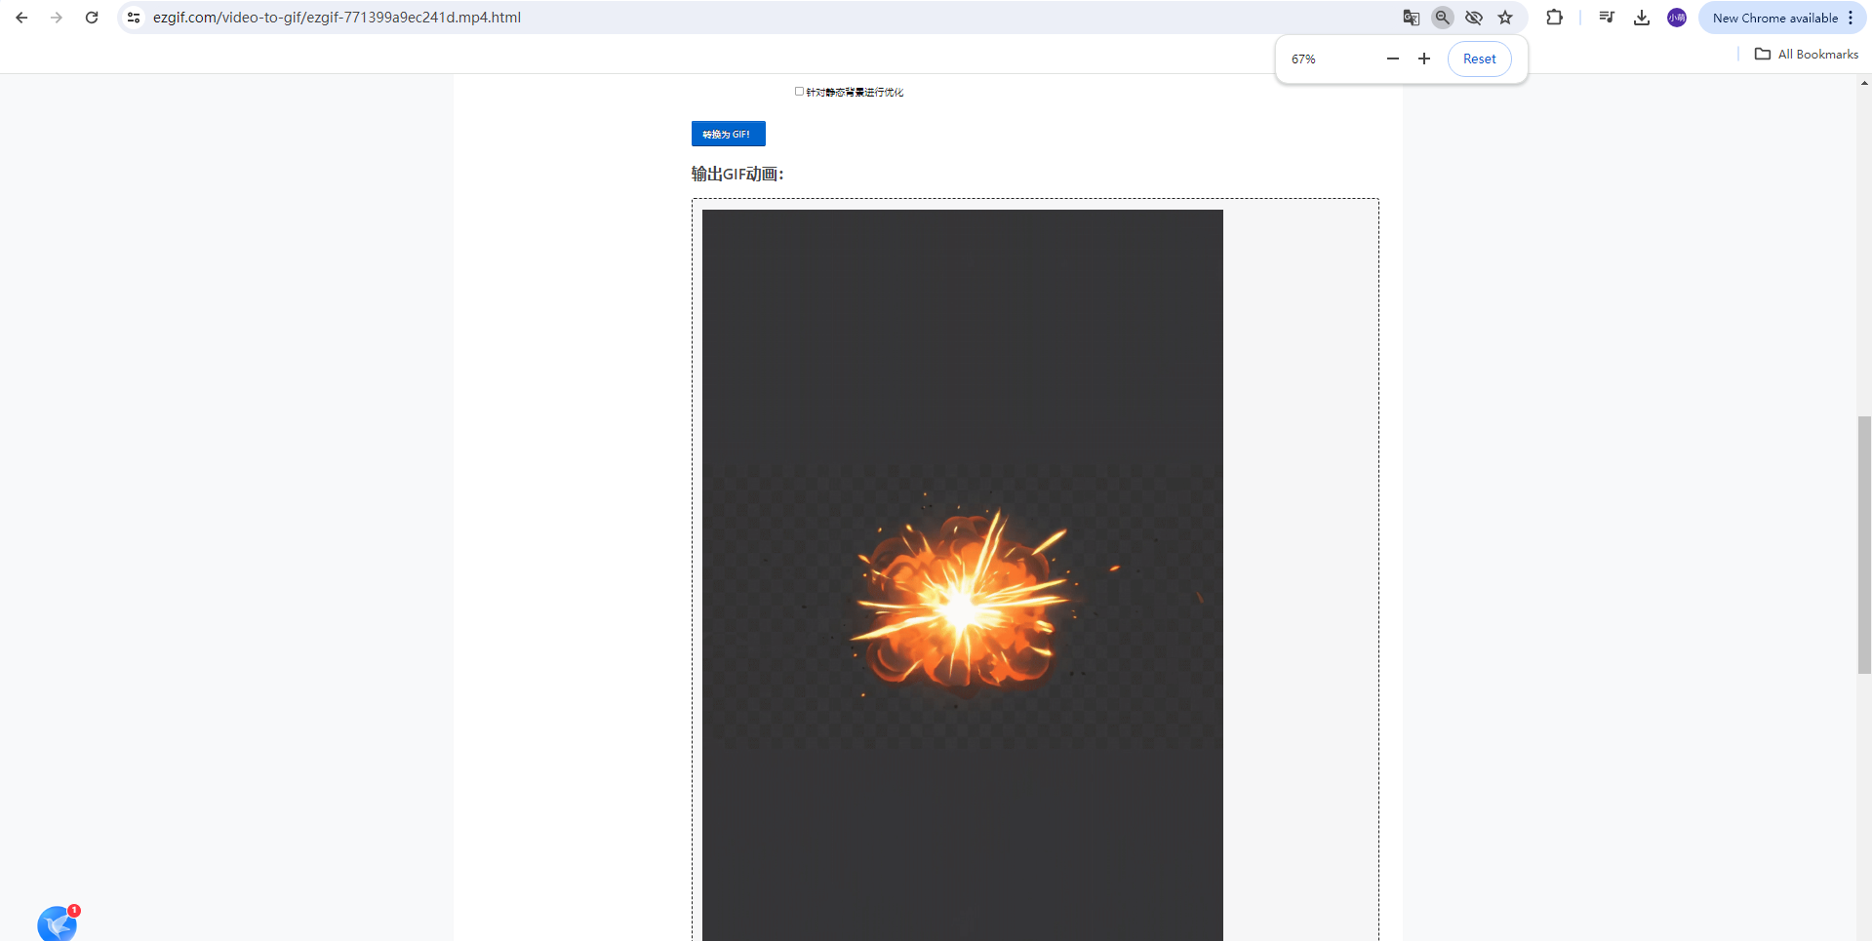
Step 4. Split the GIF into individual frames.
Website: https://uutool.cn/gif2img/#google_vignette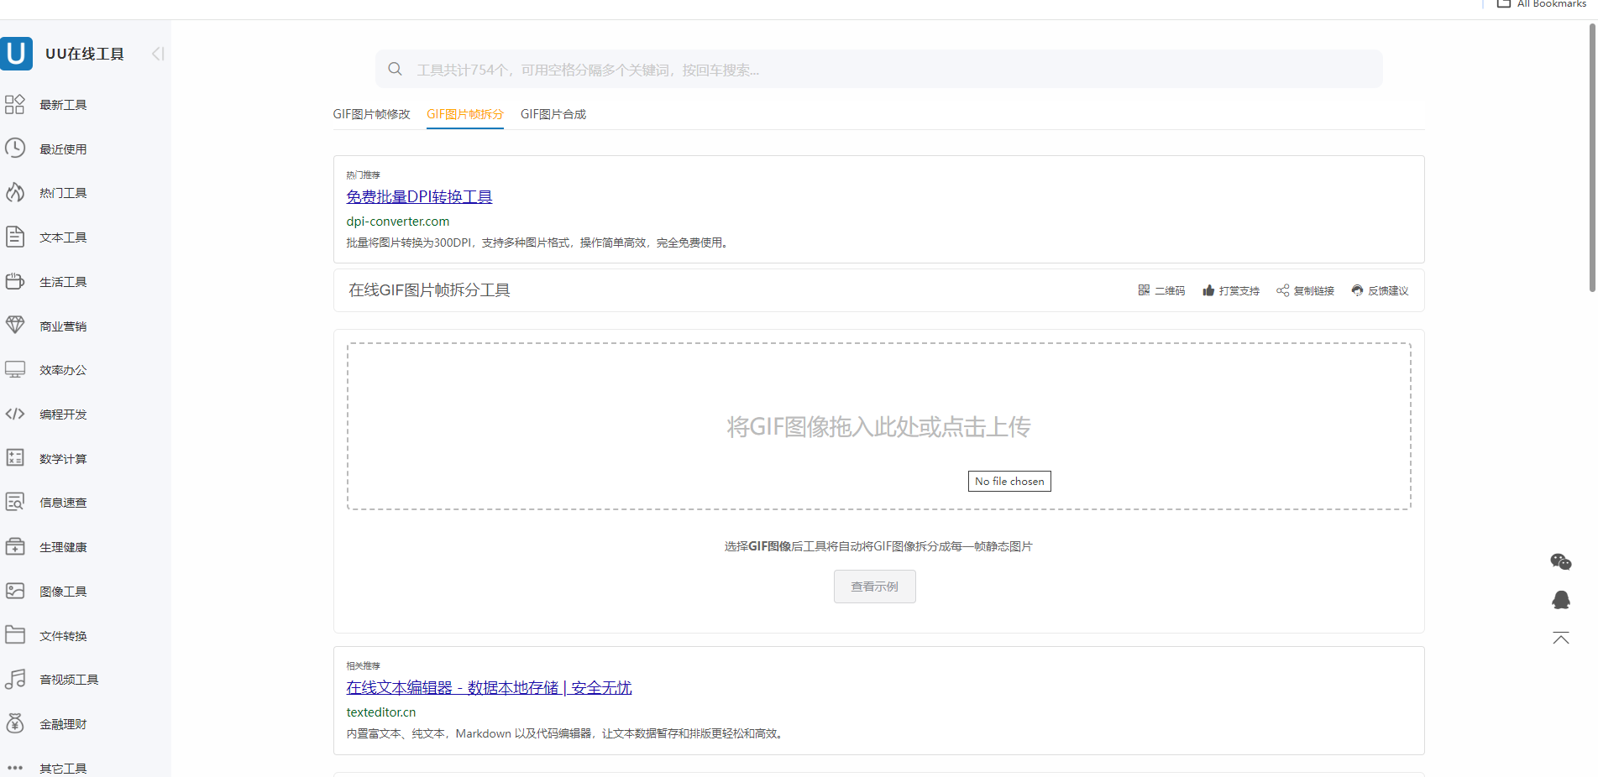
Download the frame archive and extract it before continuing.
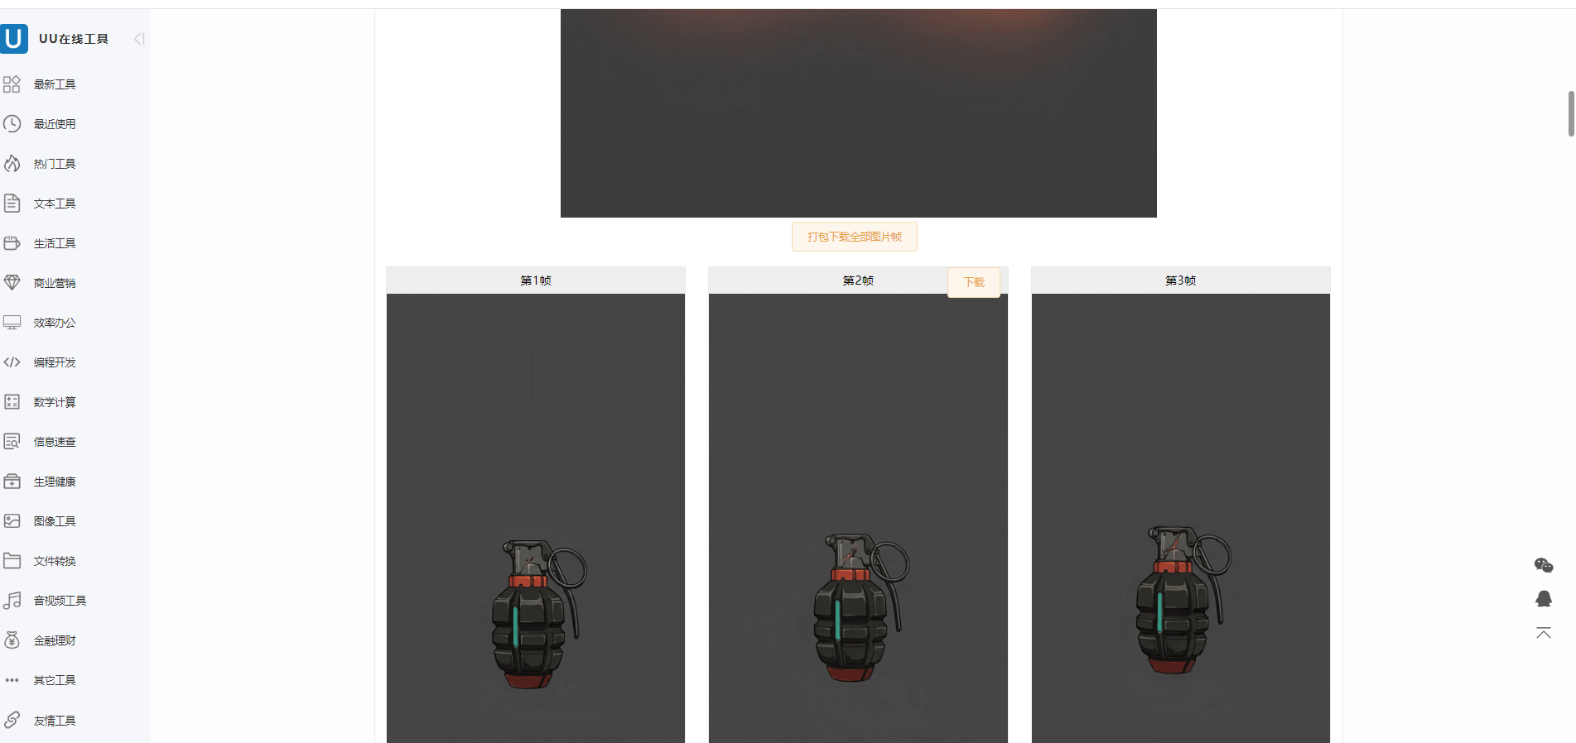
Step 5. Remove the background from each frame to preserve transparency.
Tool: Pixian. Website: https://pixian.ai/free. Batch processing works well for frame sequences.
Example
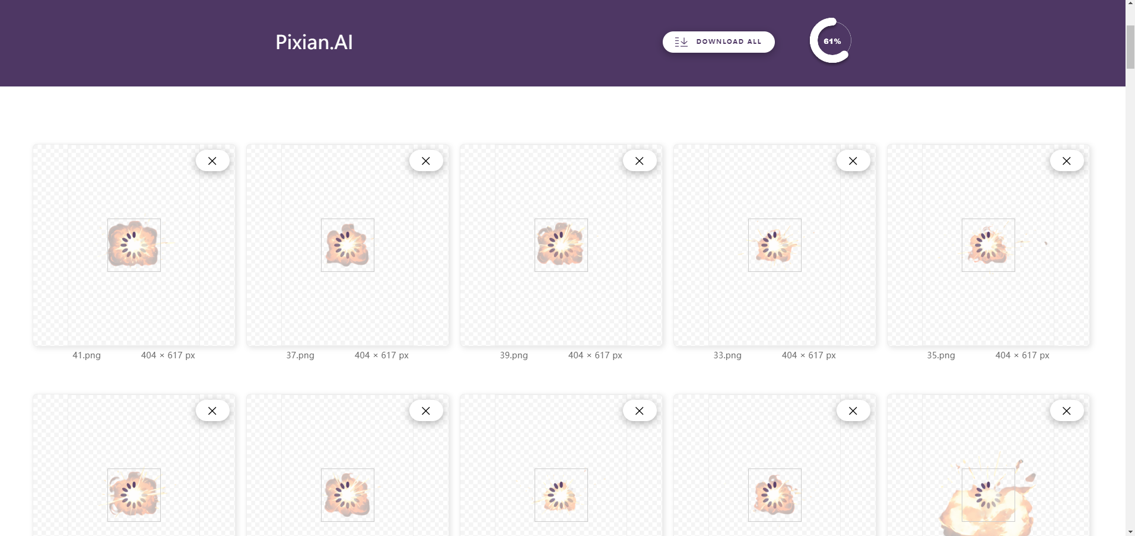
After processing, select Download All. Deliver the extracted frame sequence as a folder so it can be imported into the game project.
3. Creating WAV audio assets
Step 1. Refine the prompt as described above.
Step 2. Use Kling AI as described in the video section.
Option 1: Download the audio track from a generated video.
Option 2: Generate audio separately.
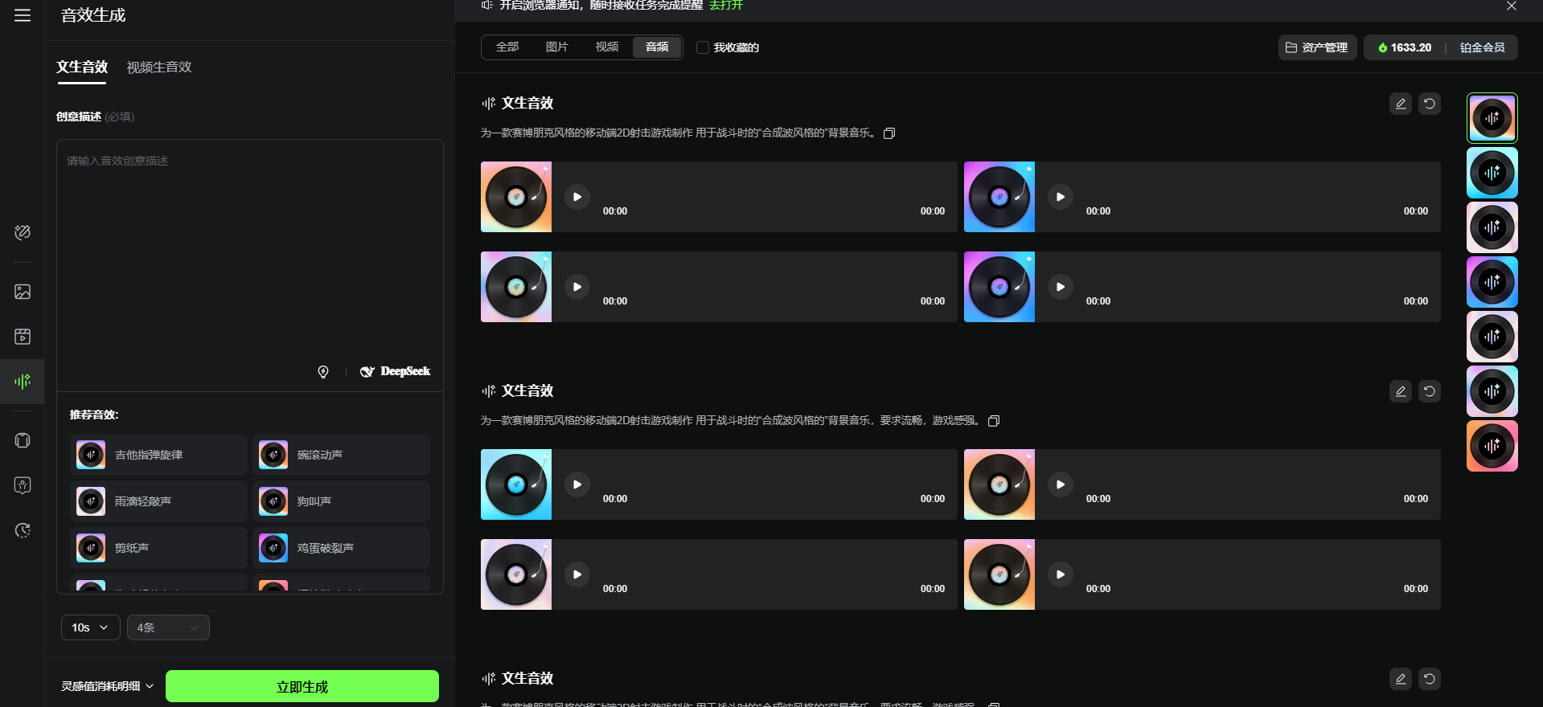
At the time this workflow was written, generated audio was limited to about 10 seconds. Check current limits for longer clips.

4. Organizing deliverable files
The following folder structure is an example. Adjust it if another arrangement works better for the team.
Example
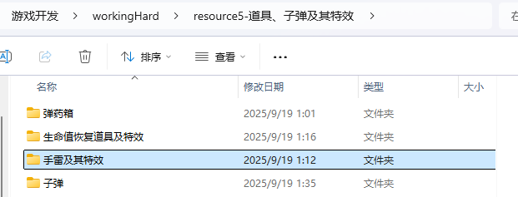
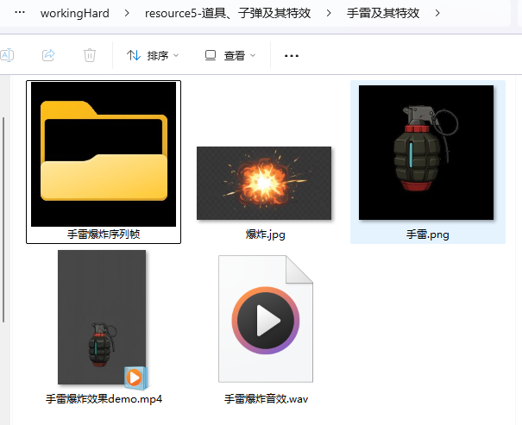
5. Preparing layered image assets
Character art often needs separate layers. Some characters also need assets from multiple viewing angles. Example:


