Projector Management System

Design Document

Document ID | 1
Original Author | Wei Xue
Version | 0.1
Draft Status | Draft

Revision History:
Version | Date | Author | Description
0.1 | 2/25/2019 | Wei Xue | First Draft

Overview

Background
Assume an office that has 3 projectors and 5 teams utilizing them. If an administrator were to manage access to the projectors for those 5 teams, it would be inefficient - here’s the process roughly:
- Whenever a team requires a projector, one of the team members sends an email to the admin mentioning the start and end times within which they want to use the projector.
- The admin goes through the requests in a first come, first served fashion and sees if the requested slot can be accommodated or not for a particular projector; if not, they look at the next projector.
- In the end either they allocate a projector and reply to the team with the projector’s name or they simply deny the request, saying that it cannot be accommodated. Also, sometimes they recommend the closest available time to the original requested time, so that the team can consider changing the time of their meeting and request again.

Requirements
Design and build a simple “Projector Management System” that manages access to these 3 projectors including the following:
- Design the database, service, and controllers and provide a REST endpoint that lets people check the availability of projectors, request a projector, cancel a request,...
- Separate the responsibilities of different classes and methods.
- Use efficient data structures to manage and see the availability of the projectors and extensibility of future requirements (for example, instead of simply denying a request when there is no availability, we should be able suggest the closest times to initial request when a projector could be allocated).

Design

Technologies
- Spring Boot – 2.1.2 RELEASE
- Spring Data JPA – 2.1.2 RELEASE
- MySQL – 8.0.13
- Springfox-Swagger – 2.9.2 (used for REST API documentation)
- JDK – 1.10
- Maven – 4.0

Database
Projector table
Field | Type | Null | Key
id | Int(11) | NO | PRI
name | Varchar(32) | NO | UNI
Team table
Field | Type | Null | Key
id | Int(11) | NO | PRI
name | Varchar(32) | NO | UNI
Booking table
Field | Type | Null | Key
id | Int(11) | NO | PRI
end_time | datetime | NO
start_time | datetime | NO
Projector_id | Int(11) |  | MUL
Team_id | Int(11) |  | MUL

The above new tables are created automatically during Spring Boot application start.

Sequence Diagram
The following section describes the key scenarios.

Team successfully books a projector with requested time slot
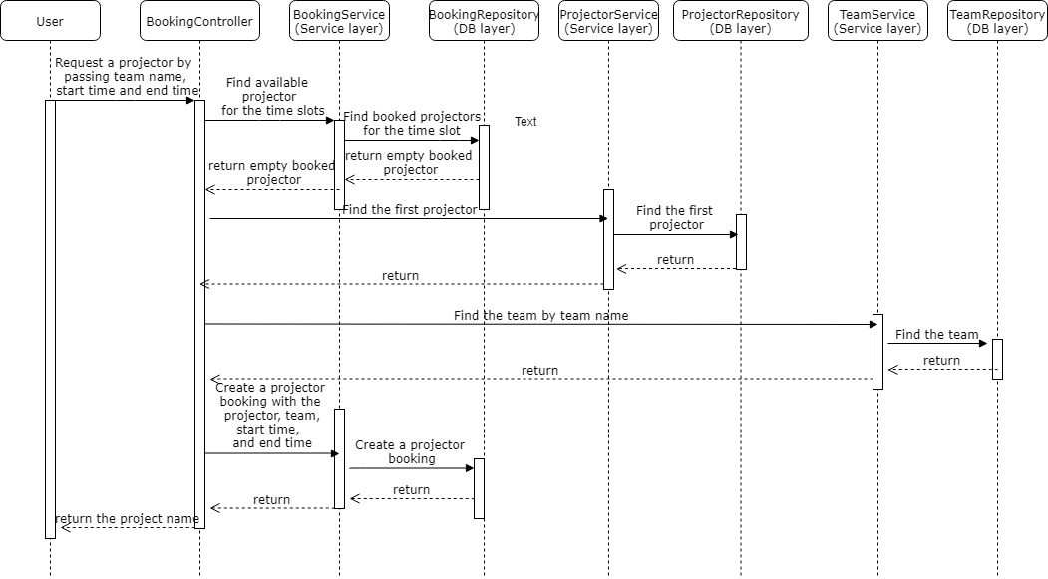

Team not able to book a projector with requested time slot
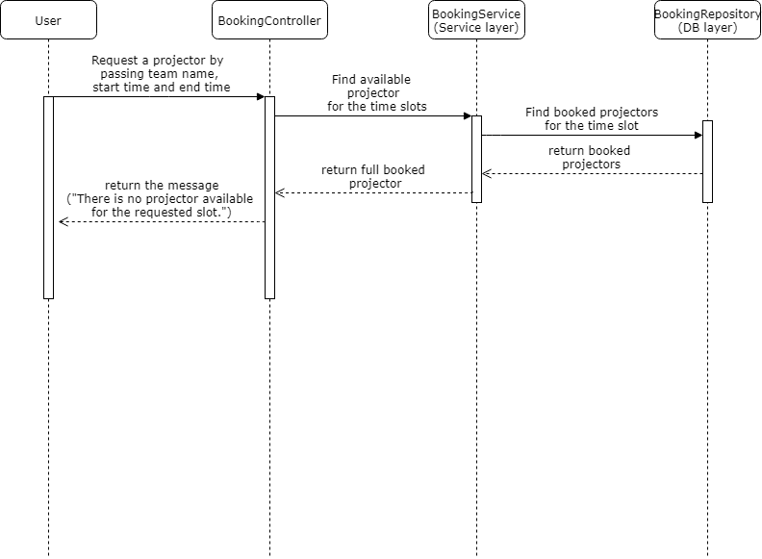

Team cancels the projector booking
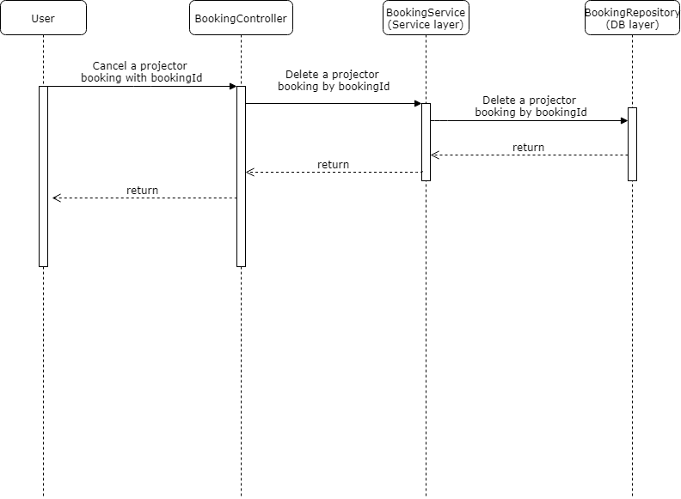

Class Diagram
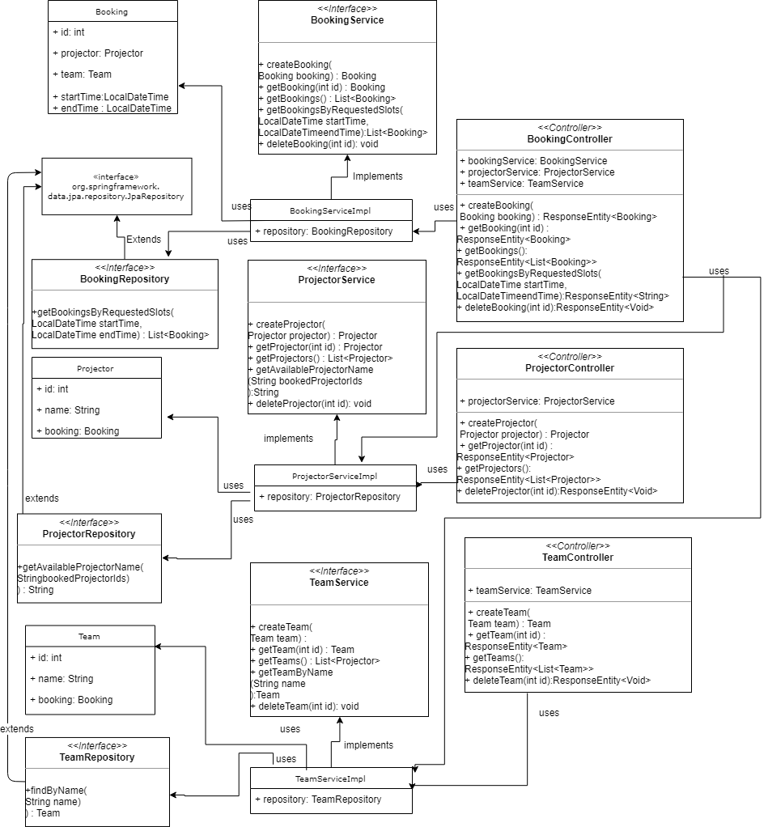

REST API
HTTP Method | Path | Description
POST | /v1/projectors | Create a projector
GET | /v1/projectors | Get a list of projectors
GET | /v1/projectors/{id} | Get a projector with an ID
DELETE | /v1/projectors/{id} | Delete a projector with an ID
POST | /v1/teams | Create a team
GET | /v1/teams | Get a list of teams
GET | /v1/teams/{id} | Get a team with an ID
DELETE | /v1/teams/{id} | Delete a team with an ID
POST | /v1/bookings | Create a projector booking
GET | /v1/bookings | Get a list of projector bookings
GET | /v1/bookings/{id} | Get a projector booking with an ID
DELETE | /v1/bookings/{id} | Cancel a projector booking with an ID
GET | /v1/bookings/projectors?team={name}  &start_time={start_time}  &end_time={end_time}&[advice=true] | Get available projector with requested time slot

