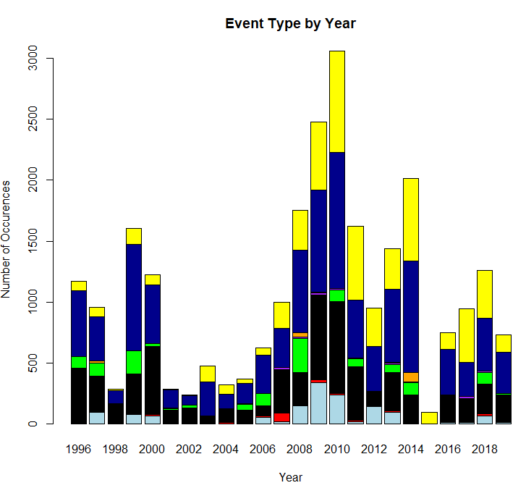

(Light Blue = Blizzard, Red = Frost/Freeze, Black = Heavy Snow, Green = Ice Storm, Purple = Lake-Effect Snow, Orange = Sleet, Dark Blue = Winter Storm, Yellow = Winter Weather)

This graphic shows a distribution of the event types by year. There is a peak around 2008-2011. This was likely due to changes in reporting with the national weather service offices.

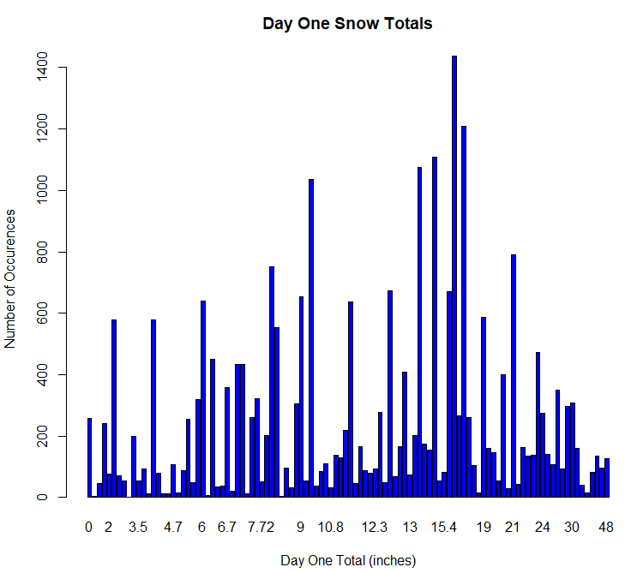

Day one snow totals, representing the greatest snowfall for the storm on that day, shows a wide range of snow totals. The most common snowfall total on day one is around 16 inches and the full range from 0 to 48 inches.

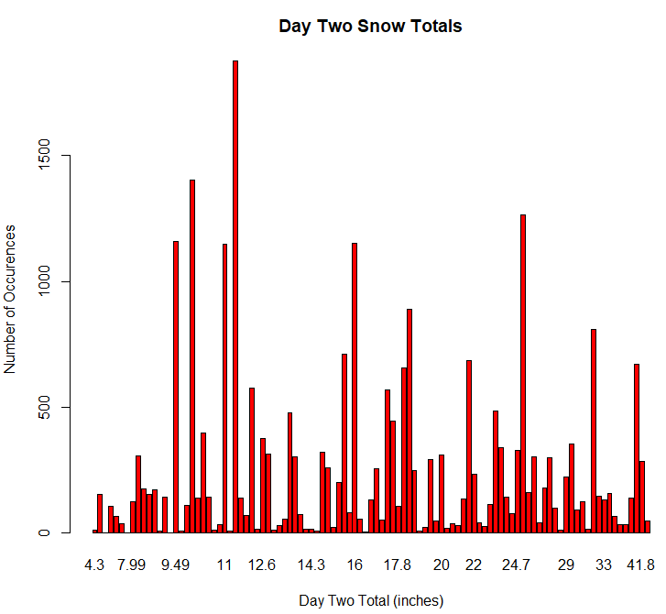

Day two snow totals ranged from 4 to 42 inches. The most common was about 11.5 inches and second most common about 10 inches.

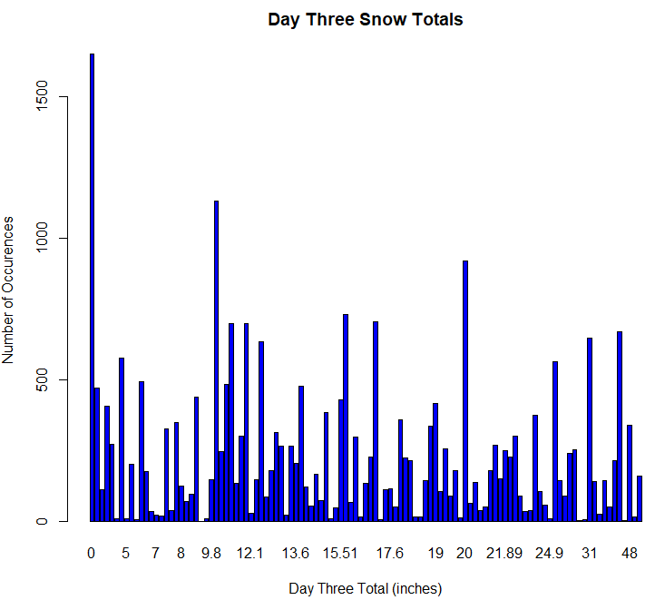

This graphic shows the day three snow totals. The most common total was 0, indicating many of the snowstorms were over within the first two days. The total range was 0 to 48 inches.

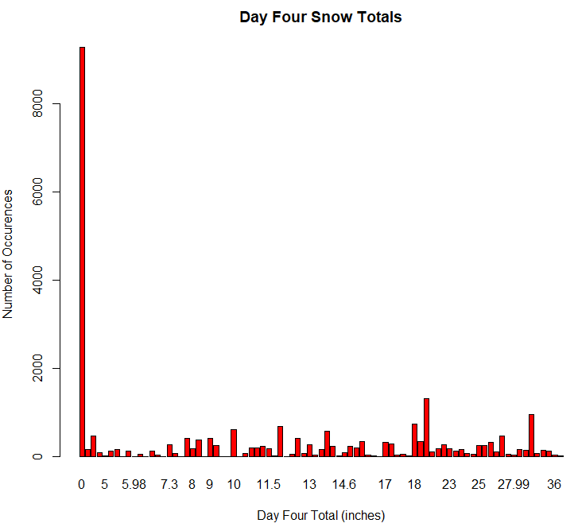

Day four snow totals shows that the majority of storms were over within the first three days, indicated by 0 being the most common total by far. The full range includes snow totals from 0 to 36 inches of snow.

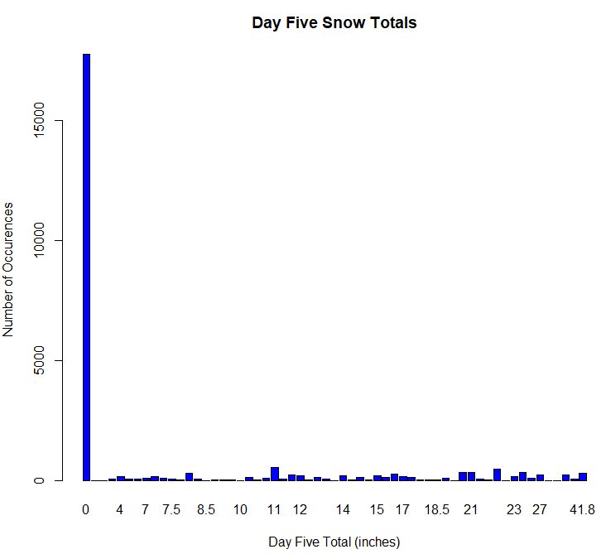

Day five snow totals show a small amount of snow storms continued into the fifth day. Those that did peaked at a total of about 42 inches of snow.

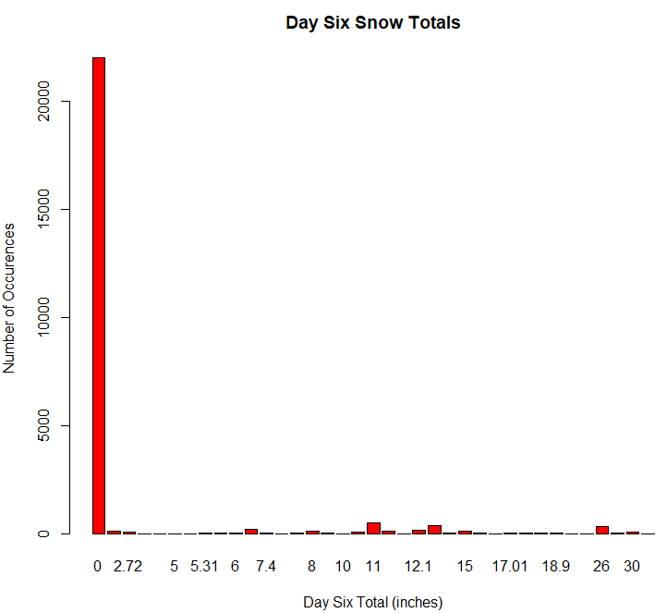

Snow totals for storms that continued into day 6 peaked at about 33 inches of snow. This was a drop of almost 10 inches from the day five totals.

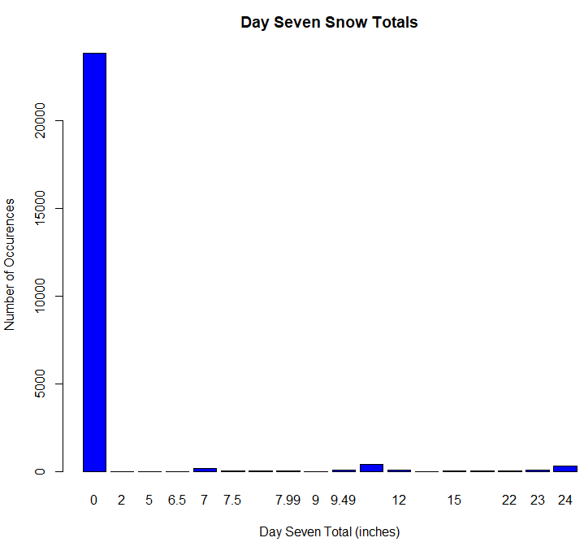

Snow storms that continued into day seven peaked at 24 inches of snow. This was another almost 10 inch drop from the previous day’s peak total.

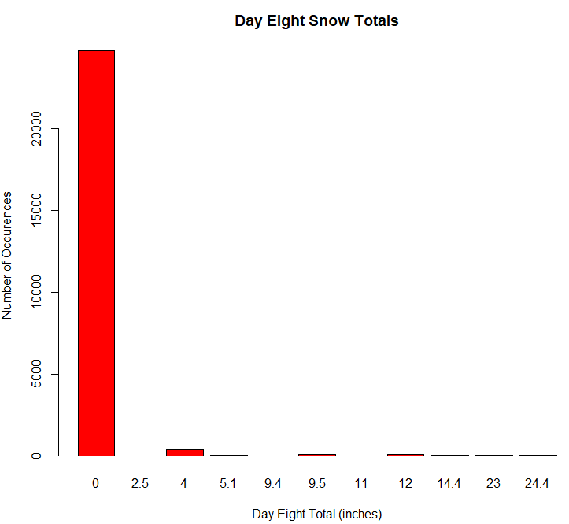

Day eight snow totals show a range of 0 to about 25 inches. While the range was similar to day seven snow totals, the number of events was significantly less.

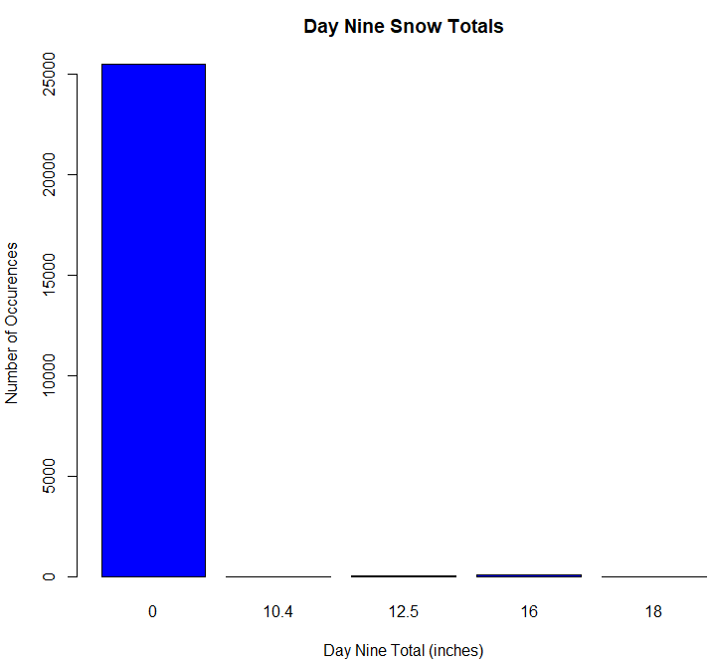

Snow storms that continued into day nine ranged from 0 to 18 inches of snow. There were not many storms that had a day nine total.

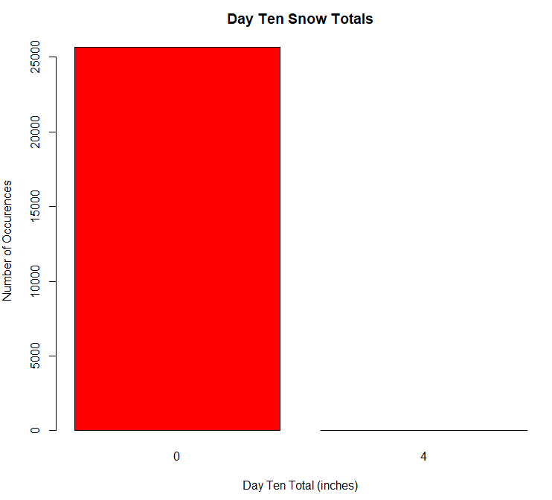

Only one storm continued into day ten. This storm produced 4 inches of snow on the tenth day.