Step1：安装apr

1. wget <http://mirrors.tuna.tsinghua.edu.cn/apache//apr/apr-1.7.0.tar.gz>
2. tar xzf apr-1.7.0.tar.gz
3. ./configure
4. make
5. make install

Step2：安装apr-until

1. wget <http://mirrors.tuna.tsinghua.edu.cn/apache//apr/apr-util-1.6.1.tar.gz>
2. tar xzf apr-util-1.6.1.tar.gz
3. ./configure --prefix=/usr/local/apr-util --with-apr=/usr/local/apr
4. Make

(编译中断。

make[1]: *** [xml/apr_xml.lo] 错误 1

make[1]: 离开目录“/usr/local/apr-util-1.6.1”

make: *** [all-recursive] 错误 1

解决方案，下载安装expat库 ：yum install expat-devel

1. make install

STEP3: 安装openssl

1. Wget <https://www.openssl.org/source/openssl-1.1.0l.tar.gz>
2. cd openssl-1.1.0l
3. ./config shared --prefix=/usr/local/openssl-1.1.0l
4. make depend
5. make
6. make install

STEP4： 安装tomcat native

1. cd apache-tomcat-9.0.16/bin
2. tar -xvf tomcat-native.tar.gz
3. cd tomcat-native-1.2.21-src/native
4. ./configure --prefix=/usr/local/tomcat-native --with-apr=/usr/local/apr --with-java-home=/usr/java/jdk1.8.0_141 --with-ssl=/usr/local/openssl-1.1.0l
5. make
6. make install

STEP5 配置ld

vim /etc/profile

export LD_LIBRARY_PATH=/usr/local/tomcat-native/lib:$LD_LIBRARY_PATH

source /etc/profile

STEP6 生成证书

cd apache-tomcat-9.0.16

mkdir ssl

cd ssl

openssl genrsa -out server.key 2048

openssl rsa -in server.key -out server.key

openssl req -new -x509 -key server.key -out ca.crt -days 3650

STEP7 配置server.xml

找到http2 并修改成如下：

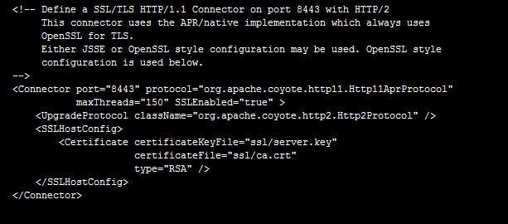

重新启动