Nsq 进程学习：

[nsqd](http://bitly.github.io/nsq/components/nsqd.html)是一个接收、排队、然后转发消息到客户端的进程。

[nsqlookupd](http://bitly.github.io/nsq/components/nsqlookupd.html) 管理拓扑信息并提供最终一致性的发现服务。

[nsqadmin](http://bitly.github.io/nsq/components/nsqadmin.html)用于实时查看集群的统计数据（并且执行各种各样的管理任务）。

./nsqlookupd --http-address=127.0.0.1:4161 --tcp-address=127.0.0.1:4160 --broadcast-address=127.0.0.1 --verbose=true

./nsqd --http-address=127.0.0.1:4151 --tcp-address=127.0.0.1:4150 -lookupd-tcp-address=127.0.0.1:4160 --broadcast-address=127.0.0.1 --verbose=true

./nsqd --http-address=127.0.0.1:5151 --tcp-address=127.0.0.1:5150 -lookupd-tcp-address=127.0.0.1:4160 --broadcast-address=127.0.0.1 --verbose=true

./nsqadmin --lookupd-http-address=127.0.0.1:4161 &

## 增加一条topic记录

curl -d "hello world 1" "http://127.0.0.1:4151/put?topic=testTopic"

## 查看topic信息

curl http://127.0.0.1:4161/lookup?topic=testTopic

nsq_to_file --topic=test --output-dir=F:\tmp --lookupd-http-address=127.0.0.1:4161

curl -d "hello world 2" "http://127.0.0.1:4151/put?topic=testTopic"

curl -d "hello world 3" "http://127.0.0.1:4151/put?topic=testTopic"

curl -d "hello world 1" "http://127.0.0.1:4151/create_channel?topic=testTopic&channel=testChannel"

http://127.0.0.1:4171/

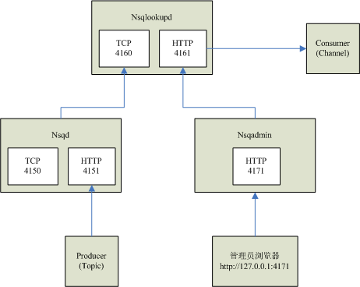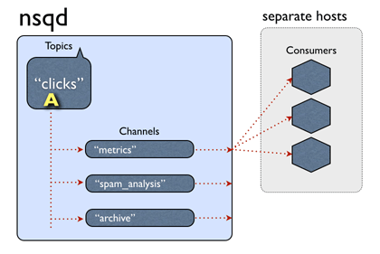

1. Ping 命令: 检测server服务;

Request: curl http://127.0.0.1:4151/ping

Response: ok

1. Info命令: server版本信息;

Request: curl http://127.0.0.1:4151/info

Response: **{**"status_code": **200**,"status_txt": "OK","data": **{**"version": "0.2.21"**}}**

1. Put 命令: put一条订阅为testTopic的消息;

Request: curl -d "hello world 2" "http://127.0.0.1:4151/put?topic=testTopic"

Response ok

1. Mput 命令: mput一条订阅为testTopic的消息;

Request: curl -d "hello world 2 \n hello world 3 " "http://127.0.0.1:51/mput?topic=testTopic"

Response ok

<http://127.0.0.1:4161/lookup?topic=testTopic>

**{**"status_code": **200**,"status_txt": "OK","data": **{**"channels": **[]**,"producers": **[{**"remote_address": "127.0.0.1:50068","address": "wangxiong","hostname": "wangxiong","broadcast_address": "wangxiong","tcp_port": **4150**,"http_port": **4151**,"version": "0.2.21"**}]}}**

Sources:

http://www.oschina.net/translate/day-22-a-journey-into-nsq

http://www.baiyuxiong.com/?p=886