<http://bigdatamr10.hksmartone.com:18080/>

http://bigdatamr10.hksmartone.com:4041/

http://bigdatamr10.hksmartone.com:8088



/home/mapr/el/test/bigdataetl02/daily/script

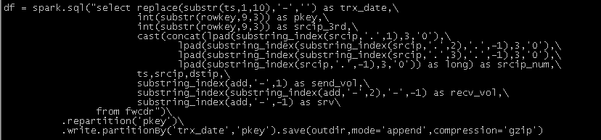

hadoop fs –ls /HDS_VOL_HIVE/FWCDR/start_date=20200822

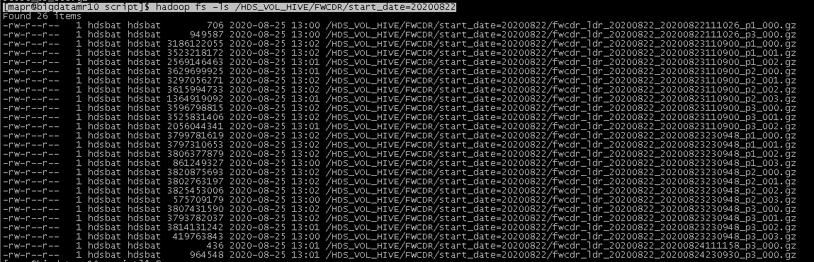

26 files

hadoop fs -du -h /HDS_VOL_HIVE/FWCDR

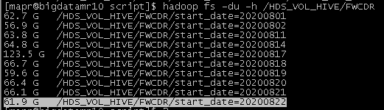

hadoop fs -du -h /HDS_VOL_HIVE/FWCDR_PQ

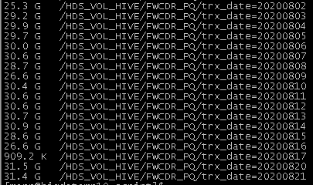

补22号的截图



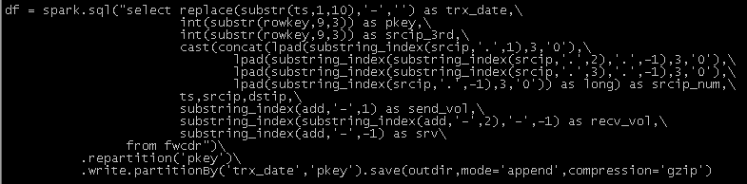

hadoop fs -ls /HDS_VOL_HIVE/FWCDR_PQ/trx_date=20200821

hadoop fs -ls /HDS_VOL_HIVE/FWCDR_PQ/trx_date=20200821/pkey=85

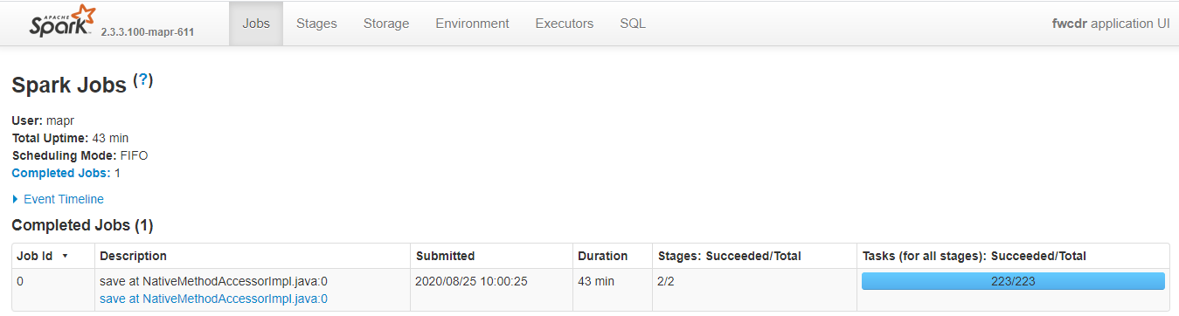 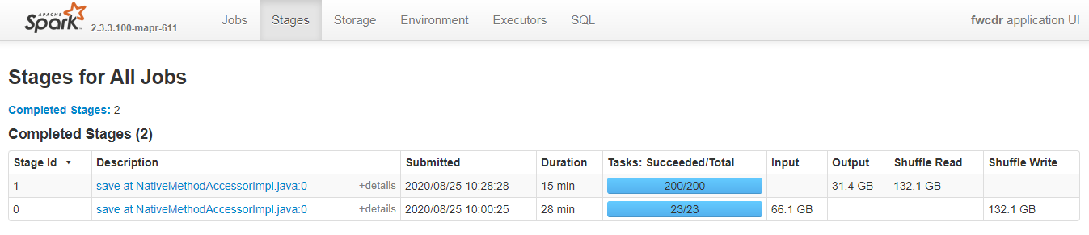 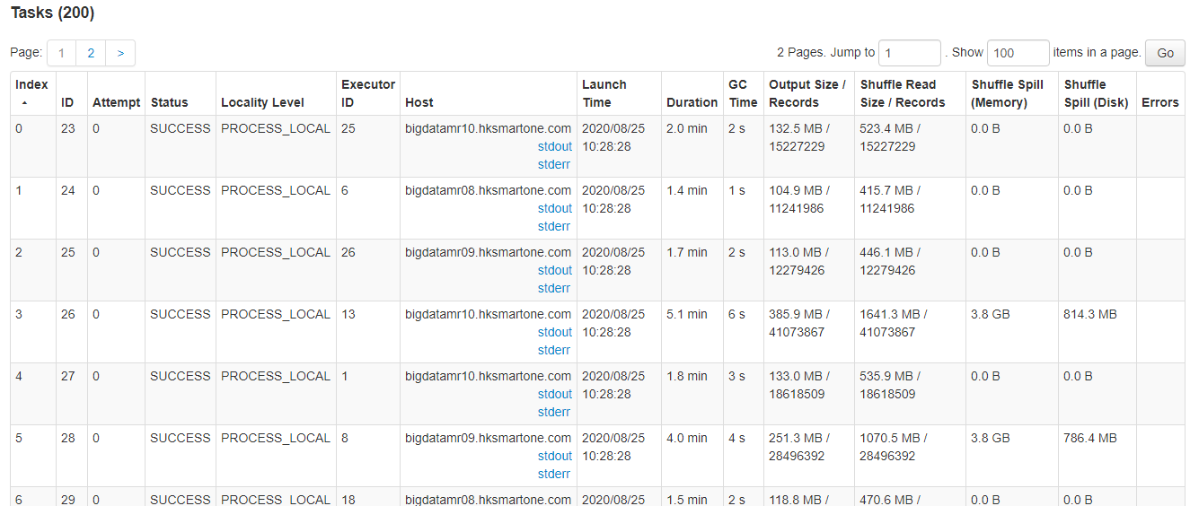

/home/mapr/el/test/test_min_max/oneday/test/training



hadoop jar /home/mapr/pq_tools/parquet-tools-1.9.0.jar –help

cat head schema meta dump merge

hadoop jar /home/mapr/pq_tools/parquet-tools-1.11.0.jar cat /HDS_VOL_TMP/el_tra/par_256/part-00000-b1aedc81-dca4-4f6d-be39-2c1f0831e2dc-c000.gz.parquet | head -100

hadoop jar /home/mapr/pq_tools/parquet-tools-1.11.0.jar head /HDS_VOL_TMP/el_tra/par_256/part-00000-b1aedc81-dca4-4f6d-be39-2c1f0831e2dc-c000.gz.parquet | head -100 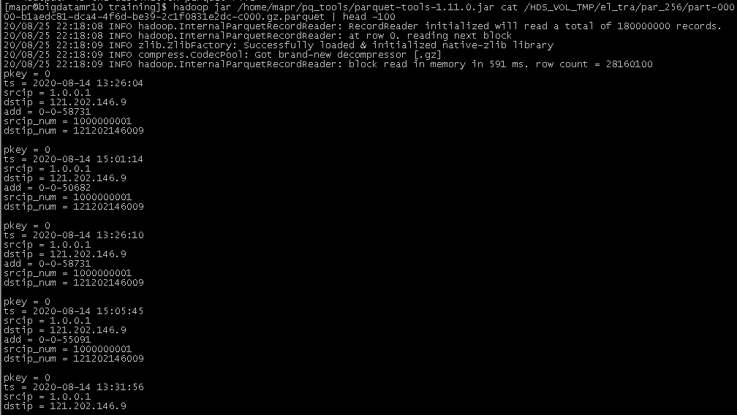



hadoop jar /home/mapr/pq_tools/parquet-tools-1.11.0.jar meta /HDS_VOL_TMP/el_tra/par_256/part-00000-b1aedc81-dca4-4f6d-be39-2c1f0831e2dc-c000.gz.parquet | grep "row group"

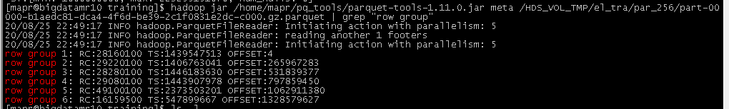



hadoop jar /home/mapr/pq_tools/parquet-tools-1.11.0.jar meta /HDS_VOL_TMP/el_tra/par_512/part-00000-13450d0f-85a1-40f5-8473-03220cb36231-c000.gz.parquet | grep "row group"

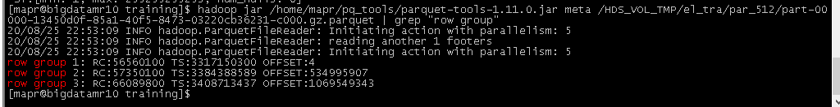

hadoop jar /home/mapr/pq_tools/parquet-tools-1.11.0.jar dump -n /HDS_VOL_TMP/el_tra/par_256/part-00000-b1aedc81-dca4-4f6d-be39-2c1f0831e2dc-c000.gz.parquet |head -100

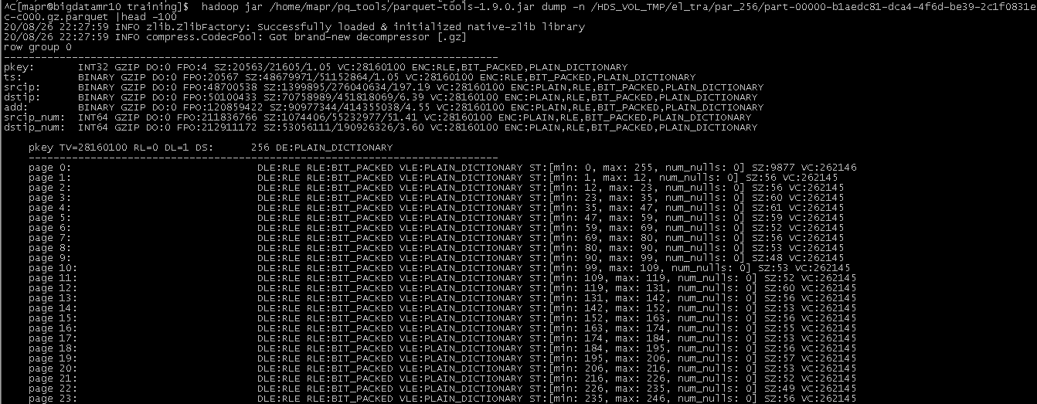

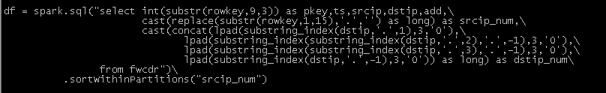

hadoop jar /home/mapr/pq_tools/parquet-tools-1.11.0.jar meta /HDS_VOL_TMP/el_tra/par_256/part-00000-b1aedc81-dca4-4f6d-be39-2c1f0831e2dc-c000.gz.parquet | head -100

hadoop jar /home/mapr/pq_tools/parquet-tools-1.11.0.jar meta /HDS_VOL_TMP/el_tra/par_512/part-00000-13450d0f-85a1-40f5-8473-03220cb36231-c000.gz.parquet| head -100

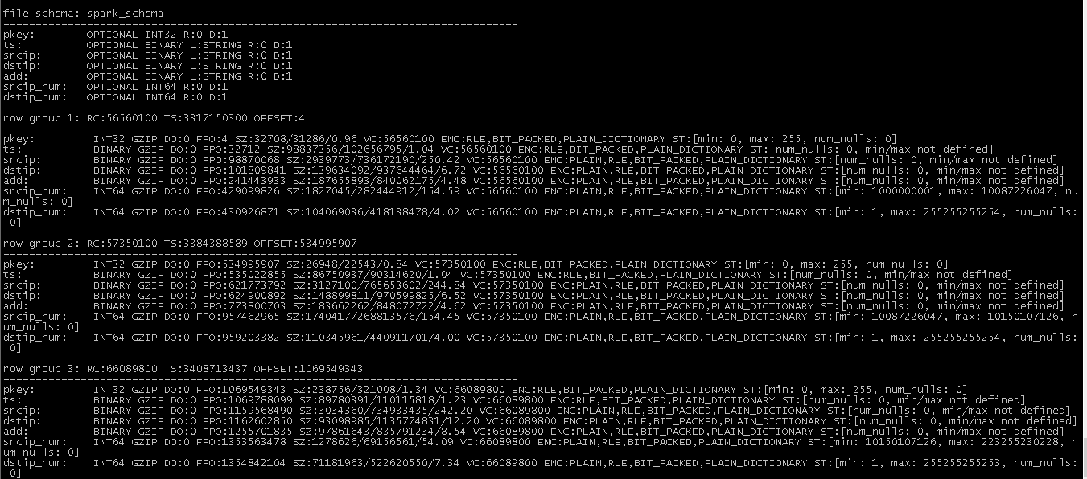

/HDS_VOL_TMP/el_tra/par_256/part-00000-b1aedc81-dca4-4f6d-be39-2c1f0831e2dc-c000.gz.parquet

/HDS_VOL_TMP/el_tra/par_512/part-00000-13450d0f-85a1-40f5-8473-03220cb36231-c000.gz.parquet