

**本科毕业设计（论文）参考文献译文本**

译文出处：Guo Y, Li Y, Qiao X, et al. BiLSTM Multitask Learning-Based Combined Load Forecasting Considering the Loads Coupling Relationship for Multienergy System[J]. IEEE Transactions on Smart Grid, 2022, 13(5): 3481-3492.

院 系 人工智能与自动化学院

专业班级 物流1901

姓 名 吴优

学 号 U201914669

指导教师 肖江文

2023 年 1 月 19

**译文要求**

1. 译文内容须与课题（或专业内容）联系，并需在封面注明详细出处。
2. 出处格式为

图书：作者.书名.版本（第×版）.译者.出版地：出版者，出版年.起页～止页  
期刊：作者.文章名称.期刊名称，年号，卷号（期号）：起页～止页

1. 译文不少于5000汉字（或2万印刷符）。
2. 翻译内容用五号宋体字编辑，采用A4号纸双面打印，封面与封底采用浅蓝色封面纸（卡纸）打印。要求内容明确，语句通顺。
3. 译文及其相应参考文献一起装订，顺序依次为封面、译文、文献。
4. 翻译应在第七学期完成。

**译文评阅**

**考虑多能源系统负荷耦合关系的BiLSTM多任务学习组合负荷预测**

**1.引言**

摘要

准确的负荷预测是多能系统经济调度和高效运行的关键。提出了一种基于双向长短期记忆(BiLSTM)多任务学习的MES负荷组合预测方法。本文首先研究了多能量相互作用机理和多负荷特性，分析了不同季节多负荷之间的相关性。在此基础上，提出了一种充分利用多负荷耦合关系的组合负荷预测方法。在预测模型中，根据最大信息系数(MIC)组合选择不同负荷作为输入特征。采用多任务学习构建了基于BiLSTM算法的冷、热、电联合负荷预测模型，有效地共享了负荷间的耦合信息。最后，通过实例分析验证了该方法在学习速度和预测精度上的有效性和优越性。

指标术语-多任务学习，负荷之间的耦合关系，多能量系统，负荷联合预测

近年来，多能源系统(MES)因其灵活高效的能源生产和利用优势而成为研究热点。与传统的独立能源系统相比，MES的能量连接更紧密，通过能量转换和存储装置[2]、[3]中各种能量的相互作用，实现能量供应和消耗的平衡。此外，还需要提前准确预测MES的短期负荷，以保证经济调度和高效运行。但由于MES系统的结构为交互结构，其冷、热、电负荷不同于传统单一电力系统的电负荷。多个负荷不仅在不同季节波动更随机，而且各负荷之间的联系更复杂，这给MES负荷预测带来了更大的挑战。

在传统的独立能源系统中，负荷影响因素主要包括历史负荷、天气和日期类型。但由于多种能源的相互转换，导致MES系统中不同负荷之间存在耦合关系。目前研究表明，冷、热、电负荷之间的耦合关系是影响MES负荷预测的重要因素。参考文献[4]采用Pearson相关分析定量描述电、冷、热负荷之间的耦合关系。对[5]中的冷、热、电负荷进行Spearman相关分析，表明不同负荷之间的耦合信息可以提高负荷预测的效果。参考值[6]通过基于多任务学习方法的共享权重机制，将冷、热、电负荷之间的耦合信息传递给预测模型。文献[7]提出了基于相关分析和构建的负荷指标的协同电力负荷预测模型，表明负荷之间的耦合关系可以提高负荷预测的准确性。

上述研究表明，负荷预测必须考虑多个负荷之间的耦合关系。然而，目前的研究还存在一些不足。首先，MES负荷受季节变化影响较大。上述研究仅考虑了全年负荷之间的耦合相关性，缺乏不同季节负荷耦合关系变化的研究工作。其次，上述负荷预测方法存在一定的局限性。多任务学习可以增加共享负荷波动较大时的噪声，协同预测方法结合了多个指标的预测结果，可能会造成预测误差的累积。因此，应考虑负荷在不同季节的波动，以提高负荷预测的性能。

对于短期负荷预测，与线性回归和自回归综合移动平均等统计方法相比，数据驱动智能算法是解决负荷预测问题的有效技术。有很多文献报道了结合历史数据[8]-[11]进行负荷预测的人工智能算法。长短期记忆(Long Short-term Memory, LSTM)神经网络作为一种深度学习智能算法，可以传递有效的时间信息[12]，[13]。许多研究证实LSTM具有较强的非线性映射和自学习能力，在短期负荷预测中取得了有效的性能。但是LSTM是一种单向算法，在训练过程中会忽略历史数据的全局信息，导致预测模型[14]的泛化能力较差。因此，本文选择[15]中的BiLSTM进行负荷预测，通过正向和负向训练模型，可以更有效地学习负荷在时间序列中的变化规律。

本文旨在研究不同季节多负荷之间的耦合关系，并提出一种适用于MES的负荷组合预测方法。本文的贡献可以概括为:

1)分析了MES系统的能量相互作用机理和能量利用结构，推导出了多能量供给与多负荷需求之间的能量平衡矩阵。得到的相互作用机理有助于理解MES的能量流动规律，解释不同负荷之间耦合关系的原因。

2)研究不同季节和时间尺度下MES多负荷能耗特征。采用MIC相关分析方法计算各季节冷、热、电负荷之间的相关系数，便于分析多负荷耦合关系的季节变化。

3)提出了一种MES组合负荷预测方法。首先，通过多负荷的耦合关系对不同季节各负荷进行组合特征选择，组合选择负荷预测模型对应的输入特征;其次，通过共享不同负荷预测任务的隐含层信息，建立基于BiLSTM的组合预测模型，充分利用多负荷之间的耦合信息，有效提高短期负荷预测的准确性;

**2. MES负荷特性分析**

A.MES的能量相互作用机制图1为典型MES的相互作用结构。该结构由三部分组成:输入层、中间层和输出层。首先，电能与天然气在输入层提供能源。中间层通过燃气轮机(GT)、压缩式制冷机(CRM)、余热锅炉(WHB)等能量转换装置，实现冷、热、电、气之间的能量转换。其中，P2C表示电转化为冷却的过程，P2H表示电转化为加热的过程，G2P同样表示气转化为电的过程。此外，不同的能量通过储能装置储存。能量被传输到输出层，以满足用户的冷却、加热和电力负荷需求。

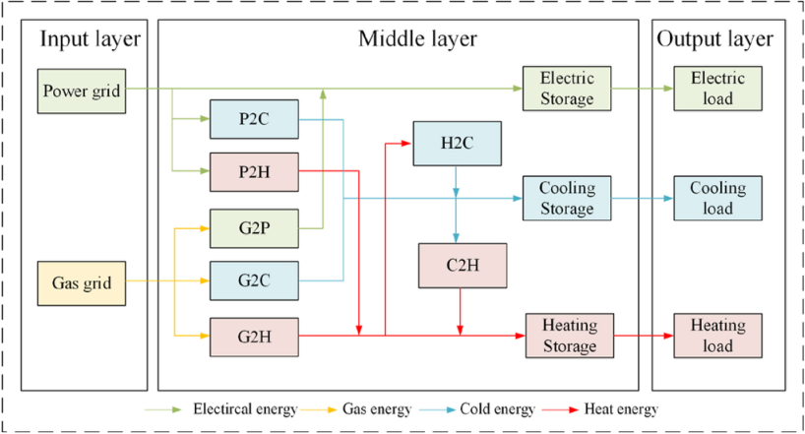

图1.多能量系统的相互作用结构

从图1可以看出，每个负荷所消耗的能量不是简单地由一个能源来支撑的，在能量转换过程中，冷却、加热和电能不可避免地会相互影响。因此，冷、热、电负荷是耦合的，为了准确预测MES的负荷需求，有必要考虑能量相互作用机理。本文推导了多能量供给与多负荷需求之间的能量平衡矩阵，如(1)所示，有助于理解多负荷的能量相互作用机理和耦合关系。

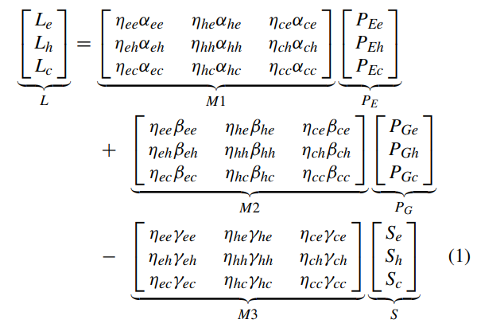

由(1)可知，冷负荷、热负荷和电负荷的初始能源分别来自电和气。能量转换设备消耗电和气来获得冷却、加热和电能，并储存多余的能量。在使用多个能量源的过程中，各个能量源通过M1、M2、M3的耦合转换矩阵相互影响，由于转换器件的转换效率呈非线性变化，不同能量之间的转换过程涉及线性和非线性关系。因此，在MES交互过程中，冷、热、电负荷之间的耦合关系会更紧密，这些都需要考虑。

B.不同季节负荷特征分析MES包括制冷、供热和电力负荷，这些负荷受气候条件、能源消费习惯、社会发展水平和日期类型等因素的影响。由于天气条件的不同，多重荷载呈现出不同的季节特征。本文以亚利桑那州立大学坦佩校区的用户级MES数据为例。重点分析了冷、热、电负荷的季节特征。

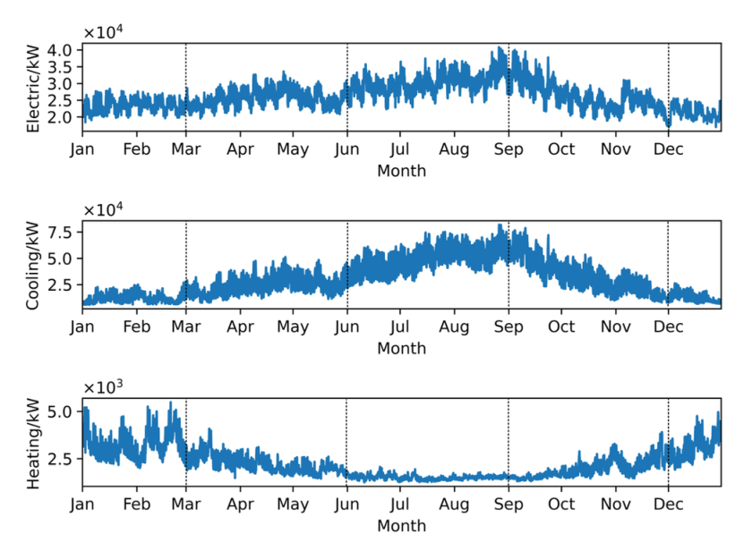

图2. 一年内多重负荷的季节变化曲线

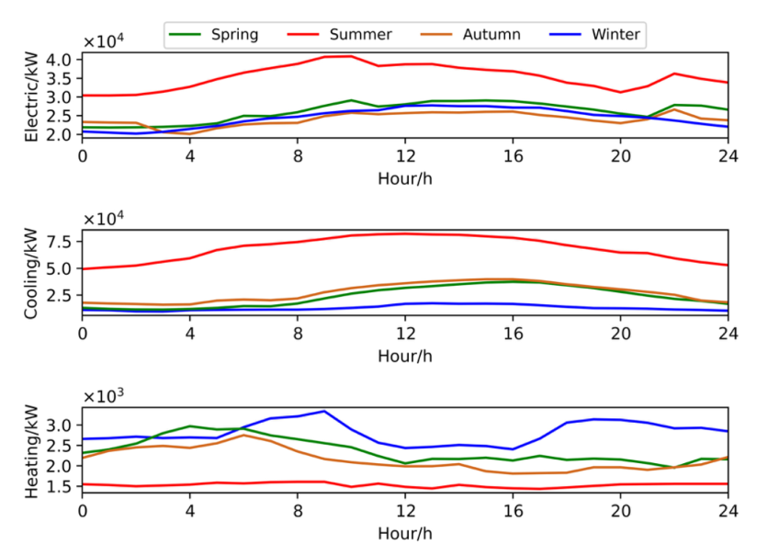

图3. 不同季节多能源系统典型日负荷曲线。

季节划分如下:春天是从3月到5月，夏天是从6月到8月，秋天是从9月到11月，冬天是从12月到2月。2019年多荷载波动曲线如图2所示。可以看出，电力负荷和冷负荷曲线趋势相似;两者都具有夏季增加、冬季减少的特点，而供热负荷具有相反的特点。这表明，在夏季和冬季，电、冷、热负荷具有很强的互补性。从图2的季度变化趋势来看，图3中供冷、供热的变化和春季的电力负荷都很平稳。随着夏季气温的升高，电力负荷和制冷负荷逐渐增加，并在9月达到峰值，而供暖负荷需求下降到最低水平，变化很小。秋季，随着温度的逐渐降低，电负荷和冷负荷呈下降趋势，而热负荷呈逐渐上升趋势。冬季，电力负荷变化平稳，冷负荷下降至较低水平，热负荷上升至全年峰值。

图3为各季节冷、热、电负荷的典型日24小时波动曲线。夏季用电负荷值最大。日曲线上会出现两个峰值，出现在10:00和22:00左右，这与居民的日常生活习惯有关。而冬季电力负荷变化相对平缓，峰值现象不明显。夏季冷负荷也最大，在12:00达到峰值，其他季节的峰值延迟在16:00。春、秋季冷负荷日变化曲线相似，冬季冷负荷需求量最低。供暖负荷在冬季保持最高，有两个峰值，分别出现在9:00和20:00。此外，春季热负荷值略高于秋季，秋季峰谷差值较小。热负荷日变化曲线在春秋两季均为单峰，春季峰值在4时左右，秋季峰值在6时左右。而夏季供热需求属于刚需，因此供热负荷日曲线最小，波动较小。

从以上分析可以看出，不同季节的负荷特征差异较大，冷、热、电负荷在四季中的变化趋势相似或互补。因此，根据季节对负荷进行分析，可以更准确地掌握多负荷的波动规律。

C.不同季节负荷相关性分析：由于MES通过能量转换和存储装置向负载提供能量，因此在冷却，加热和电力负荷之间存在耦合关系。负荷在不同季节的变化也表现出相似或互补的现象，因此一个负荷的变化会相应地将信息传递给其他负荷，不同负荷在不同季节也会相互影响。分析负荷相关影响因素对负荷预测具有重要意义。为了衡量不同负荷之间的相关性，采用MIC方法[16]-[18]对多个负荷的线性和非线性相关程度进行分析。

MIC的计算基于互信息原理，通过联合概率[19]来衡量两个变量之间的相关性。与[20]中Pearson的线性相关分析相比，MIC是通过对样本网格划分的互信息计算得到线性或非线性相关，可以衡量多个负荷之间的复杂相关性，为更准确的负荷预测特征选择奠定基础。

由式1分析可知，MES的负荷不仅包括电能、气体能和储能的线性加减关系，还包括能量转换和储能矩阵m的复杂线性非线性关系。因此，为了更准确地分析负荷之间的耦合相关性，采用MIC算法，其优点是能够同时测量线性和非线性相关性，具有较低的计算复杂度和优秀的鲁棒性。MIC的计算公式如下:

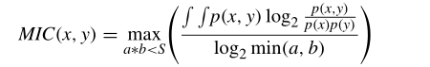

其中a和b表示在x轴和y轴方向上划分的网格数;S为网格总数，为数据样本的0.6次幂;P (x, y)表示变量样本分布在网格x和y中的概率，互信息由样本分布在网格中的联合概率计算，MIC取归一化互信息的最大值。

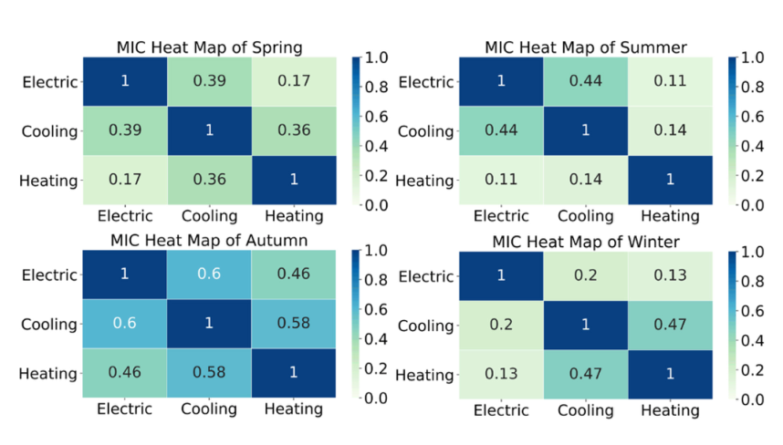

图4. 不同季节负荷的MIC热图

图4为不同季节负荷的MIC热图，揭示了MES负荷之间的季节相关性:1)冷负荷与热负荷之间存在线性或非线性相关性。在MES中，电力负荷与冷却负荷之间的相关性强于电负荷和热负荷两者之间的相关性;2)冷、热、电负荷之间的MIC相关性随季节变化。

从图4可以看出，春季的电负荷与冷负荷的MIC相关系数大于0.3，说明电负荷与冷负荷的联系密切。同样，冷负荷和热负荷之间的关系也是一样的。而电负荷与热负荷的MIC仅为0.17，相关性较弱。夏季制冷负荷与电力负荷的相关性达到0.44，说明相关性较强，符合夏季大量使用电力制冷设备的规律。秋季负荷间MIC均在0.45以上，说明冷、热、电负荷之间相互影响，相关性较强。冬季热负荷和冷负荷的MIC为0.47，具有较强的相关性。

本文重点研究了不同季节多个负荷之间的耦合关系，通过负荷联合预测方法实现负荷之间的信息共享，从而提高了负荷预测的准确性。

**3. 联合负荷预测法**

A.输入特征的组合选择负荷预测的关键是选择与负荷最相关的特征作为预测模型的输入。根据负载之间的耦合关系，提出了一种选择输入特征的组合方法。

首先，计算各季节用电负荷、冷热负荷之间的相关性。然后，统计每个季节中MIC相关系数大于阈值的个数，根据MIC统计结果选择输入特征。根据不同季节的MIC分析结果，选取不同的输入特征，构建相应的负荷预测模型。具体特征选择如表I所示，在以下场景下获得组合输入特征:场景1:选择电、冷、热负荷组合作为输入特征。MIC值大于阈值的个数为2或3，输入特征由三类负载决定。

场景2:同时选择两种负载作为输入特征。MIC值大于阈值的负载个数为1。选择MIC值大于阈值的两类负载作为输入特征，其他类型的负载只选择自己的历史数据作为输入特征。

场景3:用电负荷、冷热负荷分别作为输入特征。MIC值大于阈值的个数为0，输入特征为每一种负载类型。

B. BiLSTM模型BiLSTM是一个包含前向LSTM层和后向LSTM层[21]的神经网络。在LSTM的基础上，导出了BiLSTM的基本结构单元和算法。以t时刻的LSTM为例，LSTM单元输入最后一次输出结果y(t−1)和当前变量x(t)。首先需要确定单元状态c(t−1)的遗忘内容，通过遗忘门计算输入变量，得到遗忘因子f (t)。

接下来，输入变量x(t)和y(t−1)通过输入门的sigmoid激活函数确定需要更新哪些新的单元状态信息，并通过输入门的tanh激活函数创建一个新的单元候选状态u(t)。

输入门和遗忘门的关键功能是控制信息保存和遗忘，从而建立一个新的神经元细胞状态c(t)来更新神经元细胞状态。最后，输出门o(t)使用sigmoid激活函数确定部分输出信息，再乘以tanh变换后的新单元状态c(t)，得到输出结果y(t)。LSTM的计算公式如下:

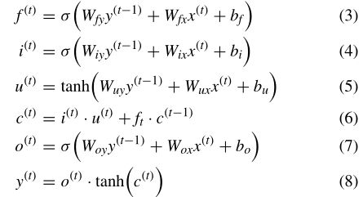

其中Wfy、Wfx、Wix、Wiy、Wuy、wx、Woy、Wox为网络对应门的权值矩阵，bf、bi、bu、bo为偏置矩阵;σ和tanh分别代表sigmoid和tanh激活函数。同时考虑时间序列数据的正向信息和反向信息，可以有效提高预测精度。

与标准LSTM中的单向状态传输相比，BiLSTM的结构可以同时学习正向和反向的调节。通过双向时间序列特征提取，BiLSTM的性能优于LSTM，其网络结构如图5所示。结合双向LSTM，计算BiLSTM输出结果如下:



其中yf和yb分别表示前向LSTM和后向LSTM的输出结果。Wyf和Wyb为图5中的权重矩阵。BiLSTM的网络结构的计算输出结果y(t)，而by为输出偏置矩阵;G表示输出层激活函数。

C.基于组合负荷的多任务学习提出的MES负荷预测在于负荷之间的耦合关系和相互影响，选择多个相关负荷作为预测的输入。在模型训练方面，还可以与多种类型的负荷预测任务相结合，即多任务学习[22]，在多个负荷预测任务之间共享相关信息，提高预测的准确性。从图1可以看出，冷、热、电负荷之间的转换存在耦合关系，冷、热、电负荷之间的相关性有待进一步探讨。因此，通过这种多任务学习方法，可以共享冷、热、电负荷之间的信息，从而挖掘冷、热、电负荷内部转换的信息。基于多任务学习的组合负荷预测框架如图6所示。

组合负荷预测方法包括冷、热、电负荷预测三个任务。首先，输入特征组合选择得到的数据集，建立相应的BiLSTM进行学习。然后，通过多任务学习的信息共享层，将三个任务一起训练，有效地融合了耦合冷、热、电负荷预测任务之间的信息。采用(10)所示的动态加权方法优化多任务学习的损失函数，根据预测任务[23]的学习阶段动态调整权重。

基于以上分析，组合负荷预测过程如图7所示。基于负荷耦合关系和BiLSTM多任务学习的短期负荷联合预测的步骤如下:

(1)数据预处理。首先，剔除负荷和气象数据中的异常值，并通过数据清洗方法填充缺失值。然后，通过数据归一化将数据维数转换为0-1的范围。

(2)数据集划分和输入特征选择。将数据集划分为不同的季节，然后计算各负荷之间的MIC，根据各季节负荷之间的相关性实现组合特征选择。最后，将每个季节的数据分为训练集、验证集和测试集。

(3)负荷预测模型训练与性能评价。首先，输入训练集训练预测模型。然后，评估训练模型在验证集上的性能，通过网格搜索[24]得到模型的最优参数。最后，通过建立对比实验，在试验集上验证了负荷预测的性能。

为了比较负荷预测性能，采用[25]中的均方根误差(RMSE)和[26]中的平均绝对百分比误差(MAPE)作为评价指标，衡量预测值与实际值之间的偏差。

**4.总结**

本文提出了一种基于BiLSTM多任务学习的冷、热、电负荷联合预测方法，主要在特征选择和预测模型上进行了改进。研究了冷、热、电负荷在不同季节的耦合关系，包括输入特征的组合选择和基于BiLSTM的多任务学习模型。该方法通过特征与模型的融合，传递负荷之间的耦合关系信息，更好地了解冷、热、电负荷的调节情况。通过不同季节负荷预测实例，验证了组合预测方法的有效性。试验结果表明，该方法显著提高了负荷预测精度和模型训练时间成本，在MES系统中具有重要的工程应用价值。

**参考文献原文**

**BiLSTM Multitask Learning-Based Combined Load Forecasting Considering the Loads Coupling Relationship for Multienergy System**

**Abstract—Accurate load forecasting is the key to economic dispatch and efficient operation of Multi-Energy System (MES). This paper proposes a combined load forecasting method for MES based on Bi-directional Long Short-Term Memory (BiLSTM) multi-task learning. Firstly, this paper investigates the multi-energy interaction mechanism and multi-loads characteristics and analyzes the correlation of multi-loads in different seasons. Then, a combined load forecasting method is proposed, which focuses on making full use of the coupling relationship among multiple loads. In the forecasting model, the different loads are selected combinedly as the input features according to the Maximum Information Coefficient (MIC). The multi-task learning is adopted to construct the cooling, heating and electric combined load forecasting model based on the BiLSTM algorithm, which can effectively share the coupling information among the loads. Finally, case studies verify the effectiveness and superiority of the proposed method in both learning speed and forecasting accuracy.**

**Index Terms—Multi-task learning, coupling relationship among loads, multi-energy system, combined load forecasting.**

1. INTRODUCTION

IN RECENT years, the multi-energy system (MES) has become a research hotspot due to the advantages of flexible and efficient energy production and utilization [1]. Compared with the traditional independent energy system, he energy connections of MES are closer, and it realizes a balance between energy supply and consumption through the interaction of various energy in energy conversion and storage devices [2], [3]. What’s more, it is necessary to accurately predict the short-term load of MES in advance ensuring economic dispatch and efficient operation. However, due to the interactive structure, the cooling, heating and electric loads of MES are different from the traditional electrical load in the single power system. Multiple loads not only fluctuate more randomly in different seasons, but also the connection among them is more complicated, which brings greater challenges to the load forecasting of MES.

In terms of the traditional independent energy system, load influencing factors mainly include historical load, the weather and date types. However, the mutual conversion of multiple energy sources leads to the coupling relationship of different loads in the MES. The current research has shown that the coupling relationship between cooling, heating, and electric loads is the important factor affecting the load forecasting for MES. Reference [4] adopts Pearson correlation analysis to quantitatively describe the coupling relationship among electric, cooling and heating loads. Spearman correlation analysis is carried out on cooling, heating and electric loads in [5], which shows that the coupling information among different loads can improve the effect of load forecasting. Reference [6] transmits the coupling information among the cooling, heating and electric loads to the forecasting model by the shared weight mechanism, which is based on the multi-task learning method. Reference [7] puts forward a synergetic electric load forecasting model based on the correlation analysis and the constructed load indexes, which shows that the coupling relationship among loads can improve the accuracy of load forecasting.

The above research works show that it is necessary for load forecasting to consider the coupling relationship among multiple loads. However, the current research still has some shortcomings. Firstly, loads of MES are greatly affected by the seasonal changes. The above-mentioned research only considers the coupling correlation among the loads throughout the year, and there is a lack of research work concerning on the changes of load coupling relationship in different seasons. Secondly, the above-mentioned load forecasting method has certain limitations. Multi-task learning may increase the shared oise when the load fluctuates greatly [6], and the synergetic forecasting method [7] combines the prediction results of multiple indicators, which may cause the accumulation of forecasting errors. Thus, the load fluctuations in different seasons should be considered to improve the performance of load forecasting.

For short-term load forecasting, data-driven intelligent algorithms are effective techniques to solve load forecasting problems, compared with statistical methods such as linear regression and autoregressive integrated moving average. There are much literature reporting artificial intelligence algorithms for load forecasting combined with historical data [8]–[11]. As a kind of deep learning intelligent algorithm, Long Short-term Memory (LSTM) Neural Network can transmit effective temporal information [12], [13]. Many studies have confirmed that LSTM has strong non-linear mapping and self-learning ability, which achieves effective performance in short-term load forecasting. However, LSTM is a single-direction algorithm, and the global information of historical data will be ignored during the training process, which leads to a poor generalization of the prediction model [14]. Therefore, this paper chooses the BiLSTM in [15] for load forecasting, which can learn the regulation of loads in the time series more effectively by training the model in both positive and negative directions.

The aim of this paper is to investigate the coupling relationship between multiple loads in different seasons, and propose a combined load forecasting method for MES. The contribution of this paper can be summarized as follows:

1) Analyze the energy interaction mechanism and energy use structure of MES, deriving the energy balance matrix between multi-energy supply and multi-loads demand. The obtained interaction mechanism will help understand the energy flow law of MES and explain the reasons for the coupling relationship among different loads.

2) Investigate the energy consumption characteristics among multi-loads of MES under different seasons and time scales. The MIC correlation analysis method is used to calculate the correlation coefficients among the cooling, heating, and electric loads in each season, which facilitates analyzing the seasonal changes in the coupling relationship among multi-loads.

3) A combined load forecasting method of MES is proposed. Firstly, combined feature selection for each load in different seasons is carried out through the coupling relationship of multi-loads, and the corresponding input features of the load forecasting model are selected combinedly. Secondly, establish a combined forecasting model based on BiLSTM by sharing the hidden layer information of different load forecasting tasks, which take full use of the coupling information among multi-loads and effectively improve the accuracy of short-term load forecasting.

II. LOAD CHARACTERISTIC ANALYSIS OF MES

1. Energy Interaction Mechanism of MES

Fig. 1 shows the interaction structure of a typical MES. The structure is composed of three parts: the input, the middle, and the output layer. Firstly, the electric energy and natural gas provide energy source in the input layer. Then, the middle layer realizes energy conversion among cooling, heating, electric and gas by means of energy conversion devices such as Gas Turbine (GT), Compression Refrigerating Machine (CRM), Waste Heat Boiler (WHB) and so on. Among them, P2C represents the process of converting electricity into cooling, P2H represents the process of converting electricity into heating, and G2P represents the process of converting the gas into electricity similarly. In addition, different energy is stored through energy storage devices. The energy is transmitted to the output layer to meet the cooling, heating, and electric load demand of users.

It can be seen from Fig. 1 that the energy consumed by each load is not simply supported by one energy source, and the cooling, heating and electric energy will inevitably affect each other during energy conversion. Thus, the cooling, heating and electric loads are coupled, and it is necessary to consider the energy interaction mechanism in order to accurately predict the load demand of MES. This paper derives the energy balance matrix between multi-energy supply and multiload demand, as shown in (1), which can help understand the energy interaction mechanism and the coupling relationship of multi-loads.



where PE and PG are the energy input vector, which represent electric and gas energy provided by energy suppliers; S is the intermediate vector, which represents the energy storage system that stores various forms of energy; L is the output vector, which represents the energy demand of users. Among them, e, h, c and g respectively represent electric, heating, cooling, and gas energy forms in the MES. M1 and M2 represent the coupling relationship matrix of energy conversion, while M3 represents the coupling relationship matrix of energy storage; η represents the efficiency of energy conversion and storage; α, β and γ represent the distribution ratio of energy conversion and storage. It can be seen from (1) that the initial energy sources of the cooling, heating and electric loads are from electric and gas. The energy conversion equipment consumes electric and gas to obtain the cooling, heating and electric energy, and stores the excess energy. In the process of using multiple energy sources, each energy source influences each other through the coupling conversion matrix of M1, M2, and M3, since the conversion efficiency of the conversion devices changes nonlinearly, the conversion process between different energy involves linear and nonlinear relationships. Therefore, during the interaction of MES, there will be a tighter coupling relationship between the cooling, heating, and electrical loads, which needs to be considered.

1. Load Characteristics Analysis in Different Seasons

The MES includes cooling, heating, and electric loads, and these loads are affected by factors such as climatic conditions, energy consumption habits, social development level, and date types. The multi-loads present different seasonal characteristics due to the different weather conditions. In this paper, the user-level MES data of the Arizona State University Tempe campus are taken as an example. The seasonal characteristics of cooling, heating and electric loads are focused on.

The seasons are divided as follows: spring is form March to May, summer is from June to August, autumn is from September to November, and winter is from December to February. Fig. 2 shows the curve of multi-loads fluctuation in 2019. It can be seen that the electric and cooling load curves have similar trends; both of them are characterized by an increase in summer and a decrease in winter, however, the heating load has the opposite characteristic. This shows that electric, cooling and heating loads are highly complementary in summer and winter. Judging from the trend of quarterly changes in Fig. 2, the changes in the cooling, heating, and electric loads are smooth in spring. As the temperature rises in summer, the electric and cooling loads gradually increase until reaching a peak in September, while the demand of heating load drops to the lowest level with tiny change. In autumn, the electric and cooling loads show a downward trend when the temperature gradually decreases, while the heating load has gradually shown an upward trend. In winter, the electric load changes steadily, the cooling load drops to a lower level, and the heating load rises to reach the annual peak.

Fig. 3 shows the typical daily 24-hour fluctuation curve of cooling, heating and electric loads for each season. The value of the electric load is the largest in summer. There will be two peaks in the daily curve, appearing around 10:00 and 22:00, which are related to the daily living habits of residents. While the change of electric load in winter is relatively flat and the peak phenomenon is not apparent. The cooling load also has the largest value in summer, reaching its peak at 12:00, and the peaks of the other seasons are delayed at 16:00. The daily curve of cooling load is similar in spring and autumn, and the demand for cooling load in winter is the lowest. The heating load maintains the highest value in winter and there are two peaks, appearing at 9:00 and 20:00, respectively. In addition, the value of heating load in spring is slightly higher than that in autumn and the peak-valley difference in autumn is smaller. The daily curve of heating load is a single peak in spring and autumn, with the peak in spring at about 4:00 and in autumn at about 6:00.

However, the heating demand is a rigid demand in summer, so the daily curve of heating load is the smallest and hardly fluctuates.

It can be seen from the above analysis that the load characteristics in different seasons are quite different, and the trends of the cooling, heating and electric loads are similar or complementary in the four seasons. Therefore, analyzing the loads according to season can more precisely grasp the fluctuation law of multi-loads.

1. Loads Correlation Analysis in Different Seasons

Since MES provides energy to loads by means of energy conversion and storage devices, there is a coupling relationship between cooling, heating and electric loads. The load changes in different seasons also show similar or complementary phenomena, so the change of one load will correspondingly transfer information to other loads, and different loads affect each other in different seasons. It is important to analyze load-related influencing factors for load forecasting. In order to measure the correlation between different loads, the MIC method [16]–[18] is used to analyze the linear and non-linear correlation degree of the multiple loads.

The calculation of MIC is based on the principle of mutual information, which measures the correlation between two variables through joint probability [19]. Compared with the linear correlation analysis of Pearson in [20], MIC obtains the linear or nonlinear correlation based on the mutual information calculation of the sample grid division, so it can measure the complex correlation among multiple loads and lay the foundation for more accurate feature selection for load forecasting. From the analysis of equation 1, it can be seen that the loads of MES include not only the addition and subtraction linear relationship of electric energy, gas energy and energy storage, but also the complex linear and nonlinear relationship of the energy conversion and energy storage matrix M. Therefore, in order to analyze the coupling correlation between loads more accurately, the MIC algorithm is adopted, which has the advantages of being able to measure linear and nonlinear correlations at the same time, with low computational complexity and excellent robustness. The calculation equation of MIC is as follows:

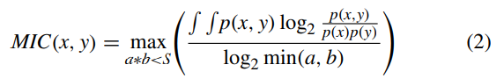

Fig. 4 shows the MIC heat map of the loads in different seasons, revealing the seasonal correlation among loads of MES: 1) There is a linear or non-linear correlation between cooling load and heating load. In MES, the correlation between electric load and cooling load is stronger than that between electric load and heating load; 2) The MIC correlation among the cooling, heating, and electrical loads changes in different seasons.

It can be seen from Fig. 4 that the MIC correlation coefficient between electric and cooling load in Spring is greater than 0.3, indicating that the connection between electric and cooling is close. Similarly, the relationship between cooling and heating load is also the same. However, the MIC of electric and heating load is only 0.17, which shows the correlation is weak. In Summer, the correlation between cooling and electric loads reaches 0.44, indicating the correlation is strong, which meets the law that a large number of electric refrigeration equipment are used in summer. In autumn, the MIC between loads are all above 0.45, showing the cooling, heating and electric loads influence each other and the correlation among them is strong. In winter, the MIC of heating load and cooling load is 0.47, so they have a strong correlation. This paper focuses on the coupling relationship between multiple loads in different seasons and realizes the sharing of information between loads by the combined load forecasting method, thereby improving the accuracy of load forecasting.

III. COMBINED LOAD FORECASTING METHOD

1. Combined Selection of Input Feature

The key to load forecasting is to select the features most relevant to the load as the input of the forecasting model. According to the coupling relationship between loads, this paper proposes a combined method to select input features. Firstly, calculate the correlation between the electric, cooling and heating load in each season. Then, count the number of MIC correlation coefficients in each season whose value is greater than the threshold, and select the input features by the statistical results of MIC. In term of the MIC analysis results in different seasons, different input features are selected to construct the corresponding load forecasting model. The specific feature selection is shown in Table I, and the combined input feature is obtained in the following scenarios:

Scenario 1: Electric, cooling and heating load are combined selected as input features. The number of MIC values greater than the threshold is 2 or 3, and the input features are determined by the three types of loads.

Scenario 2: Two types of loads are selected as input features together. The number of loads with a MIC value greater than the threshold is 1. Two types of loads with MIC values greater than threshold are selected together as input features, while the other type of load only selects its own historical data as input features.

Scenario 3: Electric, cooling and heating loads are separately used as input features. The number of MIC values greater than the threshold is 0, and the input feature is every single type of load.

1. BiLSTM Model

BiLSTM is a neural network that contains a forward LSTM layer and a backward LSTM layer [21]. The basic structural unit and algorithm of BiLSTM are derived from LSTM. Taking the LSTM at time t as an instance, the LSTM unit will input the last output result y(t−1) and the current variable x(t) . Firstly, it is necessary to determine the forgetting content of the cell state c(t−1) , so the input variables are calculated through the forgetting gate to obtain the forgetting factor f (t) . Next, the input variables x(t) and y(t−1) determine which new information of the cell state needs to be updated through the sigmoid activation function of the input gate, and a new cell candidate state u(t) is created through the tanh activation function of the input gate.

The key function of the input gate and the forgetting gate is to control information preservation and to forget, thus a new neuron cell state c(t) is established to update the neuron cell state. Finally, the output gate o(t) uses the sigmoid activation function to determine part of the output information, which is multiplied by the new cell state c(t) after the tanh transformation to obtain the output result y(t) . The calculation equations of LSTM are as follows:

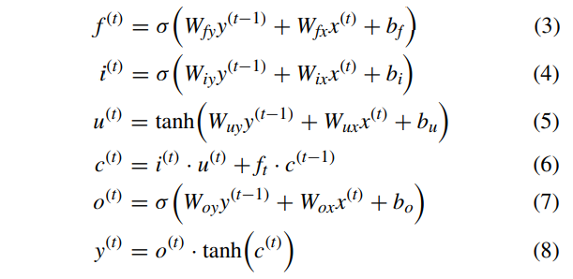

where Wfy, Wfx, Wix, Wiy, Wuy, Wux, Woy, Wox are weight matrices for the corresponding gates of the network, while the bf , bi, bu, bo are the bias matrices; σ and tanh represent the sigmoid and tanh activation function respectively.

Considering the forward and backward information of time series data can effectively improve forecasting accuracy. Compared with the unidirectional state transmission in the standard LSTM, the structure of BiLSTM can learn the regulation in the forward and backward directions simultaneously. By the bidirectional time series feature extraction, BiLSTM has more superior performance to LSTM, and its network structure is shown in Fig. 5. By the combination of twodirection LSTM, the output result of BiLSTM is calculated as the following:

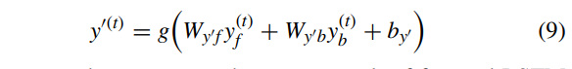

where yf and yb represent the output result of forward LSTM and backward LSTM. is the output bias matrices; g represents the output layer activation function.

C. Multi-Task Learning Based Combined Loads Forecasting

The proposed load forecasting of MES lies in the coupling relationship and mutual influence between loads and selects multiple related loads as the input for forecasting. In terms of model training, it can also be combined with multiple types of load forecasting tasks, that is, the multi-task learning [22], which shares relevant information between multiple load forecasting tasks to improve the accuracy of forecasting. It can be seen from Fig. 1 that there is a coupling relationship in the conversion of cooling, heating and electrical loads, and the correlation between cooling, heating and electrical loads needs to be further explored. Therefore, through this multi-task learning method, the information between the cooling, heating and electric loads can be shared, so that the information on the internal conversion of the cooling, heating, and electric loads can be excavated. The combined load forecasting framework based on multi-task learning is shown in Fig. 6.

The combined load forecasting method includes three tasks of cooling, heating and electric load forecasting. Firstly, input the data set obtained by the feature combination selection, and establish the corresponding BiLSTM for learning. Then, the three tasks will train together by the information sharing layer of multi-task learning, which effectively merges the coupling information between the cooling, heating, and electric load forecasting tasks. The loss function of multi-task learning is optimized by a dynamic weighting method shown in (10), the weights are dynamically adjusted according to the learning stages of forecasting tasks [23].

D. Modeling Process

Based on the above analysis, the combined load forecasting process is shown in Fig. 7. The steps of short-term combined load forecasting based on the coupling relationship of loads and BiLSTM multi-task learning are as follows:

(1) Data preprocessing. Firstly, eliminate the outliers in the load and meteorological data, and fill in the missing values by the data cleaning method. Then, convert data dimensions into the range of 0-1 by data normalization.

(2) Data set division and input feature selection. Divide the data set into different seasons, then calculate the MIC between the loads, and realize combined feature selection according to the correlation of the loads in each season. Finally, divide the data of each season into the training, validation and test set.

(3) Model training and performance evaluation of load forecasting. Firstly, input the training set to train the forecasting model. Then, the performance of the training model on the validation set is evaluated, and the optimal parameters of the model are obtained by grid search [24]. Finally, verify the load forecasting performance on test set by setting up the comparative experiments.

In order to compare the load forecasting performance, Root Mean Squared Error (RMSE) in [25] and Mean Absolute Percentage Error (MAPE) in [26] are used as the evaluation index to measure the deviation between the forecasting value and the actual value.

IV. CONCLUSION

This paper proposes a combined cooling, heating and electric load forecasting method based on BiLSTM multi-task learning, which is mainly improved on the feature selection and the forecasting models. The coupling relationship of cooling, heating and electric load in different seasons is investigated, including the combined selection of input feature and the multi-task learning model based on BiLSTM. This method can transmit information about the coupling relationship between loads via the fusion of features and models, which learns the regulation of cooling, heating, and electric loads better. The effectiveness of the combined forecasting method is verified by load forecasting cases in different seasons. The test results show that the proposed method significantly improves both load forecasting accuracy and the time cost of model training, which has a critical engineering application value in the MES.