实验报告10

学号：117060400115 姓名：魏莹 班级：应用统计1班 指导老师：林卫中

实验名称：python第七章程序练习题

实验要求：1.对python源文件进行改写

1. 熟悉图像文件压缩
2. 学会制作英文学习词典

实验结果：

1.

import keyword

kws = keyword.kwlist

file = input("读取的源程序文件:")

fr = open(file,'r',encoding='utf-8')

wline = ' '

for line in fr:

wline += '\n'

if 'import' in line:

wline += line

else:

j = 0

while line[j] == ' ':

wline += ' '

j += 1

sline = line.split()

for w in sline:

if ':' in w:

w = w[0:-1]

elif w in kws:

wline += w

else:

wline += w.upper()

wline += ' '

fr.close()

fw = open(file,'w',encoding='utf-8')

fw.write(wline)

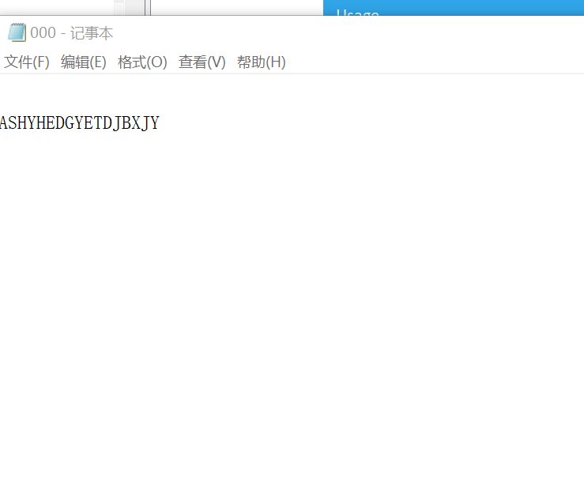

2.

from PIL import Image

im = Image.open("D:\课堂练习/rabbit.jpg")

w,h = im.size

c = 10

im.thumbnail(w//c,h//c)

im.save('D:\课堂练习/rabbit.jpg','JPEG')

im.show()

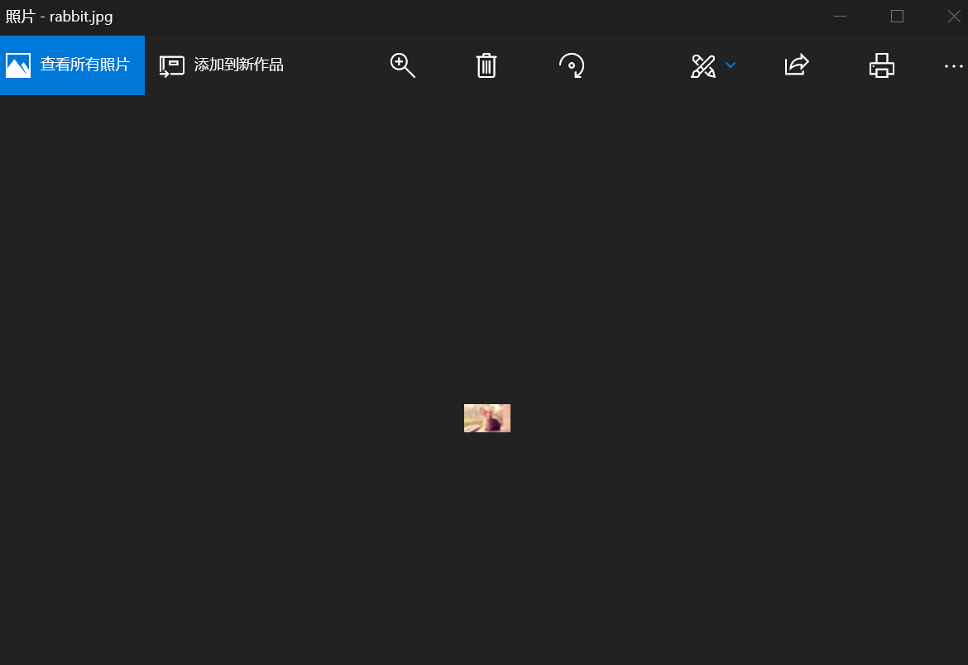

3.

import os

def userOperateInterface():

print("\n请选择词典功能模块")

print("i: 添加单词")

print("s: 查询单词")

print("Q: 退出词典")

print("请选择功能：")

return input()

def addWord(wordDict:dict, fileName):

str = input("您输入要加入的单词：")

if str in wordDict.keys():

print("该单词已添加到字典库\n")

userOperateInterface()

else:

t = input("请输入此单词的中文释义：")

wordDict[str] = t

with open(fileName, 'a') as fw:

fw.write(str + " " + t + '\n')

def selectWord(wordDict:dict):

str = input("请输入您要查询的单词：")

if str not in wordDict.keys():

print("字典库中未找到这个单词\n")

else:

print(wordDict[str])

def main():

wordDict = {}

if os.path.exists("dict.txt"):

with open("dict.txt", 'r') as fr:

for ln in fr:

s = ln.split(" ")

wordDict[s[0]] = s[1]

else:

fw = open("dict.txt",'w')

fw.close()

print("\*\*\*\*\*\*欢迎使用简明英汉词典\*\*\*\*\*\*")

while True:

op = userOperateInterface()

if op == 'i':

addWord(wordDict, 'dict.txt')

elif op == 's':

selectWord(wordDict)

elif op == 'Q':

break

else:

print("输入有误\n")

main()

