详细设计
- 搜索
import java.io.*;
import java.util.*;
public class DAO {
private String findSnumBySname(String Sname)
{
String result = "";
try
{
//相对路径创建文件字符输入流：..\\..\\名字
FileReader file = new FileReader("D:\\Workspaces\\MyEclipse 8.5\\Student.txt");
//创建缓冲的字符输入流对象
BufferedReader brea = new BufferedReader(file);
//读取第一行数据
String str = brea.readLine();
while(str!=null)
{
//用逗号将一行数据切割为字符串数组
String[] strs = str.split(",");
if(strs[1].equals(Sname))
{
result = strs[0];
break;
}
//未找到读取下一行数据
str = brea.readLine();
}
file.close();
}catch(Exception ex)
{
System.out.println("未找到");
}
return result;
}
private ArrayList<String> findCnumsBySnum(String Snum)
{
ArrayList<String> result = new ArrayList<String>();
try
{
FileReader file1 = new FileReader("D:\\Workspaces\\MyEclipse 8.5\\SC.txt");
BufferedReader bre = new BufferedReader(file1);
String tmp = bre.readLine();
while(tmp != null)
{
String[] strs = tmp.split(",");
if(strs[0].equals(Snum))
{
result.add(strs[1]);
}
tmp = bre.readLine();
}
file1.close();
}
catch(Exception ex)
{
System.out.print("");
}
return result;
}
private ArrayList<String> findSnumByCnum(String cnum)
{
ArrayList<String> result = new ArrayList<String>();
try
{
FileReader file = new FileReader("D:\\Workspaces\\MyEclipse 8.5\\SC.txt");
BufferedReader rea = new BufferedReader(file);
String str = rea.readLine();
while(str!=null)
{
String[] tmp = str.split(",");
if(tmp[1].equals(cnum))
{
result.add(tmp[0]);
}
str = rea.readLine();
}
file.close();
}catch(Exception ex)
{
System.out.println("");
}
return result;
}
private String findSnameBySnum(String Snum)
{
String result = "";
try
{
FileReader file = new FileReader("D:\\Workspaces\\MyEclipse 8.5\\Student.txt");
BufferedReader bre = new BufferedReader(file);
String str = bre.readLine();
while(str!=null)
{
String[] tmp = str.split(",");
if(tmp[0].equals(Snum))
{
result = tmp[1];
}
str = bre.readLine();
}
file.close();
}
catch(Exception ex)
{
System.out.println("");
}
return result;
}
private ArrayList<String> findCnamesByCnum(String Cnum)
{
ArrayList<String> list=new ArrayList<String>();
try
{
FileReader file2 = new FileReader("D:\\Workspaces\\MyEclipse 8.5\\Course.txt");
BufferedReader brea2 = new BufferedReader(file2);
String tmp = brea2.readLine();
while(tmp!=null)
{
String[] strs = tmp.split(",");
for(int i = 0;i<list.size();i++)
{
if(strs[0].equals(Cnum))//?????
{
list.add(strs[1]);
//break;
}
}
tmp = brea2.readLine();
}
file2.close();
}
catch(Exception ex)
{
System.out.println("");
}
return list;
}
private String findCnameByCnum(String cno)
{
String result = "";
try
{
FileReader file2 = new FileReader("D:\\Workspaces\\MyEclipse 8.5\\Course.txt");
BufferedReader brea2 = new BufferedReader(file2);
String tmp = brea2.readLine();
while(tmp!=null)
{
String[] strs = tmp.split(",");
if(strs[0].equals(cno))
{
result = strs[1];
break;
}
tmp = brea2.readLine();
}
file2.close();
}
catch(Exception ex)
{
System.out.println("");
}
return result;
}
public ArrayList<String> findCnamesBySname(String sname)
{
String snum = findSnumBySname(sname);
ArrayList<String> cnums = findCnumsBySnum(snum);
if(cnums.size()!=0)
{
ArrayList<String> list = new ArrayList<String>();
for(int i = 0;i<cnums.size();i++)
{
list.add(findCnameByCnum(cnums.get(i)));
}
return list;
}
else
{
return null;
}
}
private String findCnumByCname(String Cname)
{
String result = "";
//ArrayList<String> list=new ArrayList<String>();
try
{
FileReader file2 = new FileReader("d:\\Workspaces\\MyEclipse 8.5\\Course.txt");
BufferedReader brea2 = new BufferedReader(file2);
String tmp = brea2.readLine();
while(tmp!=null)
{
String[] strs = tmp.split(",");
if(strs[1].equals(Cname))
{
result = strs[0];
break;
}
tmp = brea2.readLine();
}
file2.close();
}
catch(Exception ex)
{
System.out.println("");
}
return result;
}
private ArrayList<String> findGradeByCname(String Cname)
{
ArrayList<String> result = new ArrayList<String>();
String cnum = findCnumByCname(Cname);
try
{
FileReader file = new FileReader("d:\\Workspaces\\MyEclipse 8.5\\SC.txt");
BufferedReader brea = new BufferedReader(file);
String str = brea.readLine();
while(str!=null)
{
String[] tmp = str.split(",");
if(tmp[1].equals(cnum))
{
result.add(tmp[2]);
}
str = brea.readLine();
}
file.close();
}catch(Exception ex)
{
System.out.println("");
}
return result;
}
public ArrayList<String> findSnameByCname(String Cname)
{
ArrayList<String> result = new ArrayList<String>();
String cnum = findCnumByCname(Cname);
ArrayList<String> Snum = findSnumByCnum(cnum);
try
{
FileReader file4 = new FileReader("D:\\Workspaces\\MyEclipse 8.5\\Student.txt");
BufferedReader bre = new BufferedReader(file4);
String str = bre.readLine();
while(str!=null)
{
String[] tmp = str.split(",");
for(int i = 0;i<Snum.size();i++)
{
if(tmp[0].equals(Snum.get(i)))
{
result.add(tmp[1]);
}
}
str = bre.readLine();
}
file4.close();
}catch(Exception ex)
{
System.out.println("未找到");
}
return result;
}
public float AverageGrade(String Cname)
{
float result = -1.0f;
ArrayList<String> list = findGradeByCname(Cname);
for(int i = 0;i<list.size();i++)
{
result+=Integer.parseInt(list.get(i));
}
result = result/(float)(list.size());
return result;
}
public int findGradeBySnameCname(String sname,String cname)
{
int result =-1;
String snum = findSnumBySname(sname);
String cnum = findCnumByCname(cname);
try
{
FileReader file3 = new FileReader("D:\\Workspaces\\MyEclipse 8.5\\SC.txt");

BufferedReader bre = new BufferedReader(file3);
String str = bre.readLine();
while(str!=null)
{
String[] tmp = str.split(",");
if((tmp[0].equals(snum))&&(tmp[1].equals(cnum)))
{
result =Integer.parseInt(tmp[2]);
}
str = bre.readLine();
}
file3.close();
}
catch(Exception ex)
{
System.out.println("");
}
return result;
}
}
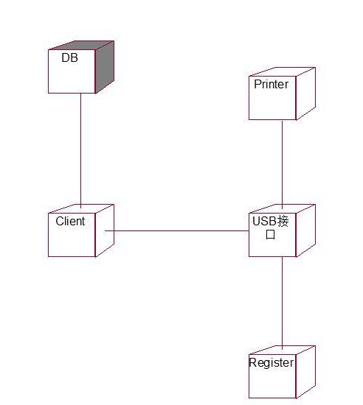
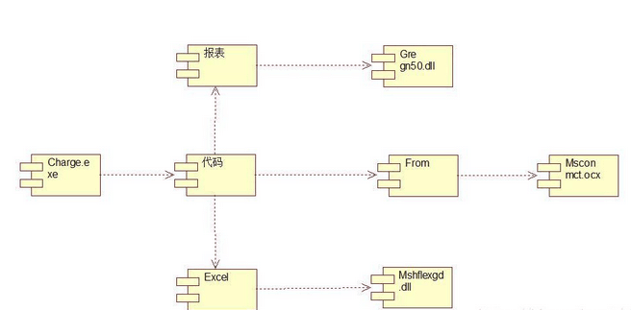

- 聊天室

package communicatetest4;
import java.io.IOException;
import java.net.ServerSocket;
import java.net.Socket;
public class ChatServer {
//主函数入口
public static void main(String[] args) throws IOException {
//实例化一个服务器类的对象
ChatServer cs=new ChatServer();
//调用方法，为指定端口创建服务器
cs.setUpServer(9000);
}
private void setUpServer(int port) throws IOException {
// TODO Auto-generated method stub
ServerSocket server=new ServerSocket(port);
//打印出当期创建的服务器端口号
System.out.println("服务器创建成功!端口号："+port);
while(true) {
//等待连接进入
Socket socket=server.accept();
System.out.println("进入了一个客户机连接："+socket.getRemoteSocketAddress().toString());
//启动一个线程去处理这个对象
ServerThread st=new ServerThread(socket);
st.start();
}
}

package communicatetest4;
import java.io.BufferedReader;
import java.io.IOException;
import java.io.InputStream;
import java.io.InputStreamReader;
import java.io.OutputStream;
import java.net.Socket;
/*
* 每当有客户机和服务器连接时，都要定义一个接受对象来进行数据的传输
* 从服务器的角度看，这个类就是客户端
*/
public class ServerThread extends Thread{
private Socket client;//线程中的处理对象
private OutputStream ous;//输出流对象
private UserInfo user;//用户信息对象
public ServerThread(Socket client) {
this.client=client;
}
public UserInfo getOwerUser() {
return this.user;
}
public void run() {
try {
processSocket();
} catch (IOException e) {
// TODO Auto-generated catch block
e.printStackTrace();
}
}
//在显示屏中打印信息，例如"用户名"、"密码"等等
public void sendMsg2Me(String msg) throws IOException {
msg+="\r\n";
ous.write(msg.getBytes());
ous.flush();
}
private void processSocket() throws IOException {
// TODO Auto-generated method stub
InputStream ins=client.getInputStream();
ous=client.getOutputStream();
BufferedReader brd=new BufferedReader(new InputStreamReader(ins));
sendMsg2Me("欢迎你来聊天，请输入你的用户名：");
String userName=brd.readLine();
sendMsg2Me("请输入密码：");
String pwd=brd.readLine();
user=new UserInfo();
user.setName(userName);
user.setPassword(pwd);
//调用数据库，验证用户是否存在
boolean loginState=DaoTools.checkLogin(user);
if(!loginState) {
//如果不存在这个账号则关闭
this.closeMe();
return;
}
ChatTools.addClient(this);//认证成功，把这个用户加入服务器队列
String input=brd.readLine();
while(!input.equals("bye")) {
System.out.println("服务器读到的是:"+input);
ChatTools.castMsg(this.user, input);
input=brd.readLine();
}
ChatTools.castMsg(this.user, "bye");
this.closeMe();
}
//关闭当前客户机与服务器的连接。
public void closeMe() throws IOException {
client.close();
}
}
package communicatetest4;
import java.util.HashMap;
import java.util.Map;
//定义一个处理用户登录信息的类
public class DaoTools {
//内存用户信息数据库
private static Map<String,UserInfo>userDB=new HashMap();
//静态块：模拟生成内存中的用户数据，用户名为1~10
//当程序启动时这段代码会自动执行向userDB放入数据
static {
for(int i=1;i<=10;i++) {
UserInfo user=new UserInfo();
user.setName("user"+i);
user.setPassword("psw"+i);
userDB.put(user.getName(), user);
}
}
public static boolean checkLogin(UserInfo user) {
//在只验证用户名是否存在
if(userDB.containsKey(user.getName())) {
return true;
}
System.out.println(user.getName()+"用户验证失败！");
return false;
}
}
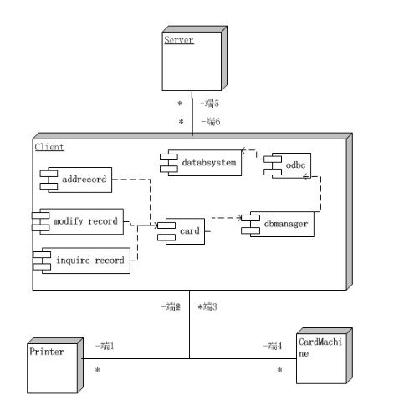

- 登陆
