**CMSC203 Assignment 0**

Class: CMSC203 CRN 22297

 Program: Assignment 0

Instructor: Dr. Grinberg

 Summary of Description: Setup GitHub, install, setup, and test JDK, Eclipse, Junit program, and JavaFX application.

 Due Date: 09/06/2021

 Integrity Pledge: I pledge that I have completed the programming assignment independently.

 I have not copied the code from a student or any source.

**Complete the following five parts of Assignment 0:**

**Part1: Setup GitHub:** Provide the screen shots of your GitHub account with Assignment 0 file is uploaded here:

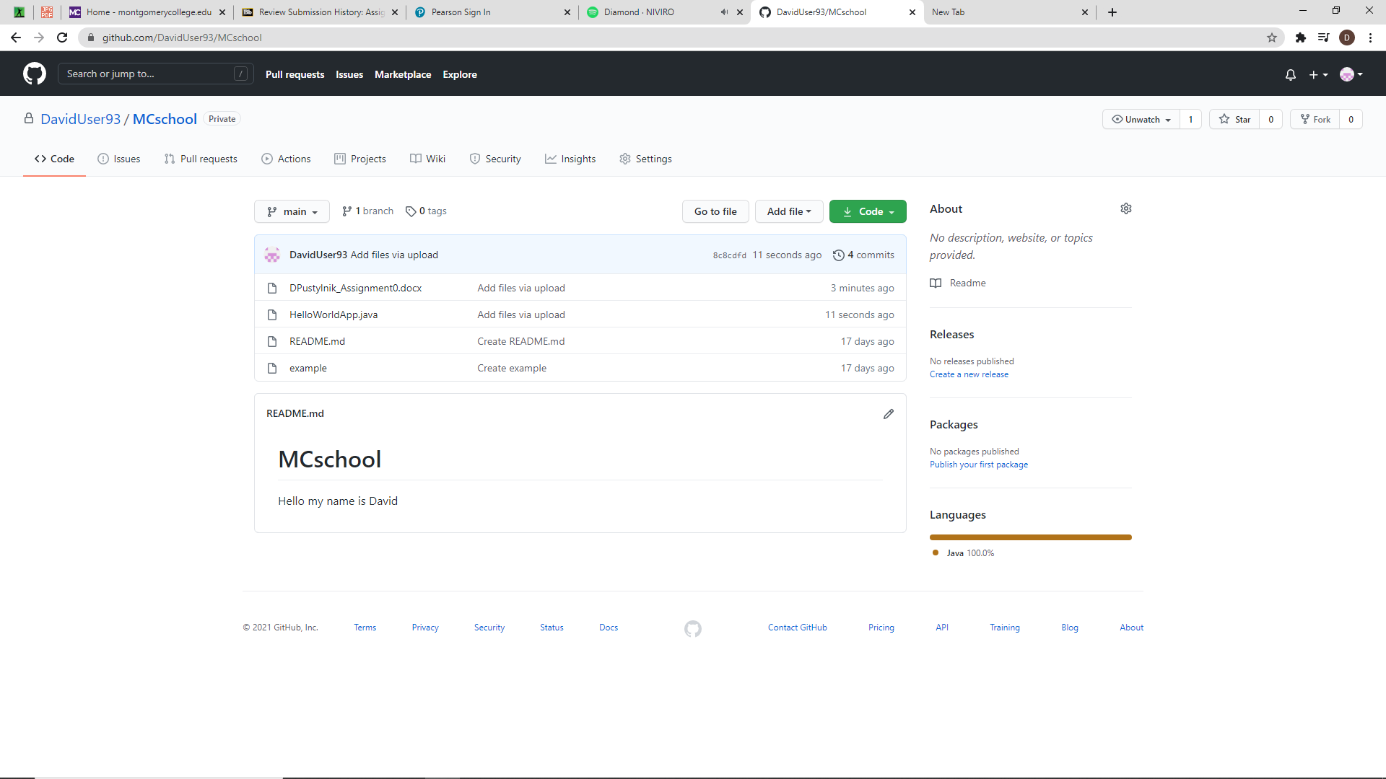

**Part 2 -Install JDK, Test java Application from Command Line**

Provide the screen shots from Step 1 and 2 here:

**Part 3 - Install Eclipse, Test Eclipse Java Application**

Provide the screen shots from Step 1 and 2 here:

**Part 4 - Install, Setup, Test Junit Program.**

Eclipse showing JUnit Test example working:

* 1. Project screenshot
  2. Running example screenshot

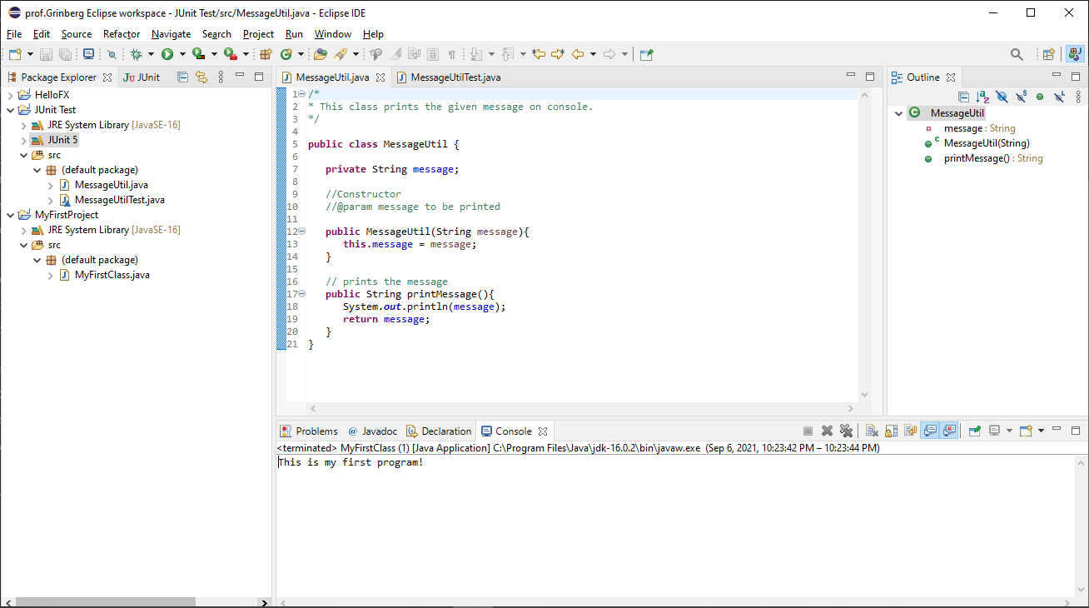

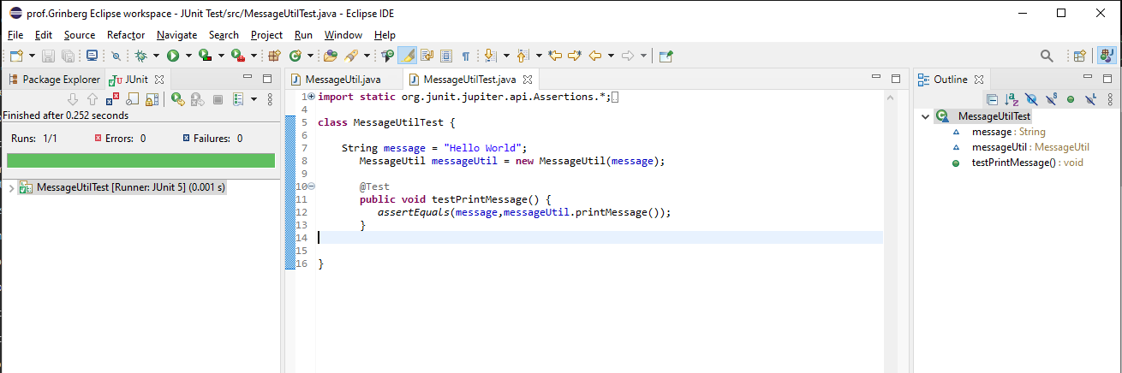

**Part 5 - Install, Setup, and Test JavaFX Application.**

Provide the screen shots showing:

1. JavaFX Project screenshot
2. Running example screenshot
3. Java Source Code File

**Lessons Learned:**

Write about your Learning Experience, highlighting your lessons learned and learning experience from working on this assignment.

What have you learned?

I have learned that I should do assignments much more earlier and do not select “Create module-info.java file” when creating a new Java Project. This caused me so many troubles.

What did you struggle with?

Getting JUnit test program to work.

What parts of this assignment were you successful with, and what parts (if any) were you not successful with?

Installation was quite successful. Even though the “cd command” in the command prompt did not work for me, I found a workable solution on the internet after multiple tries. I am not successful with setting up some of the Libraries.

**Check List:** <Provide answers to the column Y/N or N/A >**:**

|  |  |  |  |
| --- | --- | --- | --- |
| **#** |  | **Y/N** | **Comments** |
|  | **Assignment files:** |  |  |
|  | * FirstInitialLastName_Assignment0.docx/pdf | **Yes** |  |
|  | * Source java files |  |  |
|  | **Program compiles** | **Yes** |  |
|  | **Program runs with desired outputs related to a Test Plan** | **Yes** |  |
|  | **Documentation file: Screenshots of** |  |  |
|  | * Part1: Setup GitHub | **Yes** |  |
|  | * Part 2 -Install JDK, Test java Application from Command Line | **Yes** |  |
|  | * Part 3 - Install Eclipse, Test Eclipse Java Application | **Yes** |  |
|  | * Part 4 - Install, Setup, Test Junit Program | **Yes** |  |
|  | * Part 5 - Install, Setup, and Test JavaFX Application. | **Yes** |  |
|  | * Lessons Learned | **Yes** |  |
|  | * Checklist is completed and included in the Documentation | **Yes** |  |