Lab 4 2D Array Screen shots

Task 1
Print Array
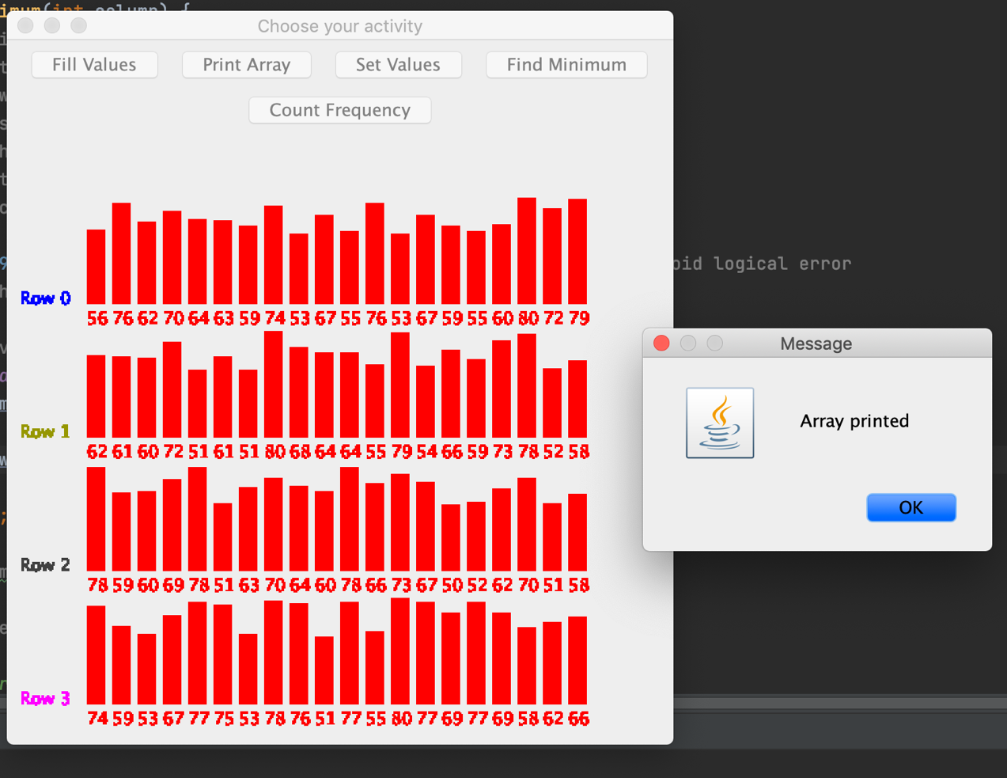

Task 2
Set Value of row with index = 2 to 65
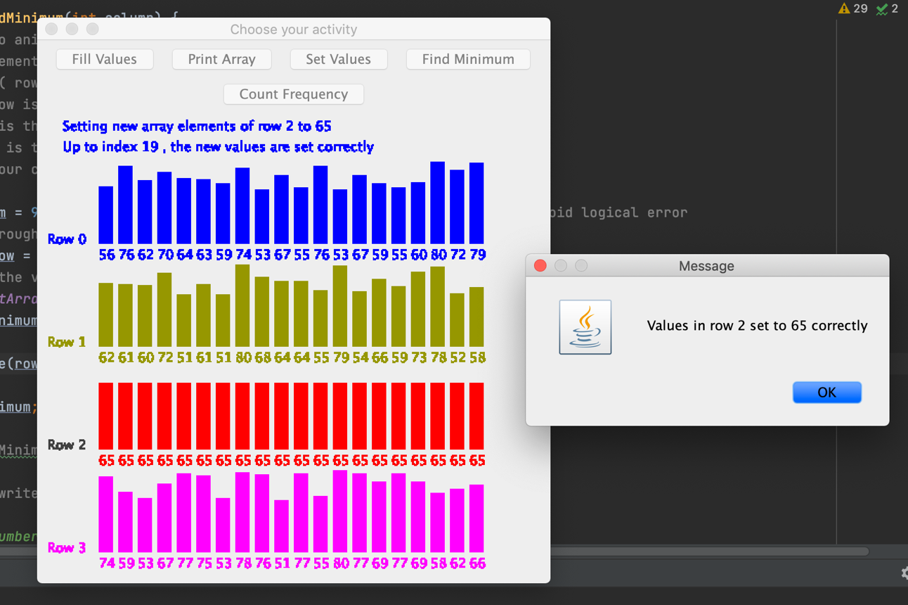

Task 3
Find the minimum value in column 3
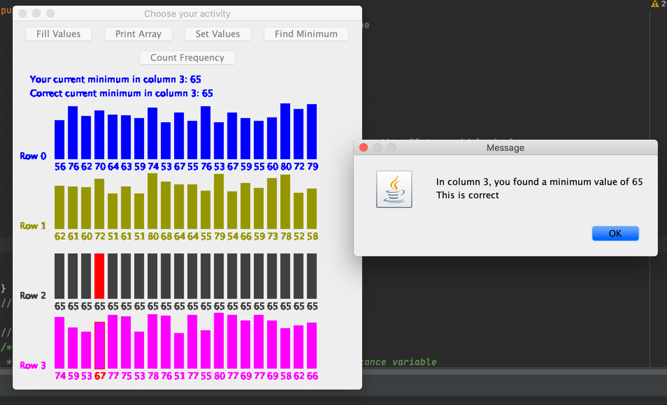

Task 4
Find how many 66 are within the 2D array.
