Make all the required changes including the keys, secrets, and scopes, and then Run:

Node server.js (which will set up all the correct parameters for getting accessToken later).

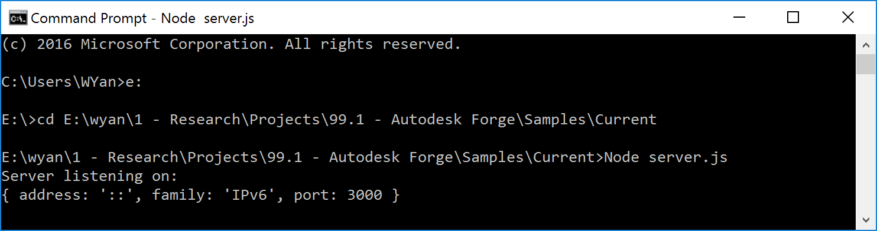

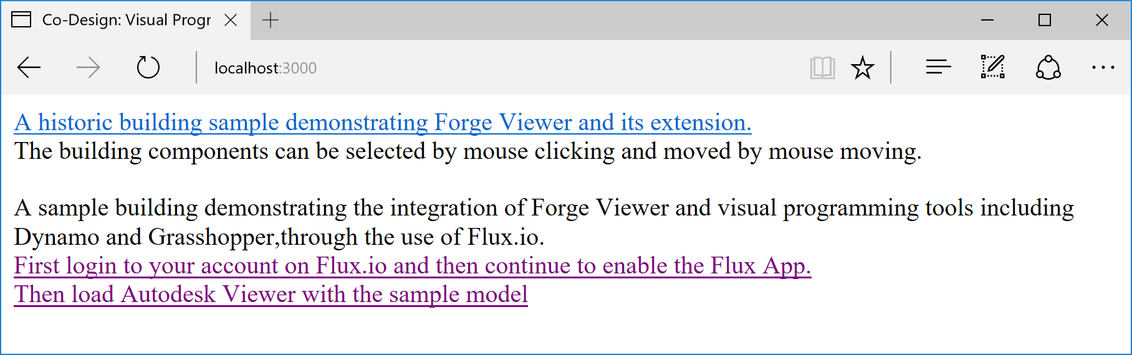

Helper resources:

<https://github.com/leefsmp/view.and.data-boilerplate>

<https://github.com/jeremytammik/roomedit3d>

<http://adndevblog.typepad.com/cloud_and_mobile/2015/05/deploy-nodejs-viewer-sample-to-heroku.html>

<https://github.com/adamenagy/model.derivative.api-nodejs-sample>

<http://through-the-interface.typepad.com/through_the_interface/2014/07/my-first-autodesk-360-viewer-sample.html>

Flux api app update: <https://flux.gitbooks.io/flux-javascript-sdk/content/>

Flux app manager: <https://flux.io/developer/apps/>

Note that Flux app needs callback URL to have “https” instead of “http”, otherwise: “the page doesn’t exist” error. For example: this is a good one: https://co-design.herokuapp.com/Flux/index.html

Why use Heroku?

Heroku has Node.js which supports server sider Javascript for Forge access token refresh functions.

How to use Heroku?

<http://adndevblog.typepad.com/cloud_and_mobile/2015/05/deploy-nodejs-viewer-sample-to-heroku.html>

and “how to deploy” document after logging in Heroku account.

You can create a new app from Heroku account UI (The new app there should be using Node.js as default.)

Then you will find the document for deploying website to the app, e.g. <https://dashboard.heroku.com/apps/co-design/deploy/heroku-git>

After installing Heroku commandline interface, Run Heroku command line interface from: Start Command Prompt with Ruby

The URL to view the sample is:

<https://co-design.herokuapp.com/>

After updating any files in the sample project folder, push again the changed files by:

$ git add .

$ git commit -am "make it better"

$ git push heroku master

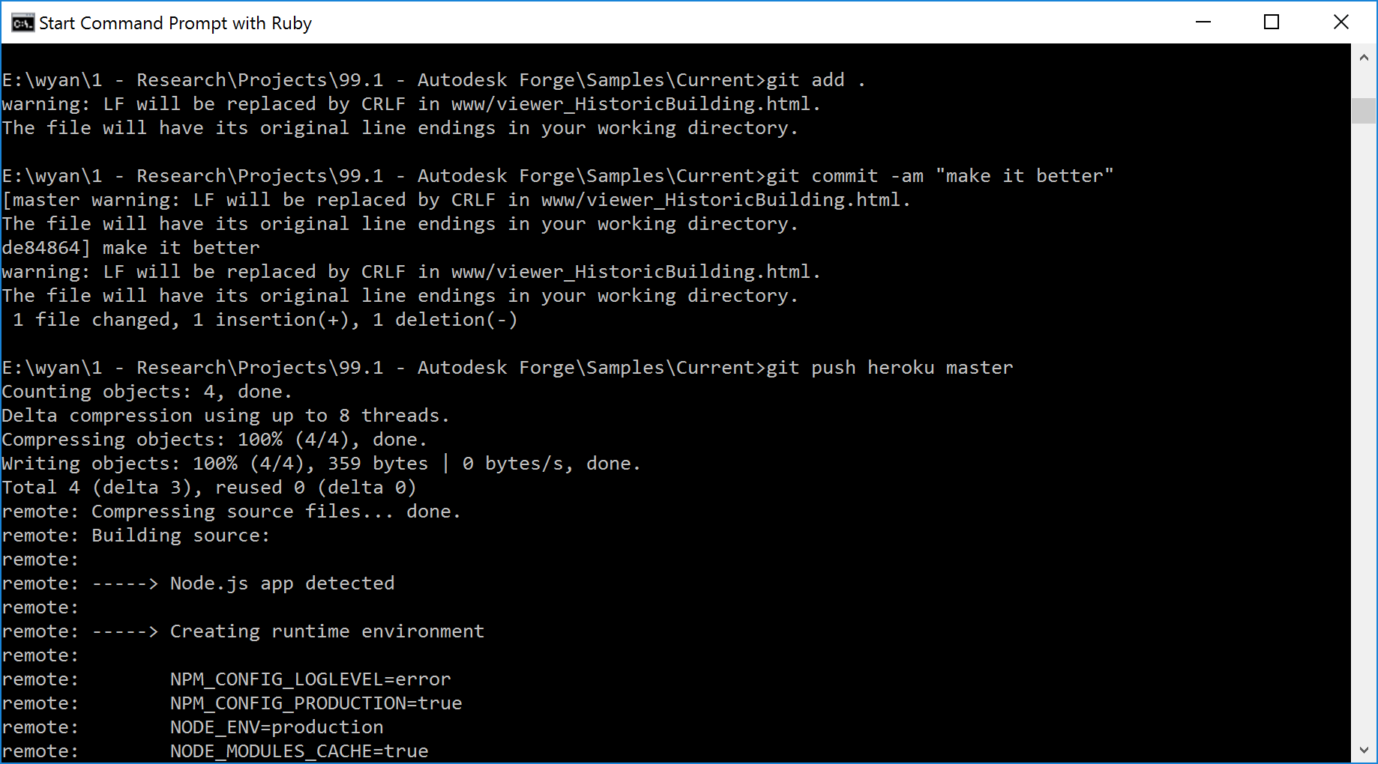

Future work: directly connect Dynamo to Forge Viewer without using Flux. Check out the sample:

https://github.com/xiaodongliang/Forge-Viewer-Mobile-Sensor