**System Setup and Usage**

(DRAFT Underconstruction)

Wei Yan, Ph.D.

Professor, Department of Architecture

Texas A&M University

January 9, 2017

To set up the system that combines many different techniques, one needs to learn Autodesk Forge Viewer and APIs, Flux.io and API, Node JS, and Heroku, in addition to visual programming tools, such as Dynamo and Grasshopper, and modeling tools such as Revit and Rhinoceros.

**To work with Autodesk Forge Viewer:**

1. Use Autodesk examples of Forge APIs and Viewer
2. Learn to use *cURL* command to get accessToken for Viewer
3. Use GUI <http://developer-autodesk.github.io/LmvQuickStart/> to load and translate BIM or 3D models to Forge servers.
4. Learn Viewer Extensions from: <https://developer.autodesk.com/en/docs/viewer/v2/tutorials/extensions/>

**To work with Flux:**

1. Learn to create a Flux project (database storing model parameter values): <https://flux.io>
2. Learn to use Flux API to connect the Flux database to models in Autodesk Viewer: <https://flux.io/developer/>

**To run the system on localhost for testing:**

Make all the required changes including the keys, secrets, and scopes, and then Run:

Node server.js (which will set up all the correct parameters for getting accessToken later).

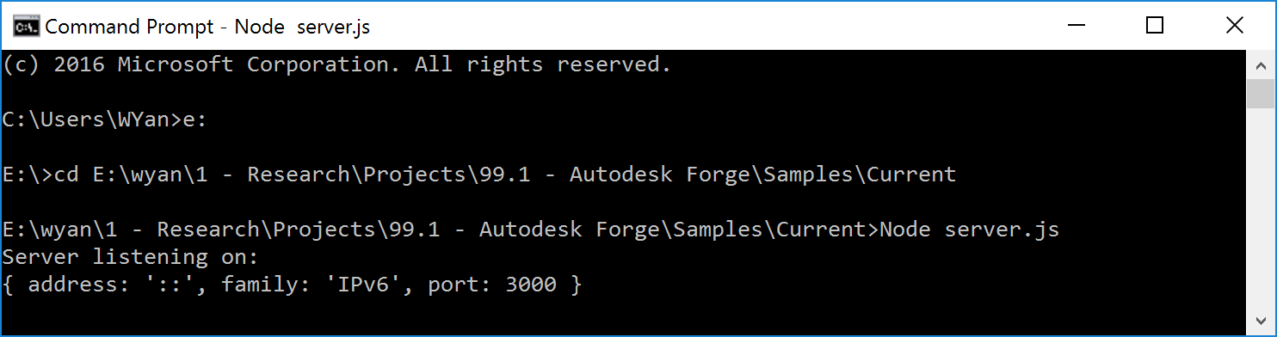

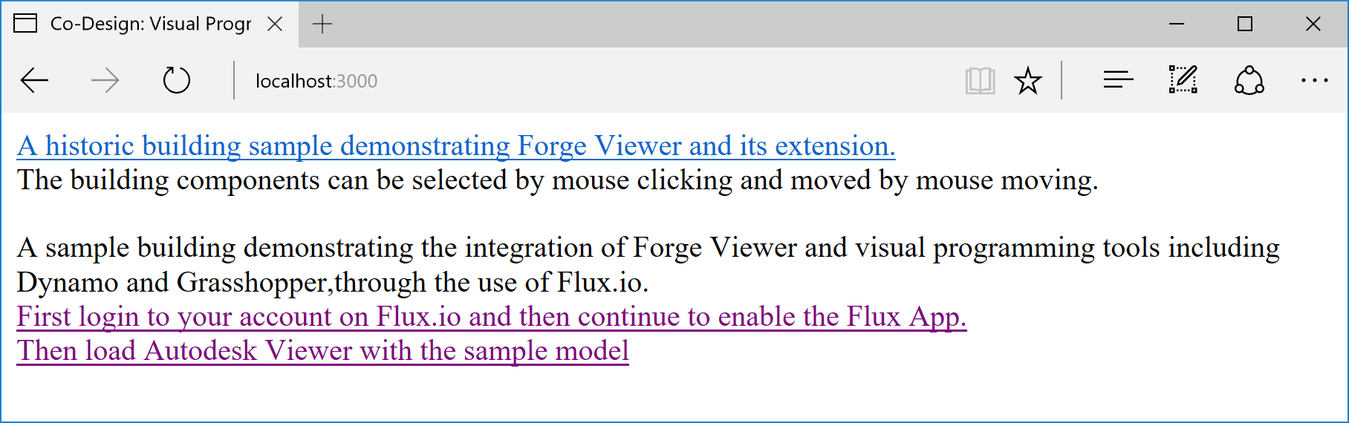

**To run the system on the Web,**

1. Use Heroku: <https://www.heroku.com>
2. Why use Heroku?

Heroku has Node.js which supports server sider Javascript for Forge access token refresh functions.

1. How to use Heroku? Check the following:

<http://adndevblog.typepad.com/cloud_and_mobile/2015/05/deploy-nodejs-viewer-sample-to-heroku.html>

and “how to deploy” document after logging in Heroku account.

You can create a new app from Heroku account UI (The new app there should be using Node.js as default.)

Then you will find the document for deploying website to the app, e.g. <https://dashboard.heroku.com/apps/co-design/deploy/heroku-git>

After installing Heroku commandline interface, run Heroku command line interface from: “Start Command Prompt with Ruby”

The URL to view the sample is:

<https://co-design.herokuapp.com/>

**Note** that Flux app needs callback URL to have “https” instead of “http”, otherwise: “the page doesn’t exist” error will occur. For example: this is a good one:   
<https://co-design.herokuapp.com/Flux/index.html>

After updating any files in the sample project folder, push again the changed files by:

$ git add .

$ git commit -am "make it better"

$ git push heroku master

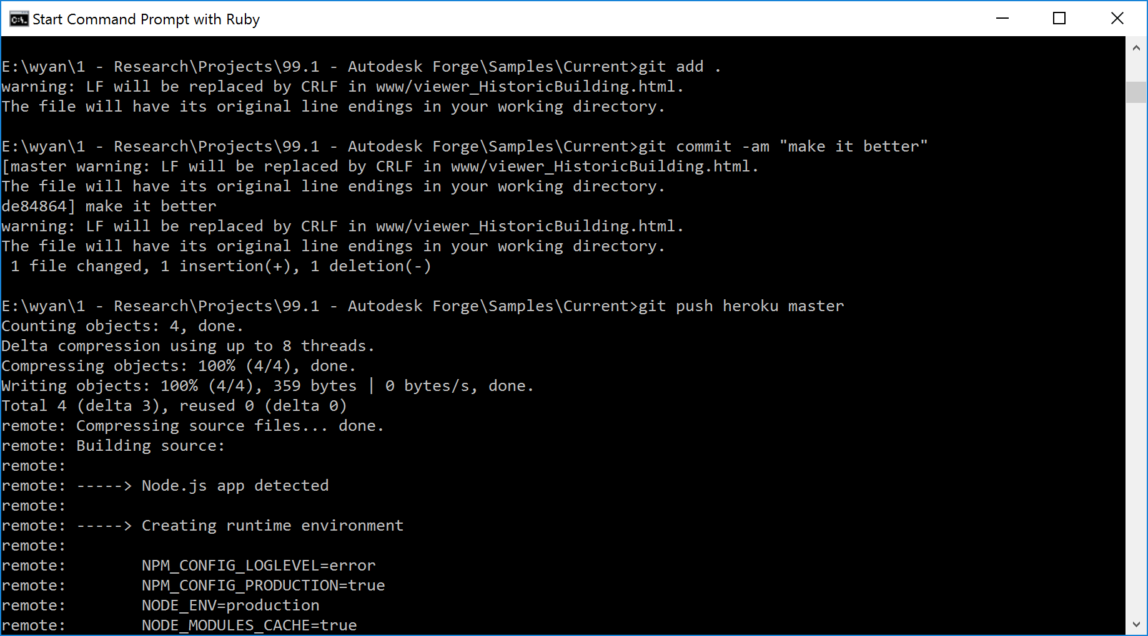

**Useful resources:**

<https://github.com/leefsmp/view.and.data-boilerplate>

<https://github.com/jeremytammik/roomedit3d>

<http://adndevblog.typepad.com/cloud_and_mobile/2015/05/deploy-nodejs-viewer-sample-to-heroku.html>

<https://github.com/adamenagy/model.derivative.api-nodejs-sample>

<http://through-the-interface.typepad.com/through_the_interface/2014/07/my-first-autodesk-360-viewer-sample.html>

https://docs.npmjs.com/getting-started/fixing-npm-permissions

Flux api app update: <https://flux.gitbooks.io/flux-javascript-sdk/content/>

Flux app manager: <https://flux.io/developer/apps/>

**Future work:**

Directly connect Dynamo or Grasshopper to Forge Viewer with a more efficient use of Flux or other networking/interoperability technique.

Check out the sample:

<https://github.com/xiaodongliang/Forge-Viewer-Mobile-Sensor>