

Northeastern University, Khoury College of Computer Science

CS 6220 Data Mining | Assignment 3

Due: February 15, 2023(100 points)

YOUR NAME

YOUR GIT USERNAME

YOUR E-MAIL

Multisource Joins

News articles are commonly aggregated from multiple sites and companies. The landscape of news has been evolving ever since social media has ampli ed its e ects. In politics, Congress has explored the topic of bias with the diversity of news sources. That is, news articles may cover news stories with di ering perspectives and language.

The data that we will be using today comes from Kaggle, and it is available [here](https://course.ccs.neu.edu/cs6220/homework-3/). There are two CSV les that we wish to join in this week’s homework:

* data/id_titles.csv data/id_publishers.csv

As there name suggests, there is publishing data associated with articles and there is title and description information associated with the same articles. Each table has many instances, and each instance for both tables have an associated ID, where it is possible to join the two data sources.

In this particular case, there is some missing information in the join. Your task is as follows.

Question 1 a.) [15 pts]

Write out a le that has all the publishers for which there are no titles, called publish-ers no titles.txt. This table should look something like the below (ignore the values):

1

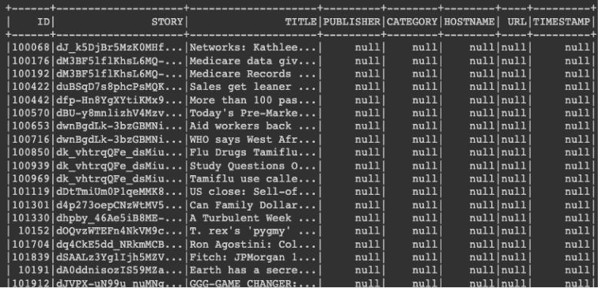

Question 1 b.) [15 pts]

Write out a le that has all the publishers for which there are no titles, called titles no publishers.txt.

That table should look something like the below (ignore the values):

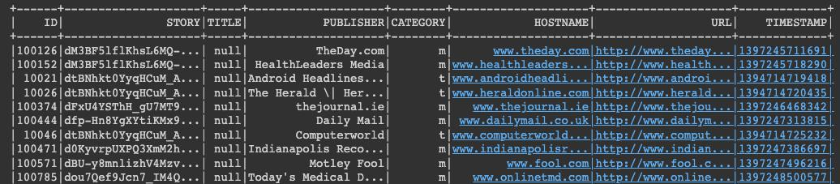

Question 1 c.) [5 pts]

Explore the data further, and identify any potential problems that could arise if we were to apply any algorithm to it. Is there still missing data? If there are any issues with the data, what might you do to x it? (You needn’t code anything, but conceptually describe any issues you see and how you would remedy it.)

.

Frequent Itemsets

Consider the following set of frequent 3-itemsets:

{1, 2, 3}, {1, 2, 4}, {1, 2, 5}, {1, 3, 4}, {2, 3, 4}, {2, 3, 5}, {3, 4, 5}.

Assume that there are only ve items in the data set. This question was taken from [Tan et al.](https://www-users.cse.umn.edu/~kumar001/dmbook/ch5_association_analysis.pdf), which may help in reviewing Candidate Generation in Rule Generation.

Question 2a.) [10 pts]

List all candidate 4-itemsets obtained by a candidate generation procedure using the Fk 1 F1 merging strategy.

Question 2b.) [10 pts]

2

List all candidate 4-itemsets obtained by the candidate generation procedure in A Priori, using Fk 1 Fk 1.

Question 2c.) [10 pts]

List all candidate 4-itemsets that survive the candidate pruning step of the Apriori algorithm.

Principle Components Analysis

Italy is home to over 2000 grape varieties. Even within a single region, wines exhibit distinct attributes from di erent cultivators that can be measured with objective and numerical fea-tures. Notably, in the dataset we are exploring today, there are thirteen di erent measurements taken for di erent constituents found in the three types of wine. We would like to visualize how well-separated the data is for the di erent wineries in a 2D scatter plot.

We will be using the UCI Wine’s dataset. Please review sklearn’s description of [wine data](https://scikit-learn.org/stable/modules/generated/sklearn.datasets.load_wine.html), and load it in with the following code:

from sklearn.datasets import load_wine wine = load_wine()

Question 3 [20 pts]

Preprocess the the data with z-score normalization and scatter the data that’s been projected onto the rst two principle components with di erent colors for each target/class of wine.

Parameter Estimation

It is well-known that light bulbs commonly go out according to a Poisson distribution, and are independent regardless of whether or not they’re made in the same factory. The Poisson distribution has the form:

p(Xj ) = exp xi

xi!

An architect has out tted a building with 32,000 of the same lightbulb. The factory has pro-vided him with data on when N of these lightbulbs have gone out over their lifetimes. They’ve been measured with D = fx1; x2; ; xN g

Question 4 [20 pts]

Derive the maximum likelihood estimate of the parameter in terms of xi. Please show your work.

Submission Instructions

3

When you have nished, follow the instructions on the [homework main page](https://course.ccs.neu.edu/cs6220/homework-3/). Commit your code, outputs, and PDF writeup to your repository and provide the repository link to [Gradescope](https://www.gradescope.com).

4