f(n) <= cg(n) if c and n_0 exists for every n>n_0
f(n) < cg(n) for all c, every n>n_0
 | countable | regular | context-free | recursive (decidable) | r.e. (recognizable/enumerable) | P | NP
 | Finite sets  Sets from which there is a bijection to set of Natural numbers | regular expression  DFA {Q, Sigma, delta, q0, F}  NFA {same, but delta nondeterministic}  Right-regular Grammars | CFG {V, Sigma, R, S}  PDA {Q, Sigma, Gamma, delta, q0, F} | Turing Machine (decider) {Q, Sigma, Gamma, delta, q0, qaccept, qreject}  Enumerable in order | Turing Machine (recognizer)  Enumerator  General grammar  2-PDA | Deterministic Polynomial-time algorithm | Polynomial time verifier  Non-determinitstic Polynomial-time algorithm
Closure | Countable union of countable sets  Subset  Cartesian product of finitely many countable sets is countable--  ie, all pairs of integers, and generally, all k-tuples, is countable | Union  Complement (+ pumping)  Intersection  Star  Concatenation  Difference  Reverse | Union  concat  star  reversal  intersection with regular set  difference with regular set (CF-R) | star  concat  union  intersection  complement  set difference (difference can be in terms of intersection and complement) | intersection  union  concat  star | Complement  Union  Intersection  Concatenation  Star  Composition | star  union  concat
NOT Closed Under | Power set (set of all subset) of infinite set | Subset | intersection  complement  difference |  | Complement  Set difference |  | complement (if P not NP)
Relative Properties |  | Non-determinism adds no power  Described by a finite string | Non-determinism adds power (see even palindromes) | recursive iff r.e. and co-r.e. | Non-determinism adds no power (only time efficiency)  Neither does 2-way infinite tape |  | Complement of NP-complete problems NP-complete
Examples | all rational numbers  Simga* countably infinite  Regular languages (all subsets of Sigma*) |  |  | regular languages  context free languages  <R,w>: R is a regexp that generates w  <X>: X is a DFA/NFA/RE and L(X) = null  <X>: X is a DFA/NFA/RE and |L(X)| = inf  <M,w>: M is PDA that accepts w | ATM<M,w>: M accepts w  HALT<M,w>: M halts on w  The set of all TMs that halt on some input | Regular languages  CFLs  Non-obvious P-time:  2-SAT  Eulerian Circuit (traverse all edges of graph once)  Composites, Primes | NP:  Traveling Salesman (shortest path to visit each once)  Hamiltonian Circuit, Composite #s, Boolean Logic  NP-complete:  SAT  3-SAT  Vertex cover (has k-node v.c. [touch every node])  Clique  Hamiltonian Circuit (touch all nodes of graph once)  Subset sum
Counter Examples | All languages over an alphabet [P(Sigma*)] |  |  | Rice’s Theorem (every nontrivial property of r.e. is undecidable)  Given CFGs G1 G2, whether  L(G1) intersect L(G2) = empty  Tiling  A_TM  HALT_TM  HALTe_TM | ~A_TM  ~HALT_TM  ~HALTe_TM
Examples (NOT co-re) |  |  |  |  | A_TM  HALT_TM  HALTe_TM
Properties | infinite subset of a countably infinite set is countably infinite |  |  | L decidable iff ~L decidable |  | Uses PSPACE | NP-complete:  1. Show L in NP  2. Reduce known NP-complete problem  Uses PSPACE
 |  |  |  |  | Dovetail M on lexicographic inputs

Alphabet finite by definition
Sigma* countably infinite
so every lang is either finite or countably infinite
Power set -> uncountably many languages over any alphabet that’s not null

Pumping Lemma:
If A regular, then there is a number p where if |s| >= p, then s=xyz satisfies:
1. for each i >= 0, xy^i z in A
2. |y| > 0
3. |xy| <= p

To show non-regular: forall p there exists w s.t. forall xyz, exists n>=0, s.t. xy^n z notin L
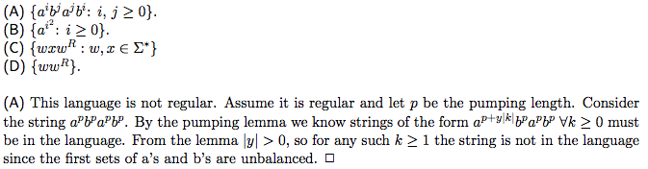

SAT < 3SAT < CLIQUE/VC
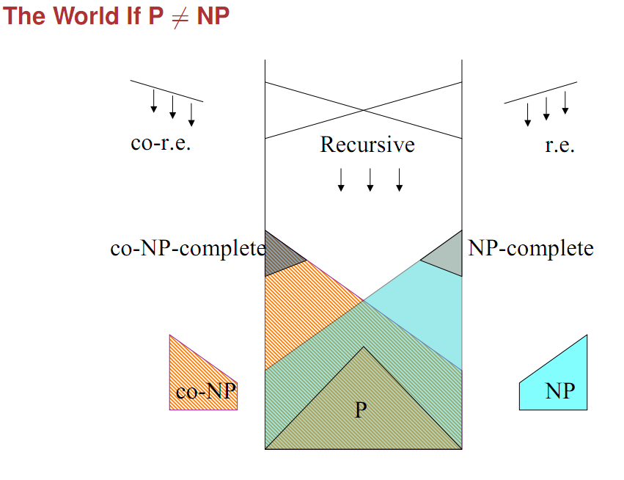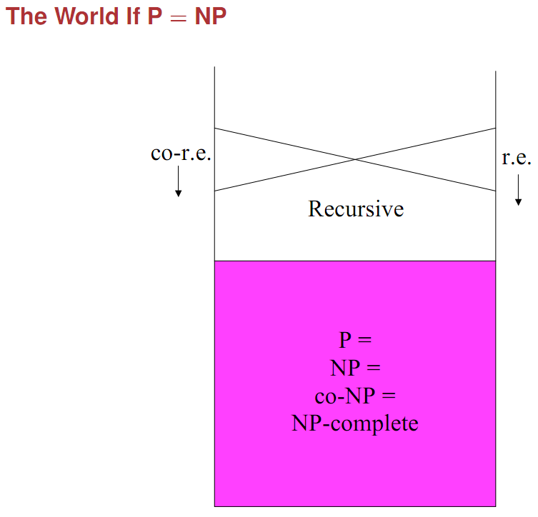

Important Reductions
ATM to HALT
Suppose HALTTM = {⟨M, w⟩ : M halts on w} were decided by some TM H. Then we could use H to decide ATM as follows.

On input ⟨M, w⟩,
· Modify M so that whenever it is about to go into qreject, it instead goes into an infinite loop. Call the resulting TM M′.
· Run H(⟨M′,w⟩) and do the same.

Note that M′ halts on w iff M accepts w, so this is indeed a decider for ATM

HALT to HALTE
Suppose H were a TM that decided {⟨M⟩: M halts on ε }. Then H could be used to decide HALTTM:
- Given ⟨M, w⟩, construct ⟨Mw⟩, where Mw is a TM that writes w on an empty tape and then runs M.
- Then run H on input ⟨Mw⟩
H halts on ⟨Mw⟩ ⇔ Mw halts on ε ⇔ M halts on w
But HALTTM is undecidable.

ATM to Afinite
Suppose F decides Afinite.
To decide ATM, given ⟨M, w⟩, construct ⟨Mw∗ ⟩ so that
· If M accepts w then Mw∗ accepts its input, regardless of what it is, and if M does not accept w then Mw∗ runs forever.
· Then run F on input ⟨Mw∗ ⟩.
· L(Mw∗ ) is either Σ∗ (and therefore infinite) or ∅ (and therefore finite) depending on whether or not M accepts w.
Reduce ATM to Afinite; since ATM is undecidable, so is Afinite

HALTE to LP (Proof of Rice’s Theorem)
Suppose without loss of generality that ∅ ∈/ P. Then, P is a nontrivial property of a language recognized by a Turing machine
Pick any L0 ∈P and say L0 = L(M0).
Define f(⟨M⟩) = ⟨M′⟩, where M′ is TM which, on input w,
· First simulates M on input ε
· Then, if M halts on input ε, simulates M0 on input w
Claim: f is a mapping reduction from HALTεTM to LP. If M halts on ε, M’ will behave as M0, and thus would pass any test for membership in P. If M’ passes the test for membership in P, M must have halted on ε, since that is the only condition under which M’ will begin to run M0.
Since HALTεTM is undecidable, so is LP.

SAT to 3-SAT
- Number the operators of the Boolean formula
- Create a new variable for each operator and list out its relations to the others with “equals” statements (such as “a = (b or c)”)
- Join the statements together with “and” operators
This 3-CNF is equivalent to the original formula, so there must a truth assignment for both or neither

3-SAT to Vertex Cover
- For each variable, make a barbell corresponding to true-false
- For each clause, make a triangle representing the 3 variables
- Link the barbells to the triangles appropriately;
VC of 2*clauses + vars will exist iff the 3-CNF is satisfiable

VC to Clique
- Construct G’ from G, where all previously unconnected nodes are connected and visa-versa
A k-cover exists for G iff a |G|-k clique exists for G’

