**Name**: Walum Yasin

**Student ID**: 162-466

**Course**: BCS

**Yea**r: 3

**Semester:** 1

**Project Overview**

**Title**: Academic Office Chatbot

**Purpose**: The Academic Department Chatbot aims to provide students and staff with quick and easy access to essential information about academic programs, course offerings, and support services. The chatbot aims to enhance communication, streamline inquiries, and facilitate a better understanding of educational processes, ultimately improving the overall experience for students and faculty alike.

**Technologies used**

HTML, CSS, and JS for the website, Dialog flow for the chatbot

**Deployment Links**

* Website link: <https://thriving-souffle-cab50f.netlify.app/>
* Phone Number: **+1 413-273-7310**

**Screen Shots**

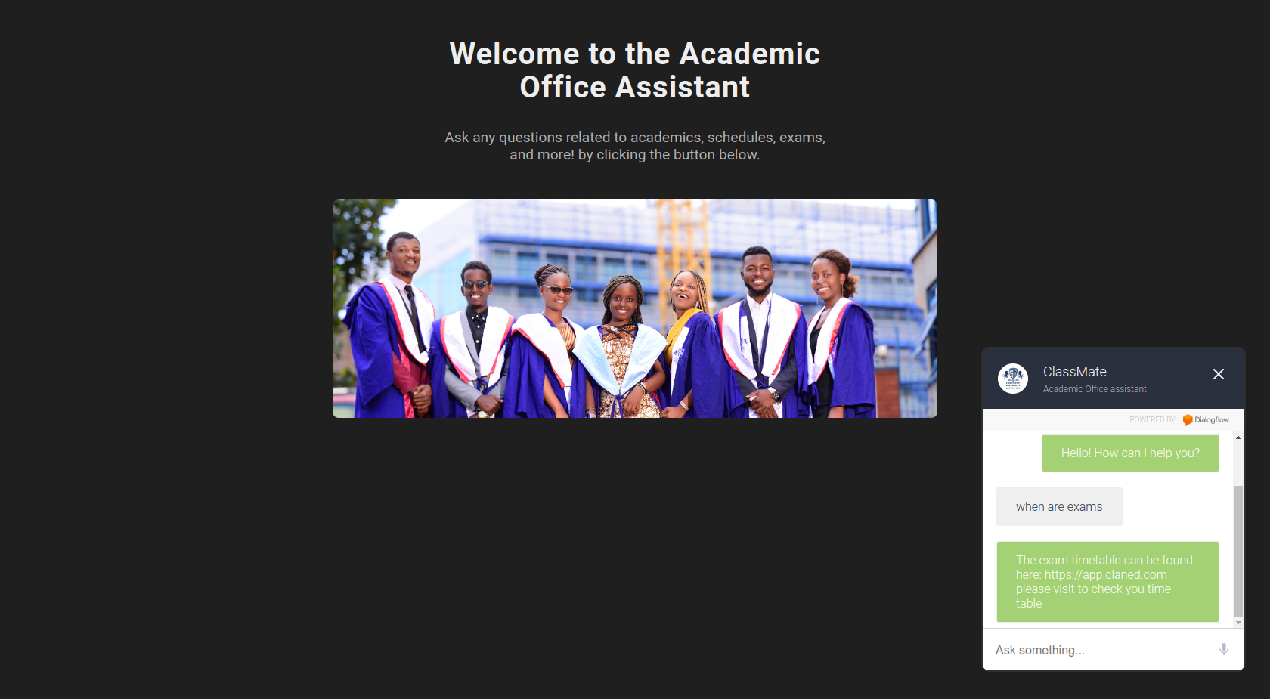



End