**Cavendish University Uganda**

**Faculty of science and technology**

**CAT 1 OCT 2023**

Name: Walum Yasin

Student ID: 162-466

Course: BCS

Module: Simulation and modeling

Module code: COM321

Lecturer: Kumakech Micheal

Date: 17/10/2023

Question 1

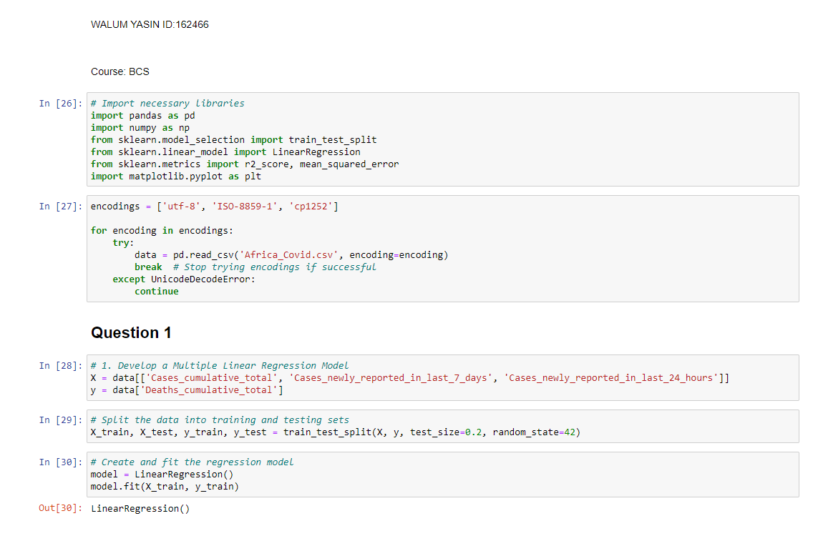

Question 2

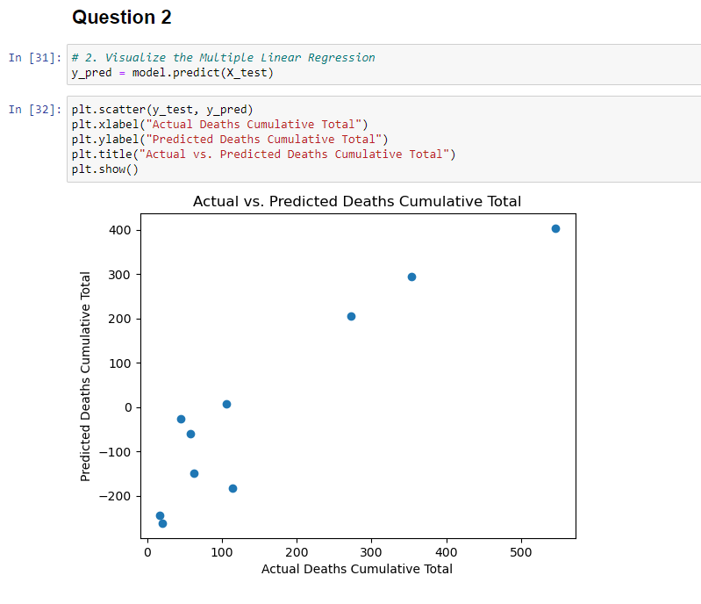

Question 3

