**Cavendish University Uganda**

**Faculty of science and technology**

**CAT 1 OCT 2023**

Name: Walum Yasin

Student ID: 162-466

Course: BCS

Module: Internet and web development II

Module code: BIT213

Lecturer: Kagona Edison

Date: 17/10/2023

Question 1

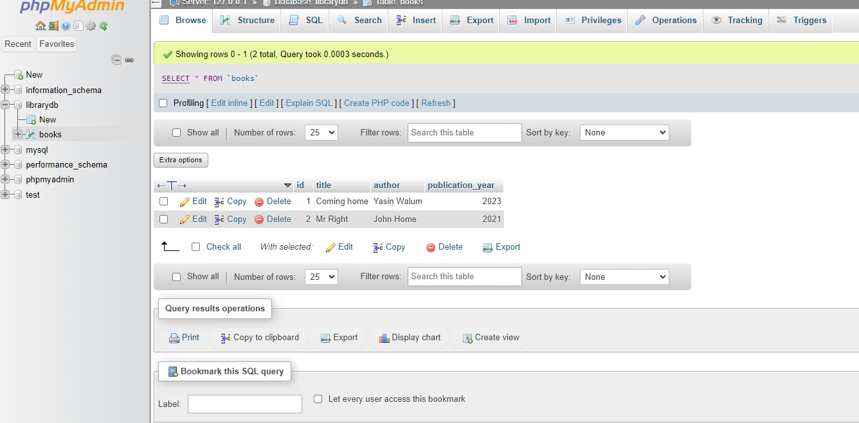

Question 2

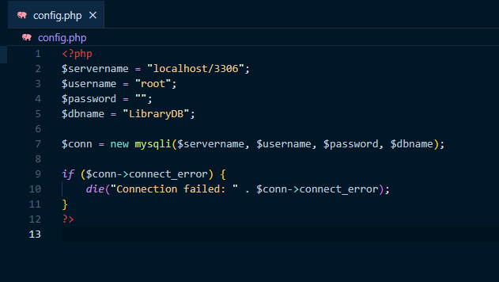

Question 3

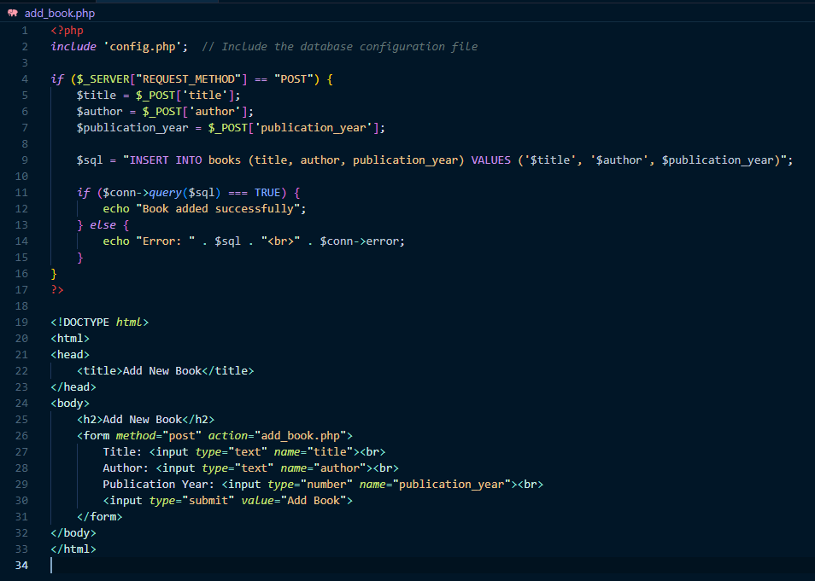



Question 4

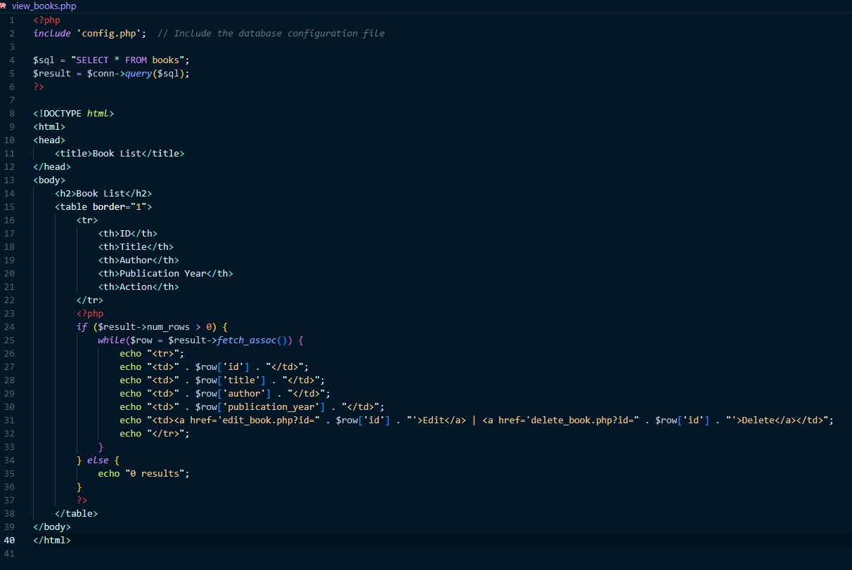



Question 5

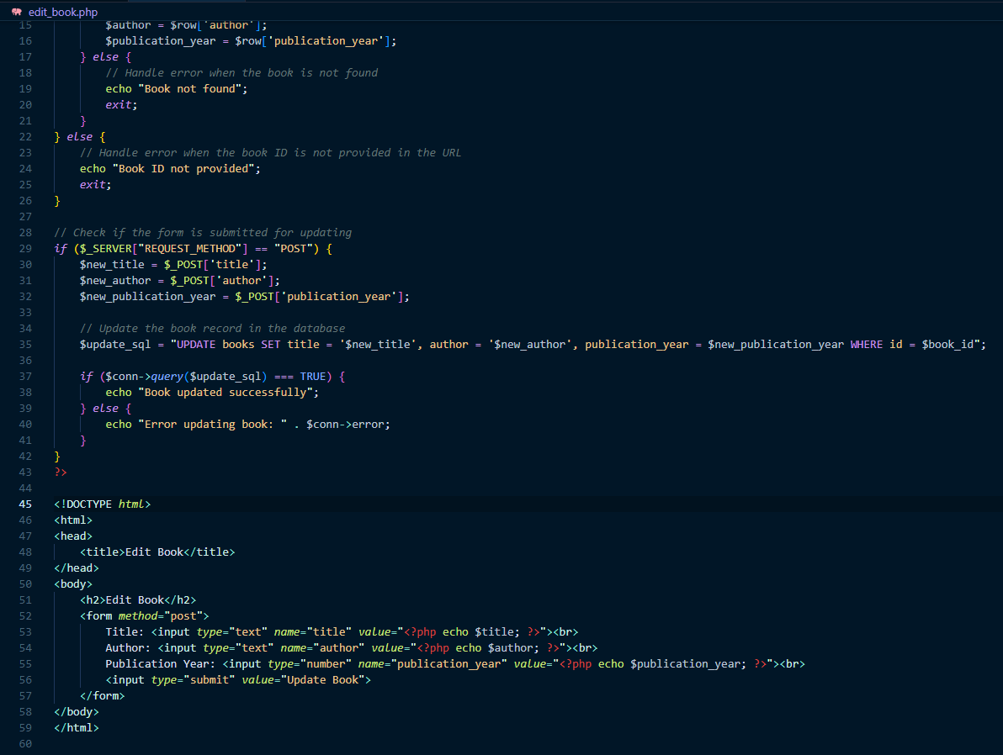



Question 6

