**Cavendish University Uganda**

**Faculty of science and technology**

**CAT 1 OCT 2023**

Name: Walum Yasin

Student ID: 162-466

Course: BCS

Module: Object Oriented Programming

Module code: COM211

Lecturer: TBA

Date: 17/10/2023

Question 1:

Class Diagram

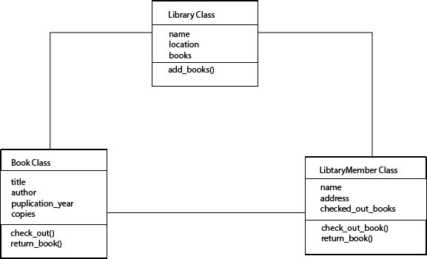

Object diagram

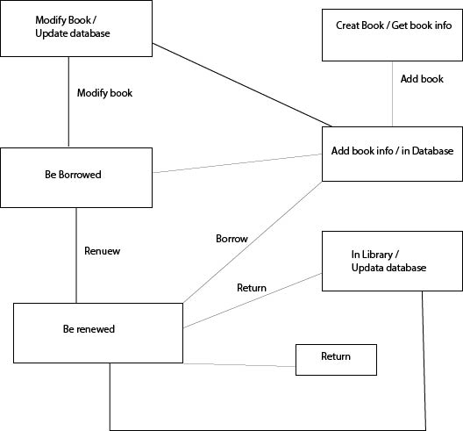

Question 2:

