Wyatt Clark
I547, Homework 3

- Here is a table of modulus, argument, frequency, amplitude and phase values for each equation.
 | modulus | argument | frequency | amplitude | phase
cos(2π5n/N ) | 512 | 0 | 5 | 1 | 0
4 sin(2π5n/N ) | 2048 | -2 | 5 | 4 | 0
4 sin(2π5n/N ) + cos(2π5n/N ) | 2111 | -1 | 5 | 4 | -0.00258
3 cos(2π8n/N − 1) | 1536 | -1 | 8 | 3 | -0.00195
x(n) = sin(2π8n/N + 1) | 512 | -1 | 8 | 1 | -0.00111

- If we want to make a complex number that approximates an N-vector x we can apply toe DFT equation to obtain a complex number X of the same length or shorter length. In order to approximate x as closely as possible we would want to make sure the length of X is equal to N. In order to approximate the ’s, ’s, and ’s we apply the formula below to our N-vector x:
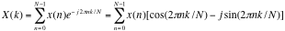
where k ranges from 0 to N-1 and is the particular frequency component we are considering. The transformation on the right is taken from “understanding Digital Signal Processing” by Richard G. Lyons.

- Please refer to my code titles spectral_movie.r for additional information on this question
  - It seems that the transitions between notes is smoother when a shorten the frame length, and in I lengthen it too long
  - When I added the Hann window I noticed that the erratic gyrations that when looking at fft values for a particular note went away, and the plots became a lot more stable during a sustained note. It especially smoothes the curves that I make from taking the sum of differences between the modulus of the fft at position i and i -1
  - I created a plot of the sum of the differences between the modulus of the fft at frame i and i-1. Using this plot one can tell where there is a major change in the frequencies present as we move forward in time. As we can see from the figure below, using a frame width of 1024 it looks like the first 5 notes appear at frames 50, approximately 75, 100, 125 and 130. When I look at the “movie” at frame length 512 the first note begins at 86 and ends at 101, which would be equal to 43 to 50 at the 1024 window length. The second note seems to run from 101 to 154, the third from 154 to 184 the fourth from 184 to 191, and the fifth from 191 to 238.

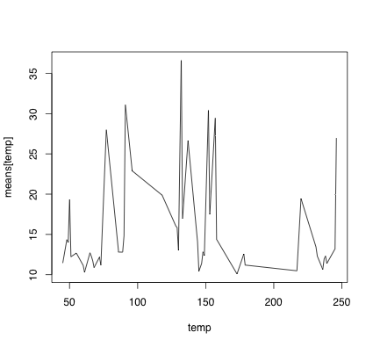
- See the file named question_4.r for my code for this question
  - when I window the wave it doesn’t sound as similar ans when I don’t window it. When I listen to the N/2 components from the fft it kind of sounds like it fluctuates with a da-da-da-da-da. The pitch also sounds higher
  - Taking only the N/4frequencies with the highes amplitudes gives me an even weirder sound.
  - I don’t hear anything when I take the frequencies associated with the N/4 lowest amplitudes
  - The da-da-da-da-da is even more apparent, and I don’t really know how to describe the sound
  - It just sounds like static at this point

- Please refer to the code titles question_5.r for my answer to this question

