# 3D Printers

This is where you can turn 3D models into PLA plastic objects using a 3D printer.

This resource allows individuals to create their own 3D models or use currently available models, then slice them and “bring them to life”.

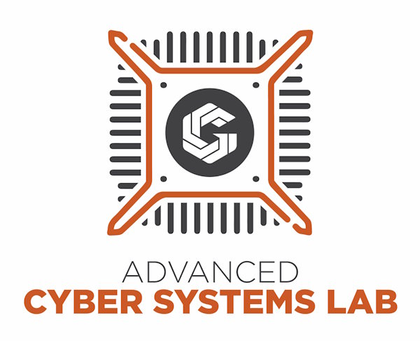

# Cisco Networking Rack

This is where you can configure Cisco devices in order to build and test networks.

This resource allows individuals who are learning network administration to get hands-on experience while outside of the classroom. Or, jump in and give networking a try for the first time.



# Digital Workspace

These machines are configured with Linux, Internet access, and available for your general use.

They have a standard set of applications already installed. Any work not saved on a USB Flash drive, etc. will be automatically deleted, so plan accordingly.



# Disk Wiping Station

This is where you can completely wipe a hard drive using ShredOS.

This resource destroys the sensitive data before discarding, donating or reusing a drive.



# Bench Test Area

This is where you can test and experiment with operating systems.

This resource allows individuals to try out operating system images currently available on our flash drives. You can test it, try new things, mess stuff up, reload it, and try again.



# Hashing Station

This is where you can use Hashcat to learn more about password cracking.

This resource allows individuals to see how easily a modern GPU can “guess” less complex passwords. You will see the importance of using complex passwords for your accounts.



# Lock Picking Station

This is where you can learn how locks can be picked.

This resource teaches individuals the importance of good physical security for their assets.



# Podcasting Studio

You can record podcasts, create AV recordings, create audio recordings, or use the quiet space for virtual meetings.

This is a sound dampened room where individuals can use our mixer, microphones, and computers to create their own media.



# Right To Repair Hub

This is a place where you can bring electronic devices they wish to repair.

The significance of this is to motivate people to repair things instead of buy new thing. This reduces the amount of e-waste sent to the junkyard and saves individuals money!



# Secure Small Business Network

This is a demo of a small business network. This network follows best practices of cyber security, as applied to a small business.

The significance of this is to demonstrate how to transform a small business network into a harder target for cyber criminals.



# Server Rack

This is where you can get hands-on experience using professional server computers.

This resource allows individuals the opportunity to configure and test their own server configurations. It is important to test the functionality of configurations before implementing them in a production environment.

