   Wyatt Tack

Kalon Bienz  
   EE 329-01 F'24

Group H

   2024-Oct-25

**EE 329 A7**

This code is designed to use the UART peripheral to communicate across USB to the targeted device, using a VT100 Terminal. The STM32 produces text that acts as a rudimentary game, displaying a splash screen with a bubbles graphic, and a boarder and character that move, and scroll to the next screen when jumped. This game was used with the terminal PuTTY in mind.

**Link to YouTube Presentation:**

<https://youtu.be/cXt5tV1ykHU>

**Calculations:**

Equation A7.a(a): Baud Rate From Reference Manual:

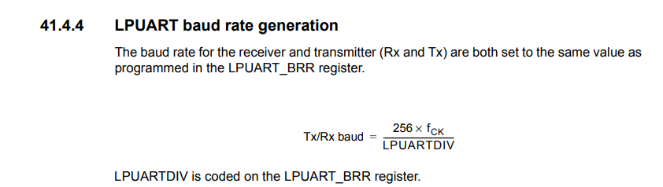

**LPUART->DIV** = 256*4e6/115200= **8889**

**Captures:**

Figure A7.a(a): Sample Home Screen

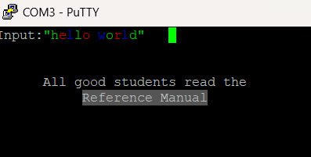

**Pseudocode Flow Chart:**

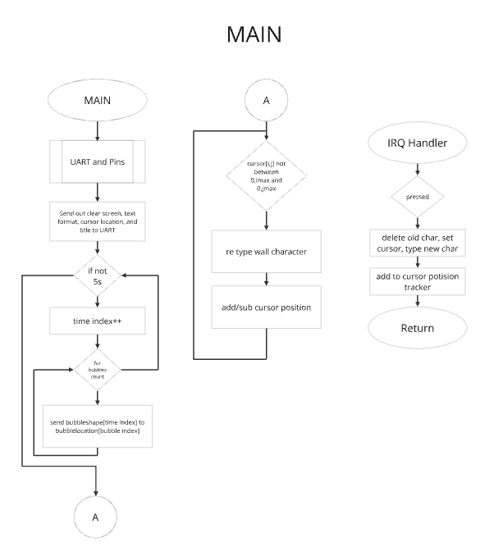

**Formatted Source Code main.h:**

/**

******************************************************************************

* @file : main.h

* project : EE329 Lab A7

* author : Wyatt Tack (wwt) - wtack@calpoly.edu

* date : 10/12/2024

* firmware : ST-Link V1

* @attention : Copyright (c) 2024 STMicroelectronics. All rights reserved.

******************************************************************************

*

* main header for defines for C and stm32 headers/hal

*

******************************************************************************

*/

#ifndef __MAIN_H

#define __MAIN_H

#ifdef __cplusplus

extern "C" {

#endif

/* Created defines and function prototypes -----------------------------------*/

void Execute(const char *messages[]);

void Bubbles(void);

void LPUART1_IRQHandler( void );

/* Includes ------------------------------------------------------------------*/

#include "stm32l4xx_hal.h"

/* Exported functions prototypes ---------------------------------------------*/

void SystemClock_Config(void);

void Error_Handler(void);

#ifdef __cplusplus

}

#endif

#endif

**Formatted Source Code main.c:**

/**

******************************************************************************

* @file : main.c

* project : EE329 Lab A7

* author : Wyatt Tack (wwt) - wtack@calpoly.edu

* date : 10/12/2024

* firmware : ST-Link V1

* @attention : Copyright (c) 2024 STMicroelectronics. All rights reserved.

******************************************************************************

*

* Device uses UART and a VT100 terminal to act as a very simple game. WASD

* keys are used as control, and taking character off screen places it as if

* screen scrolled over. Uses a baud rate of 115200.

*

******************************************************************************

*/

#include "main.h"

#include "delay.h"

#include "uart.h"

volatile uint16_t cursor[2] ={0,0};

int main(void)

{

//Initialize clock, keypad, spi config

HAL_Init();

SystemClock_Config();

SysTick_Init();

UART_Init();

//homescreen lines and commands

char *homescreen[] = {

"\e[2J", //clear screen

"\e[10;30H", //set cursor in middle

"\e[1m", //set cursor bold

"\e[31m", //set font red

"EE329 ADVENTURE", //title

NULL};

//execute homescreen text and bubbles graphic

Execute(homescreen);

Bubbles();

//screen boarder for game

char *gamescreen[] = {

"\e[2J", //clear screen

"\e[H",

"\e[36m", //set font cyan

"____________________________________________________________\e[2;0H"

"| |\e[3;0H"

"| |\e[4;0H"

"| |\e[5;0H"

"| |\e[6;0H"

"| |\e[7;0H"

"| |\e[8;0H"

"| |\e[9;0H"

"| |\e[10;0H"

"| |\e[11;0H"

"| |\e[12;0H"

"| |\e[13;0H"

"| |\e[14;0H"

"| |\e[15;0H"

"| |\e[16;0H"

"| |\e[17;0H"

"| |\e[18;0H"

"| |\e[19;0H"

"|__________________________________________________________|"

"\e[10;30H", //set cursor in middle

"\e[1m", //set cursor bold

"\e[35m", //set font purple

"&", //character

NULL};

Execute(gamescreen);

cursor[0] = 10; //set cursor

cursor[1] = 30;

//boundaries and character

while (1){

//if collision detected, repair wall and send character to other side

if (cursor[0] < 2) {

LPUART_Print("\e[36m\e[D_\e[D");

LPUART_Print("\e[17B");

LPUART_Print("\e[1m\e[35m&"); //print char

cursor[0] = 18;

}

if (cursor[0] > 18) {

LPUART_Print("\e[36m\e[D_\e[D");

LPUART_Print("\e[17A");

LPUART_Print("\e[1m\e[35m&"); //print char

cursor[0] = 2;

}

if (cursor[1] < 2) {

LPUART_Print("\e[36m\e[D|\e[D");

LPUART_Print("\e[58C");

LPUART_Print("\e[1m\e[35m&"); //print char

cursor[1] = 59;

}

if (cursor[1] > 59) {

LPUART_Print("\e[36m\e[D|\e[D");

LPUART_Print("\e[58D");

LPUART_Print("\e[1m\e[35m&"); //print char

cursor[1] = 2;

}

}

}

//------------------------- Movement in IRQ Handler -------------------------------

void LPUART1_IRQHandler( void ) {

uint8_t charRecv;

if (LPUART1->ISR & USART_ISR_RXNE) {

charRecv = LPUART1->RDR;

switch ( charRecv ) {

case 'w':

LPUART_Print("\e[D \e[D");

LPUART_Print("\e[A"); //move up

LPUART_Print("\e[1m\e[35m&"); //print char

cursor[0] = cursor[0]-1; //move cursor

break;

case 'a':

LPUART_Print("\e[D \e[D");

LPUART_Print("\e[D"); //move left

LPUART_Print("\e[1m\e[35m&"); //print char

cursor[1] = cursor[1]-1; //move cursor

break;

case 's':

LPUART_Print("\e[D \e[D");

LPUART_Print("\e[B"); //move down

LPUART_Print("\e[1m\e[35m&"); //print char

cursor[0] = cursor[0]+1; //move cursor

break;

case 'd':

LPUART_Print("\e[D \e[D");

LPUART_Print("\e[C"); //move right

LPUART_Print("\e[1m\e[35m&"); //print char

cursor[1] = cursor[1]+1; //move cursor

break;

default:

LPUART_Print_Char(charRecv); // echo char to terminal

break;

}

}

}

//---------------------------------------------------------------------------

void Execute(const char *messages[]){

//executes all messages in script

for(uint8_t idx = 0; messages[idx] != NULL; idx++){

LPUART_Print(messages[idx]);

}

}

void Bubbles(void){

//Time index for home screen, bubble locations colors and time stamps

char *bubble[] = {".","o","0","O","()","( )","*"," "};

int timex = 0;

int bSeed[] = {1, 3, 8, 12, 16, 18, 22, 27};

char *sSeed[] = {"\e[11;47H\e[32m", "\e[12;25H\e[36m", "\e[7;45H\e[35m", "\e[8;22H\e[33m",

"\e[8;49H\e[34m", "\e[7;25H\e[35m", "\e[12;44H\e[36m", "\e[13;35H\e[32m"};

//print bubbles around middle of screen for 5 seconds

for(int timer = 0; timer < 40; timer++){

for (int bubblex = 0; bubblex < 8; bubblex++){

if(timex > bSeed[bubblex] && timex < bSeed[bubblex]+8){

LPUART_Print(sSeed[bubblex]);

LPUART_Print(bubble[timex-bSeed[bubblex]]);

LPUART_Print(" ");

LPUART_Print("\e[H");

}

}

timex++;

delay_us(125000);

}

}

//----------------------------- System --------------------------------------

void SystemClock_Config(void)

{

RCC_OscInitTypeDef RCC_OscInitStruct = {0};

RCC_ClkInitTypeDef RCC_ClkInitStruct = {0};

/** Configure the main internal regulator output voltage

*/

if (HAL_PWREx_ControlVoltageScaling(PWR_REGULATOR_VOLTAGE_SCALE1) != HAL_OK)

{

Error_Handler();

}

/** Initializes the RCC Oscillators according to the specified parameters

* in the RCC_OscInitTypeDef structure.

*/

RCC_OscInitStruct.OscillatorType = RCC_OSCILLATORTYPE_MSI;

RCC_OscInitStruct.MSIState = RCC_MSI_ON;

RCC_OscInitStruct.MSICalibrationValue = 0;

RCC_OscInitStruct.MSIClockRange = RCC_MSIRANGE_6;

RCC_OscInitStruct.PLL.PLLState = RCC_PLL_NONE;

if (HAL_RCC_OscConfig(&RCC_OscInitStruct) != HAL_OK)

{

Error_Handler();

}

/** Initializes the CPU, AHB and APB buses clocks

*/

RCC_ClkInitStruct.ClockType = RCC_CLOCKTYPE_HCLK|RCC_CLOCKTYPE_SYSCLK

|RCC_CLOCKTYPE_PCLK1|RCC_CLOCKTYPE_PCLK2;

RCC_ClkInitStruct.SYSCLKSource = RCC_SYSCLKSOURCE_MSI;

RCC_ClkInitStruct.AHBCLKDivider = RCC_SYSCLK_DIV1;

RCC_ClkInitStruct.APB1CLKDivider = RCC_HCLK_DIV1;

RCC_ClkInitStruct.APB2CLKDivider = RCC_HCLK_DIV1;

if (HAL_RCC_ClockConfig(&RCC_ClkInitStruct, FLASH_LATENCY_0) != HAL_OK)

{

Error_Handler();

}

}

void Error_Handler(void)

{

__disable_irq();

while (1)

{

}

}

#ifdef USE_FULL_ASSERT

void assert_failed(uint8_t *file, uint32_t line)

{

}

#endif

**Formatted Source Code uart.h:**

/**

******************************************************************************

* @file : uart.h

* project : EE329 Lab A7

* author : Wyatt Tack (wwt) - wtack@calpoly.edu

* date : 10/13/2024

* firmware : ST-Link V1

* @attention : Copyright (c) 2024 STMicroelectronics. All rights reserved.

******************************************************************************

*

* main header for defines for uart.h

*

******************************************************************************

*/

#ifndef INC_UART_H_

#define INC_UART_H_

#include "stm32l4xx_hal.h"

#define BAUD_RATE (8889) //256 * 4MHz / 115.2kb/s = 8888.8

void UART_Init(void);

void LPUART_Print( const char* message );

//void LPUART1_IRQHandler( void );

#endif /* INC_UART_H_ */

**Formatted Source Code uart.c:**

/**

******************************************************************************

* @file : uart.c

* project : EE329 Lab A7

* author : Wyatt Tack (wwt) - wtack@calpoly.edu

* date : 10/13/2024

* firmware : ST-Link V1

* @attention : Copyright (c) 2024 STMicroelectronics. All rights reserved.

******************************************************************************

*

* Functions for UART module, set up as LPUART1 through GPIOG.

* PTG-7 -> Tx

* PTG-8 -> Rx

*

******************************************************************************

*/

#include "uart.h"

// -----------------------------------------------------------------------------

void UART_Init(void){

//Power and Clock

PWR->CR2 |= (PWR_CR2_IOSV); // power avail on PG[15:2] (LPUART1)

RCC->AHB2ENR |= (RCC_AHB2ENR_GPIOGEN); // enable GPIOG clock

RCC->APB1ENR2 |= RCC_APB1ENR2_LPUART1EN; // enable LPUART clock bridge

//GPIO Ports - AF8, no PU/PD, fast (despite uart being slow)

GPIOG->MODER &= ~(GPIO_MODER_MODE7 | GPIO_MODER_MODE8);

GPIOG->MODER |= (GPIO_MODER_MODE7_1 | GPIO_MODER_MODE8_1);

GPIOG->OTYPER &= ~(GPIO_OTYPER_OT7 | GPIO_OTYPER_OT8);

GPIOG->PUPDR &= ~(GPIO_PUPDR_PUPD7 | GPIO_PUPDR_PUPD8);

GPIOG->OSPEEDR |= ((3 << GPIO_OSPEEDR_OSPEED7_Pos) | (3 << GPIO_OSPEEDR_OSPEED8_Pos));

GPIOG->AFR[0] &= ~(0x000F << GPIO_AFRL_AFSEL7_Pos);

GPIOG->AFR[0] |= (0x0008 << GPIO_AFRL_AFSEL7_Pos);

GPIOG->AFR[1] &= ~(0x000F << GPIO_AFRH_AFSEL8_Pos);

GPIOG->AFR[1] |= (0x0008 << GPIO_AFRH_AFSEL8_Pos);

//LPUART

LPUART1->CR1 &= ~(USART_CR1_M1 | USART_CR1_M0); // 8-bit data

LPUART1->CR1 |= USART_CR1_UE; // enable LPUART1

LPUART1->CR1 |= (USART_CR1_TE | USART_CR1_RE); // enable xmit & recv

LPUART1->CR1 |= USART_CR1_RXNEIE; // enable LPUART1 recv interrupt

LPUART1->ISR &= ~(USART_ISR_RXNE); // clear Recv-Not-Empty flag

LPUART1->BRR = (BAUD_RATE);

/* USER: set baud rate register (LPUART1->BRR) */

NVIC->ISER[2] = (1 << (LPUART1_IRQn & 0x1F)); // enable LPUART1 ISR

__enable_irq();

}

void LPUART_Print( const char* message ) {

uint16_t iStrIdx = 0;

while ( message[iStrIdx] != 0 ) {

while(!(LPUART1->ISR & USART_ISR_TXE)) // wait for empty xmit buffer

;

LPUART1->TDR = message[iStrIdx]; // send this character

iStrIdx++; // advance index to next char

}

}

void LPUART_Print_Char (uint8_t charRecv){

while( !(LPUART1->ISR & USART_ISR_TXE) );// wait for empty TX buffer

LPUART1->TDR = charRecv; // send char to terminal

}