PPVC App: A cross platform Application for People Profiling and Violation Complaint with Descriptive Analytics

Prince Edjervy Cacas

BS Information Technology  
Diho, Buhangin  
Davao City   
(+63)9309008864

pcacas@umindanao.edu.ph

John Theo Mari Escarlan

BS Information Technology  
Blk 7 Lot 42, Evisa Sub, Matina   
Davao City   
(+63)9065848980

j.escarlan.469825@umindanao.edu.ph

Jan Carlo Arroyo

University of Mindanao

(+63)9177246528

Jancarlo_arroyo@umindanao.edu.ph

Rey Fauna Narcilla

BS Information Technology  
Rose-J Marian Village, Matina  
Davao City   
(+63)9959237559

rnarcilla@umindanao.edu.ph

**Categories and Subject Descriptors**

k.6.3 [**Software Management**]: Android and Web Development.

**General Terms**

Documentation, Standardization, Management, Reliability, Human Factors, Verification

**Keywords**

Descriptive Data Analytics, Nexmo SMS API, Laravel Framework, Android

1. **INTRODUCTION**
   1. **Project Context**

Davao City, reputedly the largest city in the world, has an area of 244,000 hectares, or 8 percent of the land area of Southern Mindanao Region or Region XI. It is divided into 3 congressional districts and furthermore divided into 11 administrative districts and a total of a 182 barangays [1]. These can be very complicated and can quickly be disorganized without proper computer assistance. Currently we are in the middle of a crisis, the proposed project will be beneficial and somewhat important in for the barangay. By means of having a list of constituents for easier contact tracing if ever needed, easier monitoring for distribution of goods, and much faster announcements and notifications for the barangays residents. Since each barangay has almost the same way of doing their respective business, the researchers have chosen Barangay Boulevard as the base for this study.

Barangay is considered to be the smallest municipal division in the Philippines and is the native Filipino word for an area, district or village. Since it is the main administrative division of the Philippines, all the rules and regulations enacted by the legislature will be enforced and disseminated, first, by barangay officers, through petitions, clearances, licenses and many others. The barangay takes care of every single one of them.

The goal of the researchers is to be able to fasten and help the barangay execute their tasks in a basic yet very convenient manner. The researchers plan to provide additional automatic functionality, such as electronic complaint filing, and a real-time chat support feature, so that citizens can report some act of violence or actions that may violate the law for rapid response directly to the barangay.

The proposed PPVC plan will be based on Barangay Boulevard and will rely on how Barangay works. Mainly to solve the issues in the barangay such as no up-to-date census data, etc. This system can be used by those who have the same design and transactions as Barangay Boulevard. The program will accept all barangay officials and barangay residents as its users and will allow all groups to coexist with notices, rules and regulations, surveys, and other barangay issues. Since almost everyone currently has either a smartphone that can access the Internet or a pc, this initiative will be practical and will be of great benefit to those involved.

In order to develop the project, the researchers will use the Agile Methodology to support the development of the plan. Agile Methodology is a software development methodology that significantly increases the adaptability of the people involved in the project and at the same time reduces the overall risk that the development of the project will most likely encounter. Through continued preparation and input on each milestone reached or still underway, researchers will have an insight into which aspect they should develop and which section they can collaborate more together to achieve a more efficient and effective project even though each task is still in development. Methodology helps researchers to collaborate better in order to get concepts in a coherent way.

# Purpose and Description

The purpose of the research is to be able to provide a means of efficiently disseminating the required and essential knowledge that the barangay must advise its leaders or people of less uncertainty as to how they use their resources. This will solve the problem for properly allocating the budgets for barangay programs and will also help with deciding what program would be beneficial to the barangay constituents or what they would currently need. It's also a way for barangay to have an outlet for announcements, since almost everyone today owns or uses Android devices as part of their daily lives. Most importantly, to provide barangay assistance in helping to eliminate violent acts within their barangay, to provide people living within their perimeters with the opportunity to report illegal acts through their android phones for their safety and well-being through real-time alert notification.

PPVC is an interactive web and mobile application that provides access to the existing economic, social, educational and infrastructural problems that some barangay are facing. Using Descriptive Data Analytics to tap into their people profiling to analyze and properly address these issues such as (e.g., feed programs, project infrastructure budget, and educational programs). These will act as a basis where leaders of the barangay can have access to be up-to-date on the Barangay office's initiatives and proposals, or will be enforced. The application will also be able to collect the necessary data for analytical purposes in order to keep track of the current situation of the members of the barangay (e.g. population, employment rate, age range) for the office's plans and decisions.

PPVC also provides constituents of the barangay with a forum in which they can file complaints directly with the office on their negative encounters with some of their neighbors, current projects being reported by the office, or even direct charges against members of the barangay board, for barangay officials to take action on joint resolutions. The app also provides detailed, reliable and secure peacekeeping data. PPVC can also be installed on the assigned officer’s android phones so that they can also be notified.

PPVC aims to improve the way in which it operates and maintains secure documents for all residents. The data provided by this system in the form of detailed reports are invaluable for planning, program execution and related purposes. This application will be designed for long term use. Therefore, if the app were to be realized, it would make more use of the Local Government Unit to access and address what needs to be discussed in the municipality and also to the residents. To cater for their needs; data analysis can be used to assess the plans for the future Barangay program.

Barangay Boulevard sends out two officers in charge of circling around the barangay late at night, but not in all situations around the places where emergency cases exist. In the event of emergency (e.g., riots, house break-in, violent acts against members of the barangay), users can send alerts to the barangay to warn them that there is an ongoing violent scenario in a specific area of the barangay where the barangay can send Tanods to that spot.

# Objectives

* + 1. **General Objectives**

**T**he researchers aim to develop a cross platform application that let the officials of barangay boulevard Davao city to have a list of their residents/profile the people in barangay boulevard, provide a notification/announcement feature, and a report violation complain.

# 1.3.2 Specific Objectives

To successfully achieve the general objectives the study, the researcher will certainly provide the following

* + - 1. To develop a web application that lets the barangay post existing and newly implemented rules and announcements using Laravel Framework.
      2. To develop a Web application that sends a notification the moment admin post new announcement using Nexmo SMS API.

**1.3.2.3** To develop an android application that includes real time chat using Firebase real time chat to let the barangay officials reply from the chat of the citizens regarding their concerns.

**1.3.2.4** To develop an android application that includes violation report and information guide for users.

**1.3.2.5** To help barangay boulevard organize all the record of their people by providing them a Profiling System with Descriptive Data Analytics Using Laravel Framework.

**1.3.2.6** To generate report charts for Descriptive Data Analytics using Lavacharts in Laravel Framework.

# 1.4 Scope and Limitation

This study proposed a People Profiling System with Descriptive Data Analytics feature which can run through a web platform. Both web and mobile platforms cannot be accessed without an internet connection, also the system will be and only be accessed by Barangay 37-D and its residents.

The system will provide an easy-to-read and user-friendly interface. The system will require a minimum of knowledge when it comes to navigation, as long as users are well informed about the fundamentals of mobile applications. Complaints sent through the application will only be dealt with as long as the complainant is part of the barangay that is currently running the system and is within barangay limits only.

The system for users will include the following functionalities: user (employee and residents) user profile management, violation complaint, real-time chat for users and notification for Barangay announcements using NEXMO. Since NEXMO is not free to use, the researchers will pay for the amount needed to use NEXMO for a short time frame while development is ongoing. Further use charges after the development is done will be taken care of by the barangay.

The application can run through Android devices but will not be available for iOS devices. The Descriptive Data Analytics feature will only be applied to the People Profiling System. The estimated time of arrival of the Peace and Order team to the place a report has been made will depend on the transportation speed and the time of travel from the barangay to the location provided by the one who filled a report.

# 2. REVIEW OF RELATED LITERATURE AND SYSTEMS

Stated in this chapter are articles of contrasting concepts and approaches relate to the study, which focuses developing PPVC. This chapter cited and tackles altered ideas, concept, understanding, and a conclusion which serve as the researcher's guide in developing the proposed project.

# 2.1 The Role of Automated SMS Text Messaging in Survey Research

The research discusses the effect of the use of Automatic SMS Text Messaging in the execution of the survey. The goal of the study is to make it clear that messages is the "main" mode of data collection and that it is very useful in the conduct of survey research. The study also aims to know what the response of the recipient of the SMS is [2].

# The comparisons of the studies are both intended to suggest that SMS text messaging is the most open means of communicating and disseminating information to many recipients. The distinction between the two studies is that the PPVC SMS notification function only sends a resident message and does not require the resident to respond to the said SMS notification, while the study above allows the receiver to reply to the source and to be recorded afterwards.

# 2.2 Barangay Justice Service System (BJSS) Project as an Alternative Mechanism in Dispute Resolution in Maguindnao, Southern Philippines: A Content Analysis

The study focuses on the implementation of the Barangay Justice Support System (BJSS) initiative in the Southern Philippines province of Maguindanao. This study revealed that setting arguments between people in the community mentioned were not yet established. The project enhanced awareness ease of access to justice, practical knowledge or abilities of people grappling with conflicts, cases at the local level, offered more effective, organized ways to resolve disputes at the local level by providing proper paperwork, case reports and resolutions that have not been given due consideration at the barangay level in the past [3].

# Since this research focuses on methods of resolving conflicts, debases and disagreements between people, it is clear that there is still a need to systematize the approach to resolving problems. Researchers will help to address a problem such as this in the Barangay by implementing a system that will allow people to have easy access to their complaints so that Barangay officials and other stakeholders can effectively control such concerns, keep a record of all allegations and track the progress of cases that aim to settle them. The proposed project, PPVC, is a computerized barangay system that allows citizens to file structured and emergency complaints.

# 2.3 Real-time Communication Application Based on Android Using Google Firebase

The goal of the analysis is to create a mobile communication application using the firebase platform. Researchers in the study intend to imitate several common contact apps such as WhatsApp and WeChat to show other developers how valuable and ideal a firebase system is for creating a chat application [4].

# Likewise, the PPVC program has a real-time chat feature that is used by both the Barangay Hall (web-based app) and the purok leaders / citizens (mobile-based app) using the firebase fire chat. The feature described requires the ability in real time to achieve its sole purpose of "providing a secure means of communication between barangay public servants."

# 2.4 Mobile-Based Notification System for University’s Events

The goal of the research is focused on the crucial aspects of having a notification platform for the University's events and announcements. The researcher in the study intend to provide a SMS notification for timely messages and relevant information like event schedules, locations, and details regarding the events. This will ensure that the announcement will be delivered to the students and faculty members [5].

# Some similarities of both the study stated above and PPVC are mainly for the distribution of information through announcements to end users. PPVC on the other hand provides notification and announcements through SMS or via the application. While the study only provides notifications through SMS messages.

# 2.5 E-Reklamo: Web-Based and SMS-Based Barangay Complaints with Analytics

Established an SMS and Web-based technology network that can document and track grievances from all Barangay Looc residents with a population of almost 20,000.It also gets rid of manual transactions, especially in the Barangay. E-Reklamo: Web-based and SMS-based barangay Complaint w / Analytics allowed residents to text or submit their concerns, issues and complaints through access to the Barangay website. Complaint collection, storage and data extraction have become very simple, and the most classified charges can be graphed [6].

# Basically, both the E-Reklamo and the new framework, the PPVC are almost the same. Both are barangay-based systems that help users file complaints in the barangay. Which distinguishes the two systems is that PPVC is more sophisticated and provides more functionality such as a Mobile-based framework, an up-to-date notification website, and Descriptive Data Analytics People Profiling.

# 2.6 Coproduction of Government Services and the new Information Technology: Investigating the Distributional Biases

The research reflects on how Boston should solve the problem they face with staff unemployment and bankruptcies. The alternative for the local government in Boston is to use innovations to their benefit. The Boston Council has created the 311 hotline to respond to all demands for government services, including a request for reporting information, which ensures that their program will produce a database on the overall number of requests for services provided by the City on a weekly, monthly and yearly basis [7].

# The distinction of both studies is that they both focus on local government services, both use technological advances to enable people to access government services without heading to their town hall and barangay. These systems seek to insure that every citizen complaint is answered in the most convenient way for both the government entity and the people under it. Discrepancies of both programs are that PPVC does not allow for phone numbers where people can lodge inquiries or grievances, and that PPVC is mainly a breach issue that the 311 in Boston does not have because they have a different hotline for that sort of inquiry by their citizens.

# 2.7 An Integrated Information Management System for Barangay 1-A Davao: Profiling, Incident Recording, Project/program Monitoring, and Document Request

The IIMS Integrated Information Management System for Barangay is a system that maintains information and keeps track of data for Barangay 1-A Población, Bolton Extension Davao City. The program consisted of four main components: the Document Request Program, which introduced a paper request protocol that meets the client's specifications, the Incident Recording System, where the client's grievances were registered on a local computer, and the Project Monitoring System, where successful project tracking was carried out and taken into account. This program has led to the avoidance of over-spending or under-spending in the execution of barangay programs and in the compilation, review and reporting of the necessary information in barangay [8].

# Similarities of this framework are that they can deal with profiling and violation / reporting. PPVC does not have a project monitoring feature and a document request. The distinction between the proposed systems is that it has Data Analytics as opposed to the proposal mentioned above. The PPVC is an electronic report that can be sent to the customer through smartphone or desktop. The Barangay Officials (Tanod's) can therefore respond quickly to where the complainants are situated.

# 2.8 Localization-Aware Content and Localization-Based Advertising with Mobile Device

The goal of the project is to provide users with a mechanism by which they can use the Geo-tagging of the mobile device, so that the mobile application can provide personalized ads based on location. The advertisement of this application helps the user to know specific data based on the geographical location of the mobile device. Application developers use cellular towers to locate the device [9].

# Same as the PPVC framework, it also sends notification to its users about upcoming barangay activities and programs and potential facilities to be offered to residents. The distinctions between the two implementations are that the application uses geotagging to disseminate advertising, while the PPVC application just spreads advertisements regarding meetings, services, and notifications that are sent to the barangay hall through a web-based application to disseminate information.

# 2.9 Data Analysis with Visualization for a Geographic Information System of Schistosomiasis Community Health Data

This study focuses on Data analytics for Schistosomiasis diseases endemic in tropical and sub-tropical areas in which bodies of water had infested with Schistosomiases having freshwater snails as host that can infect the urinary track and intestines of the people in the community. A particular geographic information system (GIS) called Altair GIS was developed to monitor patients and visualize community health survey data gathered from four endemic barangays of Salvador, Lanao del Norte, Philippines. The database of the GIS was designed based on the community health data provided by the Municipal Health Office of Salvador. The integration of user interface and the database model allowed the management of the gathered data and the mapping model utilized the coordinates of households from the database, visualizing community health data through maps using Google Maps API [10].

This study enhanced the existing geographic information system by providing it with data analytics model with data visualization. The proposed system, PPVC has data analytics that provides reports such as population growth and age ranges. It is to help barangay officials to monitor each of them and be able to provide proper budget allocation for projects that need to be prioritized.

**Table 1: Features Checklist**

|  |  |  |  |  |  |
| --- | --- | --- | --- | --- | --- |
|  | **PPVC** | E-Reklamo | IIMS | CGS-IT | GIS |
| Cross-platform | **✔** |  |  |  |  |
| Real-Time Chat  Feature | **✔** |  |  | ✔ |  |
| SMS Notification Feature | **✔** | ✔ |  | ✔ |  |
| GPS/Geo-tagging | **✔** | ✔ |  |  | ✔ |
| People Profiling | **✔** |  | ✔ |  | ✔ |
| Violation Complaint Feature | **✔** | ✔ |  |  |  |
| Descriptive Data Analytics | **✔** |  |  |  |  |
| Register Residents of BRGY (admin and users) | **✔** |  | ✔ |  |  |

Table 1 shows the common features that are present in E-Reklamo, IIMS, CGS-IT and GIS. As shown in table 1, all the systems have almost the same feature, and the only differences are some sub-feature, purposes, and processes. the advantage of PPVC are: real-time chat feature for users inquiries and concerns, SMS notification for announcements, descriptive data analytics for interpretation of data to better understand historic data, and it allows users to file violation reports or complaints without going to the Barangay Office.

# 3 TECHNICAL BACKGROUND

The main focus of this chapter will be to provide a brief discussion on how researchers will use the technical aspects that will be implemented in the study. In addition, this chapter will also provide a lot of conceptualize idea that will be presented comprehensively through images, along with some explanation of how and when the idea occurs during and after the processes.

## Conceptual Framework

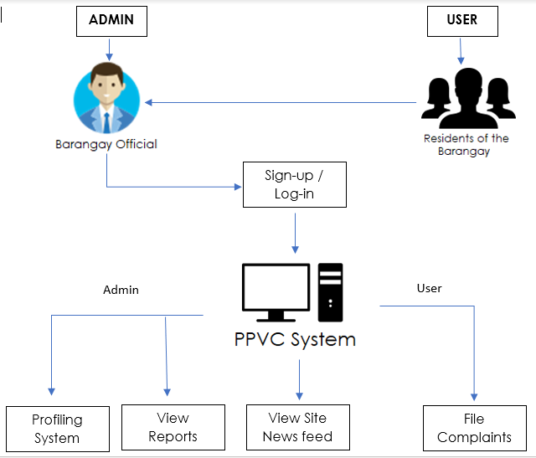

## Figure 1: *Overview Conceptual Framework*

Figure 1 explain the logical flow of the system wherein the citizen will be required to go to the barangay hall and be registered by the barangay officials for them to be able to use the Android Application. By this the barangay officials will know who will send a prank report in the future and we can be sure that only the citizen of barangay 37-D will be the one who is using the Android Application. The admins of the system will have to log on for security purposes and be able to access the system, admins can access all the features of the PPVC system while the user will only be able to view the news feed and file complaints.

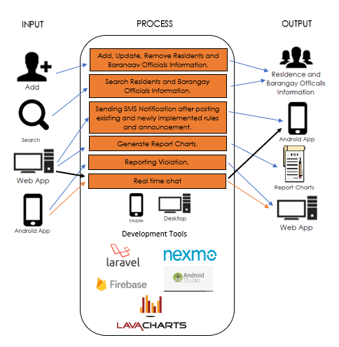

**Figure 2:** *The Conceptual Framework*

Figure 2 shows the overall conceptual framework of the PPVC app. By using the proposed system, PPVC is a profiling system that collects data and information of the citizen that lives in barangay 37-D Boulevard Davao City, where in the admin can Add, Update and Remove a person’s information, the admin can also search individual using full name, the admin can also post existing and newly implemented rules and announcement using the Web application and automatically send a SMS notification to all users, the system can generate report charts for proper visualization and understanding on what will be the best project or activity the barangay will do. The user can send a complaint or report a violation using the Android Application.

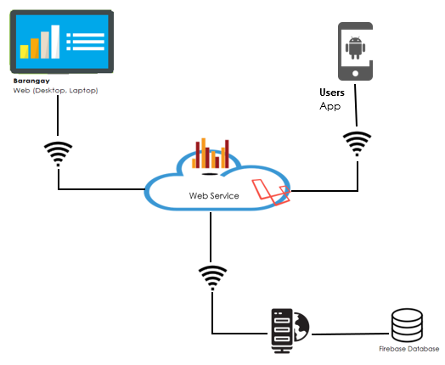

**Figure 3:** *Barangay 37-D Web Infrastructure*

Figure 3 shows the barangays web infrastructure, by using the proposed system and with the use of specific tools, the barangay will adopt innovation that will help them grasp the idea of the proposed system. This includes, particularly for admin by using the web system they can easily records all the information of the citizen that lives in their barangay, admins can also easily relay the announcement by posting it in the system. For the users using the android application they will receive a notification the moment admin post an announcement the users can also send a complaint or report a violation using the android application.

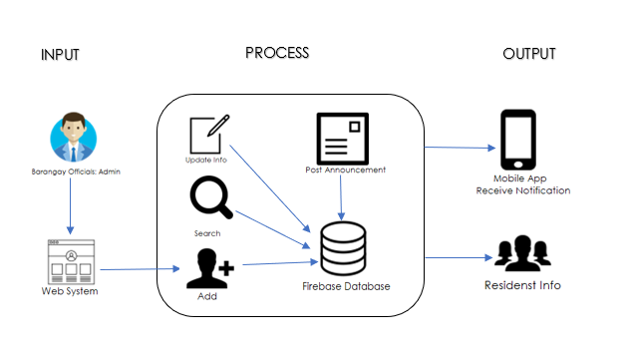

**Figure 4:** *Conceptual Framework of Web system*

Figure 4 shows the process on how the Web System works. The admin which is the barangay officials is the only one who can access the web system, where in the admin can Add, Update and Remove a person’s information, the admin can also search individual using full name, the admin can also post existing and newly implemented rules and announcement using the Web System and automatically send a notification in the Android Application.

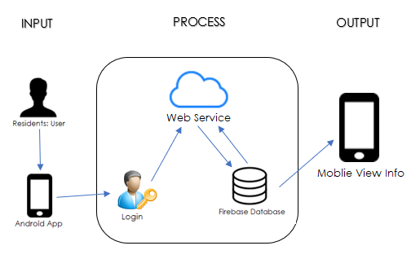

**Figure 5:** *Conceptual Framework of Android Application*

Figure 5 shows the process on how the Android application works. The user which is the citizen of barangay 37-D is the only one that can user the Android application, where in the user can see the post of the admin in the newsfeed, the user can also send their complaint using the real time chat and report a violation.

**Table 2: Input Process Output of the Web System**

|  |  |
| --- | --- |
| INPUT | * Barangay Official Information * Citizen Information * Modify Citizen Information * Post existing and newly implemented Rules and announcement |
| PROCESS | * Handles the admin and user’s information by the Web System * New information update * Auto-filter of the Citizen information after search |
| OUTPUT | * Admin and Citizen information view * Send SMS notification to Android application |

In the Table above shows the input process and the output of the Web Application administered by the barangay officials. Where in the admin needs to login using their username and password to be able to use all the function of the Web System. The admin can add, modify, remove, and search persons information, admin can also post existing and newly implemented rules and announcement and Web System automatically sends notification to all the users.

**Table 3: Input Process Output of the Android Application**

|  |  |
| --- | --- |
| INPUT | * Users username and password |
| PROCESS | * Send complaints and can report violation |
| OUTPUT | * View the existing and newly implemented rules that has been posted in the news feed. * Receive Notification |

In the Table above shows the Input Process Output (IPO) of the Android Application. The user needs to log in using their username and password for them to use the Android Application. Using the application, they can send their complaints through the real time chat or report a violation, if the report is confirmed to be true the barangay tanod will respond to the scene and takes care of the disturbance and if the report turns out to be a prank or a false report the owner of the account that sends the report will be summon in the barangay hall and will face the following consequence:

1st offense: the owner of the account will be given a warning by the barangay officials.

2nd offense: the owner of the account will pay a fine of 1,000 pesos.

3rd offense: the owner of the account will pay a fine of 5,000 pesos and will be imprison for a day.

The user can view the posts and announcement in the news feed.

* 1. **Search**

Search is one of the features of the PPVC App wherein the admin can look to all the information in the system. The admin will simply input the full name and the system will retrieve and display the data from the Firebase database in the systems view.

* 1. **Generate Charts**

Generating chart is one of the features of the PPVC app wherein the admin can generate charts using Lavachart. The charts will help the barangay officials to think a new barangay projects based on the data they have.

* 1. **Report Violation**

Report Violation is one of the features of the PPVC App wherein the user can send a report using the Android application and the admin will receive it in the Web System. The Android application is created using the Android Studio.

* 1. **Notification**

The Nexmo API will handle the sending of SMS notification to all the user. All users will be notified the moment admin post a new announcement.

* 1. **Development Tools**

The researcher will utilize the following tools in order to create the proposed system.

* + 1. **Laravel Framework**

Researchers will develop a web-based system using the Laravel Framework. Since it’s an easy syntax and makes our proposed web application faster and more reliable.

* + 1. **Nexmo SMS API**

The Nexmo SMS API will be used to send a notification message to the purok leader/resident. Nexmo is used by researchers because it is less costly than other SMS APIs and Nexmo also guarantees that the message is transmitted well to its path with minimum amount of conceivable traffic.

* + 1. **Lavacharts**

The researchers will use Lavacharts to generate reports for the Laravel Framework. Since Lavacharts is more compatible with Laravel than other report generating charts. Also, by applying this, the reports needed will be more precise and detailed.

* + 1. **Firebase Database**

A Firebase database will be used by the researchers to store all the users input data. Due to its fast process people nowadays usually use Firebase database.

# REFERENCES

[1] Hoe, National Economic and Development Authority Regional Office XI, NEDA-RDC XI Center

[http://nro11.neda.gov.ph/davao-region/davao-city/](http://nro11.neda.gov.ph/davao-region/davao-city/%20)

[2] Hoe, N. & Grunwald, H. (2015). The Role of Automated SMS Text Messaging in Survey Research, Retrieved February 18,2019, from

https://www.researchgate.net/publication/290390461_The_Role_of_Automated_SMS_Text_Messaging_in_Survey_Research

[3] Sam, R. A., Sam S. A. & Usop A. M. (2013) Barangay Justice Service System (BJSS) Project as an Alternative Mechanism in Dispute Resolution in Maguindnao, Southern Philippines: A Content Analysis. International Journal of Humanities and Social Sciences, Vol. 3 No. 12. Retrieved February 19, 2020, from

<http://www.ijhssnet.com/journals/Vol_3_No_12_Special_Issue_June_2013/22.pdf>

[4] Edah Darul Aman (2016). Mobile Based Notification System for University’s Events, Retrieved June 18, 2020, from

<https://www.researchgate.net/publication/312174531_MobileBased_Notification_System_for_University's_Events>

[5] Borgman, B., Decker, R. & Asperen, E (2013). Evaluating the impact of truck announcements on container stacking efficiency. Retrieved February 18, 2020, from

https://link.springer.com/content/pdf/10.1007/s10696-011-9108-1.pdf

[6] Meriam Makinano-Makinano-Santalla, Jojene R. Santalla*, Edsel Matt O. Morales (2017), E-Reklamo: Web-Based and SMS-Based Barangay Complaints with Analytics. Retrieved February 19, 2020, from

https://prezi.com/q-4ptpfdfnvf/e-reklamo-a-web-based-and-sms-based-barangay-complaints-wit/

[7] Clark, B., Brudney, J. et al. (2013). Coproduction of Government Services and the new Informattion Technology: Investigating the Distributional Biases. Retrieved February 18, 2020, from

https://uncw.edu/bbwc/brudney/documents/coproductionofgovernmentservicesandthenewinformationtechnologybrudney2013.pdf

[8] Cainong, J.J, Galvez, D.D. & Javellane, J. (2015). An Integrated Information Management System for Barangay 1-A Davao: Profiling, Incedent Recording, Project/program Monitorinng, and Document Request. Retrieved February 20, 2020, from

<https://www.researchgate.net/publication/314774122AnIntegratedInformationManagementSystemforBarangay1-ADavaoProfilingIncedentRecordingProjectProgramMonitorinngandDocumentRequest>

[9] Moshfeghi, M. & Verdes, R. (2016). Localization-Aware Content and Localizaton-Baseed Adventizing with Mobile Device. Retrieved February 19, 2020, from

<https://patentimages.storage.googleapis.com/38/a5/a3/dc71cfd8d5b521/US9282446.pdf>

[10] J. M. D. Acibar, L.N. Aguanta, J. D. E. Gomora, and †L.C. P. Velasco (2015). Data Analysis with Visualization for a Geographic Information System of Schistosomiasis Community Health Data. Mindanao State University-Iligan Institute of Technology, Iligan City, 9200, Philippines. Retrieved February 19, 2020, from

<https://www.researchgate.net/publication/313823987_Data_Analysis_with_Visualization_for_a_Geographic_Information_System_of_Schistosomiasis_Community_Health_Data>

[11] McDade J (n.d). Laravel Philosophy. Retrieved February 2020, from <https://laravel.com/docs/4.2/introduction>

[12] W3schools (2018). Google Maps API. Retrieved February 2020, from <https://www.w3schools.com/graphics/google_maps_intro.asp>