Agile Train the Trainer: Prework # 2

Review the diagram below. As part of the course, you’ll be expected to talk through this diagram, noting the key events, who attends them, the inputs and outputs of each event and of course, the timebox/length. Good thing you completed Prework #1 and this is just an easy review now huh😊.

We tell all of our trainers and students, by the end of class you can either talk your way through this…or you have to get a matching tattoo. So far, everyone has learned it.

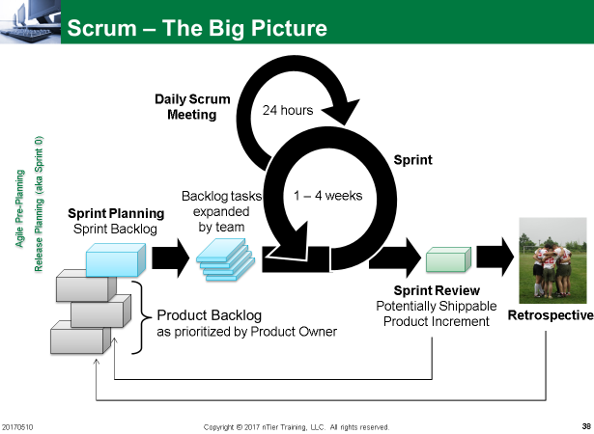

The Agile Manifesto

Read the first page of the Agile Manifesto over a couple of times (very short!) [http://agilemanifesto.org](http://agilemanifesto.org/)

Spend a few minutes thinking about it. Agree? Disagree? Did they miss anything?

The Agile Principles

The first link on the Agile Manifesto will take you to this page <http://agilemanifesto.org/principles.html>

DELIVERABLE: Divide the 12 principles up in your group. Self-organize, decide amongst your team who does which ones.

For each principle you are assigned:

1. Spend at least 5 minutes per principle, writing/searching online/reading a book to get a sense of what the principle is about.
2. The goal is that you are ready in your team to facilitate (not teach) a short discussion about each principle.
3. BONUS – if you can think of a specific way Scrum implements a principle. Write it down…will come in handy for an in class exercise.