Wyatt McCurdy

COS 570

Computer Vision Assignment 2

# Task 1: Object Size Measurement

To properly measure the size of the book on the A4 paper, I used OpenCV to load, preprocess, and analyze the image. I first loaded the image and preprocessed: converting to grayscale and blurring to enhance edge detection accuracy. Subsequently, I used the Canny edge detection algorithm and contour finding techniques to identify the outer boundary of the paper. To obtain a clear, top-down perspective of the object, I applied a perspective transformation using the identified corner points of the A4 paper.

In the resulting warped image I used a second contour detection to detect the book, in a similar way to the previous implementation. I found its approximate rectangular polygon, and then got the width and height, converting to centimeters based on the size of the warped image, the real size of the A4 paper, and the size of the book’s geometry in pixels. I displayed two images: the contour detection for the paper, and the contour detection and size display for the book. The results were reasonable, with an error of %7.06 for the book width and an error of %9.39 for the book height.

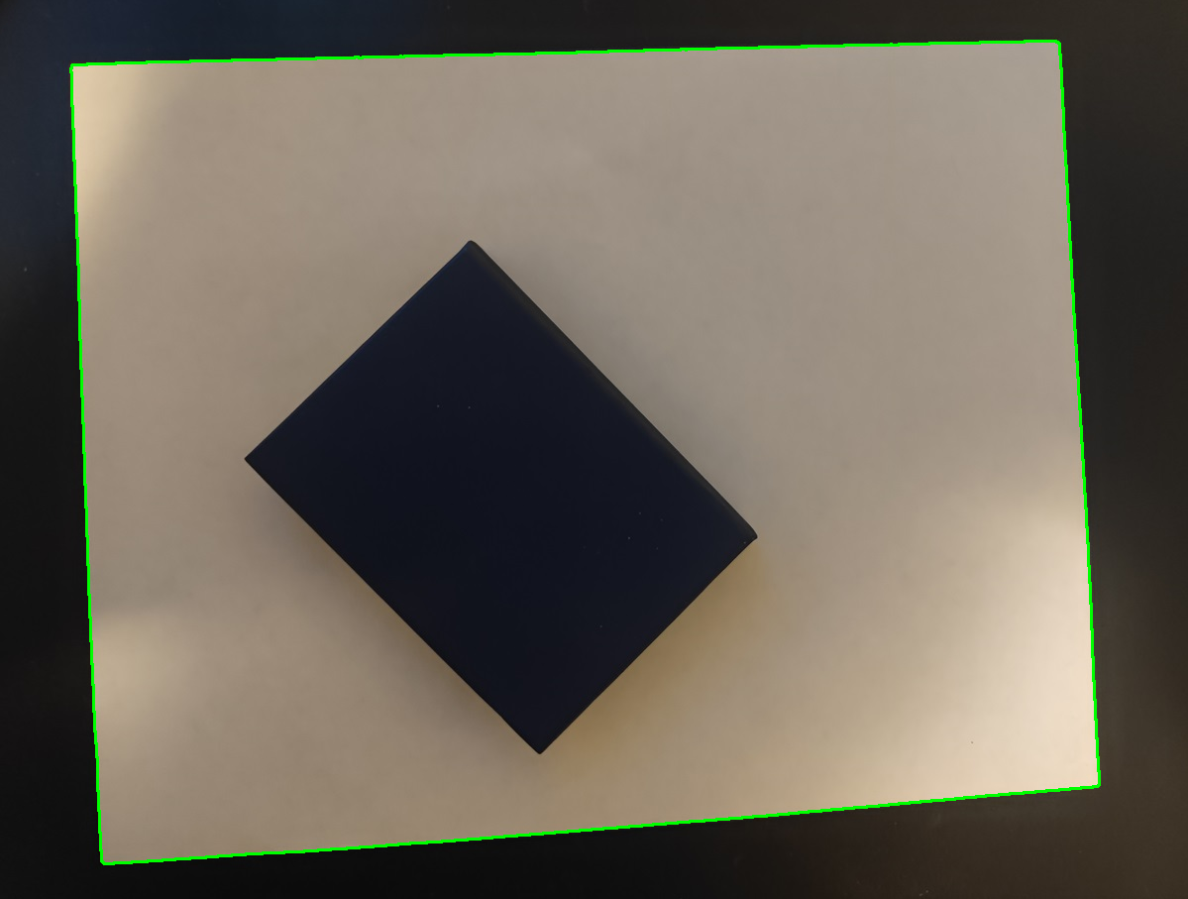

Figure 1: Original image with green contour lines around the edges of the piece of paper.

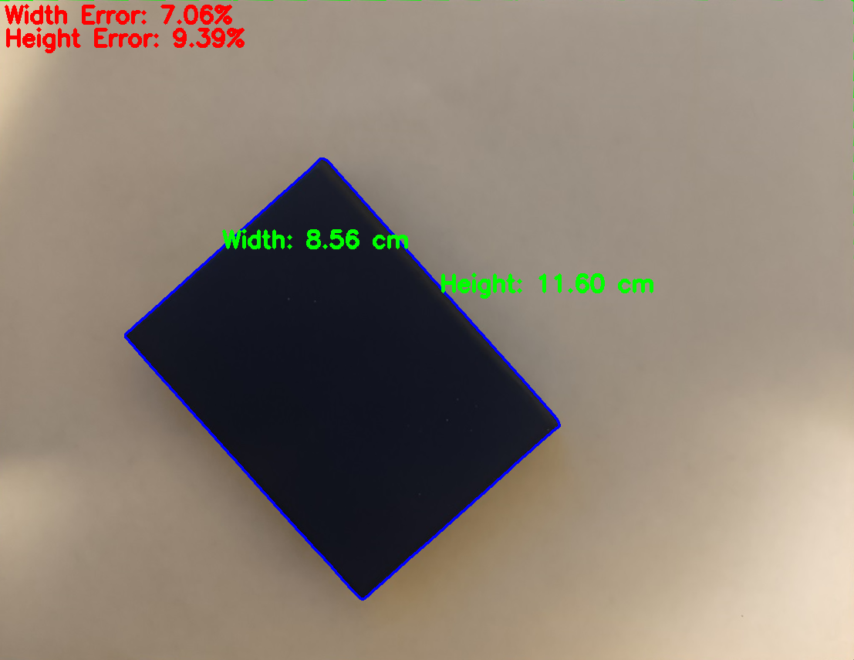

Figure 2: Measurement estimates and error for book laying on A4 paper.

# Task 2: Text Recognition

## Text Analysis

The text analysis script is designed to recognize text in a JPG image using OpenCV and PyTesseract. First, I read in the target image and convert to grayscale. Then, I apply thresholding to the grayscale image to create a binary image, which enhances the text regions for better recognition. I use PyTesseract to extract text from the thresholded image, and print it to the console. Using PyTesseract, it is a relatively simple process, relying on PyTesseract’s image_to_string method to do most of the heavy lifting.

ifgure 2: Sample text original image for first text recognition task.

figure 3: original text picture for text recognition task, thresholded to highlight text.

Figure 4: output for the first text recognition task.

## Sign Recognition