[nrf51822EK]

The nRF51822 Evaluation kit is a stand-alone platform for evaluation and initial prototyping of*Bluetooth*Smart (previously called Bluetooth low energy) and 2.4GHz proprietary designs with the nRF51822 SoC. The kit gives access to all GPIO pins via pin headers and incorporates a coin-cell battery holder for portability enabling in-situ evaluation and test. Each board has 2 buttons, 2 LEDs, DC/DC converter circuit (optionally enabled in software), power supply and current measurement pins and a Segger J-Link device which enables program, debug and UART communication with the nRF51822 device over USB. A range of software examples from the nRF518 SDK can be used with the evaluation kit.

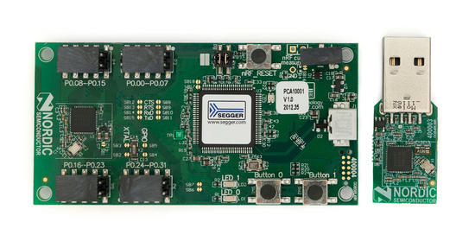

* Evaluation and initial prototyping solution for nRF51822 SoC
* Independent coin cell operation
* Full GPIO accessibility
* Segger J-link on board
* nRF518 SDK examples

[nrf51822DK]

When used in conjunction with the nRFgo Starter Kit, the nRF51822 Development Kit enables engineers to do full evaluation, prototyping and application development for *Bluetooth®*low energy and 2.4GHz proprietary applications. The platform provides a solid development environment for RF application development. This platform together with the nRF518 SDK enables extensive firmware development with the nRF51822 System-on-Chip (SoC).

The nRF51822 Development Kit includes nRF51822 modules that integrate all required external circuitry, including antenna match, 16MHz crystal, and 32.768kHz crystal. When plugged into the nRFgo Motherboard, the device I/O pins are easily accessible via the I/O port headers on the Motherboard. The kit also includes a compact nRF51822 USB dongle that can act as a *Bluetooth*low energy master emulator when developing *Bluetooth* low energy applications.

* nRFgo-compatible evaluation, prototyping, and firmware development solution for nRF51822 SoC
* Compact nRF51822 nRFgo module with PCB antennas
* Compact nRF51822 nRFgo module with SMA connector for use with external antennas or a closed loop set-up
* Compact nRF51822 USB dongle with on-board Segger J-link debugger
* Easy access to generic I/O pins with nRFgo Motherboard I/O port headers

