Assignment-1:

Q1:
Consider the following code snippet.

if (aNumber >= 0)
if (aNumber == 0)
System.out.println("first string");
else System.out.println("second string");
System.out.println("third string");

Q1.1. What output do you think the code will produce if aNumber is 3?
Answer: The output will be second string
third string
Q1.2. Write a test program containing the previous code snippet; make aNumber 3.
Answer:
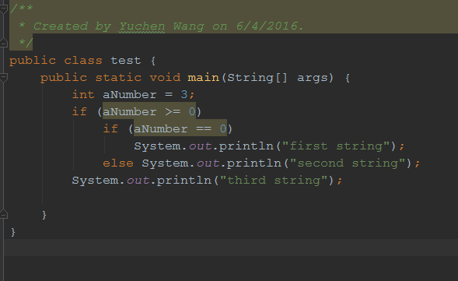
Q.1.3. What is the output of the program? Is it what you predicted?
Answer:
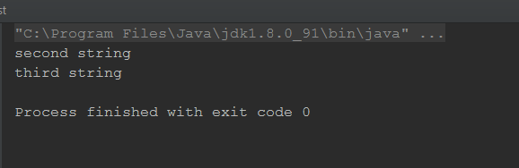
Yes, it is what I predicted.

Q2:
Define a home security system class that has three fields,
1. isDoorOpen: a Boolean to indicate whether the door is opened or not,
2. isArmed: a Boolean to indicate the state whether the system is turned on:
3. onDuration: a float or integer to indicate how long the system is to be turned on:
the value for the field can't be negative, here, the minimal of the value is 0 (which means 0 day), 0.1 means 0.1 days to be turned on.

Q2.1. Constructor:
define several different constructors, at least should have the following 3 constructors:
1. a default constructor without any parameter,
2. a constructor has one parameter with the initial state of the system as a parameter (such as turn-on time)
3. a constructor with multiple parameters for the above variables.
4. or other constructor you think reasonable

Q2.2. The class should have following methods:
1. a method to arm or disarm the whole system,
2. a method to check the current status of the door,
3. a method to set how long the system will be turned on
4. a method to return how long the system has been turned on.

Q2.3. if there is any variable missing, just add reasonable variables,
Answer:
Yes, 1. I want to add a new Boolean value named setArm, as the parameter pass to setSystemArmed method, if ture means arm the system, otherwise disarm the system.

2. I want to add two float value named initialTime and currentTime to keep record of the time stamp in order to calculate duration of the system turned on.

Q2.4. Also, write a main() function which can be used to test all the method.
Answer: I had included the main function in my submission.

Submission:
Submit to me as <student id>.zip file such as submit 88188.zip file to me.
inside it:
a. the zip file will include .java source file, as well as
b. a readme to include instructions about how to run/test the code;
c. a .log file to include the result of the code.

Example, if that my name is Jason Lee (student # = 012345), then the submitted file will be
012345.Jason.Lee.zip or 012345.zip.
Due date will be in one week.

