**VITABU MTAANI PROJECT.**

**OBJECTIVE.**

A project that aims at fostering a reading culture amongst the youth within the metropolitan areas of Nairobi

**DEFINE THE PROBLEM**

* Rise in negative behaviors amongst the youth due to lack of productive activities to engage in.
* Decrease in literacy levels among the people hence and indication that fewer people are able to read and write effectively.
* Decrease in the reading culture among the youth.
* Existing libraries are not keeping up with the digital age making them less appealing to the tech-savvy youths.
* Lack of sufficient libraries and bookstores making it difficult for residents to access books and educational materials.
* Lack of readily available infrastructure and resources to run mobile libraries (e.g. adequate vehicles, staffs and technology)
* Mobile libraries are facing safety and security issues including theft and vandalism.
* Lack of maintenance and sustainability of both mobile libraries and physical libraries, regular maintenance of vehicles and library materials is essential for long term sustainability.
* Lack of integration with educational institutions, coordination with educational institutions would maximize impact of mobile libraries.

**DEFINE THE SOLUTION.**

* Providing the youths with libraries will offer them a constructive way to spend their time encouraging reading and learning hence eliminating idleness and encouraging industriousness.
* Introducing mobile libraries will make books and reading materials accessible hence improving literacy levels across the community.
* Mobile libraries will also reignite the reading culture among the people by bringing books directly to where people live and gather.
* Incorporating digital resources e.g. e-books and online catalogs and modern management systems will make them attractive and relevant to today’s youth.
* Deploying a network of mobile libraries to regularly visit under severed areas ensuring consistent access to a variety of books and resources.
* One could seek funds and resource support from the government, private sectors and NGOs. Also encourage community members and students to volunteer helping in operating the libraries in their areas.
* Mobile libraries may be equipped with security systems such as GPS tracking, alarms and security personnel’s, local communities may also be engaged in protecting and valuing the mobile libraries fostering a sense of ownership and responsibility.
* Implementing a strict maintenance schedule for vehicles and equipments to prevent breakdowns and smooth operation.
* Develop programs in partnership with local schools e.g. Reading assignments and book clubs to integrate the mobile libraries into the educational system.

**THE CONCEPT (Conceptual Modeling)**

**Brainstorming session:**

* Library in every constituency
* Books in every library
* Books will be of different genres
* People who manage the library
* Users who use the library system
* Events being hold by the libraries
* Reports from the libraries

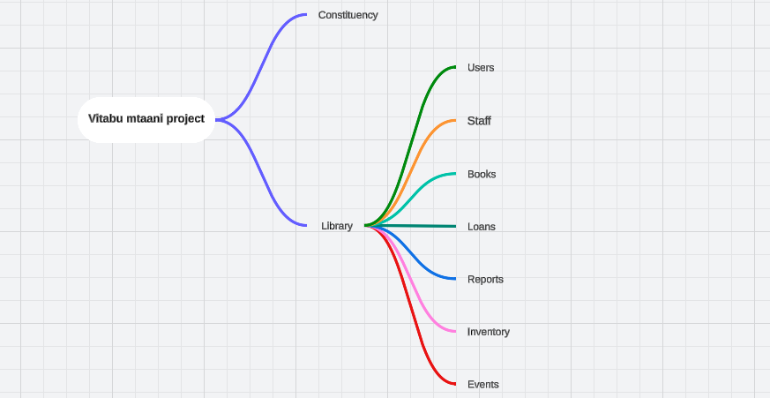

Fig 1. mind map

**Processes:**

**Identifying entities**

1. Visits

2. Visitors

3. Authors

4. Reports

5. Staffs

6. Libraries

7. Books

8. Genre

9. Location

10. Constituencies

13. Publisher

14. Vehicles

15. Loans

16. Events

17. Users

**Identifying the relationships.**

1. Visits

* A visitor can have one or many visits.
* A library can be visited many times.

2. Visitors

* One visitor can be associated with one user.
* One visitor can have many loans.
* One visitor can attend many events and one event can be attended by many visitors.

3. Authors

* One author can write many books, and one book can have many authors.

4. Reports

* One staff member can create many reports.
* One library can have many reports.

5. Staffs

* One library can have many staff members.

6. Libraries

* One library can have many books.
* One library can have many visits.
* One library can host many events.

7. Books

* One book can belong to one genre, but one genre can have many books.
* One book can have many authors, and one author can write many books.
* One book can have one publisher, but one publisher can publish many books.
* One book can be loaned out many times.

8. Genre

* One genre can have many books.

9. Location

* One location can have many libraries.

10. Constituencies

* One constituency can have many libraries.
* One constituency can have many locations.

11. Publisher

* One publisher can publish many books.

12. Vehicles

* One vehicle can be associated with many libraries, but one library can have one vehicle.

13. Loans

* One visitor can have multiple loans but each loan can involve one book.

14. Events

* One library can host many events.
* One event can have many visitors, and one visitor can attend many events.
* One event can have many vehicles, and one vehicle can be used for many events.

15. Users

* One user can be associated with one visitor.

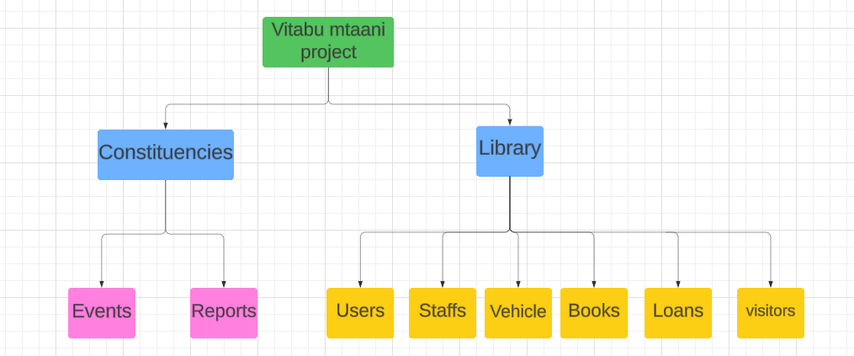

Fig 2. Conceptual model

Identified the main concepts and sub-concepts.

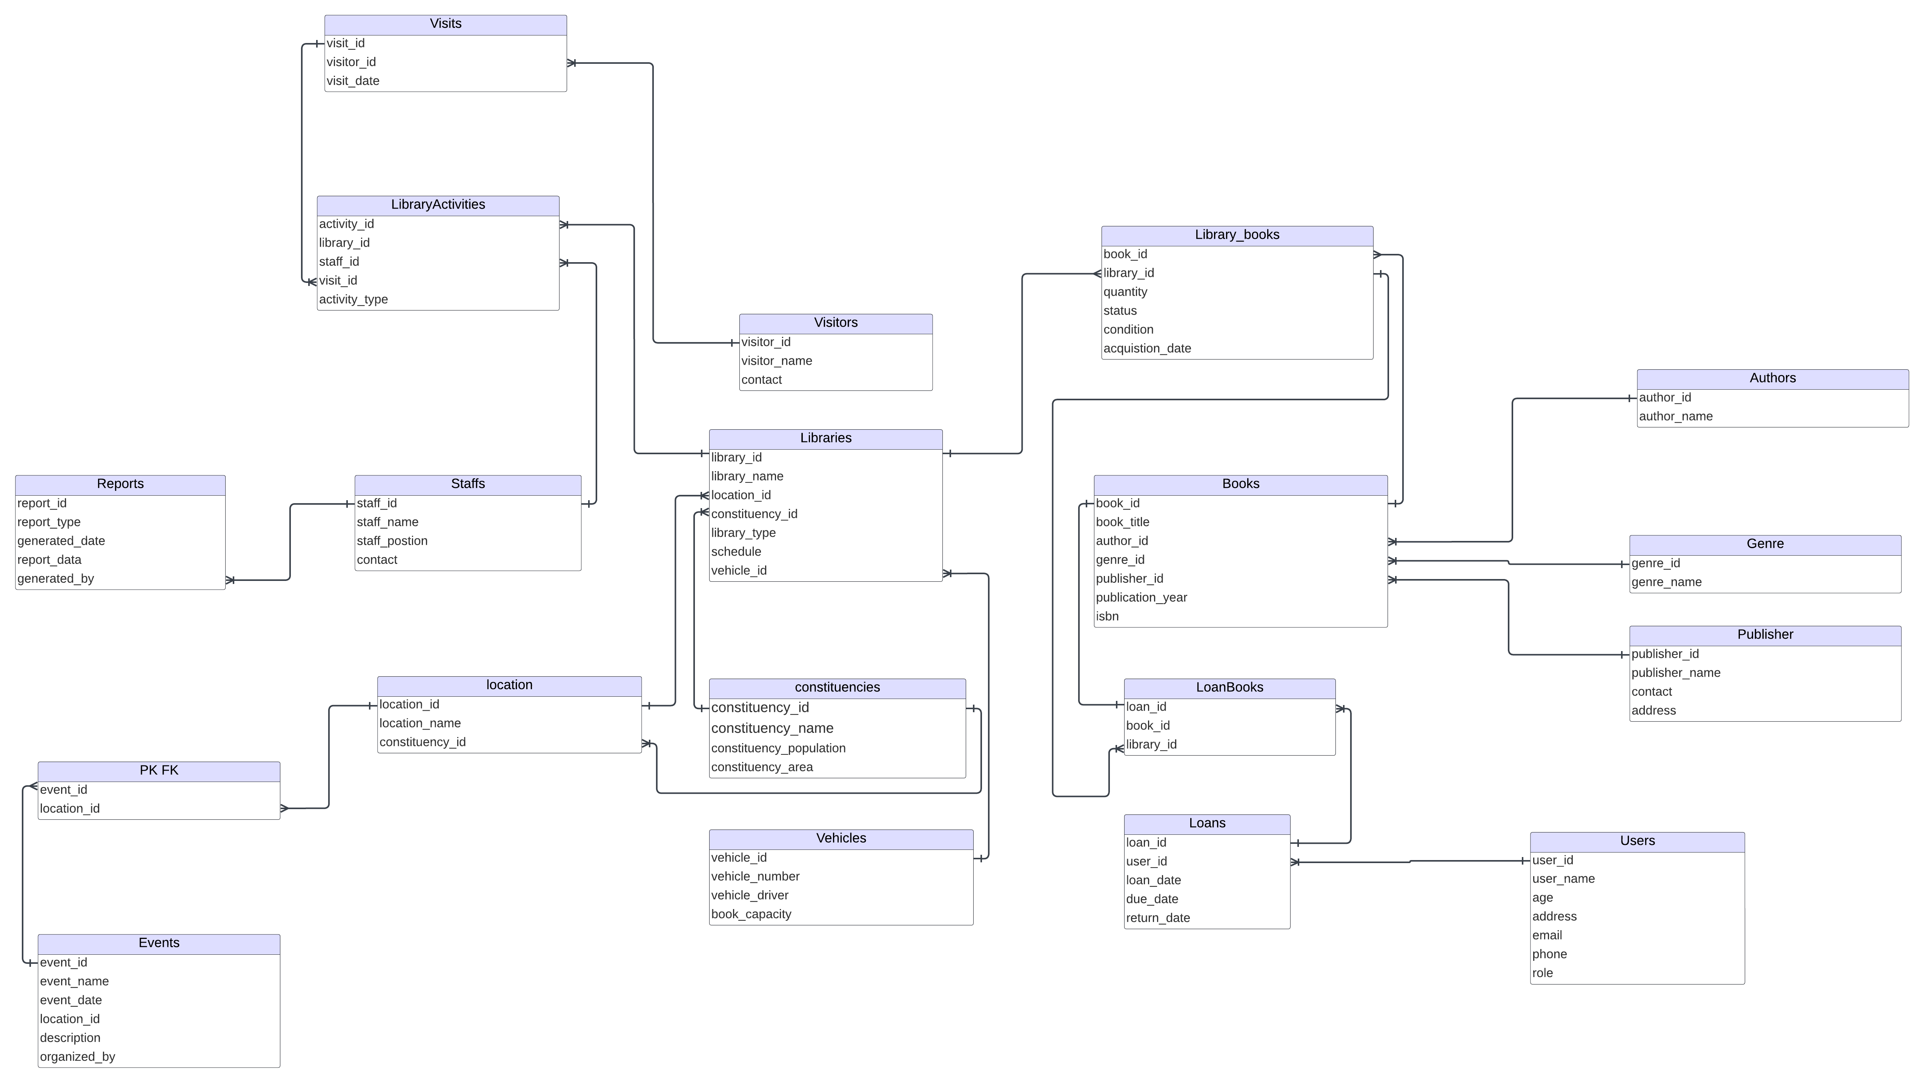

Fig 3. Logical model

Identified entities’ attributes

1. Visits

* visit_id (PK)
* visitor_id (FK)
* visit_date

2. LibraryActivities

* activity_id (PK)
* library_id (FK)
* staff_id (FK)
* visit_id (FK)
* activity_type

3. Visitors

* visitor_id (PK)
* visitor_name
* contact

5. Authors

* author_id (PK)
* author_name

6. Reports

* report_id (PK)
* report_type
* generated_date
* report_data
* generated_by (FK)

7. Staffs

* staff_id (PK)
* staff_name
* staff_position
* contact

8. Libraries

* library_id (PK)
* library_name
* location_id (FK)
* constituency_id (FK)
* library_type
* schedule
* vehicle_id (FK)

9. Books

* book_id (PK)
* book_title
* author_id (FK)
* genre_id (FK)
* publisher_id (FK)
* publication_year
* isbn

10. Genre

* genre_id (PK)
* genre_name

11. Location

* location_id (PK)
* location_name
* constituency_id (FK)

14. Constituencies

* constituency_id (PK)
* constituency_name
* constituency_population
* constituency_area

15. Publisher

* publisher_id (PK)
* publisher_name
* contact
* address

16. Vehicles

* vehicle_id (PK)
* vehicle_number
* vehicle_driver
* book_capacity

17. Loans

* loan_id (PK)
* user_id (FK)
* loan_date
* due_date
* return_date

18. Events

* event_id (PK)
* event_name
* event_date
* location_id (FK)
* description
* organized_by (FK)

19. Users

* user_id (PK)
* user_name
* age
* address
* email
* phone
* role

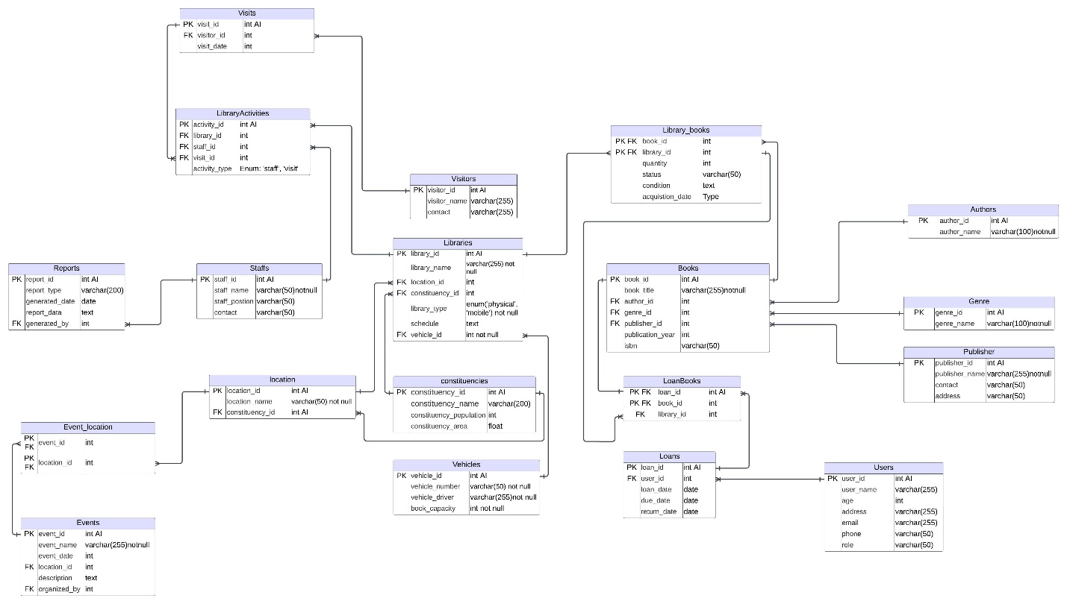

Fig 4. Physical model

* Defined attribute’s specific data types.
* Identified many to many relationships and implemented junction tables.

They include:

1. Library_books
2. Library_activities
3. Loan_books
4. Event_location

Their relationships with the other tables:

* A book can be available in multiple libraries, and a library can have multiple books.
* A visitor can participate in multiple activities at multiple libraries, and a library can host multiple visitors engaging in different activities.
* A loan can include multiple books, and a book can be included in multiple loans over time.
* An event can be held at multiple locations, and a location can host multiple events.
* Created database constraints, indices, triggers and other database specific objects.

Below are the SQL queries for creating the database schema:

--created constituencies table and added its attributes.

**CREATE** **TABLE** **IF** **NOT** **EXISTS** constituencies_tbl (

constituency_id **INTEGER** **PRIMARY** **KEY** AUTOINCREMENT,

constituency_name **VARCHAR**(200) **NOT** **NULL**,

constituency_population **INTEGER**,

constituency_area **FLOAT**

);

--created libraries table and added its attributes.

**CREATE** **TABLE** **IF** **NOT** **EXISTS** libraries_tbl (

library_id **INTEGER** **PRIMARY** **KEY** AUTOINCREMENT,

library_name **VARCHAR**(200) **NOT** **NULL** **UNIQUE**,

location_id **INTEGER**,

constituency_id **INTEGER**,

library_type TEXT **CHECK**(library_type **IN** (**'physical'**, **'mobile'**)) **NOT** **NULL**,

schedule TEXT,

vehicle_id **INTEGER**,

**FOREIGN** **KEY**(location_id) **REFERENCES** locations_tbl(location_id),

**FOREIGN** **KEY**(vehicle_id) **REFERENCES** vehicles_tbl(vehicle_id),

**FOREIGN** **KEY**(constituency_id) **REFERENCES** constituencies_tbl(constituency_id)

);

--created events table and added its attributes.

**CREATE** **TABLE** **IF** **NOT** **EXISTS** events_tbl (

event_id **INTEGER** **PRIMARY** **KEY** AUTOINCREMENT,

event_name **VARCHAR**(100) **NOT** **NULL**,

event_date **DATE** **NOT** **NULL**,

event_time **TIME** **NOT** **NULL**,

location **VARCHAR**(100) **NOT** **NULL**,

description TEXT,

organized_by **INTEGER**,

**FOREIGN** **KEY**(organized_by) **REFERENCES** staff_tbl(staff_id)

**FOREIGN** **KEY**(location)**REFERENCES** locations_tbl(location_name)

);

--created event_locations table and added its attributes.

**CREATE** **TABLE** **IF** **NOT** **EXISTS** event_location_tbl(

event_id **INTEGER** ,

location_id **INTEGER**,

**PRIMARY** **KEY**(event_id,location_id),

**FOREIGN** **KEY**(event_id) **REFERENCES** events_tbl(event_id),

**FOREIGN** **KEY**(location_id) **REFERENCES** locations_tbl(location_id)

);

--created users table and added its attributes.

**CREATE** **TABLE** **IF** **NOT** **EXISTS** users_tbl (

user_id **INTEGER** **PRIMARY** **KEY** AUTOINCREMENT,

user_name **VARCHAR**(200) **NOT** **NULL**,

age **INTEGER**,

address **VARCHAR**(200),

email **VARCHAR**(255),

phone **VARCHAR**(50),

user_role TEXT **CHECK**(user_role **IN** (**'visitor'**, **'staff'**, **'volunteer'**, **'admin'**)) **NOT** **NULL**

);

--created loans table and added its attributes.

**CREATE** **TABLE** **IF** **NOT** **EXISTS** loans_tbl (

loan_id **INTEGER** **PRIMARY** **KEY** AUTOINCREMENT,

user_id **INTEGER**,

loan_date **DATE**,

due_date **DATE**,

return_date **DATE**,

**FOREIGN** **KEY**(user_id) **REFERENCES** users_tbl(user_id)

);

--created loan_books table and added its attributes.

**CREATE** **TABLE** **IF** **NOT** **EXISTS** loan_books_tbl(

loan_id **INTEGER**,

book_id **INTEGER**,

library_id **INTEGER**,

**PRIMARY** **KEY**(loan_id,book_id),

**FOREIGN** **KEY**(library_id) **REFERENCES** libraries_tbl(library_id)

);

--created books table and added its attributes.

**CREATE** **TABLE** **IF** **NOT** **EXISTS** books_tbl (

book_id **INTEGER** **PRIMARY** **KEY** AUTOINCREMENT,

book_title **VARCHAR**(200) **NOT** **NULL**,

author_id **INTEGER**,

genre_id **INTEGER**,

publisher_id **INTEGER**,

publication_year **INTEGER**,

isbn **VARCHAR**(50),

**FOREIGN** **KEY**(author_id) **REFERENCES** authors_tbl(author_id),

**FOREIGN** **KEY**(genre_id) **REFERENCES** genres_tbl(genre_id),

**FOREIGN** **KEY**(publisher_id) **REFERENCES** publishers_tbl(publisher_id)

);

--created library_books table and added its attributes.

**CREATE** **TABLE** **IF** **NOT** **EXISTS** library_books_tbl (

book_id **INTEGER**,

library_id **INTEGER**,

quantity **INTEGER**,

status **VARCHAR**(50),

book_condition TEXT,

acquistion_date **DATE**,

**PRIMARY** **KEY** (book_id,library_id),

**FOREIGN** **KEY**(book_id) **REFERENCES** books_tbl(book_id),

**FOREIGN** **KEY**(library_id) **REFERENCES** libraries_tbl(library_id)

);

--created publishers table and added its attributes.

**CREATE** **TABLE** **IF** **NOT** **EXISTS** publishers_tbl (

publisher_id **INTEGER** **PRIMARY** **KEY** AUTOINCREMENT,

publisher_name **VARCHAR**(255) **NOT** **NULL**,

contact **VARCHAR**(50),

address **VARCHAR**(50)

);

--created genres table and added its attributes.

**CREATE** **TABLE** **IF** **NOT** **EXISTS** genres_tbl (

genre_id **INTEGER** **PRIMARY** **KEY** AUTOINCREMENT,

genre_name **VARCHAR**(255) **NOT** **NULL**

);

--created visitors table and added its attributes.

**CREATE** **TABLE** **IF** **NOT** **EXISTS** visitors_tbl (

visitor_id **INTEGER** **PRIMARY** **KEY** AUTOINCREMENT,

visitor_name **VARCHAR**(255) **NOT** **NULL**,

contact **VARCHAR**(50)

);

--created staffs table and added its attributes.

**CREATE** **TABLE** **IF** **NOT** **EXISTS** staffs_tbl (

staff_id **INTEGER** **PRIMARY** **KEY** AUTOINCREMENT,

staff_name **VARCHAR**(255) **NOT** **NULL**,

staff_position **VARCHAR**(50),

contact **VARCHAR**(50)

);

--created reports table and added its attributes.

**CREATE** **TABLE** **IF** **NOT** **EXISTS** reports_tbl (

report_id **INTEGER** **PRIMARY** **KEY** AUTOINCREMENT,

report_type **VARCHAR**(100) **NOT** **NULL**,

generated_date **DATE** **NOT** **NULL**,

report_data TEXT,

generated_by **INTEGER**,

**FOREIGN** **KEY**(generated_by) **REFERENCES** staff_tbl(staff_id)

);

--created libraryactivities table and added its attributes.

**CREATE** **TABLE** **IF** **NOT** **EXISTS** libraryactivities_tbl(

activity_id **INTEGER** **PRIMARY** **KEY** AUTOINCREMENT,

library_id **INTEGER**,

staff_id **INTEGER**,

visit_id **INTEGER**,

activity_type TEXT **CHECK**(activity_type **IN** (**'staff'**,**'visit'**)) **NOT** **NULL**,

**FOREIGN** **KEY**(library_id)**REFERENCES** libraries_tbl(library_id),

**FOREIGN** **KEY**(staff_id)**REFERENCES** staff_tbl(staff_id),

**FOREIGN** **KEY**(visit_id)**REFERENCES** visits_tbl(visit_id)

);

--created vehicles table and added its attributes.

**CREATE** **TABLE** **IF** **NOT** **EXISTS** vehicles_tbl (

vehicle_id **INTEGER** **PRIMARY** **KEY** AUTOINCREMENT,

vehicle_number **VARCHAR**(255) **NOT** **NULL**,

vehicle_driver **VARCHAR**(255) **NOT** **NULL**,

book_capacity **INTEGER** **NOT** **NULL**

);

--created locations table and added its attributes.

**CREATE** **TABLE** **IF** **NOT** **EXISTS** locations_tbl (

location_id **INTEGER** **PRIMARY** **KEY** AUTOINCREMENT,

location_name **VARCHAR**(255) ,

constituency_id **INTEGER**,

**FOREIGN** **KEY**(constituency_id) **REFERENCES** constituencies_tbl(constituency_id)

);

--created visits table and added its attributes.

**CREATE** **TABLE** **IF** **NOT** **EXISTS** visits_tbl (

visit_id **INTEGER** **PRIMARY** **KEY** AUTOINCREMENT,

visitor_id **INTEGER**,

visit_date **DATE**,

**FOREIGN** **KEY**(visitor_id) **REFERENCES** visitors_tbl(visitor_id)

);

--created authors table and added its attributes.

**CREATE** **TABLE** **IF** **NOT** **EXISTS** authors_tbl(

author_id **INTEGER** **PRIMARY** **KEY** AUTOINCREMENT,

author_name **VARCHAR**(255)

);

**COST AND IMPLEMENTATION MATRIX**

