## Introduction

A regional real estate company is interested in designing an advertisement for their business. The initial draft of the advertisement states that the average price of house is $ 280 per square foot in the pacific region. One of the sales persons raises a claim that the average cost of house per square foot is less than $ 280. This analysis provides insights on whether the actual price is less than $ 280 or not. A random sample of 750 to be used in this analysis was generated in excel using the (=Rand) formula.

## Hypothesis Test Setup

Population parameters is the average cost of houses per square feet in the pacific region.

The null hypothesis: The average cost of houses per square feet in the pacific region is $ 280.

Ho : µ = $ 280

The alternative hypothesis: The average cost of houses per square feet in the pacific region is less than $ 280.

H1: µ < $ 280

This is one sample t-test and it is a left tailed test.

**Data Analysis Preparations**

The sample size is 750 houses.

The table below shows summary statistics of the variable average cost per square foot

|  |  |
| --- | --- |
| Summary Stat. for Cost per Square foot | |
| Mean | 265.4505 |
| Median | 205.6805 |
| Standard deviation | 158.9931 |

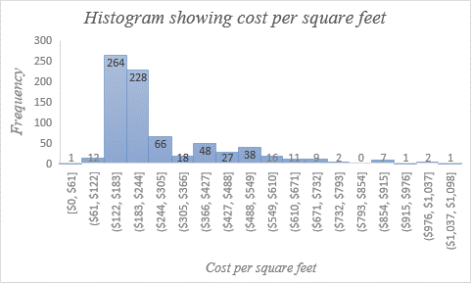

The data is right-skewed, most of the values range between $122 to $224. The center of the data is between $ 366 and $ 427. The sample size is large enough and appropriate for t-test to be conducted. The sample data was selected through random sampling, this further confirms t-test is appropriate for this test. The significance level for this test is .05.

## Calculations

The sample mean is 265.5, the standard error is 5.8. The appropriate test is one sample t-test

$$Test statistic=\frac{265.5-280}{5.8}$$

=-2.5

As per excel calculations the p value will be 0.006316051.

The test statistic falls on the left tail of the t-distribution curve. The p-value represents the area under the curve to the left of -2.5.

## Test Decision

## The p-value is 0.0063, the significance level is .05. Since the p-value is less than the

## significance level reject the null hypothesis.

## Conclusion

From the analysis conducted there is sufficient evidence to conclude that the average cost of houses per square feet in the pacific region is less than $ 280. The sales person claim that the average cost is less than $ 280 is now confirmed to be valid. The advertisement plan can therefore altered to conform with the sales person claim. The results of this analysis are statistically significant because a larger sample size was used in analysis.