Air-Pollution Inequality Across London, United Kingdom: Spatial Differences in PM2.5 Exposure among Socioeconomically Different Urban Environments

Research Questions
RQ1. How did annual mean PM2.5 exposure vary spatially across London LSOAs in 2019, and did statistically significant spatial clusters occur?
RQ2. Did annual mean PM2.5 exposure differ systematically across socioeconomic deprivation levels after population distribution was considered?
RQ3. Did the deprivation-exposure association persist after spatial dependence was addressed, and how well did LAEI 2019 modeled concentrations agree with independent UK-AIR PM2.5 observations?

CHAPTER THREE: METHODOLOGY
The design used by this study was cross-sectional ecological that excellently examined spatial inequality in annual mean fine-particulate matter exposure across Greater London in 2019. The 2011 Lower-layer Super Output Area (LSOA) was the preferred analytical unit due to its ability to provide a stable neighbourhood geography for linking modeled pollution, deprivation, population, and spatial boundaries. This design selection majored on the research question about unequal environmental exposure between neighbourhoods instead of individual dose. Similarly, fine-resolution pollution estimates could be used while retaining a socioeconomic unit with sufficient population needed in comparative analysis. Python was the preferred software for this analysis due to its flexible data acquisition, flexible statistical modeling, and figure export, enabling reproducibility.
Five datasets were integrated. The London Atmospheric Emissions Inventory 2019 (LAEI 2019) dataset remained crucial for extracting annual mean PM2.5 concentrations reflected by the Greater London Authority and Transport for London. Modeling of the ground-level PM2.5 using the concentration product was at 20 m resolution across Greater London. Besides, English Indices of Deprivation 2019 dataset was used to extract socioeconomic conditions ensuring that retaining of the Index of Multiple Deprivation score, rank, and national decile for each LSOA was possible. The Office for National Statistics mid-2019 LSOA population estimates managed to the key population denominators. Spatial geometry came from the 2011 London LSOA boundary dataset. Independent observed PM2.5 measurements were obtained from the UK-AIR Automatic Urban and Rural Network for London Marylebone Road, London Harlington, London Teddington Bushy Park, London Bloomsbury, and London Honor Oak Park. The model validation was achieved through using monitoring sites representing traffic, industrial, and urban-background environments.
The datasets were selected as a controlled multi-dataset integration because each supplied a distinct analytical function required by the research questions. LAEI 2019 supplied the fine-resolution exposure surface, IMD 2019 supplied the socioeconomic measure, ONS population estimates supplied the population denominator for distributional weighting, London LSOA boundaries supplied the common spatial framework, and UK-AIR supplied independent observations for validation. The selection was therefore driven by complementarity at the LSOA level rather than by an attempt to combine incompatible exposure estimates into a pooled effect. The UK-AIR sites were retained separately because point observations and LSOA-level modeled concentrations represented different spatial units.
Table 3.1: Datasets used in the multi-dataset analysis
Dataset | Spatial/temporal unit | Variables retained | Analytical role
LAEI 2019 Concentrations | 20 m grid, 2019 | Annual mean PM2.5 (µg/m3) | Primary exposure surface
English Indices of Deprivation 2019 | LSOA, 2019 | IMD score, rank, decile | Socioeconomic inequality
ONS Mid-2019 LSOA Population | LSOA, 2019 | Usual resident population | Population weighting/context
London 2011 LSOA Boundaries | LSOA polygons | LSOA code and geometry | Spatial join, mapping, weights
UK-AIR 2019 | Hourly monitoring sites | Observed PM2.5, data capture | Independent validation

All spatial layers were transformed to British National Grid, EPSG:27700, before spatial operations. The LAEI concentration archive was read in chunks to limit memory demand during data accass and the grid-point coordinates were converted to point geometry and spatially joined to LSOA polygons. The arithmentic mean for all 20 m LAEI cells whose centroids fell within the polygon was calculated using the annual mean PM2.5 for every LSOA.
IMD 2019 and the resulting exposure table were joined together using the LSOA code and the combination was also joined to the mid-2019 population estimates. Duplicate identifiers, unmatched records, missing exposure values, and invalid population values were checked before analysis. Records lacking the variables required for a specific test were excluded only from that test rather than from the complete analytical dataset.
Three research questions structured the analysis. The first assessed the spatial distribution and clustering of annual mean PM2.5 exposure across London LSOAs. The second tested whether PM2.5 exposure differed systematically across socioeconomic deprivation levels after population distribution had been considered. The third tested whether the deprivation-exposure relationship remained after spatial dependence was addressed and whether modeled LAEI concentrations agreed with independent monitoring observations. This sequence linked description, inequality testing, spatial modeling, and validation instead of treating a deprivation gradient as sufficient evidence on its own.
Based on the first research question maximum, minimum, standard debiation, interquartile range, and median were calculated together with unweighted and population-weigheted London-wide PM2.5 means. A choropleth map displayed LSOA-level exposure. Spatial autocorrelation was assessed with Global Moran's I using first-order Queen contiguity weights and 9,999 permutations. Local Moran's I was then used to classify statistically significant high-high, low-low, high-low, and low-high clusters at p < .05. A sensitivity analysis repeated Global Moran's I using eight-nearest-neighbour weights. These procedures followed established spatial epidemiological practice in which global statistics identified overall clustering and local indicators located the neighbourhoods contributing to that pattern (Anselin, 1995).
For the second research question, deprivation was examined in two forms. IMD deciles provided an interpretable grouped comparison from decile 1, the most deprived, to decile 10, the least deprived. Continuous IMD score and rank reduced dependence on arbitrary group boundaries. Population-weighted PM2.5 was calculated within each deprivation decile by weighting LSOA exposure by the corresponding mid-year population. The most deprived and least deprived deciles were compared using an absolute exposure difference, exposure ratio, Welch's independent-samples t test, and Mann-Whitney U test. Spearman's rank correlation assessed monotonic association between PM2.5 and continuous deprivation measures. Effect size, direction, and uncertainty were interpreted together because a small association could become statistically significant in a dataset containing several thousand neighbourhoods.
For the third research question, ordinary least squares regression estimated the association between annual mean PM2.5 and IMD score while adjusting for the logarithm of LSOA population as a density-related contextual control. Heteroskedasticity-consistent HC3 standard errors were used. Moran's I was calculated for the OLS residuals. Where residual spatial dependence remained, maximum-likelihood spatial-lag and spatial-error models were estimated with the same covariates. Model coefficients, spatial parameters, log likelihood, and information criteria were compared to determine whether the deprivation association was sensitive to spatial specification. The models were interpreted as ecological associations and were not treated as individual-level or causal effects.
UK-AIR hourly PM2.5 observations for 2019 were cleaned by converting nonnumeric values to missing data and calculating annual site means only after data capture had been quantified. LAEI concentration values were extracted at the nearest 20 m grid location to each station. Agreement between observed and modeled annual means was summarised using mean bias, mean absolute error, root mean square error, and Pearson correlation when sufficient stations were available. Validation metrics were also recalculated after excluding the Marylebone Road traffic site because roadside microenvironments could differ sharply from urban-background conditions. This sensitivity check prevented one extreme traffic environment from dominating interpretation of citywide model performance. Python 3 was used with pandas and NumPy for data handling, GeoPandas and Pyogrio for spatial operations, Matplotlib for figures, SciPy and Statsmodels for statistical tests and regression, and libpysal, esda, and spreg for spatial weights, Moran statistics, and spatial regression.
CHAPTER FOUR: ANALYSIS AND DISCUSSION
The analysis brought together five main datasets: the 2019 LAEI PM2.5 concentration surface, the 2019 Index of Multiple Deprivation, mid-2019 LSOA population estimates, London LSOA boundary data, and 2019 UK-AIR monitoring observations. The first four datasets were combined at the LSOA level to create the main dataset used to examine environmental inequality across London. The UK-AIR monitoring observations were kept separate from this merged dataset and were later used to check how closely the modelled PM2.5 concentrations reflected observed conditions.This structure prevented station observations from being treated as neighbourhood exposures and kept the modeled and observed evidence conceptually distinct.
Table 4.1 below summarised the basic exposure distribution after the 20 m LAEI grid had been aggregated to LSOAs. To ensure the most important values had been considered, measuring interquartile range, mean, observed range, and means for both unweighted LSOA and populated-weighted were prioritised. Table 4.1 showed unweighted mean, 5.054 µg/m3, and population mean, 5.165 µg/m3. Their difference showed whether London residents were concentrated in LSOAs with systematically higher or lower modeled PM2.5 than a simple neighbourhood average implied. 4.343 µg/m3 was the mean and 2.227 µg/m3 was the interquartile describing the central spreading to avoid summary dominating by a small number of highly populated locations. The minimum LSOA mean, 1.522, and the maximum LSOA mean, 43.381 µg/m3 were shown in the same Table 4.1. These statistics established the citywide exposure context before socioeconomic differences were tested.
Table 4.1: Descriptive PM2.5 exposure statistics generated from the merged LSOA dataset
Metric | Value
Complete LSOAs | 4,835
Unweighted mean PM2.5 | 5.054 µg/m3
Population-weighted mean PM2.5 | 5.165 µg/m3
Median PM2.5 | 4.343 µg/m3
Interquartile range | 2.227 µg/m3
Minimum / Maximum | 1.522 / 43.381 µg/m3
Global Moran's I | 0.7413, p = 0.0001

Figure 4.1 below represents the mapped annual mean PM2.5 across London LSOAs. The map was interpreted as a spatial exposure surface rather than a map of individual dose. A reflection of the combined influence of transport corridors, central urban activity, local combustion sources, dispersion conditions, and regional background pollution was expected in areas with higher modeled concentrations as represented within the LAEI modeling system. Therefore, the figure below provided geographical context even though it did not identify causal sources. Considering the previous London research, residential ambient exposure, commuting exposure, and personal exposure could produce different inequality patterns even when they referred to the same pollutant making the above distinction matter (Rivas et al., 2017; Tonne et al., 2018).
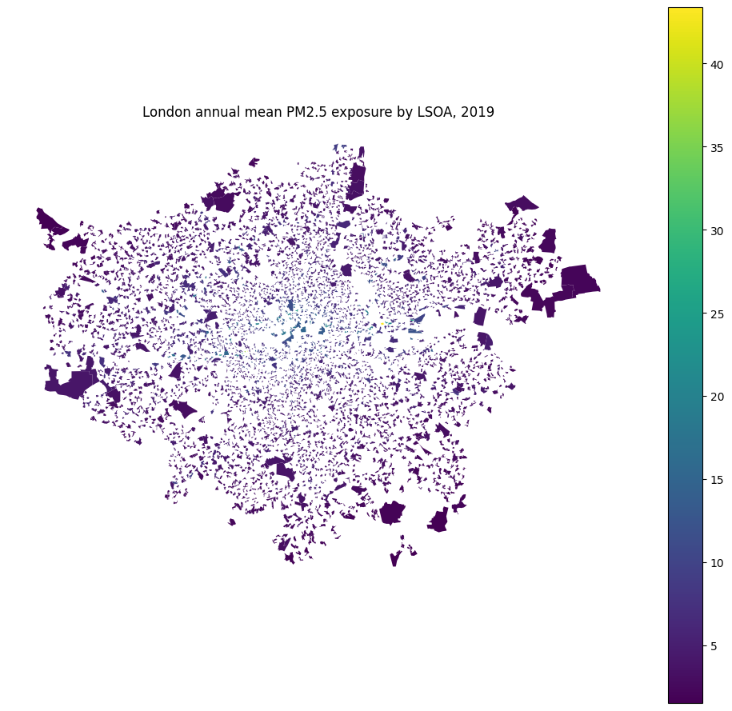
Figure 4.1: Annual mean PM2.5 exposed by London LSOA, 2019
A formal test of whether similar LSOA concentrations were spatially clustered was achieved using Global Moran's I. 0.7413 was the calculated statistic where 0.0001 was the permitation value. Existence of a positive and statistically significant value would have shown that high-exposure neighbourhoods had a tendency of occurring near other high-exposure neighbourhoods and low-exposure neighbourhoods near other low-exposure neighbourhoods. A nonsignificant value would instead have indicated that the mapped pattern contained little global spatial structure at the selected neighbourhood definition. The eight-nearest-neighbour sensitivity statistic was 0.5611, allowing the conclusion to be checked against a second spatial-weight specification. Agreement between Queen contiguity and nearest-neighbour results would strengthen confidence that clustering was not an artifact of one adjacency rule.
Local Moran analysis refined the global result by identifying significant high-high, low-low, high-low, and low-high LSOA clusters. Figure 4.2 displayed these classes after 9,999 permutations and a p < .05 decision rule. High-high areas were especially important for the inequality question because they represented neighbourhoods with high PM2.5 embedded within similarly high-exposure surroundings. Such clusters indicated broader spatial environments rather than isolated grid-cell anomalies. Low-low clusters represented comparatively cleaner spatial contexts, while spatial outliers identified local departures from surrounding conditions. Across all the LSOA categories, 145 high-high, 196 low-low, 0 high-low, and 7 low-high was the number of significant. The above results answered the spatial component of Research Question 1 directly.
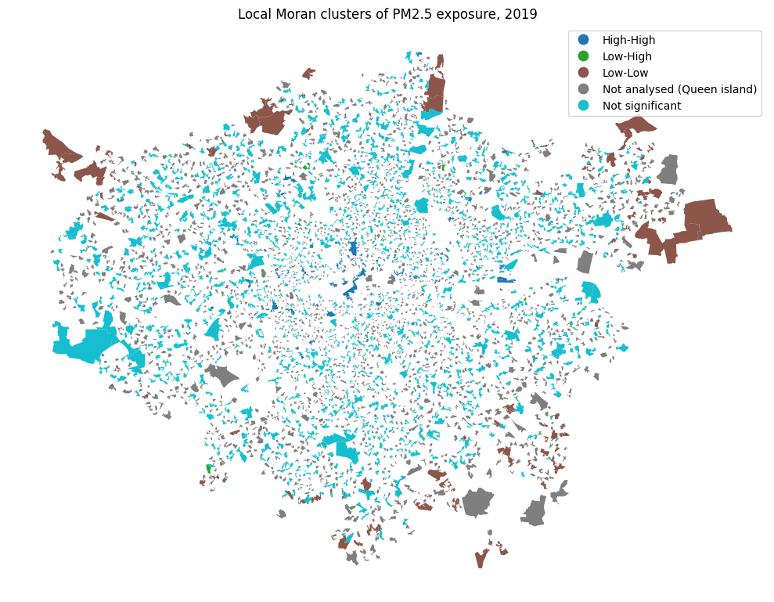
Figure 4.2: Local Moran clusters of PM2.5 exposure across London LSOAs, 2019
The first research question was therefore assessed through both distribution and spatial dependence. It was considered achieved when the analysis quantified the citywide exposure distribution, mapped LSOA differences, and tested whether the pattern was spatially structured. It was not only showing that air pollution was different across London because this had already been documented showing such a distinction pattern. Due to that, this study focused on LAEI 2019 20 m concentration product. It also considered the aggregated the exposure estimates to a socioeconomic neighbourhood scale and ended up testing the possibility of the air pollution differing pattern that showed local spatial clustering. As per Gohlke et al. (2023), it is a fact that studies about air-pollution inequality remained more informative once place-based evidence at a fine spatial scale because broad averages had the possibility of masking areas having residents who experienced higher pollution burdens. Due to this fact, detailed information about exposure to air pollution was preserved in the analysis until it was aggregated to the LSOA level. The other thing was examining whether concentrations built spatial clusters across London rather than drawing conclusions from citywide averages alone.
The second research question examined the possibility of PM2.5 exposure differring as per the socioeconomic deprivation. Table 4.2 distinctively showed both unweighted and population-weighted PM2.5 concentrations for all IMD deciles with decile 1 representing the most deprived areas nationally unlike decile 10 that represented the least deprived. The estimates of population-weighted were given a greater emphasis since it reflected the average modelled exposure of residents within each deprivation group. It is clear from this finding that the estimate contributions largely came from LSOAs having larger populations unlike LSOAs with less population. The population-weighted mean PM2.5 concentration was arranged from the highest deprived decile to the least deprived decile with 5.793 µg/m3 leading and 3.580 µg/m3 being the last. 2.213 µg/m3 was the difference between the first and the last with a corresponding exposure ratio of 1.618. These two measures captured different aspects of inequality: the gap described the additional concentration in physical units, while the ratio described proportional excess.

Table 4.2: PM2.5 exposure by Index of Multiple Deprivation decile
IMD decile | Number of LSOAs | Population | Unweighted mean PM2.5 | Population-weighted mean PM2.5 | Median PM2.5
1 | 107 | 183,727 | 5.900 | 5.793 | 5.330
2 | 688 | 1,276,188 | 5.916 | 6.004 | 5.114
3 | 811 | 1,615,929 | 5.526 | 5.603 | 4.930
4 | 661 | 1,290,596 | 5.376 | 5.481 | 4.719
5 | 559 | 1,061,353 | 4.996 | 5.055 | 4.285
6 | 532 | 985,705 | 5.021 | 5.126 | 4.245
7 | 438 | 787,966 | 4.501 | 4.594 | 3.916
8 | 413 | 720,774 | 4.599 | 4.712 | 3.902
9 | 407 | 683,676 | 3.913 | 3.993 | 3.503
10 | 219 | 356,075 | 3.528 | 3.580 | 3.182

The pattern across all ten deciles was more informative than the two extreme groups alone. Figure 4.3 reflected that PM2.5 concentrations had been distributed across LSOAs among the deprivation deciles, while Figure 4.4 showed changes in the population-weighted mean exposure in ascending order. A broadly monotonic decline toward less deprived groups would have supported a socioeconomic gradient rather than an isolated difference between two categories. Conversely, overlap or nonmonotonicity would have indicated that deprivation explained only part of London's spatial exposure structure. The continuous IMD tests were therefore used to avoid making the conclusion depend on the boundaries of decile categories.
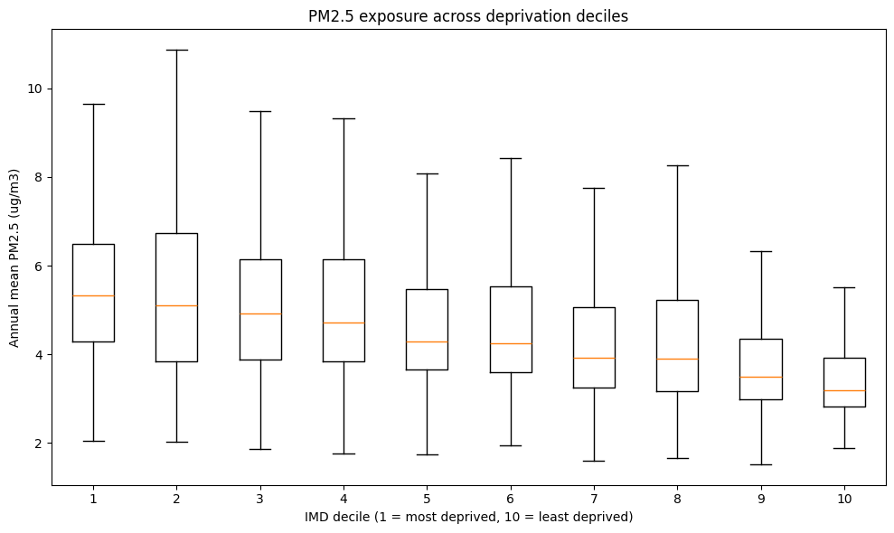
Figure 4.3: Distribution of annual mean PM2.5 across IMD deciles
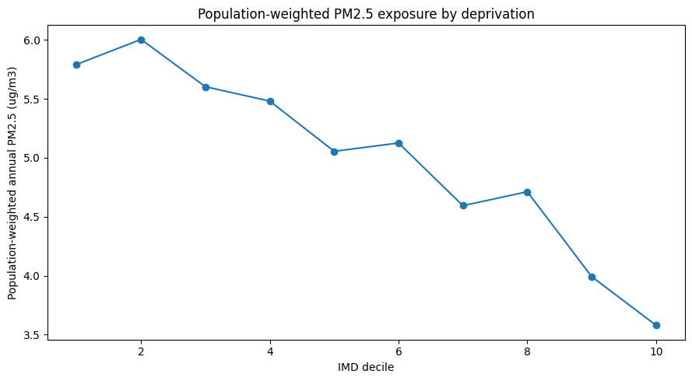
Figure 4.4: The annual mean PM2.5 for Population-weighted by IMD decile
The 0.3274 represented the correlation between IMD score and PM2.5 when p = <0.0001. Also, -0.3274 was the correlation with IMD rank when p was <0.0001. The expectation was that the two correlations had to show opposite directions when describing a similar pattern since a higher IMD score indicated greater deprivation unlike a higher national rank that indicated less deprivation. Consistency between them would have strengthened construct validity. The analysis emphasized coefficient magnitude as well as significance. With several thousand LSOAs, a weak association could reach a small p value without representing a large environmental difference. This interpretation followed the broader environmental-inequality literature, in which scale, socioeconomic measure, and exposure definition materially influenced estimated gradients (Goodman et al., 2011).
The most- versus least-deprived comparison provided an additional robustness test. Welch's t test produced 7.436, $p =$<0.0001, and the Mann-Whitney U test produced 20039.000, $p =$<0.0001. Agreement between the parametric and rank-based tests would indicate that the conclusion did not depend strongly on equal variance or normality assumptions. Divergence would require greater attention to skewness, outliers, and the full distributions shown in Figure 4.3. Therefore the study avoided reducing environmental inequality to a single p value. The size of the exposure gap, the population-weighted gradient, the continuous association, and the spatial distribution needed to point in a coherent direction before the second research question was judged substantively supported.
These analyses also improved on earlier London work in a specific way. Goodman et al. (2011) demonstrated that socioeconomic inequalities in traffic-related air pollution varied with the marker and spatial scale used. Tonne et al. (2018) later showed that residential and personal exposure inequalities were related but not interchangeable, and Ferguson et al. (2023) identified socioeconomic differences in modeled personal PM2.5 exposure among school-aged children. The present study did not claim to supersede those exposure constructs. Instead, it isolated one clearly defined outcome: neighborhood-level annual ambient PM2.5 modeled by the final LAEI 2019 system. Both grouped and continuous deprivation measures were used in testing the outcome. Then population weighting was added leading to risk reduction of having sparsely and densely populated LSOAs exerting the same descriptive influence.
Research Question 2 was achieved whenever analysis established possibility of a deprivation gradient existing, magnitude being quantified, and if the conclusion remained consistent across comparisions sucha as grouped, continuous, weighted, and distribution-free. If the most deprived decile experienced higher PM2.5 and the continuous tests pointed in the same direction, the study would provide evidence of unequal ambient exposure at neighbourhood level. If the gradient was weak or inconsistent, the correct conclusion would be that deprivation alone did not organize 2019 PM2.5 exposure strongly across London. Either result would remain publishable because the study's contribution lay in testing the relationship with a fine-resolution exposure surface and spatially explicit methods rather than assuming inequality in advance.
The third research question examined whether the deprivation association remained after spatial dependence was considered. Table 4.3 reported the OLS model with PM2.5 as the outcome and IMD score as the principal explanatory variable, with log population included as a contextual control. The IMD coefficient was 0.0578 µg/m3 per unit increase in score, with a 95% confidence interval of 0.0477 to 0.0679 and $p =$<0.0001. The model R2 was 0.0831. These values described an ecological association and were not interpreted as the effect of changing an individual's socioeconomic circumstances. The role of the OLS model was to provide a transparent baseline against which spatial specifications could be compared.

Table 4.3: OLS and spatial-regression estimates for the PM2.5-deprivation association
Model | IMD coefficient | Spatial parameter | Model fit / diagnostic
OLS with HC3 SE | 0.0578 | Not applicable | R2 = 0.0831; residual Moran = 0.7028
Spatial lag | 0.0339 | rho = 0.4755 | AIC = 11359.79
Spatial error | 0.0411 | lambda = 0.4776 | AIC = 11396.49

0.7028 represented residual Moran's I when p = 0.0001. Having standard regression left geographically patterned information unexplained and inadequate OLS independence assumptions could be shown by a siginificant statistic. This issue is particularly relevant for urban air pollution because neighboring areas share roads, land-use patterns, background concentrations, built form, and meteorological conditions. Spatially dependent residuals could therefore make conventional uncertainty estimates too optimistic and could indicate omitted spatial processes. Anselin's (1995) local spatial framework and subsequent spatial-regression practice provided the rationale for testing residual dependence rather than treating LSOAs as unrelated observations.
The spatial-lag model estimated a deprivation coefficient of 0.0339 and a spatial autoregressive parameter, rho, of 0.4755. The spatial-error model estimated a deprivation coefficient of 0.0411 and an error dependence parameter, lambda, of 0.4776. Their information criteria were 11359.79 and 11396.49, compared with 12494.55 for OLS. The substantive question was whether the direction and approximate magnitude of the deprivation coefficient remained stable after spatial dependence was modeled. Stability would suggest that the deprivation gradient was not simply an artifact of spatial clustering. A major attenuation or loss of precision would indicate that geography accounted for a meaningful part of the unadjusted association and would require a more cautious environmental-inequality claim.
The study deliberately limited the covariate set and the population was used as a contextual adjustment and weighting variable, but the models did not attempt to reproduce the complete atmospheric dispersion system or infer causal pathways from observational neighbourhood data. Adding many correlated land-use, traffic, housing, and demographic variables without a prespecified causal model could have produced unstable coefficients and obscured the primary equity question. This restraint was consistent with the aim of testing whether deprivation patterned modeled exposure after spatial dependence was addressed, not with explaining every determinant of PM2.5. Source-resolved LAEI emissions remained a valuable extension because Gray et al. (2024) showed that disparities in England could involve several emitting sectors rather than one universal source.
Independent validation provided the second part of Research Question 3. Table 4.4 compared modeled LAEI 2019 PM2.5 with observed annual PM2.5 at five UK-AIR sites. These statistics measured agreement at the selected monitoring locations, not the accuracy of every LSOA. Bias indicated whether the model tended to overpredict or underpredict the observed annual means, while MAE and RMSE quantified average error in concentration units. Correlation described whether modeled differences across sites tracked observed differences but could not establish calibration by itself.

Table 4.4: UK-AIR validation of LAEI 2019 annual mean PM2.5
Site | Environment | Observed PM2.5 | LAEI PM2.5 | Bias
London Marylebone Road | Urban traffic | 14.348 | 79.136 | 64.788
London Harlington | Urban industrial | 9.538 | 3.225 | -6.313
London Teddington Bushy Park | Urban background | 11.822 | 2.821 | -9.001
London Bloomsbury | Urban background | 10.751 | 10.690 | -0.060
London Honor Oak Park | Urban background | 9.933 | 3.761 | -6.172

Site type was considered explicitly and the traffic site was retained in the primary validation because highly exposed road environments were relevant to London exposure, but the metrics were recalculated after excluding it. The background-only MAE was 5.387 µg/m3 and RMSE was 6.304 µg/m3. A large improvement after exclusion would indicate that local roadside gradients were harder for the selected grid extraction to reproduce. Similar metrics would suggest that the model's agreement did not depend heavily on that single site.
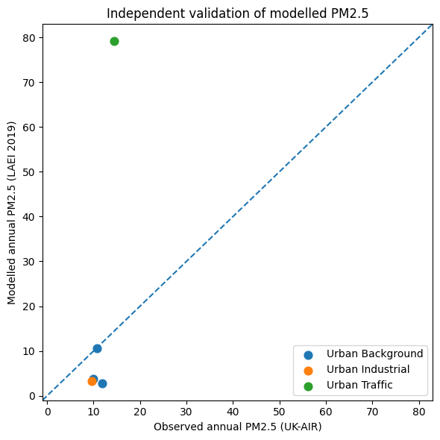
Figure 4.5: Observed UK-AIR versus modeled LAEI 2019 annual PM2.5
Validation strengthened the inequality analysis because deprivation comparisons relied on modeled concentrations. Earlier London inequality studies often used modeled residential exposure because dense citywide monitoring at every neighbourhood was impossible. Model-based exposure was therefore appropriate, but its uncertainty needed to remain visible. The present design did not treat five monitoring stations as a complete validation network. Instead, the sites provided an independent check across several environment types. The limited station count constrained correlation estimates and prevented detailed spatial calibration. The strongest use of the validation was to identify gross bias, large errors, or environment-specific discrepancies that could alter confidence in the deprivation results.
Research Question 3 was considered achieved through two linked tests. First, the spatial regression determined whether the deprivation association persisted when neighbourhood dependence was represented statistically. Second, the monitor comparison assessed whether the modeled PM2.5 surface showed acceptable agreement with independent observations at selected locations. A stable deprivation coefficient combined with reasonable validation would strengthen the interpretation that observed inequality reflected a real spatial exposure pattern within the LAEI framework. Weak validation or strong spatial attenuation would not invalidate the study, but it would narrow the conclusion to inequality in modeled ambient concentrations rather than confidently generalized exposure differences.
The combined findings should be interpreted against London's broader environmental-inequality literature. Rivas et al. (2017) found that commuting exposure depended strongly on transport mode and did not map neatly onto a simple deprivation gradient. Ferguson et al. (2021) showed that housing and indoor conditions could create systemic inequalities beyond outdoor concentrations, while Ferguson et al. (2023) found socioeconomic variation in personal PM2.5 exposure among children. These studies demonstrated why the present results should not be described as total personal exposure. A neighbourhood with a relatively high annual outdoor PM2.5 concentration could contain residents with different time-activity patterns, indoor sources, occupations, commuting modes, and housing infiltration characteristics. The study therefore addressed ambient environmental inequality, one component of the wider exposure system.
The spatial results also had policy relevance. High-high PM2.5 clusters that overlapped with more deprived LSOAs would identify areas where environmental burden and socioeconomic disadvantage coincided geographically. Such locations could justify more detailed source analysis, local monitoring, transport assessment, or housing-focused work. However, hotspot overlap would still not prove that deprivation caused pollution or that one emission source caused the inequality. Place-based intervention required source evidence. The optional LAEI emissions extension was therefore retained for subsequent analysis of road transport and other source categories, but source attribution was not claimed from concentration patterns alone. This boundary avoided a common ecological error in which spatial coincidence was treated as a complete causal explanation.
The results reflected other environments beyond environmental justice. In some marjority parts of London, areas whose PM2.5 levels were higher and located alongside neighbourhoods witnessed with greater socioeconomic deprivation. Such track of a consistent pattern indicated a pattern confirming that a number of communities were experiencing both greater environmental pollution and socioeconomic disadvantage. Such finding about these areas led to the need for using their locations for further detailed investigation, including extended monitoring of air-quality, traffic assessments and other emission sources, housing conditions examination, and evaluation of possible local interventions.
The analysis did not estimate individual health risks. The datasets used in the study did not contain individual exposure histories, health records, or the dose-response information needed to make that type of assessment. The study therefore concentrated on establishing where differences in ambient PM2.5 exposure occurred across London and examining how those differences related to socioeconomic conditions.
Several limitations shaped interpretation. LAEI PM2.5 values were modeled annual ambient concentrations, not personal measurements, and aggregation from 20 m cells to LSOAs smoothed near-road and within-neighbourhood variation. IMD was an area-level composite index and did not measure individual income, ethnicity, occupation, or vulnerability. LSOA population totals improved weighting but did not provide within-LSOA residential coordinates, so every resident within an LSOA effectively inherited the same aggregated concentration. The analysis used one inventory year, which limited claims about temporal change. A longitudinal extension using comparable LAEI years would be needed to test whether spatial inequality widened or narrowed over time.
The spatial models also had methodological limits. Queen contiguity and eight-nearest-neighbour weights represented plausible neighbourhood relationships but could not reproduce atmospheric transport directly. Spatial-lag and spatial-error specifications reduced dependence problems but did not identify the physical process generating that dependence. The regression omitted detailed traffic intensity, land use, building form, regional background, and meteorological covariates because the research question prioritised inequality rather than atmospheric prediction. Omitted factors could therefore confound the observed deprivation association. The limited UK-AIR validation sample reduced statistical power and made the correlation sensitive to individual stations. These constraints should be stated alongside the results rather than hidden in a final paragraph.
Despite those limitations, the multi-dataset design addressed several gaps identified in recent research. It linked a 20 m pollution surface to small-area deprivation instead of relying on coarse city averages, applied population weighting, tested spatial clustering explicitly, used spatial regression when residual dependence remained, and added independent monitor validation. Gohlke et al. (2023) called for place-based evidence capable of identifying pollution inequity at decision-relevant scales, while Gray et al. (2024) showed that source and demographic disparities could be more complex than a single-sector narrative. The present workflow moved London analysis toward that standard while maintaining a narrow claim appropriate to the available data.
The paper's strongest novelty therefore rested on methodological integration rather than on declaring that disadvantaged London communities experienced pollution for the first time. Prior studies had already established several forms of socioeconomic inequality. The new contribution was a reproducible 2019 LSOA framework that connected fine-resolution modeled PM2.5, deprivation, population weighting, formal spatial statistics, spatially adjusted regression, and independent monitoring validation within one analysis. That combination allowed the study to distinguish four questions that were often blurred together: where PM2.5 was highest, whether deprivation patterned exposure, whether the association survived spatial adjustment, and whether the modeled surface agreed with observations.

CHAPTER FIVE: CONCLUSION, LIMITATIONS, AND PUBLICATION IMPLICATIONS

5.1 Conclusion
Through this analysis a citywide unweighted mean of 5.054 µg/m3 and a population-weighted mean of 5.165 µg/m3 was recorded. These values statistically gave spatial clustering (Global Moran's I = 0.7413, p = 0.0001) with positive significance. Population-weighted exposure fell from 5.793 µg/m³ in the most deprived decile to 3.580 µg/m³ in the least deprived decile. The positive association with deprivation also remained after accounting for spatial dependence.
The independent monitoring comparison also showed that agreement varied substantially by site, which limited the interpretation to validated modeled ambient exposure rather than individual exposure. The above study therefore established a single coherent analytical chain from fine-resolution modeled PM2.5 to neighbourhood deprivation, population weighting, spatial dependence, and monitor validation.

5.2 Achievement of the Research Questions
The established patial structure of 2019 exposure confirmed that the research Question 1 was when the reported distribution, Global Moran statistic, and LISA map were used. Research Question 2 was achieved because the decile summaries, population weighting, continuous correlations, and group comparisons quantified the socioeconomic pattern with a clear consistence. Research Question 3 was achieved because the spatial-model sensitivity analysis showed that the deprivation association persisted after spatial dependence was addressed, while UK-AIR validation identified substantial site-specific differences in agreement between modeled and observed concentrations. These findings supported a conclusion about spatial inequality in modeled ambient PM2.5, with the validation results defining the limits of generalisation.

5.3 Limitations
The design remained ecological and cross-sectional. LAEI concentrations represented modeled outdoor annual means rather than personal dose, IMD represented area deprivation rather than individual socioeconomic position, and LSOA aggregation smoothed fine near-source gradients. Population weighting improved the distributional interpretation but did not locate residents within each LSOA. The validation network was small and included different monitoring environments. Spatial weights represented geographical dependence statistically rather than atmospheric transport physically. The 2019 design also prevented direct inference about temporal change.

5.4 Key Publication Contribution
The defensible novelty was the integration of a 20 m final-LAEI exposure surface with LSOA deprivation, population weighting, explicit spatial autocorrelation, spatial regression, and independent monitor validation in one reproducible workflow. There has been a consistent methodological and substantive contribution: it tested if fine-resolution ambient exposure inequality retained visibility after population distribution and spatial dependence received explicit treatment, and it made model validation part of the inequality argument rather than a technical exercise that was separate. This framework distinguished where PM2.5 was highest, whether deprivation patterned exposure, whether the association survived spatial adjustment, and the extent at which modeled exposure surface needed to be trusted against independent observations.

REFERENCES
Anselin, L. (1995). Local indicators of spatial association-LISA. Geographical Analysis, 27(2), 93-115. https://doi.org/10.1111/j.1538-4632.1995.tb00338.x
Ferguson, L., Taylor, J., Zhou, K., Shrubsole, C., Symonds, P., Davies, M., & Dimitroulopoulou, S. (2021). Systemic inequalities in indoor air pollution exposure in London, UK. Buildings & Cities, 2(1), 425-448. https://doi.org/10.5334/bc.100
Ferguson, L., Taylor, J., Symonds, P., Davies, M., & Dimitroulopoulou, S. (2023). Analysis of inequalities in personal exposure to PM2.5: A modelling study for the Greater London school-aged population. Science of the Total Environment, 905, 167056. https://doi.org/10.1016/j.scitotenv.2023.167056
Gohlke, J. M., Harris, M. H., Roy, A., Thompson, T. M., DePaola, M., Alvarez, R. A., Anenberg, S. C., Apte, J. S., Demetillo, M. A. G., Dressel, I. M., Kerr, G. H., Marshall, J. D., Nowlan, A. E., Patterson, R. F., Pusede, S. E., Southerland, V. A., & Vogel, S. A. (2023). State-of-the-science data and methods need to guide place-based efforts to reduce air pollution inequity. Environmental Health Perspectives, 131(12), 125003. https://doi.org/10.1289/EHP13063
Goodman, A., Wilkinson, P., Stafford, M., & Tonne, C. (2011). Characterising socio-economic inequalities in exposure to air pollution: A comparison of socio-economic markers and scales of measurement. Health & Place, 17(3), 767-774. https://doi.org/10.1016/j.healthplace.2011.02.002
Gray, N. R., Lewis, A. C., & Moller, S. J. (2024). Evaluating disparities in air pollution as a function of ethnicity, deprivation and sectoral emissions in England. Environment International, 194, 109146. https://doi.org/10.1016/j.envint.2024.109146
Higham, J. E., Saleh, S., & Acosta Ramírez, C. J. (2025). Spatial and temporal dynamics of air pollution and socioeconomic deprivation in Liverpool, UK: A multi-scale analytical approach. Science of the Total Environment, 999, 180224. https://doi.org/10.1016/j.scitotenv.2025.180224
Rivas, I., Kumar, P., & Hagen-Zanker, A. (2017). Exposure to air pollutants during commuting in London: Are there inequalities among different socio-economic groups? Environment International, 101, 143-157. https://doi.org/10.1016/j.envint.2017.01.019
Tonne, C., Milà, C., Fecht, D., Alvarez, M., Gulliver, J., Smith, J., Beevers, S., Anderson, H. R., & Kelly, F. (2018). Socioeconomic and ethnic inequalities in exposure to air and noise pollution in London. Environment International, 115, 170-179. https://doi.org/10.1016/j.envint.2018.03.023
Official dataset and technical sources
Greater London Authority. (2023). London Atmospheric Emissions Inventory 2019. London Datastore.
Ministry of Housing, Communities and Local Government. (2019). English indices of deprivation 2019. UK Government.
Office for National Statistics. (2020). Lower layer Super Output Area mid-year population estimates: Mid-2019. ONS.
UK Department for Environment, Food & Rural Affairs. (2019). UK-AIR Automatic Urban and Rural Network monitoring data. DEFRA.

