MIS500 Critical Thinking Module 1
Ty Cook
Colorado State University – Global Campus
MIS500 Critical Thinking Module 1
- Code from PyCharm Edu:
#############################################################
#Program name - Data Exploration
#input - NONE
#output - Some Exploration statistics
###############################################################
import pandas as pd #Installed pandas library as this was not intialized in the beginning and was needed to RUN -TC
# Create data_frame of array values
df = pd.DataFrame({
'name':['matt','lisa','richard','john','Julia','jane','marlon'],
'age':[23,78,22,19,45,33,20],
'gender':['M','F','M','M','M','F','M'],
'state':['DC','CO','DE','VA','MD','DE','NY'],
'years_of_service':[10,0,2,0,2,1,5],
'iq':[300,100,110,200,300,10,40]
})
########################################################
# BEGIN extract a 25% sample of data
########################################################
rows = df.sample(frac =.25)
# validate first to check if sample is 0.25 times data or not
if (0.25*(len(df))== len(rows)):
print(len(df), len(rows))
# Display Sample Percentage
print ('sample of 25%',rows) #Added missing () for print statement to RUN -TC
#END extract a 25% sample of data
############################################################
# BEGIN Split categorical variables by gender, Sum, Mean, count,
# and describe on the data
############################################################
#Categorical Variables splitting
groupby_gender = df.groupby('gender')
for gender, value in groupby_gender['iq']:
print((gender, value.mean()))
# Find the Summation of all ages in the data
SumofAge=df['age'].sum()
print ('Sum of Ages', SumofAge) #Added missing () for print statement to RUN -TC
MeanAge = df['age'].mean()
print ('Average Ages', MeanAge)
# Find the mean of all columns
print ('Means of each column', df.mean(axis=0))
# Describe the Data
print (df['iq'].describe()) #Added missing () for print statement to RUN -TC
#END
2. Screenshot of PyCharm Edu executing the program:
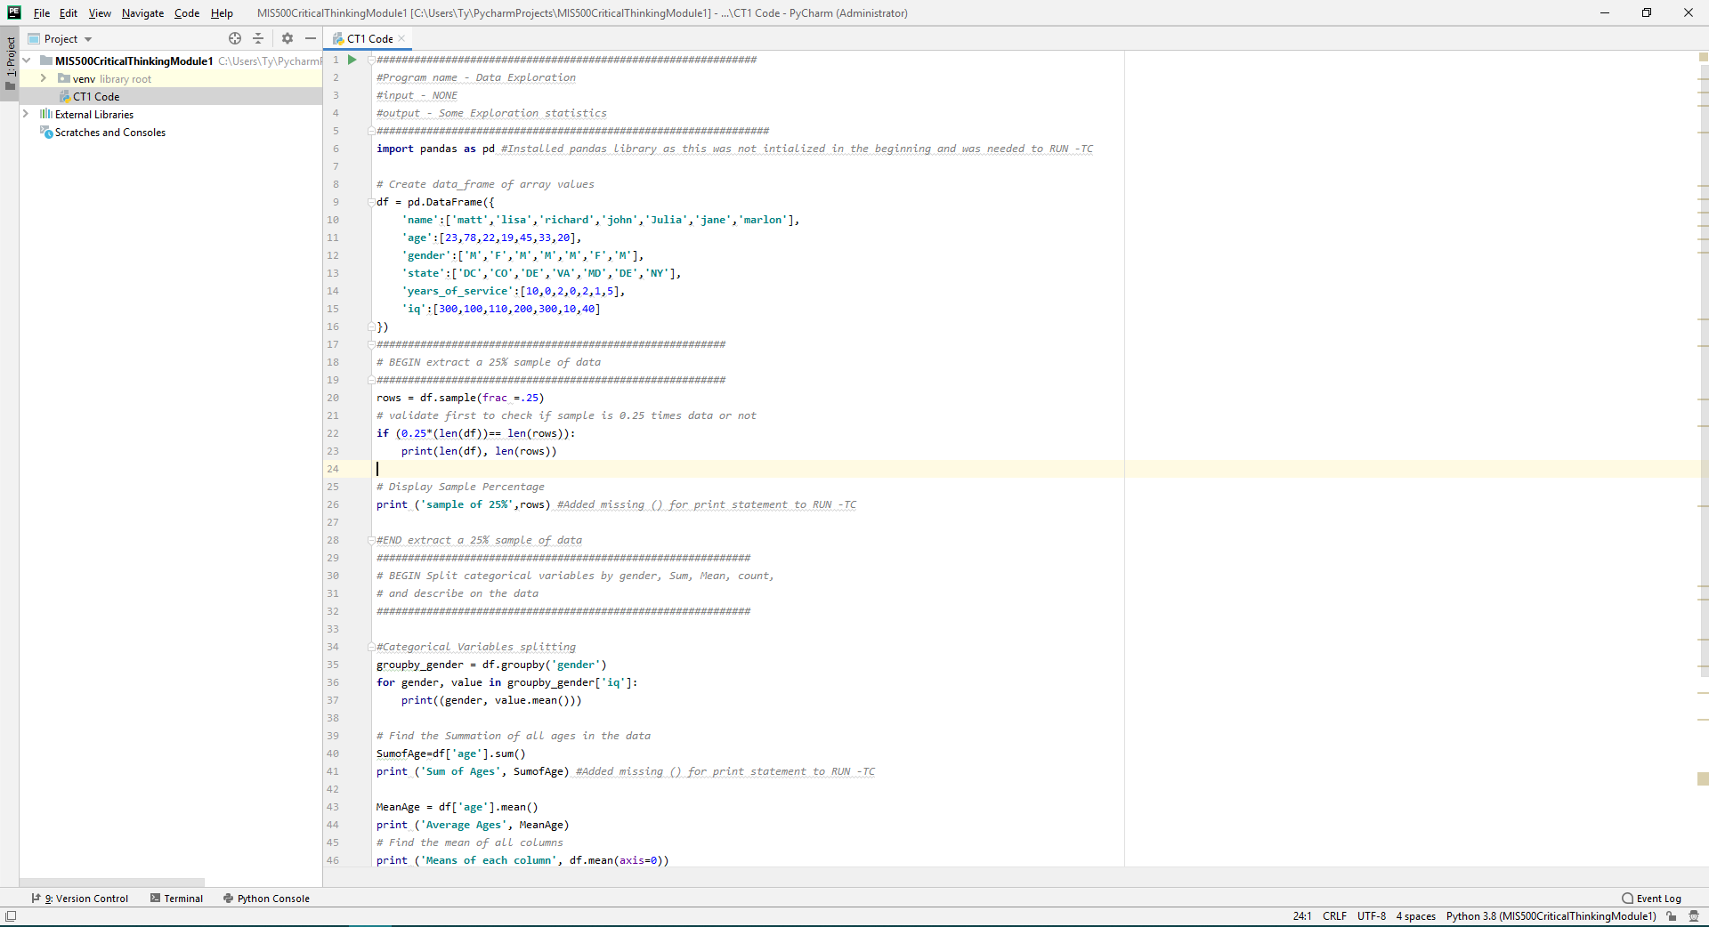
Figure 1. Screenshot of code in Pycharm 1 of 2
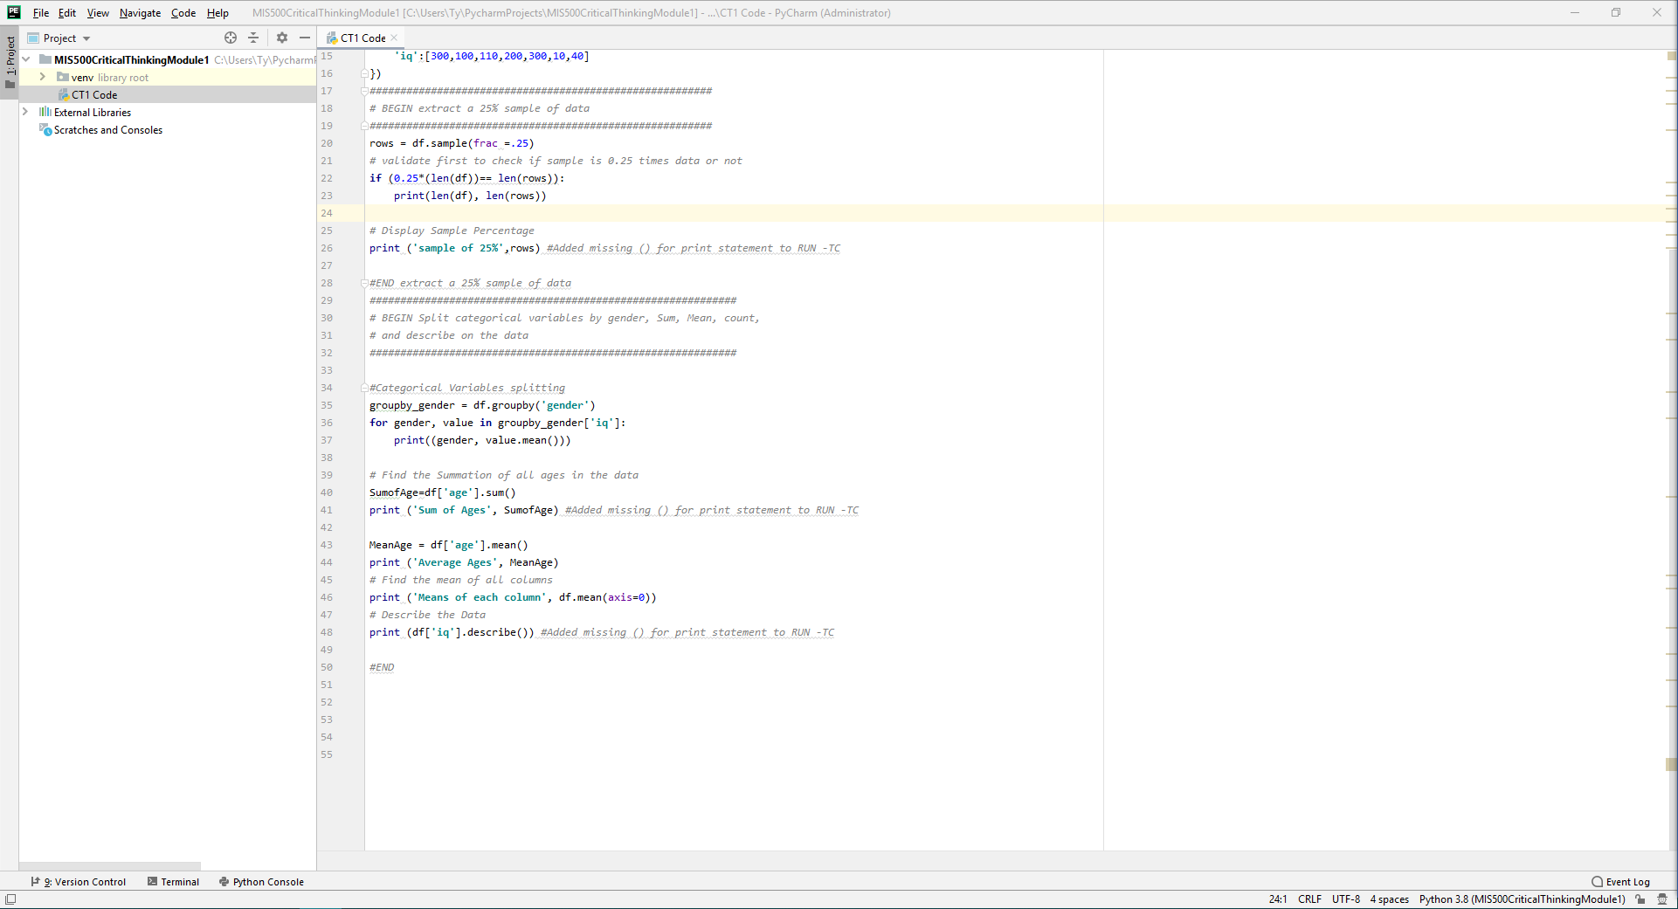
Figure 2. Screenshot of code in Pycharm 2 of 2
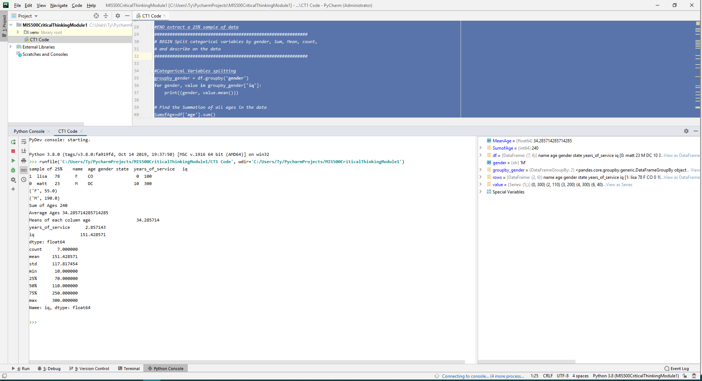
Figure 3. Code being executed in the Python Console
3. Screenshot of output from program:
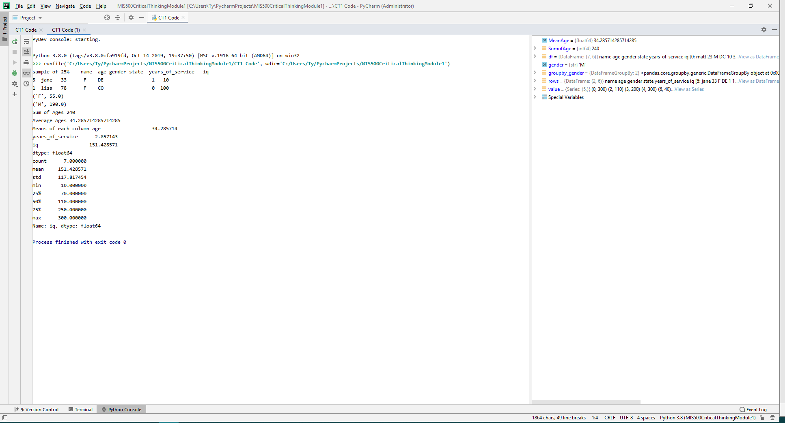
Figure 4. Screenshot of output from program

