Hypotheses Testing Using “R” Program
Ty Cook
Colorado State University – Global Campus
Hypotheses Testing Using “R” Program
Data set is from the Restaurant Scores – Lives Standard it’s a inspection report from the Health department from restaurants in San Fransico that contains scores of restaurants based on violations observed. File is a CSV file.
Dataset was retrieved from: https://healthdata.gov/dataset/restaurant-scores-lives-standard
Hypothesis
There is significance in the risk category and the score given by the description as the score decreases the risk category should increase in severity.
H0 Score does not have an effect on risk category
HA Score does have an effect on risk category
install.packages("dplyr")

#Reading From .CSV
data <- read.csv("Restaurant_Scores.csv", header = TRUE, sep=",")

#Data Frame

scores_risk<-data.frame(
scores=(data$inspection_score),
risk=(data$risk_category)
)
#Summary of Data
library(dplyr)

group_by(scores_risk, risk) %>%

summarise(

count = n(),

mean = mean(scores, na.rm = TRUE),

sd = sd(scores, na.rm = TRUE)

)

summary(scores_risk$scores)

#ANOVA Test
res.aov <- aov(scores ~ risk, data = scores_risk)
# Summary of the analysis
summary(res.aov)
TukeyHSD(res.aov)

# Box plot
boxplot(scores ~ risk, data = scores_risk,
xlab = "Risk", ylab = "Scores",
frame = FALSE, col = c("#00AFBB", "#E7B800", "#FC4E07", "#2BCD47"))
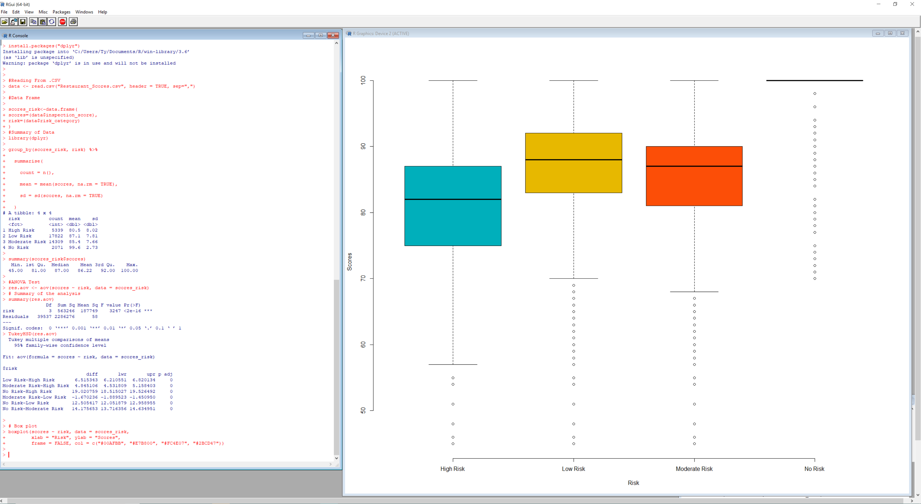
Figure 1 – Output of R program

References
City of San Franciso. (2017). Restaurant Scores - LIVES Standard [Data file]. Retrieved from https://healthdata.gov/dataset/restaurant-scores-lives-standard

