Visualization in Tableau
Ty Cook
Colorado State University – Global Campus
Visualization in Tableau
I choose the visualization method of creating a geographical chart and the line chart using the Show Me Tool Bar. Using Videos: 2. Connecting to Excel and Text Files (4:32), 11. Creating Your First Chart (2:34), and 12. Using the Show Me Tool Bar (4:15). I’ve included graphs from made from following the videos and have made a visualization form the dataset I plan on using on my final assignment.
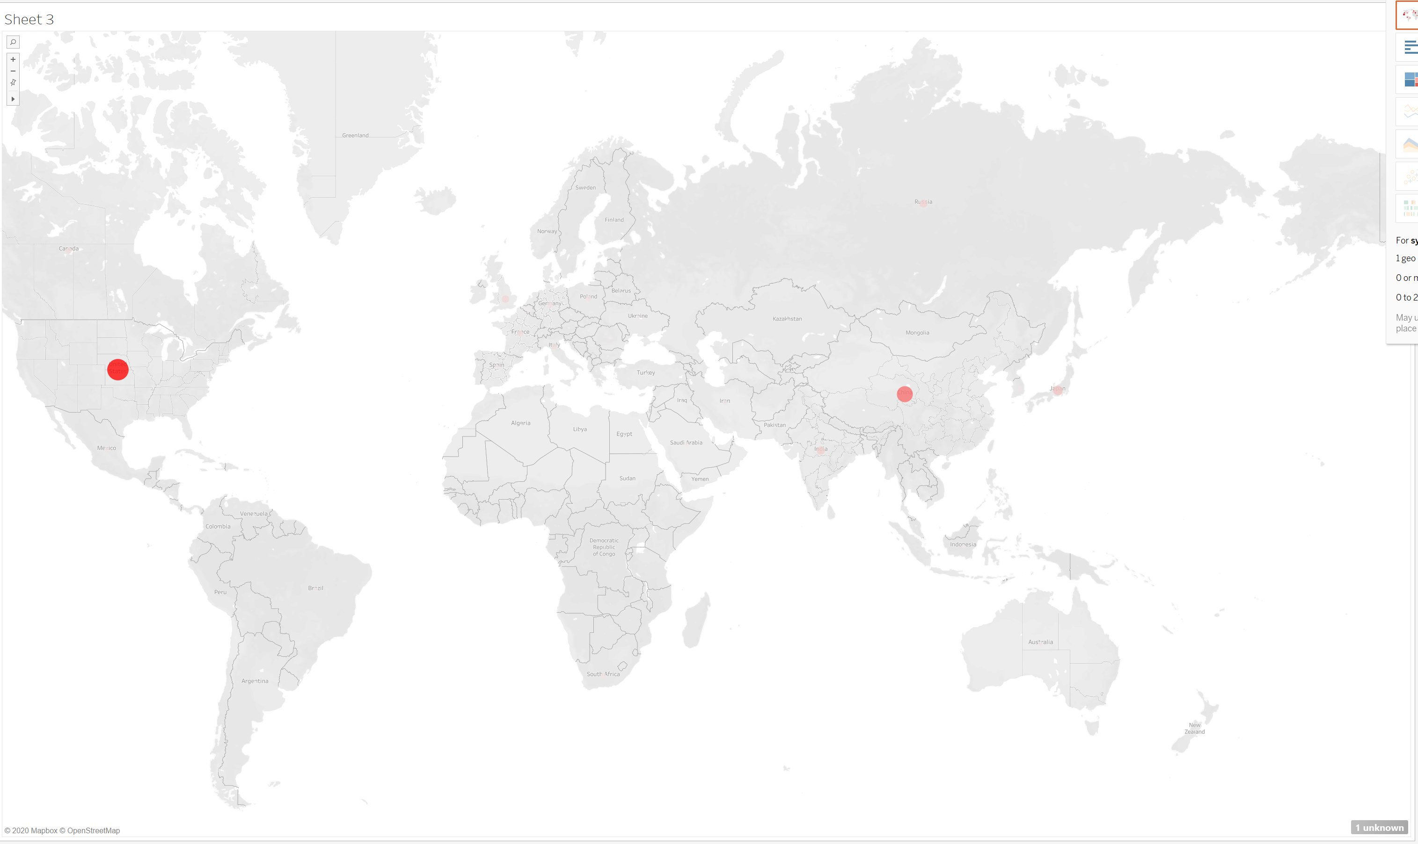Figure 1 – Graph 1 from Creating Your First Chart
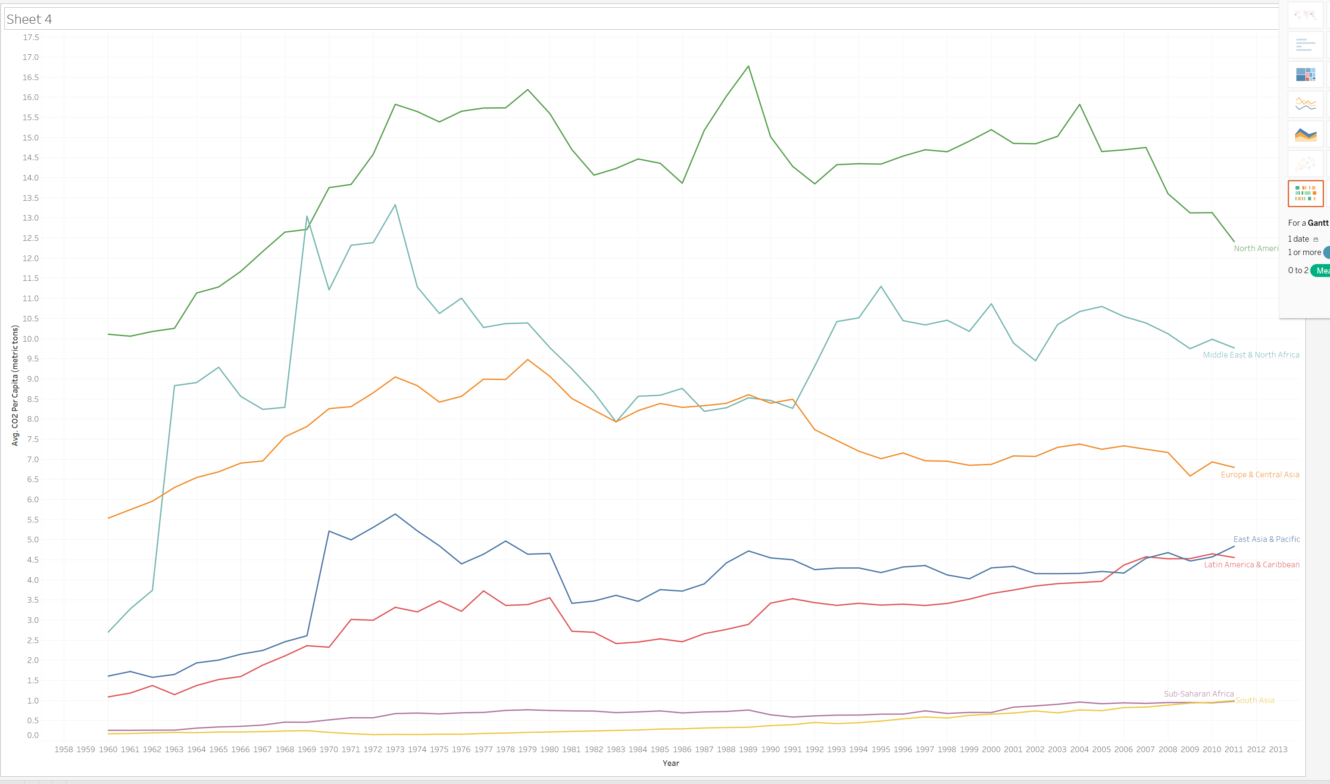
Figure 2 – Graph 2 from videos Creating Your First Chart and Using the Show Me Tool Bar
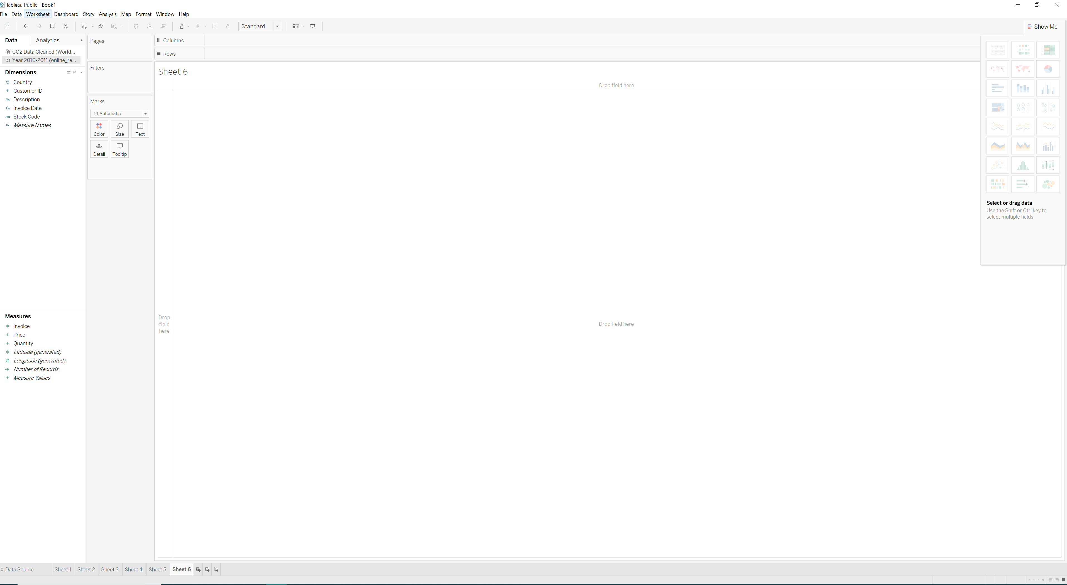
Figure 3 – Importing dataset from Excel
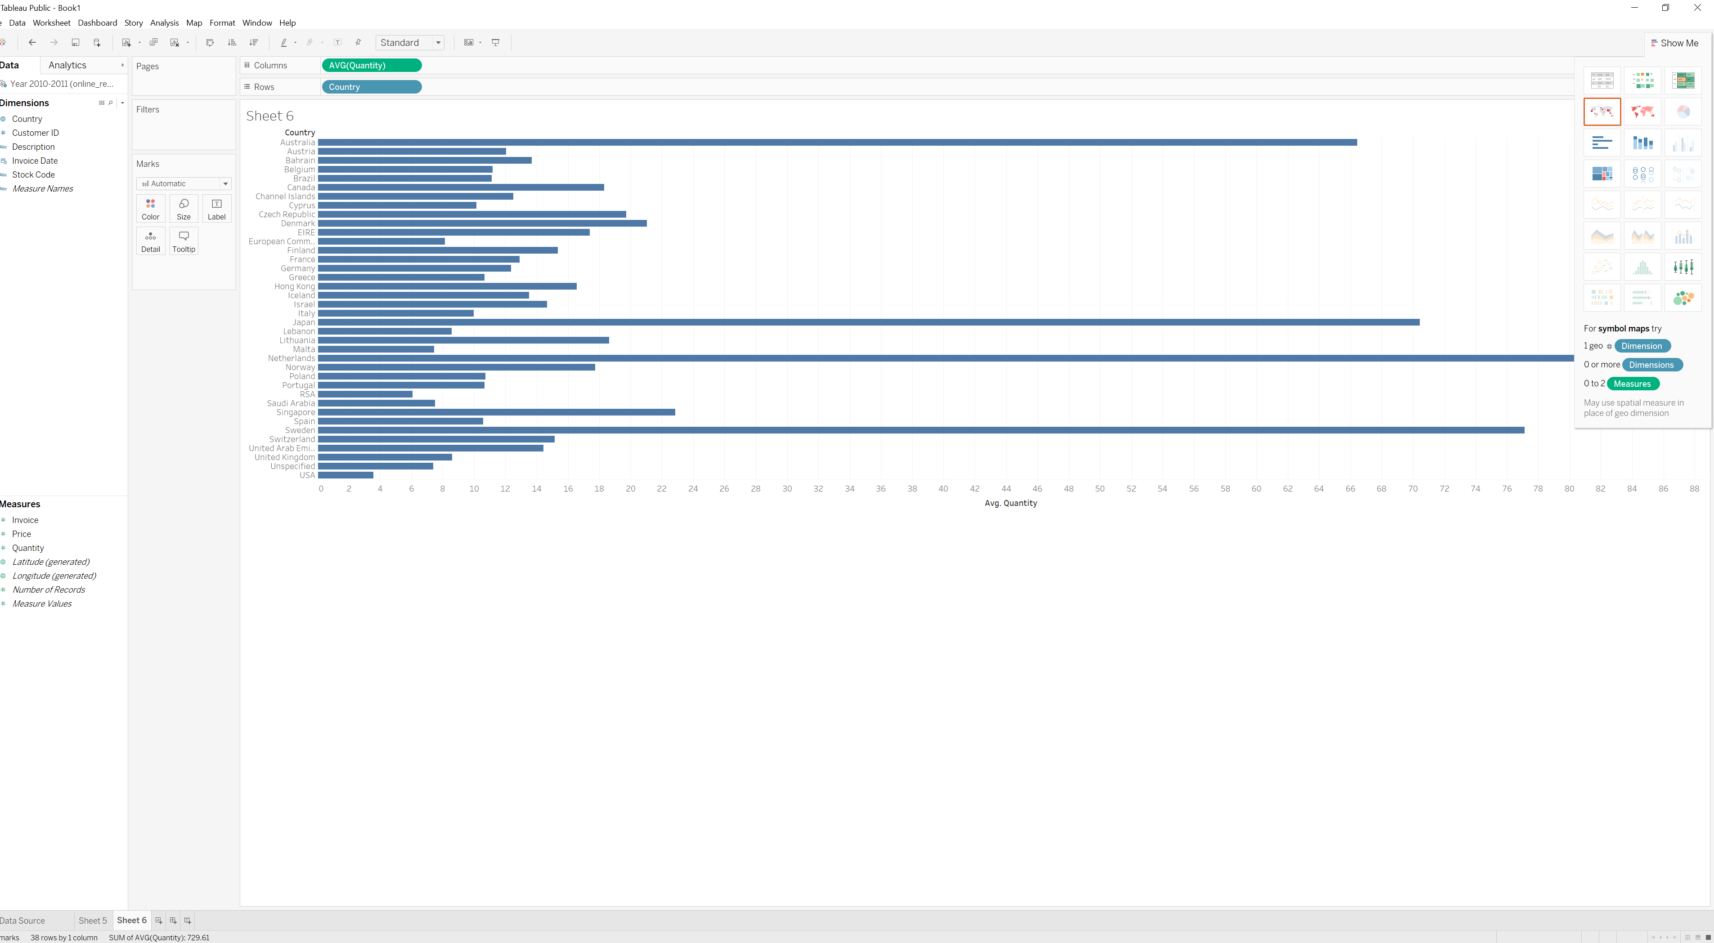
Figure 4 – Creating Bar Graph from Country and Quanity

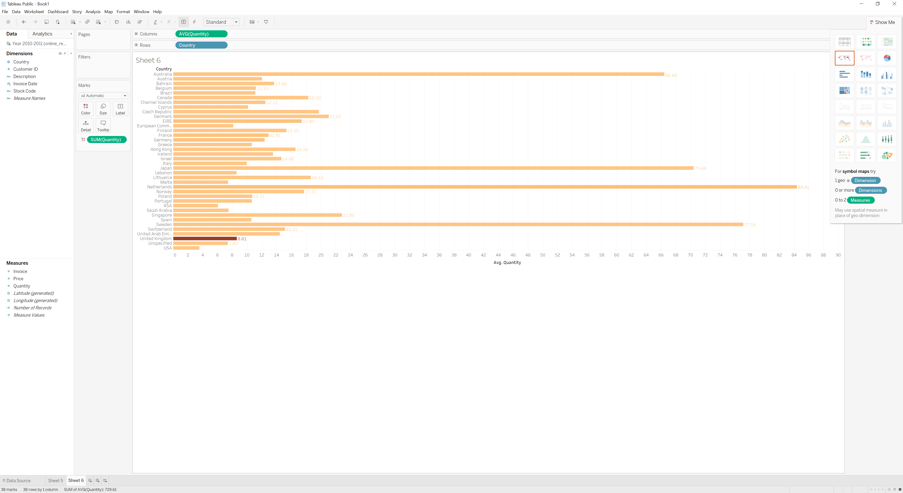
Figure 5 – Chanigng colors and adding labels

