Implementing R Hypothesis Testing
Ty Cook
Colorado State University – Global Campus
Implementing R Hypothesis Testing
R Source Code
# R Hypothesis Tests

install.packages("dplyr")

tScore_before <- c(40, 62, 74, 22, 64, 65, 49, 49, 49)

tScore_after <- c(68, 61, 64, 76, 90, 75, 66, 60, 63)

# Create a data frame

my_data <- data.frame(

group = rep(c("Score Before", "Score After"), each = 9),

scores = c(tScore_before, tScore_after)

)

# Print all data

print(my_data)

#Compute summary statistics by groups

library(dplyr)

group_by(my_data, group) %>%

summarise(

count = n(),

mean = mean(scores, na.rm = TRUE),

sd = sd(scores, na.rm = TRUE)

)

# Compute Unpaired Two Sample t-test

res <- t.test(tScore_before, tScore_after, var.equal = TRUE)

res

# Compute independent t-test

res <- t.test(scores ~ group, data = my_data, var.equal = TRUE)

res

#test whether the average score before score is less than the average after score, type this:

t.test(scores ~ group, data = my_data,

var.equal = TRUE, alternative = "less")

# Graph Unpaired T-Test

library("ggpubr")

ggboxplot(my_data, x = "group", y = "scores",
color = "group", palette = c("#00AFBB", "#E7B800"),
ylab = "scores", xlab = "Groups")

R Code Output
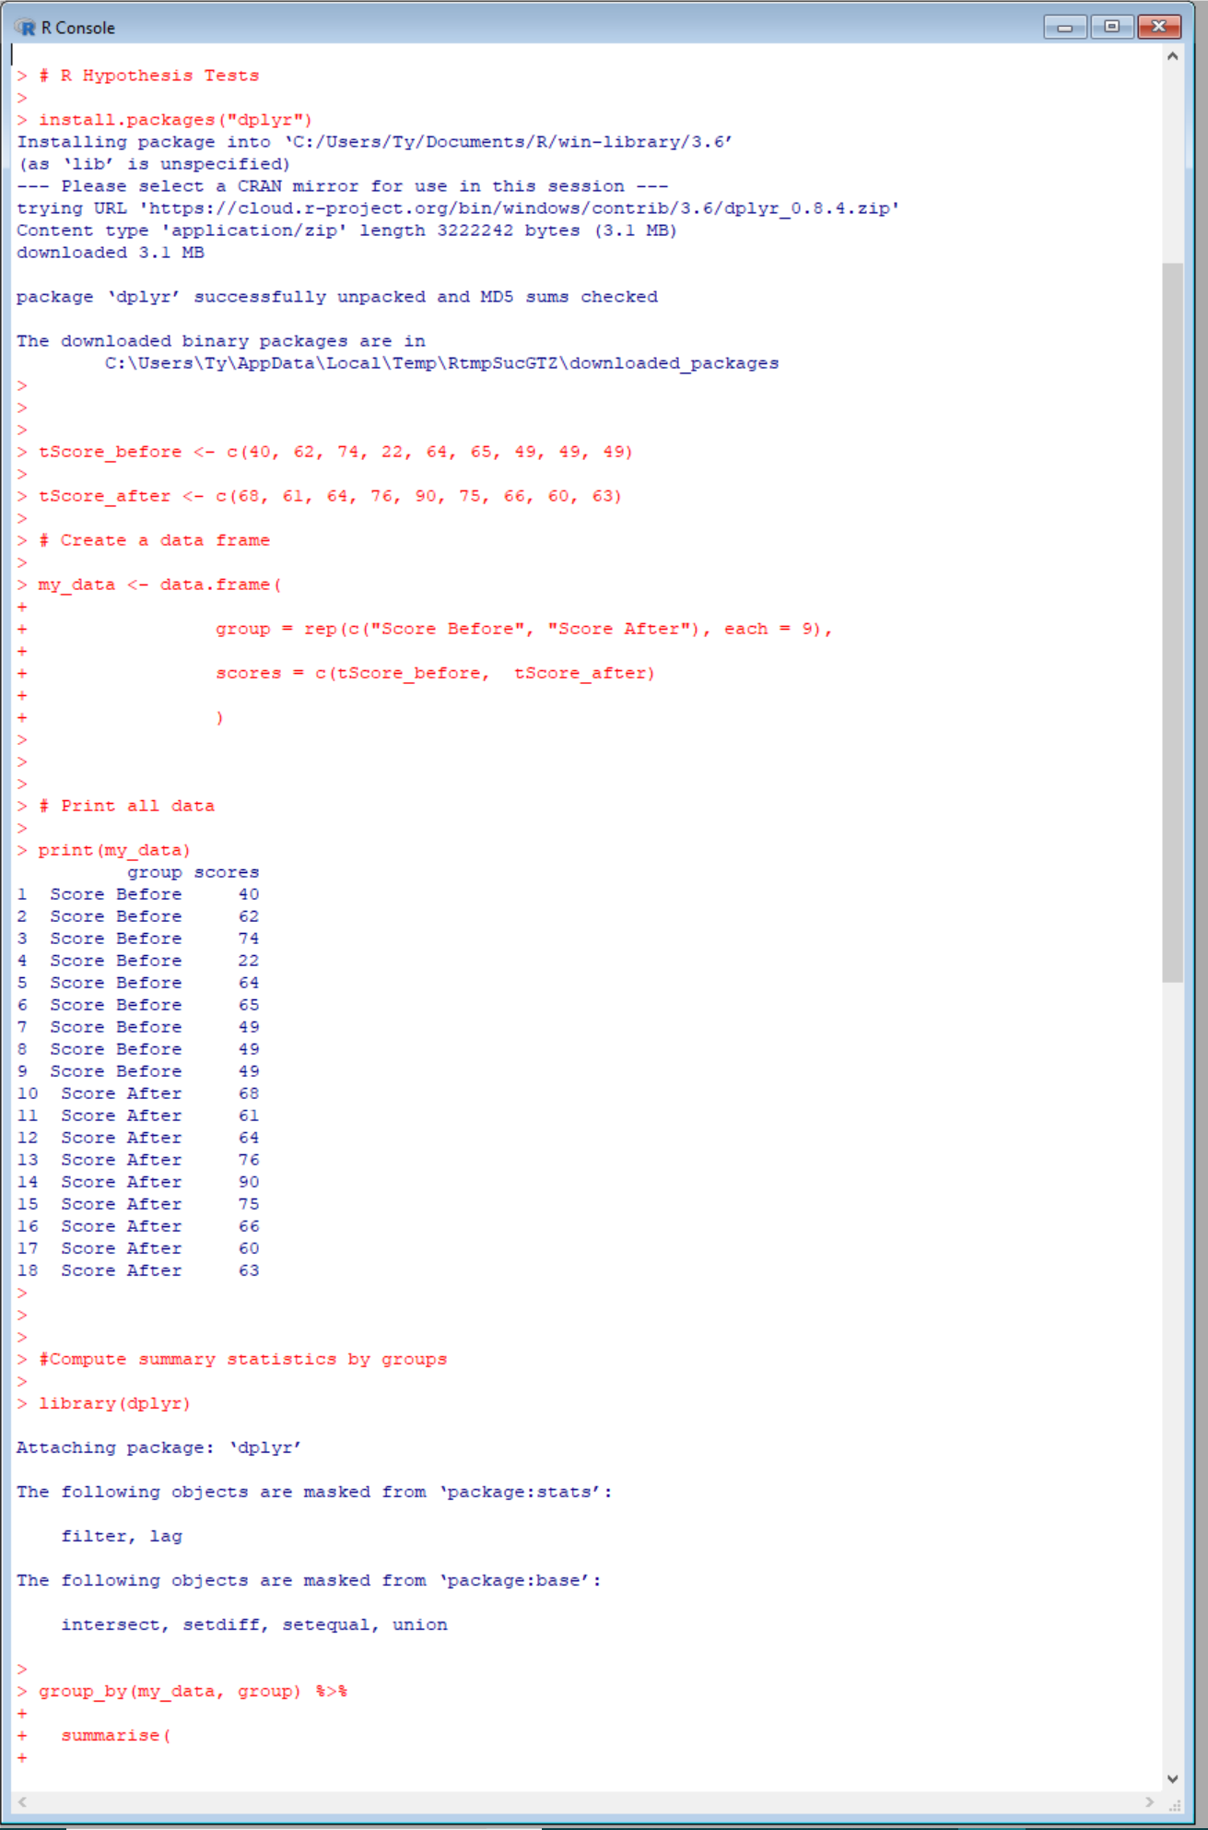
Figure 1 – Part 1 of output from above R code
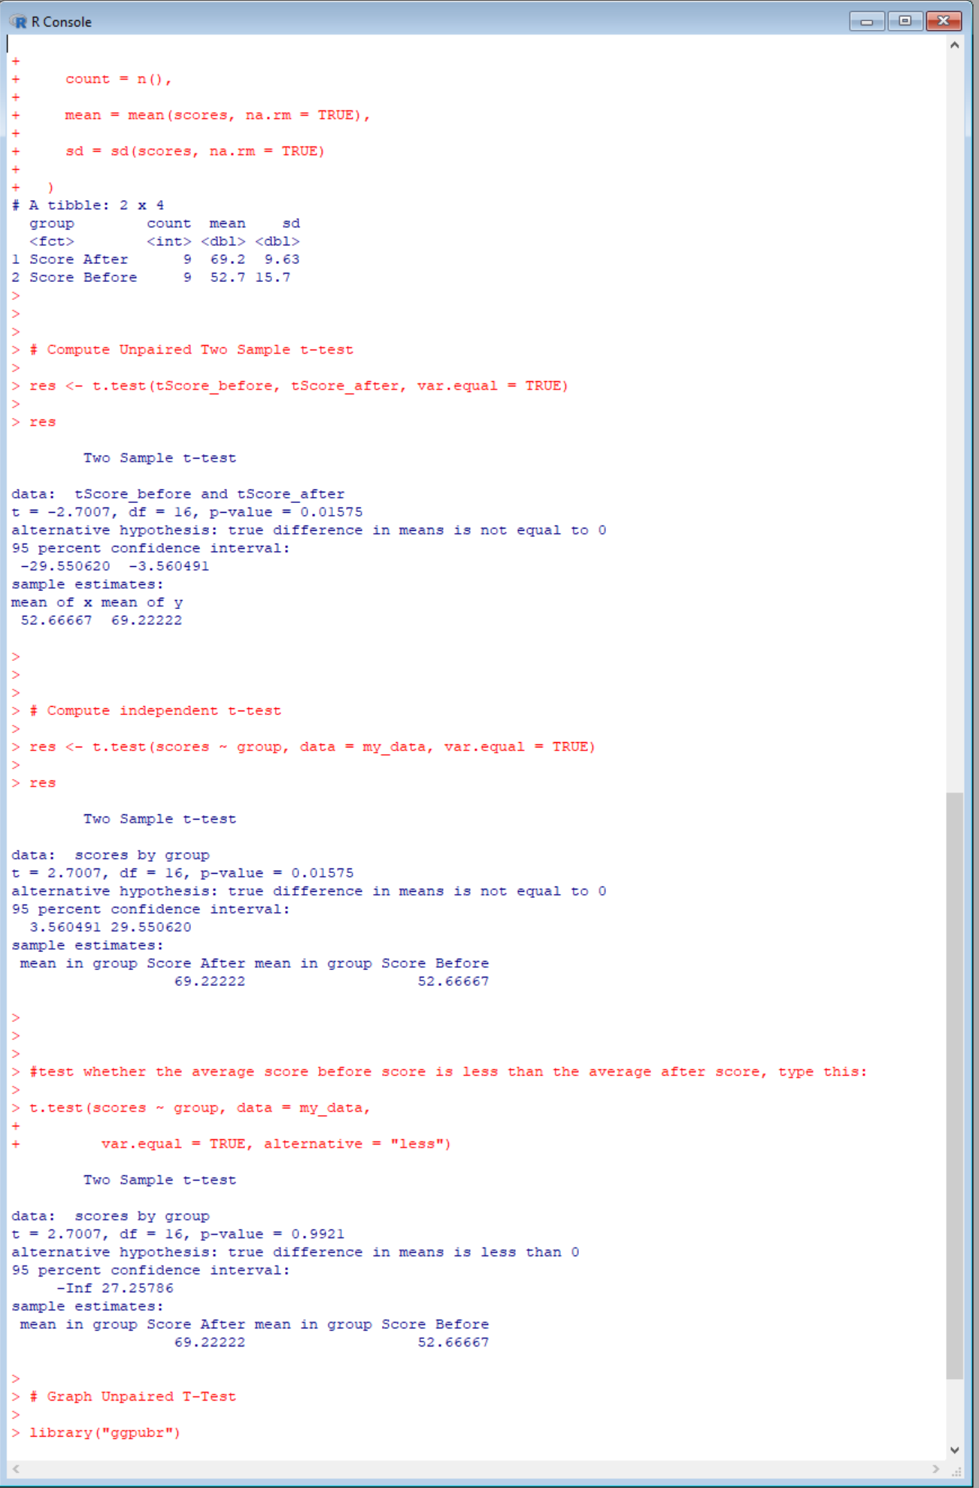
Figure 2 – Part 2 of output from above R code
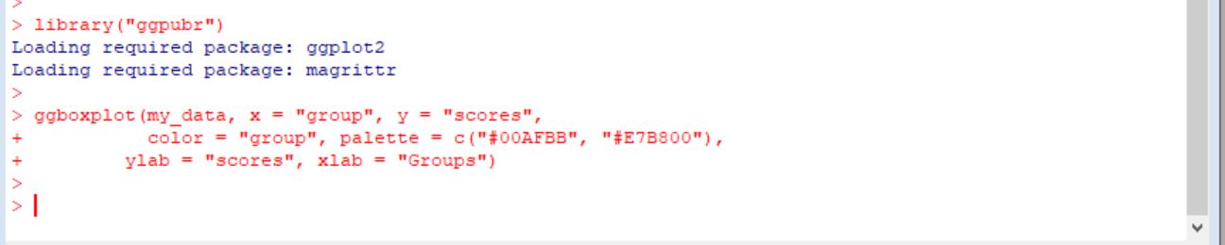
Figure 3 – Part 3 of output from above R code
R Code Graph
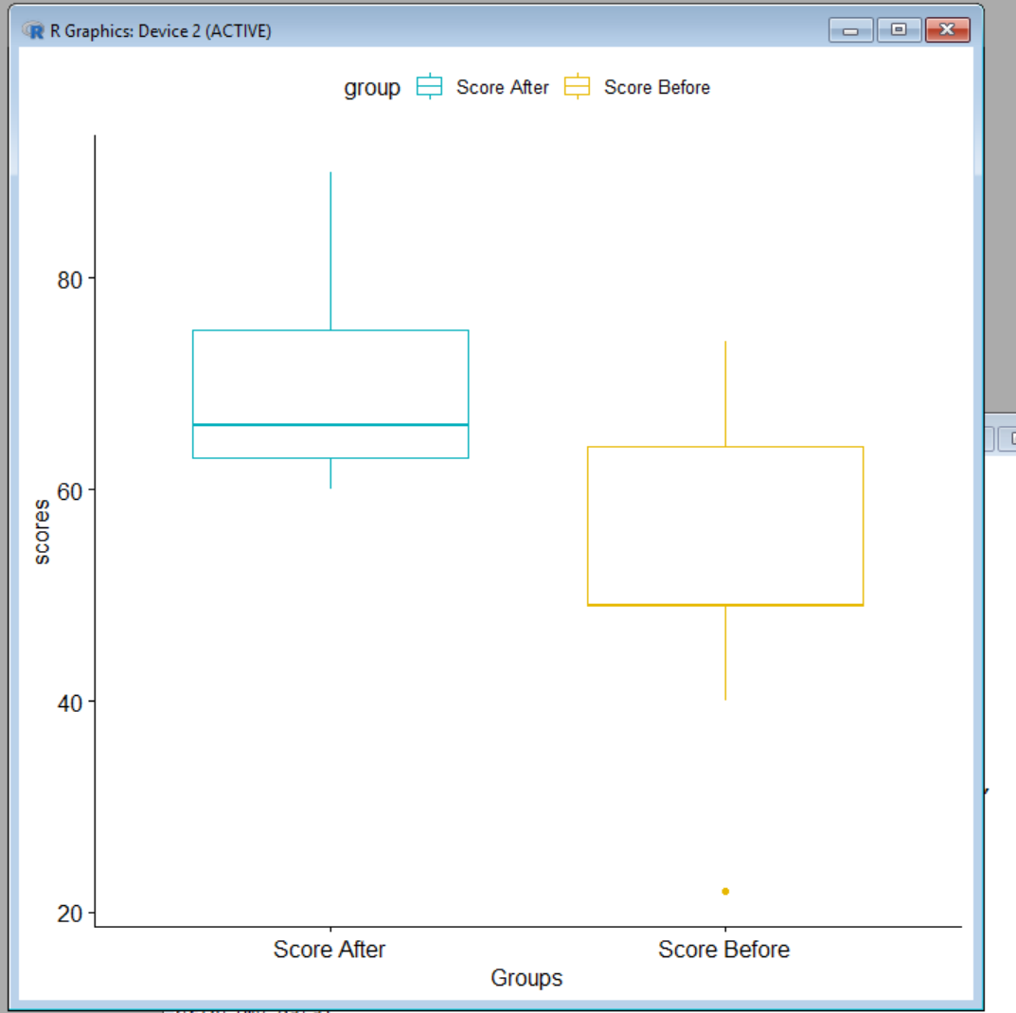

Figure 4 – T-pair Graph

