Data Analytics Using Retail Data
Ty Cook
Colorado State University – Global Campus
Data Analytics Using Retail Data
Introduction
We as people just living our lives create data based on our thoughts, behavior, opinions, and preferences, however as use the of the internet and technology has become more integrated in daily life so has the ability to be able to gather and see this Big Data. Businesses will more and more rely on data analytics of Big Data as it gives the ability to see trends and patterns, metricize current business practices, understand consumer behavior, and predict the future. Businesses and organizations will find this important as they will be able to make smarter and faster business decisions and found out how well a new product and service would do before releasing it out into the market. One of the big retail sectors that uses big data in ways such as being able to predict spending, personalizing the customer experience, forecasting demand, and customer journey analytics (Barasch, 2019). This report will go over what data set I will be using, what was done in order to assist with data processing, what hypothesis we will be testing, and finally look at the results.
Data Set
The first thing we will look at is the data set itself, for this case the “Online Retail II Data Set” from the UCI Machine Learning Repository is being used. This Data Set contains transactions for UK-based online retailer between the dates of 01/12/2009 and 09/12/2011. The company primarily sells “all-occasion gift-ware with a majority of the costumers being wholesalers. This data set includes the following variables:
- InvoiceNo: Invoice number. Nominal. A 6-digit integral number uniquely assigned to each transaction. If this code starts with the letter 'c', it indicates a cancellation.
- StockCode: Product (item) code. Nominal. A 5-digit integral number uniquely assigned to each distinct product.
- Description: Product (item) name. Nominal.
- Quantity: The quantities of each product (item) per transaction. Numeric.
- InvoiceDate: Invice date and time. Numeric. The day and time when a transaction was generated.
- UnitPrice: Unit price. Numeric. Product price per unit in sterling (Â£).
- CustomerID: Customer number. Nominal. A 5-digit integral number uniquely assigned to each customer.
- Country: Country name. Nominal. The name of the country where a customer resides.
Data Processing
The next thing we will look is data processing, after downloading the dataset and looking through the set I noticed that there quite a few entries erroneous entries within the data: there were several entries that had blank fields or even entries that were listed as “???????”, Negative quantities listed, and negative unit price listed there is a possibility that these entries could cause problems during the data analytics portion or even cause outliers. “Outliers can cause problems with certain types of models. For example, linear regression models are less robust to outliers than decision tree models. In general, if you have a legitimate reason to remove an outlier, it will help your model’s performance (Data Science Primer, 2019). These entries were dropped in cases where there was no stock or item description listed as there would be no way to tie that transaction to item, negative and 0 quantities were removed as there were several entries were there large amounts of negative quantities or zero quantities while this may represent discounts or returns this is not in scope of this project, and lastly prices for a similar reason as quantity were removed for similar reasons I would argue that the two being related is highly likely.
Data Hypothesis
Next, we will go over our data hypothesis for this project, hypothesis is an educated guess about the world around us in this case we are making an assumption about the data we are looking and using data analytics to determine if it’s true or not. For this report I will be testing two different hypotheses.
Hypothesis 1 – Price vs. More Goods Sold. The first hypothesis we will test is a pretty common one for a retail setting and that is looking at what price point a product will sell out. For this example I have looked at the top selling product for 2009-2010 and 2010-2011 which was the World War II Gliders Assorted designs which was the best selling in 2009-2010 but decreased to the third best selling item 2010-2011. We want to examine if price had anything to do with the item dropping form best selling status.
H0: There is no relationship between price and the quantity sold of the WW2 Assorted Gliders
HA: There is a relationship between price and the quantity sold of the WW2 Assorted Gliders
Hypothesis 2 – Regionality. The second hypothesis will be based on geographic location, which is important to know your market and to find blockers that may be blocking you from selling to the that market. Regionality is important in this case we are able to see what our current customer base is and strategize ourselves in the future to better position ourselves for a better global market share. For this Hypothesis we will testing the unique customer ids against the countries in order to figure out what the market looks like that we are selling to.
H0: The country we are located in will have a lesser number of customers than the global share
HA: The country we are located in will have a greater number of customers than the global share.
Data Analytics
Study of Price vs. Quantity of Goods Sold. The first thing I did was broke down the data in tableau to understand what were the top selling items were from 2009 thru 2010 and what was the average price selling price of the item.

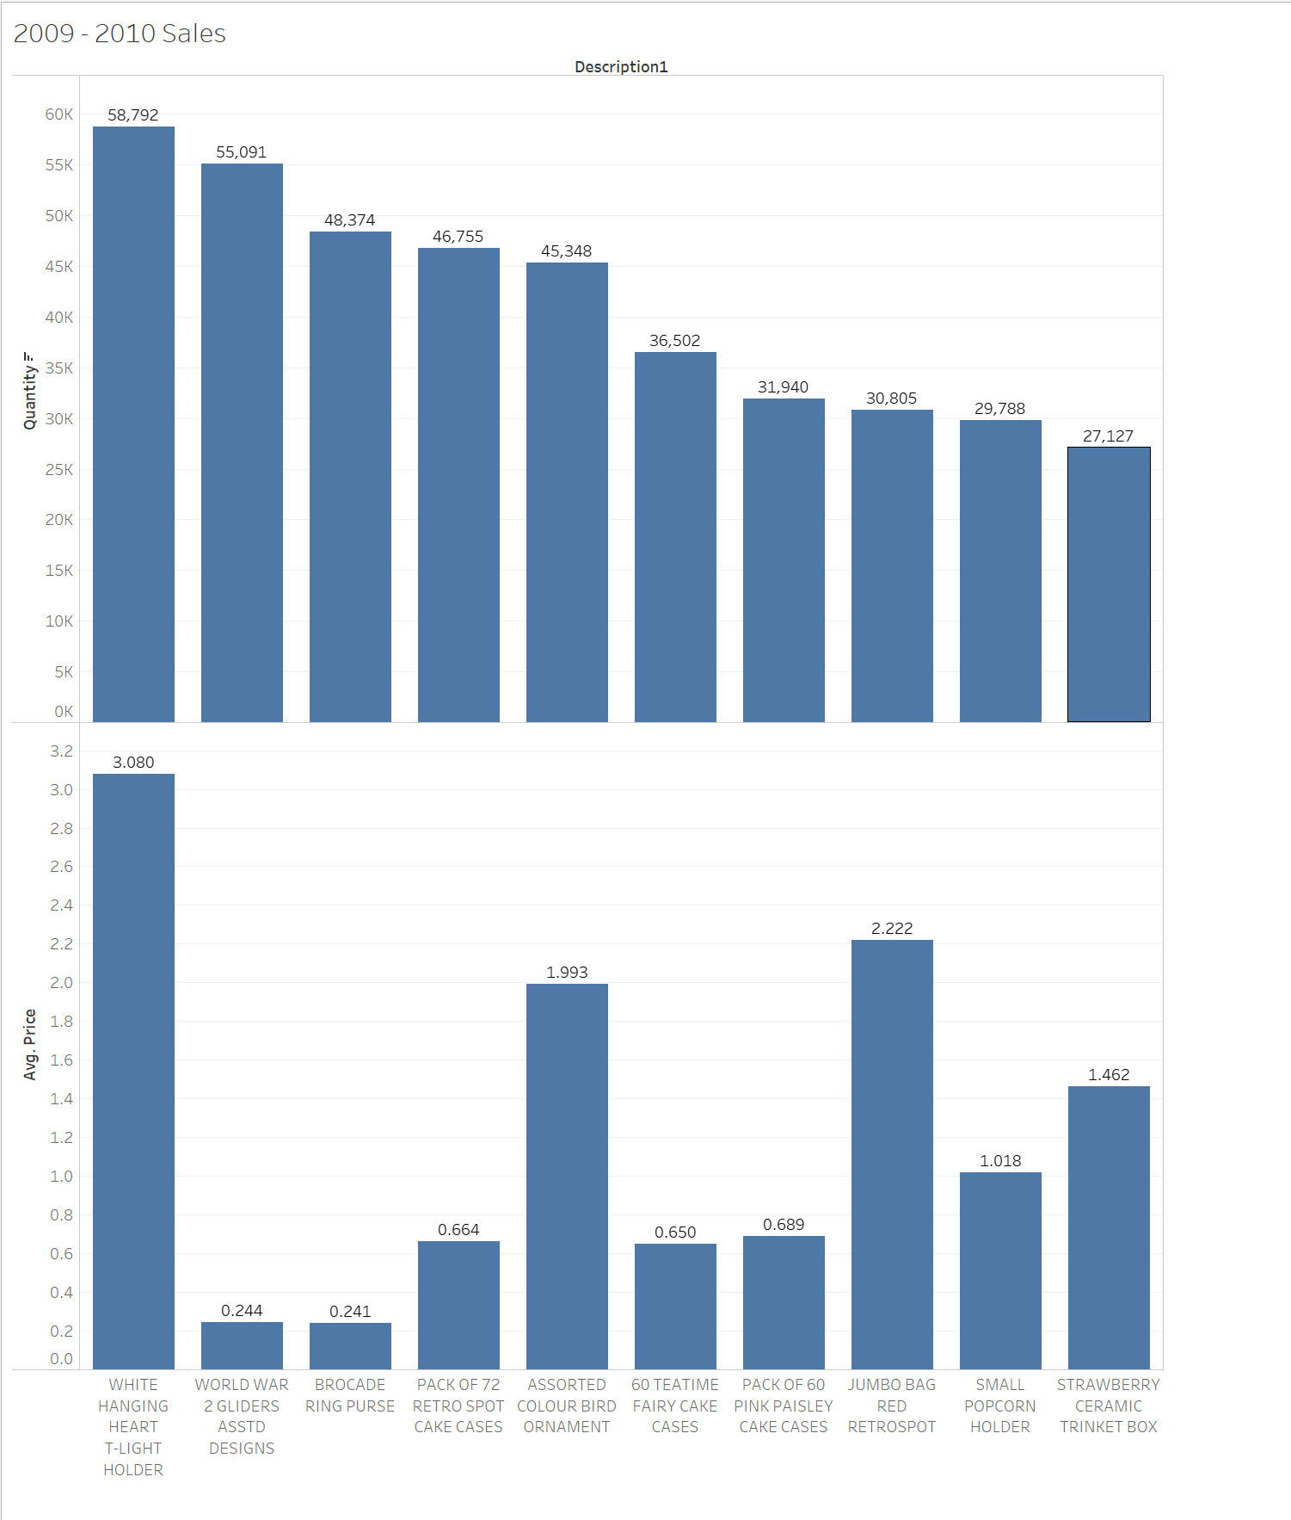
Figure 1 – 2009 – 2010 Top 10 Sales
As you can see the top selling item for the financial year was the World War II Gliders Assorted designs by 58,792 at an average selling price of 0.244.
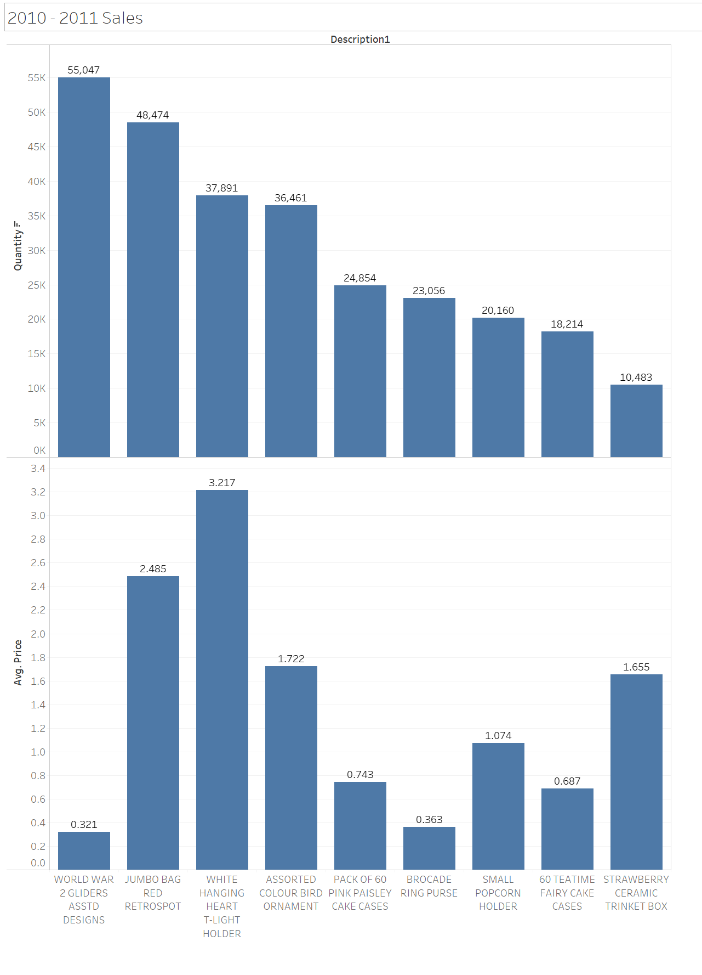
Figure 2 – 2010 – 2011 Top 10 Sales
From what this chart shows up the World War II Gliders Assorted is still the bestseller for the year but there was a decrease in sales at 58047 with an average price of 0.321 however calculating the profit made more profit was made even though the price increased from $ ‭14,345.248‬ from $ ‭18,633.087‬ next we will looking the T-Test results from R.

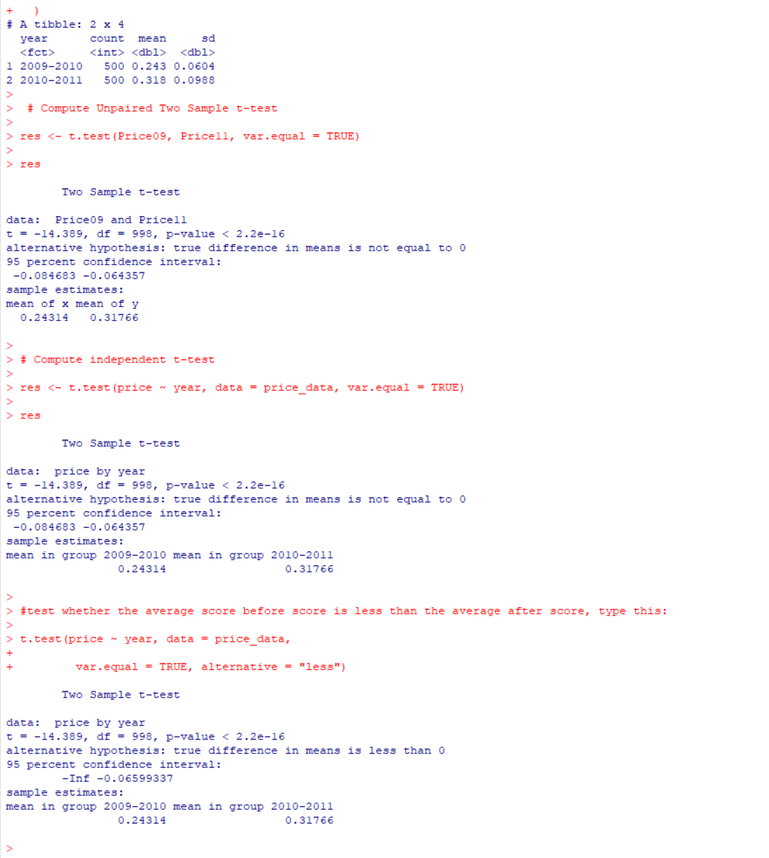
Figure 3 – Summary Statstics and T-Test Results
From these results we can see that the p-value is equal to 2.2e-16 meaning that the hypothesis in the case means it’s true due to how close the value is 0 that price effects There is a relationship between price and the quantity sold of the WW2 Assorted Gliders. Therefore, it would be worth further testing in order to find the ideal price to sell these items for in order to maximize profits.
Study of Geographical Location. The second hypothesis that I will be testing for this report which is the idea that the UK should have a greater amount of customers than the global share.
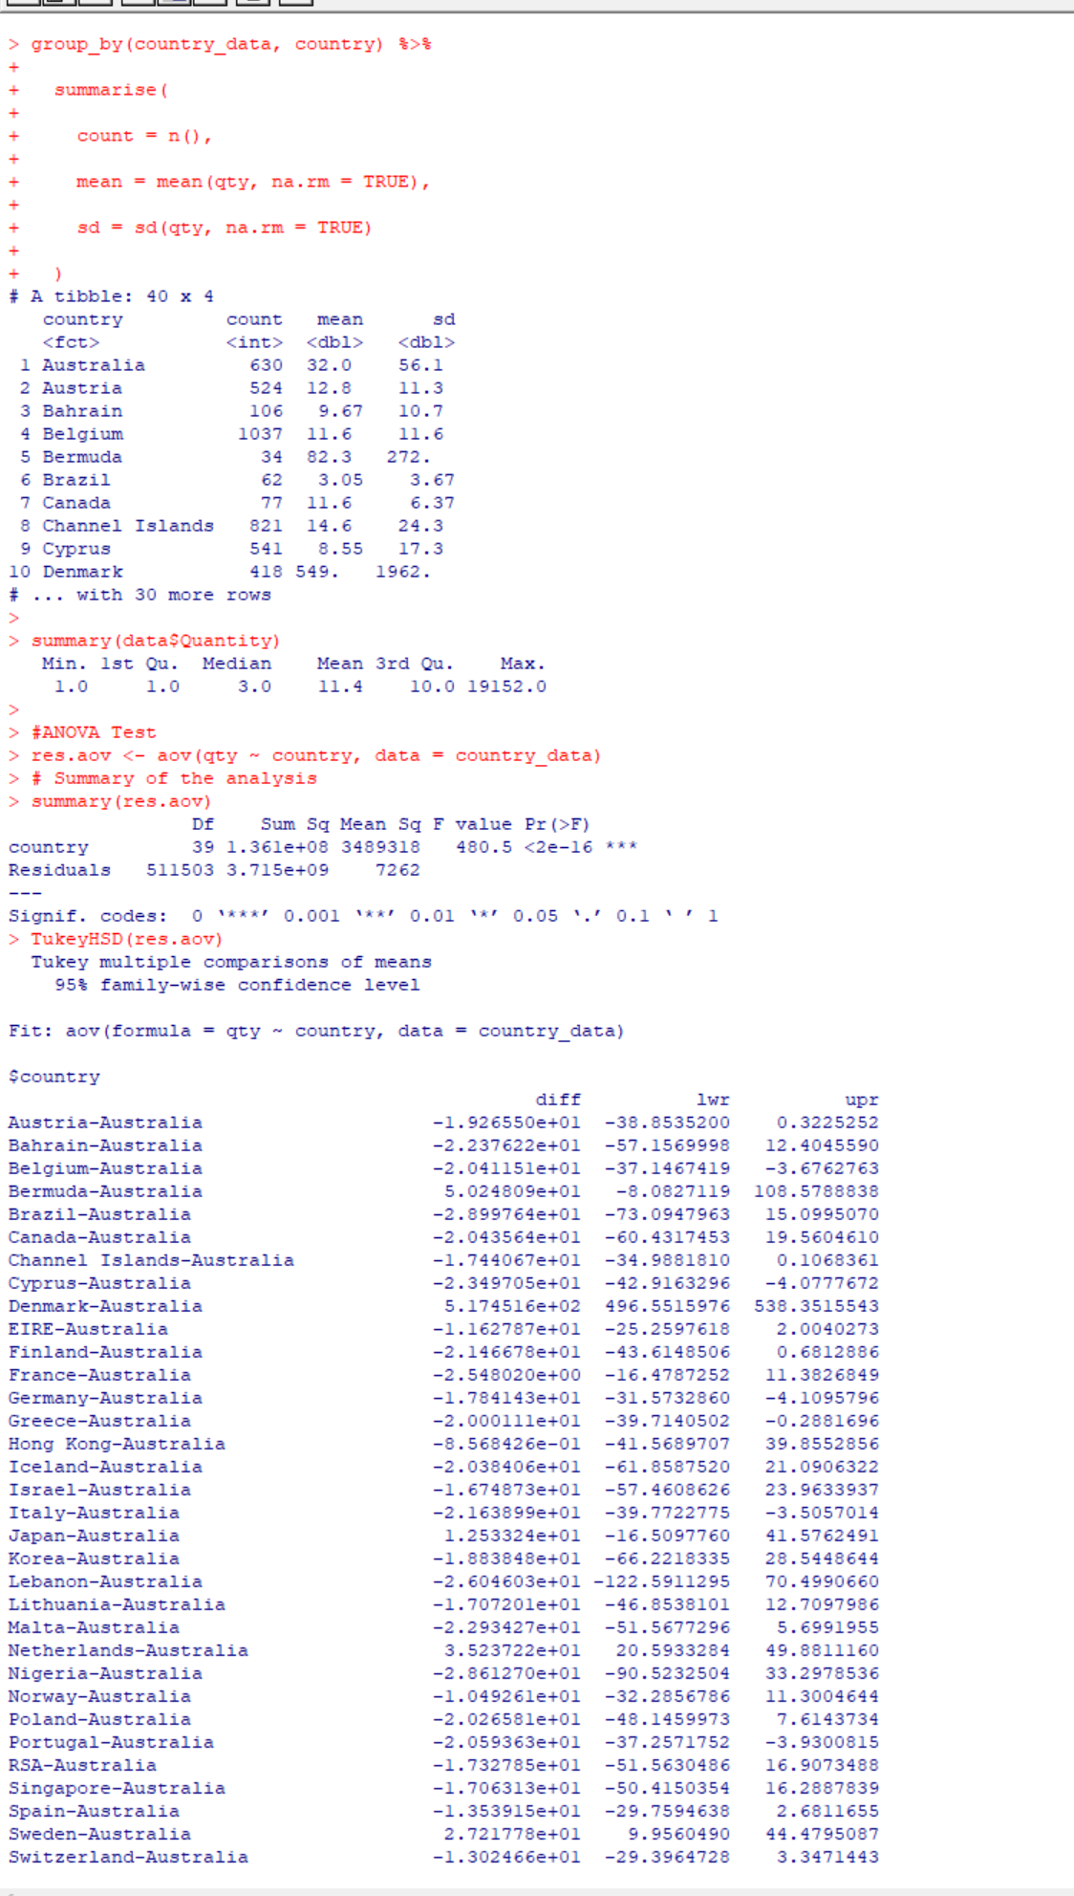
Figure 4 – Summary Statstics and Anova Test results
As you can see here the F-Value is 480.5 and the Prob(F) Statistic test is <2e-16 as this number is close to 0 we have support out null hypothesis that a majority of the business done is on the home turf and that could be a potential for growth to outside the Homefront but it would need further researching.
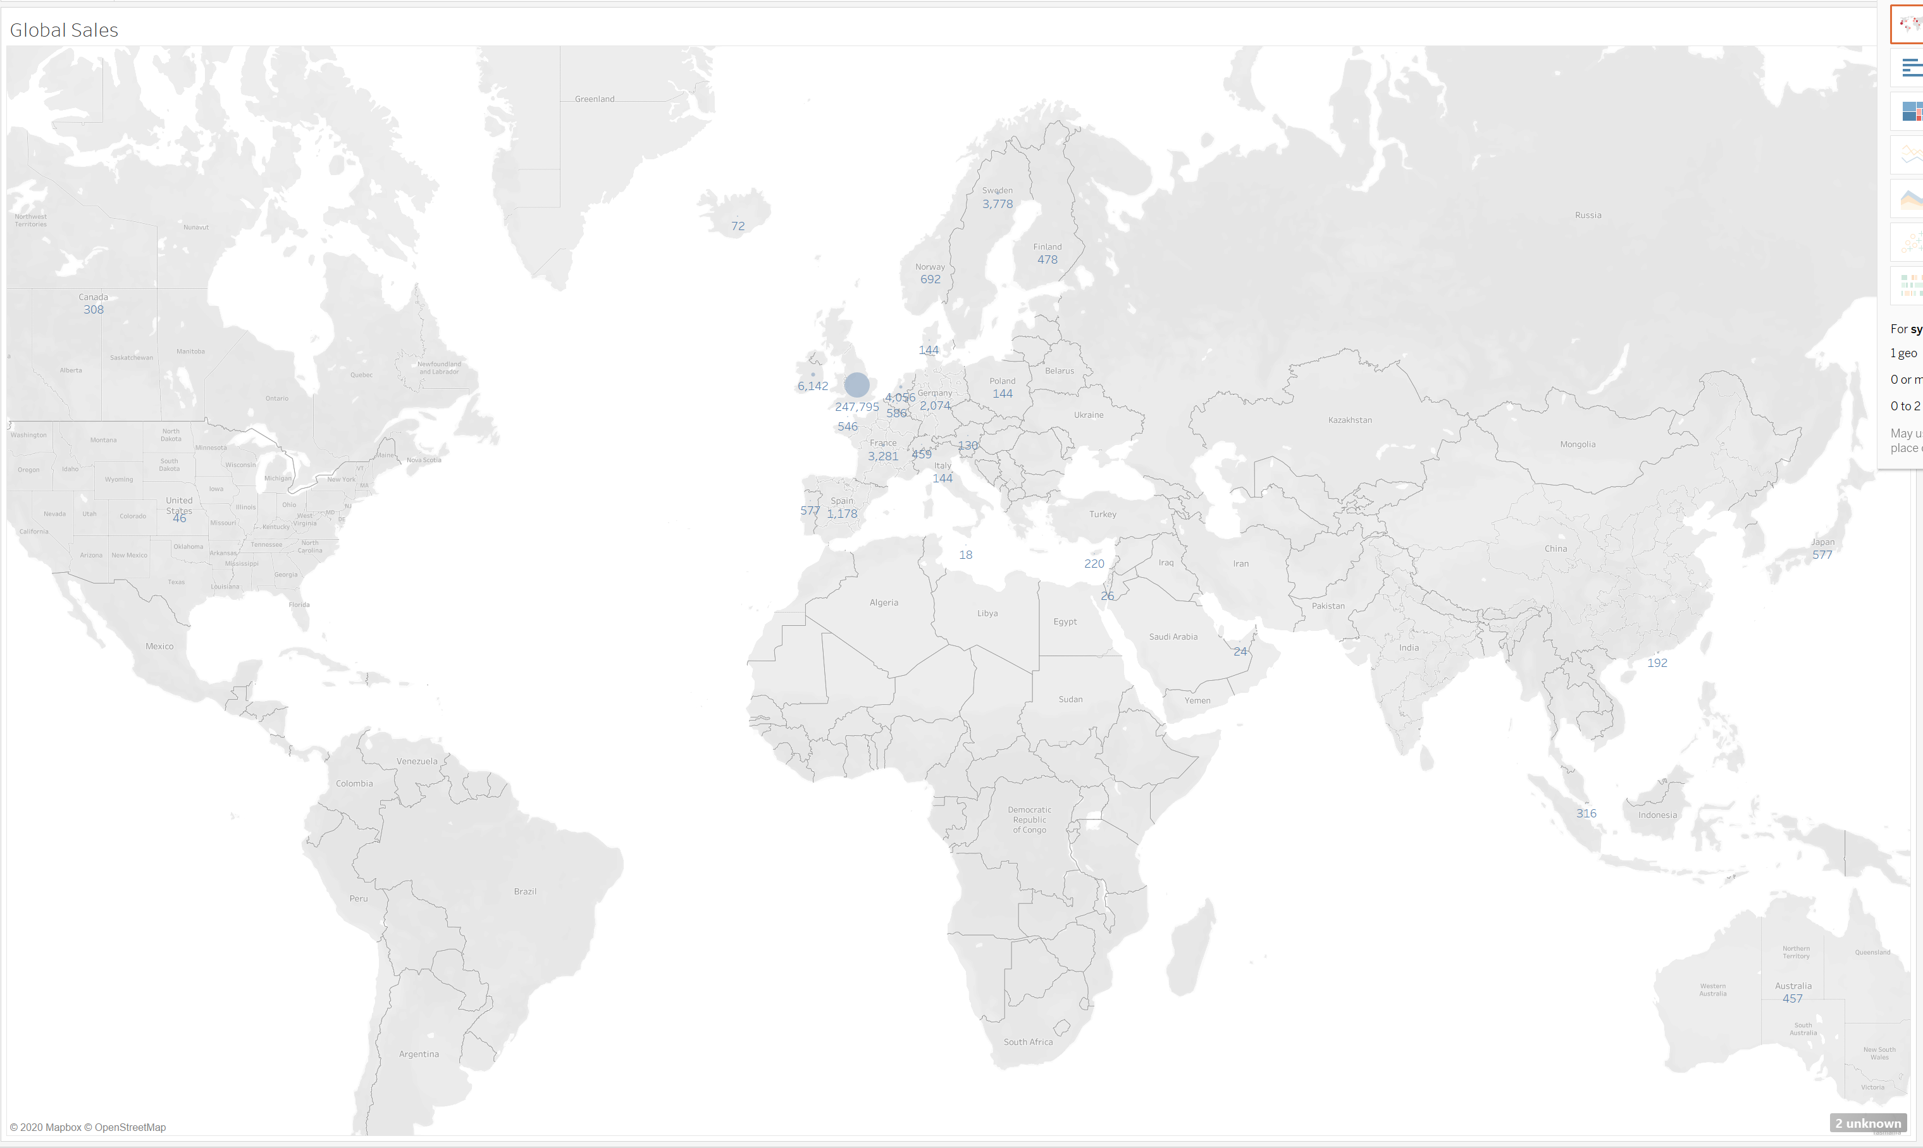
Figure 5 – Global map of Sales compared to Global Location
From this chart we are able to see that 247,795 of the company sales for 2009-2010 were locally from the UK. Meaning that from a business stragegy standpoint it is important to continue market stragergies for the local market, but there is also plenty of room to consider the global market epecillaly within the Eurpoe region.

References
Ataman, M. B., Van Heerde, H. J., & Mela, C. F. (2010). The Long-Term Effect of Marketing Strategy on Brand Sales. Journal of Marketing Research (JMR), 47(5), 866.
Barasch, R. (2019, January 14). The Power of Big Data in Retail. Envestnet | Yodlee. https://www.yodlee.com/retail-merchants/the-power-of-big-data-in-retail
Chen, D. (2019). Online Retail II Data Set [Data file]. Retrieved from https://archive.ics.uci.edu/ml/datasets/Online+Retail+II
Data Science Primer. (2019). Data Cleaning. https://elitedatascience.com/data-cleaning
Goyal, P. (2019). Measures to Improve Sales Promotion Effectiveness: The Consumer Perspective. Pranjana: The Journal of Management Awareness, 22(1), 54–67. https://doi.org/10.5958/0974-0945.2019.00005.0
Yang, B., & Mattila, A. S. (2020). How rational thinking style affects sales promotion effectiveness. International Journal of Hospitality Management, 84. https://doi.org/10.1016/j.ijhm.2019.102335

