ROC vs. Lift Charts
Student Name
Colorado State University – Global Campus
ROC vs. Lift Charts
When creating data mining projects and going through all the necessary steps: determining meaning of the project, obtaining the data set to be used, cleaning the data, decide what data mining task is needed, partition the data, pick data mining techniques, use algorithms for your task, interpret your results, and deploy the model we come to a situation where in predictivities models where we need to analyses the accuracy of the predictive model. In this paper we will be explore two of these methods the Receiving Operating Characteristic (ROC) a Lift Charts, the goal for this paper will be discussing explain what each model is used for and some of limitations of both models.
Receiving Operating Characteristic (ROC)
The ROC curve is a tool that is used to compare predictive models, in the simplest of terms in is a plot of the true positive rate against the false positive rate. The True positive Rate is the percentage of values that has been correctly classified as a Positive value. The false rate then would make sense to be the inverse of the positive rate the percentage of negative values that have been falsely classified as positive. There is a relationship between the True positive rate and false positive rate, for example if all values were classified correctly classified then the TPR and FPR will be 100%, and the reverse is true if all values are falsely classified both rates will be 0%.
An example of using ROC would be in the medical sector when try to identify the accuracy of medical tests typically used to discriminate between patient states “diseased” and “non-diseased”. (Hajian-Tilaki, 2013). When we look at ROC curve we are looking for a “Seperator” scale which we can find by looking at the pair of overlapping distributions.

Figure 1
Overlapping Distributions example
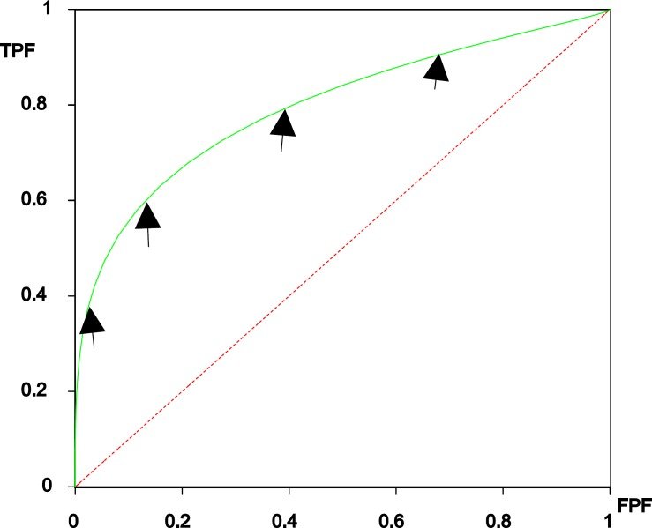
Note. ROC curve derived from two overlapping distributions. Created by Karimollah Hajian-Tilaki, 2013, Caspian J Intern Med, 4(2), pp 627–635.
Lift Chart
The last evaluation tool we will look at this paper is Lift Chart; in order to understand a lift chart, we need to first understand Lift. Lift is a measure of how effective a predicative model is based on the ratio between the results from the predictive model and without the predicative model. So with this concept you could compare the expected results of random selection of a population or using the data mining model to find the population who is the best fit. A lift chart shows just this, a data mining model if it were perfect could perfectly identify the correct results 100% rather than going off a random selection, a lift chart represents a ideal line that the model should follow vs. the random selection and improvement from a random guess is considered lift.
Figure 2
Lift Chart Example Population % of Target %(Female)
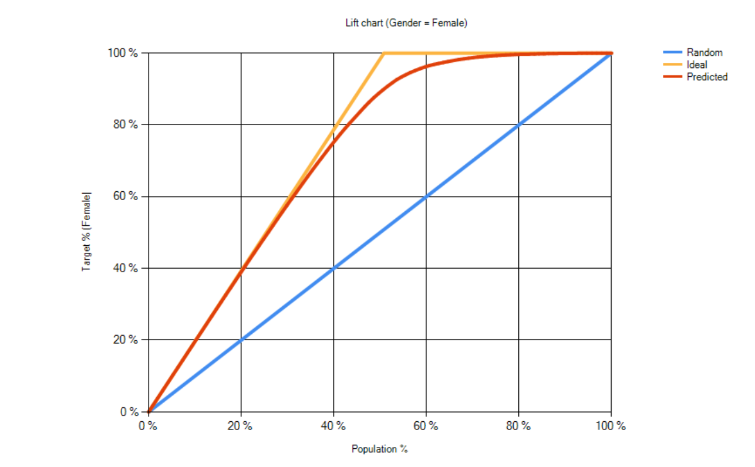
Note. ROC curve derived from two overlapping distributions. Created by Bayes Server retrieved from https://www.bayesserver.com/docs/charts/lift-chart.
According to Kea, Chiang, and Chang some of the restrictions with using lift charts is that while this chart could show the existence of influential factors but you would need the influence function and local influence in order to offer those impacts (2018).

References
Bayer Server. (n.d.). Lift Chart. https://www.bayesserver.com/docs/charts/lift-chart
Hajian-Tilaki K. (2013). Receiver Operating Characteristic (ROC) Curve Analysis for Medical Diagnostic Test Evaluation. Caspian journal of internal medicine, 4(2), 627–635.
Ke, B.-S., Chiang, A. J., & Chang, Y. I. (2018). Influence Analysis for the Area Under the Receiver Operating Characteristic Curve. Journal of Biopharmaceutical Statistics, 28(4), 722–734. https://doi.org/10.1080/10543406.2017.1377728

