Module 6: Critical Thinking – Option 1
Ty Cook
Colorado State University – Global Campus
Module 6: Critical Thinking – Option 1
Figure 1. Completed Diagram for Logistic Regression for Claims Data
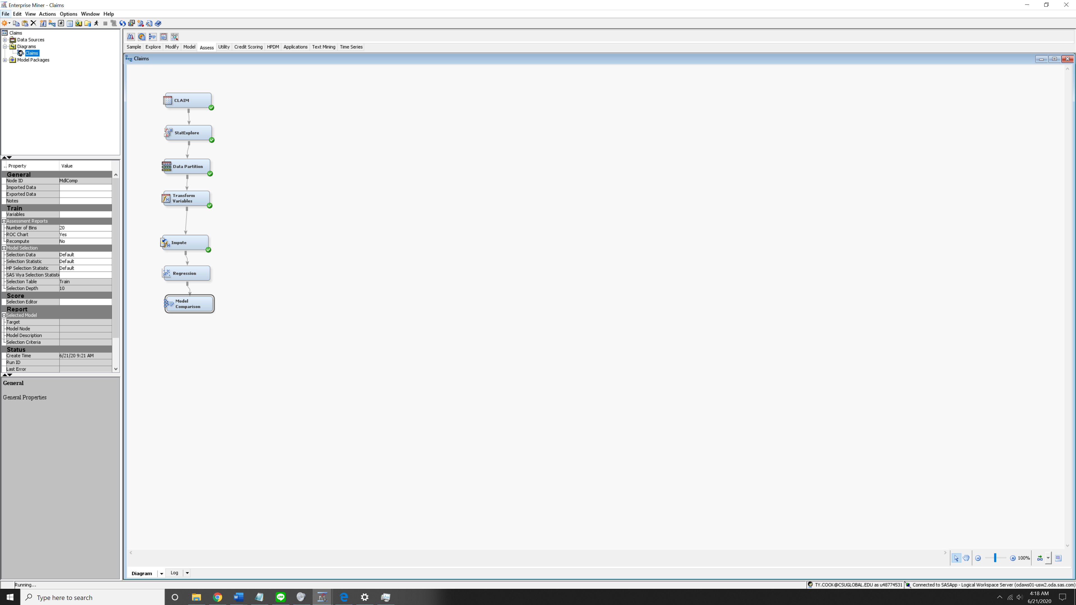
Figure 2. Logistics Regression Model Results
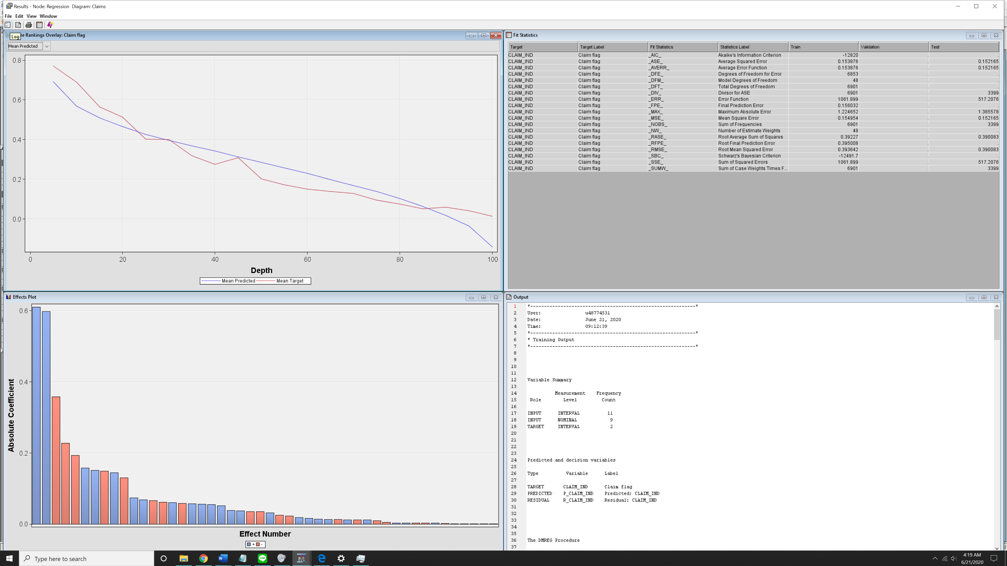

Figure 3. Model Comparison
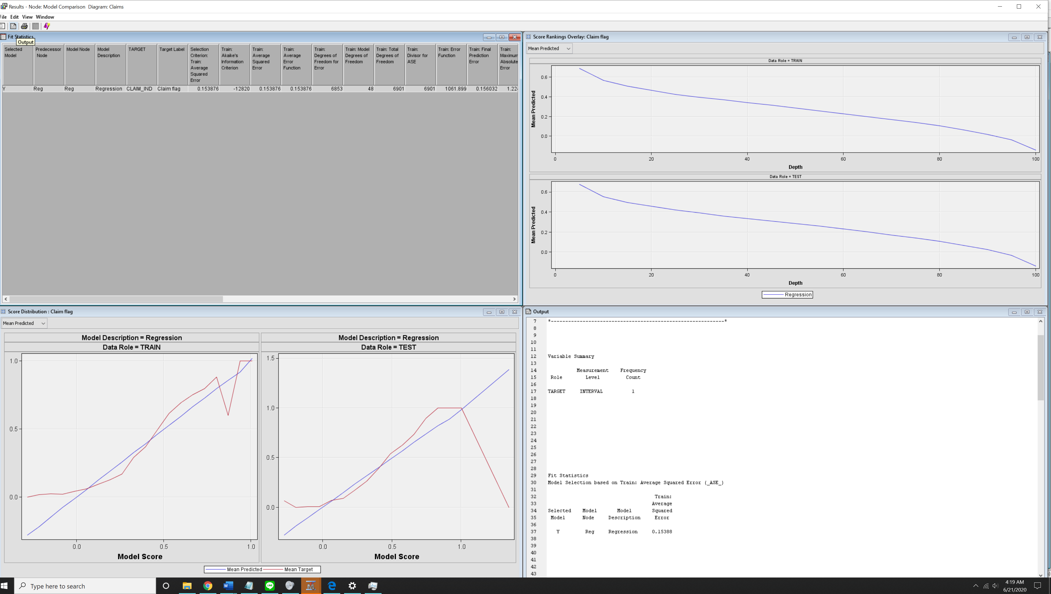

For the assignment this week I decided to use run predictive analytics on the Claims dataset. I decided to run a logistic regression model based on this week’s discussion as the topic was still fresh in my mind and seemed like something that I wanted to have more experience with working with,
In the preparation stage I first created a new project called Claims, and ensure that the Claims dataset was in the library. After that I added the dataset Claim as a data source into the claims project using the data source wizard. From there I created a new diagram in Claims titled Claims and drag and dropped the Claim Data source onto my diagram. After that I examined the different variables that this data source contained in order to consider what data analytic problem I would examine for this assignment. For this project I made the following changes in for the variables, I changed the roles of CLAIM_IND in both CLAIM_AMOUNT to Target roles as these are response variables for this data analytic problem. After that I changed the Level of variables that had character in the data to Nominal and then changed the data that had numeric data to Interval as the data source had these variables misclassified.
Next, I would run Statexplore to gain insight on the summary statistics of this data source and understand if I needed to do any transformations on the data in for the purpose of this assignment. From statexplore I realized that I would need to partition my data, transform the variables, and impute the data in order to replace the missing data variables.
After the missing variables have been dealt with, I went ahead and setup the logistic regression model. “The aim of generalized linear models for a binary dependent variable is to estimate a regression equation that relates the expected value of the dependent variable y to one or more predictor variables, denoted by x” (Manďák, & Hančlová, 2019). Which from looking at Figure 2 we can see the fit of the model that was created. Lastly I wanted to try use the model comparison node to see how the logistic regression fits against Train and Test sets, I could see that this node could be useful if you had several models that you were trying evaluate which one had a better predictive model.

References
Jan Manďák, & Jana Hančlová. (2019). Use of Logistic Regression for Understanding and Prediction of Customer Churn in Telecommunications. Statistika: Statistics and Economy Journal, 99(2), 129–141.

