Module 3: Critical Thinking – Option 1
Ty Cook
Colorado State University – Global Campus
Module 3: Critical Thinking – Option 1
Figure 1
Complete Diagram Workspace
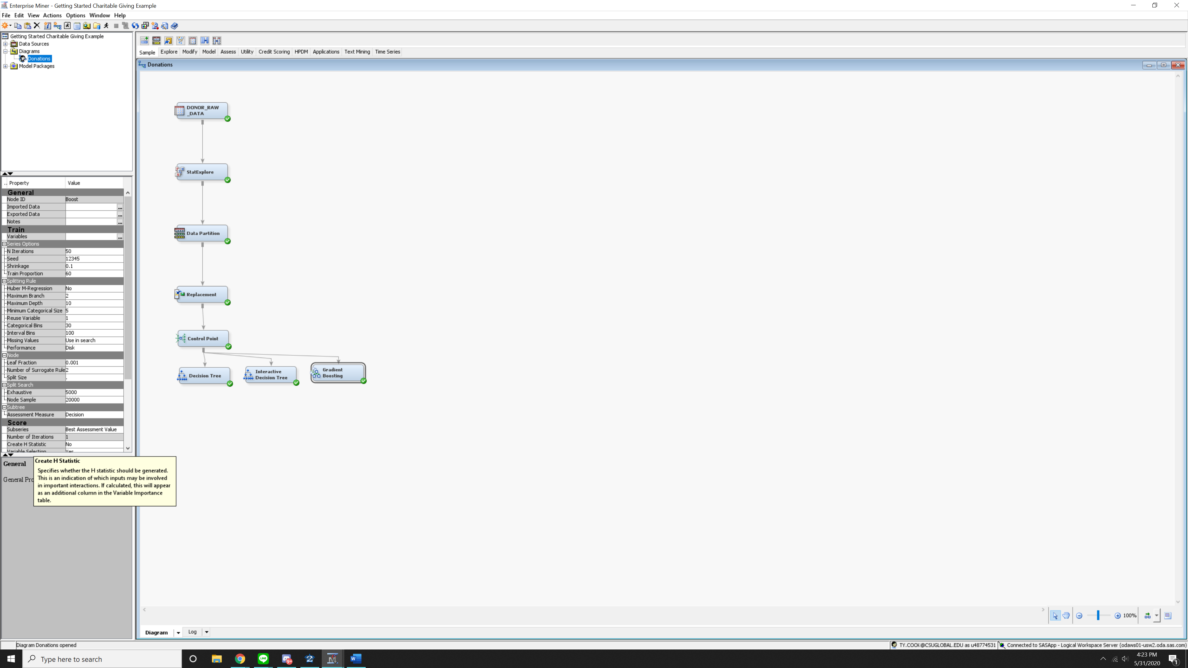
Note. Screenshot showing the complete diagram workspace after diagram trees video

Figure 2
Decision Tree Node results
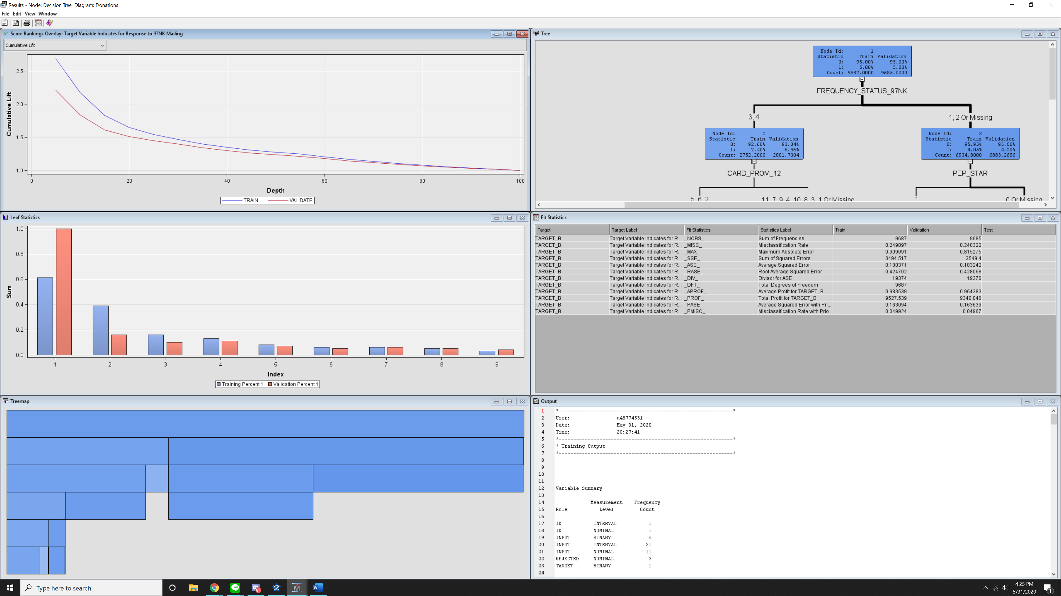
Note. Decision Tree Node results

Figure 3
Interactive Decision Tree Node results
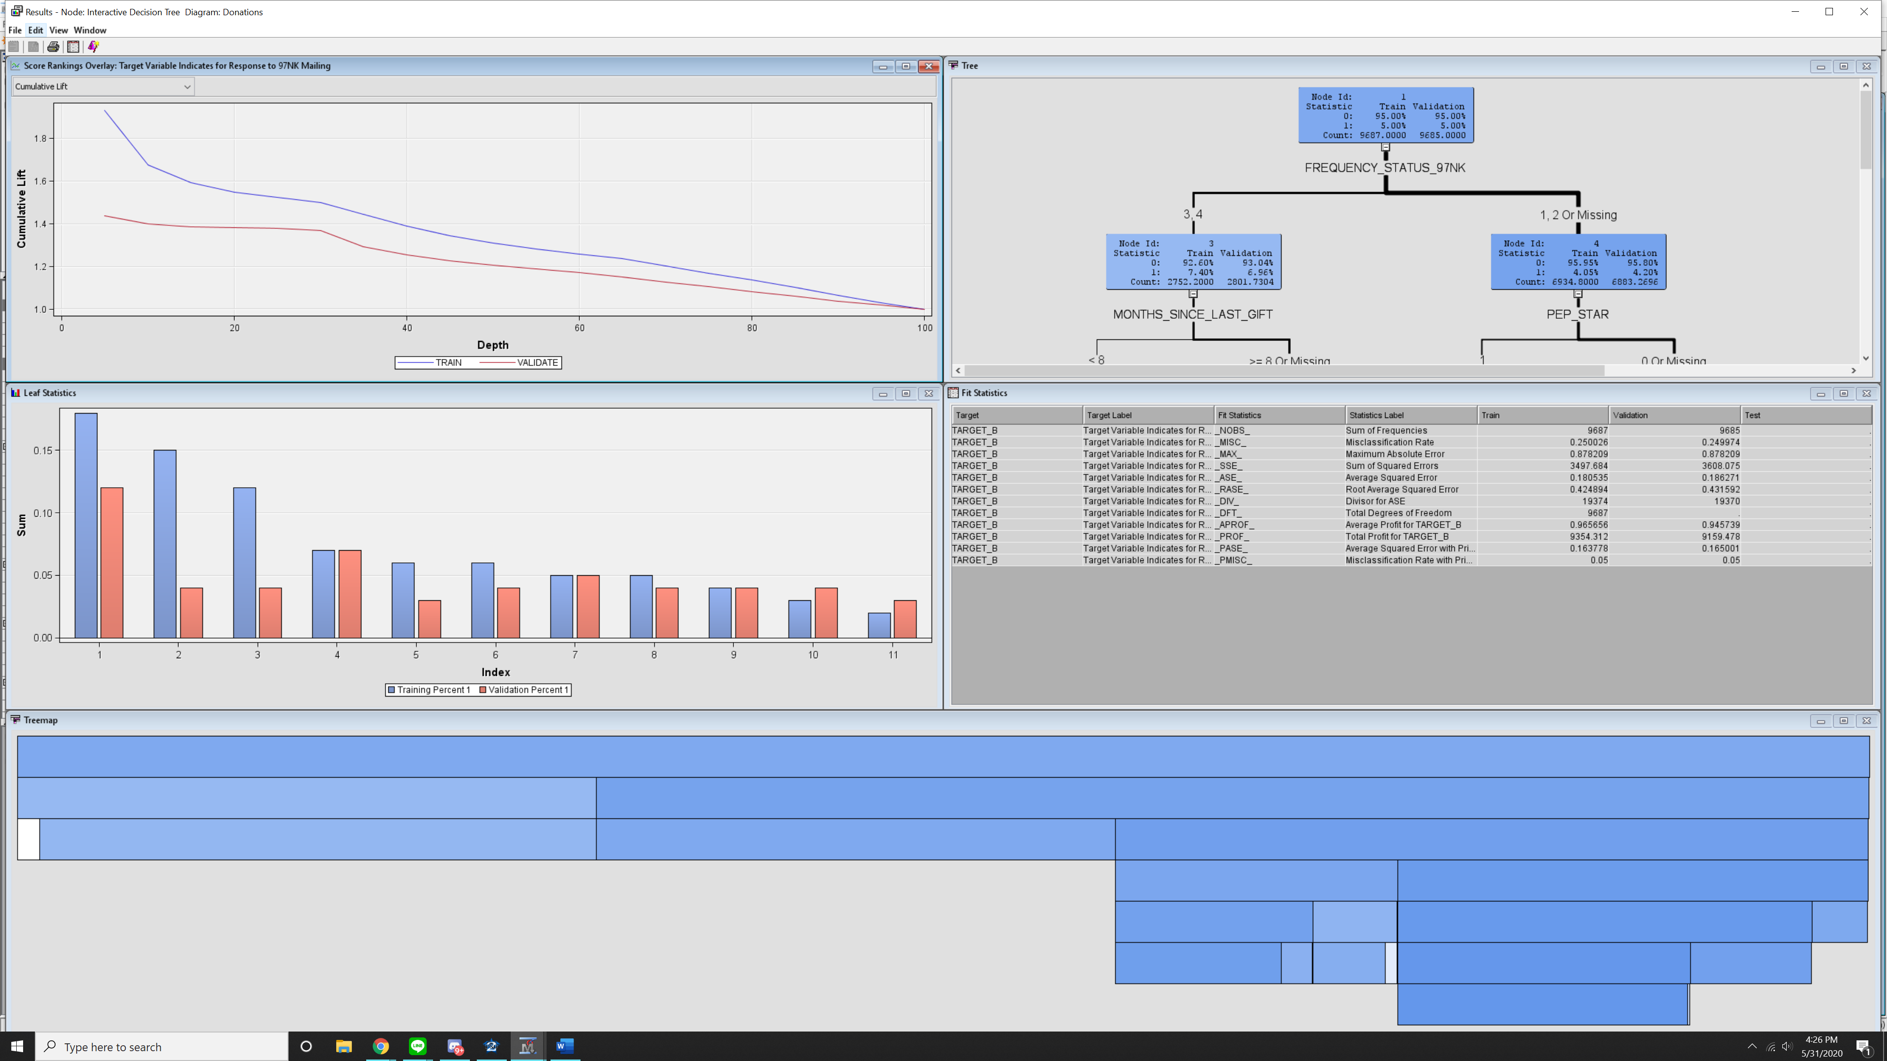
Note. Decision Tree Node results

Figure 4
Gradient Boosting Node results
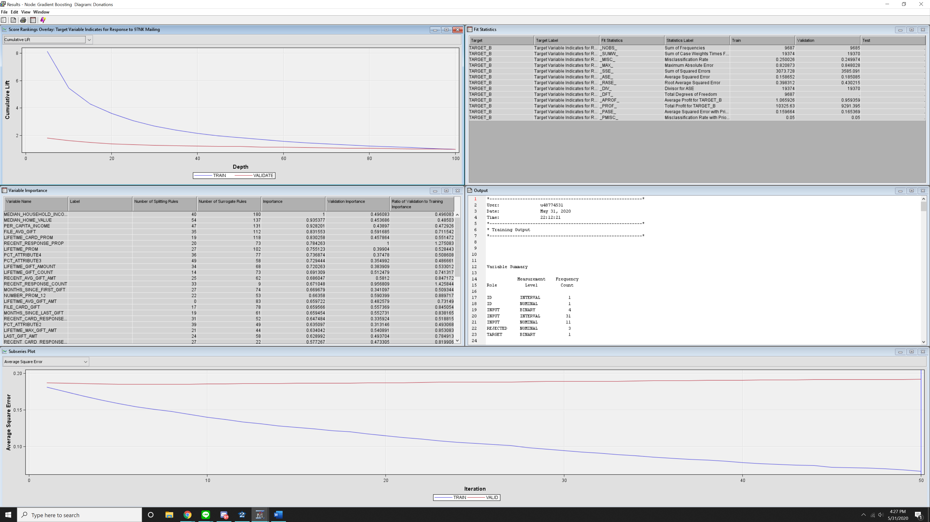
Note. Gradient Boosting Node results

Summary
This week critical thinking assignemnt covered decision trees using SAS Enterprise Miner. I once again am flabergasted by the ease of use of SAS Enterprise Miner to create decesion trees and rules, while I could see how someone could get lost within the properies of the or trying to figure out where the options might be for the a particular function of the decision trees SAS Enterprise Miner continues to prove itself as a strong tool in our data anlytic arsenal.
The first step this week was to create a control point node which would be the junction between the three decision tree models, which is nice to see there is way to have multiple nodes on diagram and not have to switch models around.
Next was creating and setting up the decsion tree node. The video showed us how to setup the the depth of the model, setting up the leaf size, setting up the number of surrogatge rules, and where to find the assessment measure options for are in the propeties of the decision tree node. It was cool to learn about the Node Rules option in results screen in order to look at the if-then rules for each leaf node in the decision tree to allow us to analyse the model.
The next model was the interactive decision tree model, which taught me how to split the node and how to train this model. To do this the video either looking at a rule to split bassed on log values, or even edit a rule based on the results we are trying to find.
The last model we looked at briefly was the gradient boosting node, which uses a partioning alogrithim in order search for the parition that is the best fit for a single variable which will produce a series of decision trees that creates a single predicitive model.
It is interesting to see each of the models the first which was automatically trained, one where we “interactively” trained a decision tree and lastly the gradient boosting to create a single prdictive model. I can’t wait till next week when we evaulte the models for one that is the best fit.

