Module 5: Critical Thinking – Option 1
Ty Cook
Colorado State University – Global Campus
Module 5: Critical Thinking – Option 1
Figure 1. Completed Diagram with Neural Network and Logistic Regression Nodes added
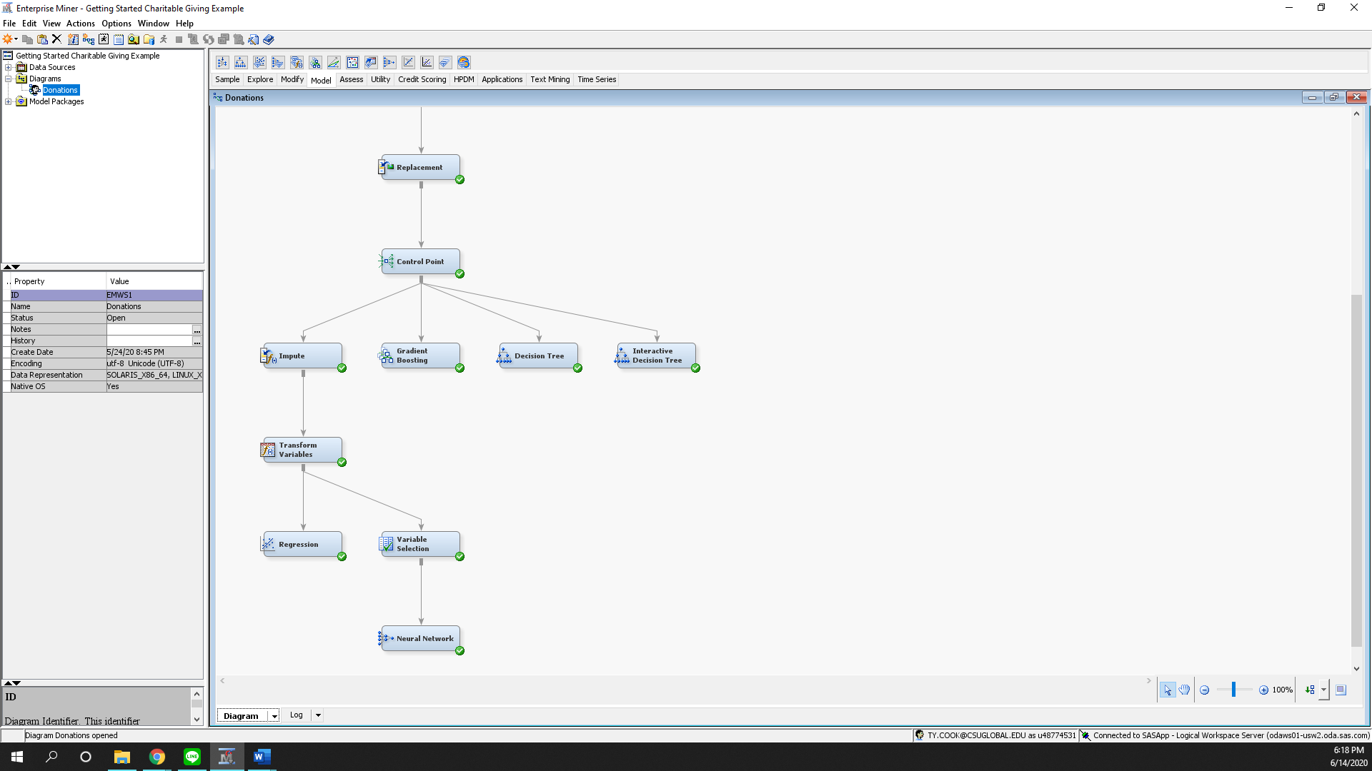
Figure 2. Logistics Regression Node Results
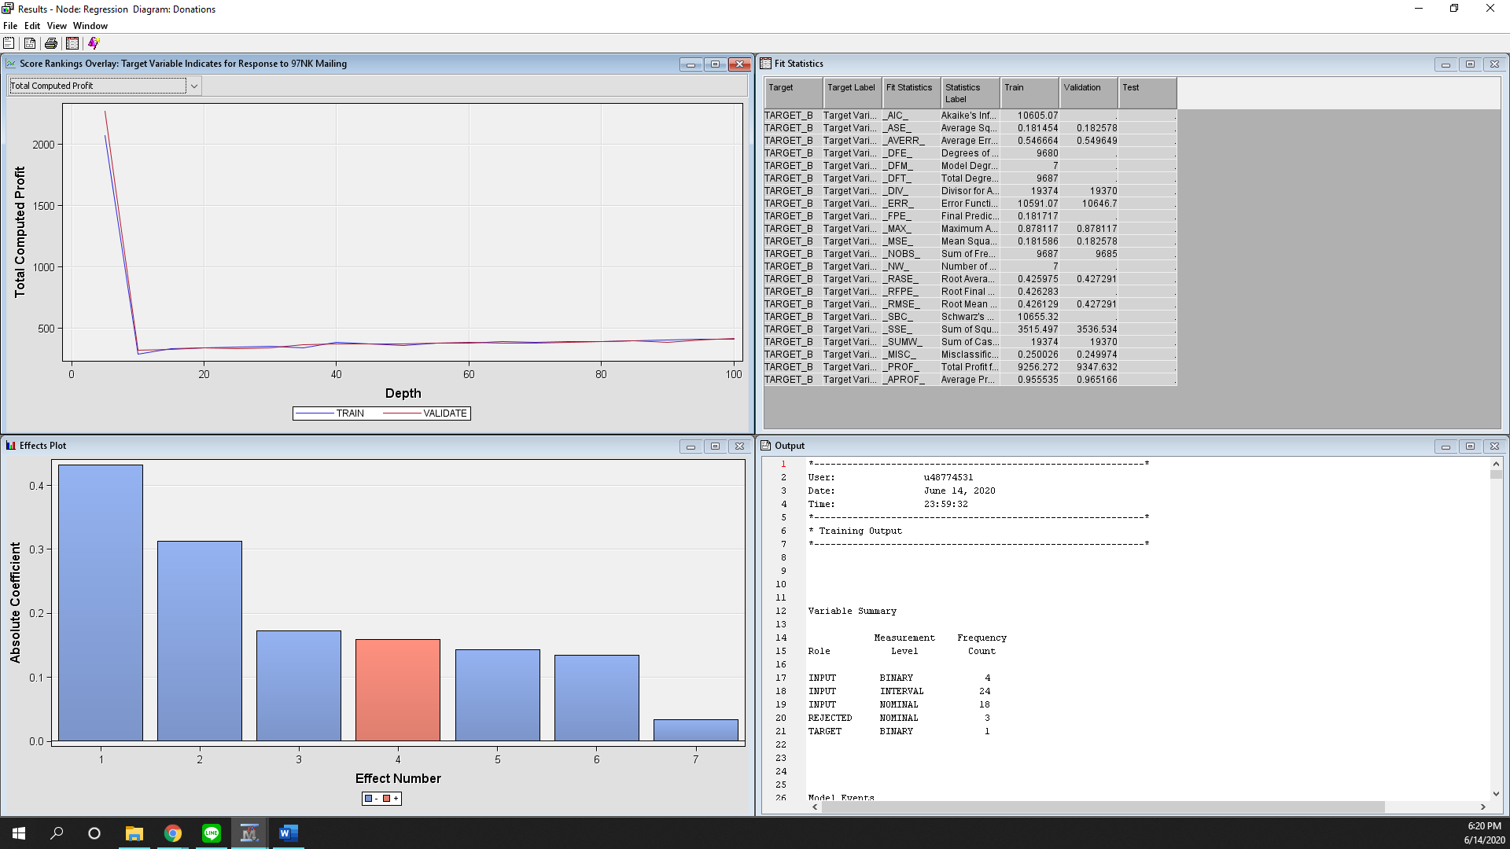

Figure 3. Neural Network Node Results
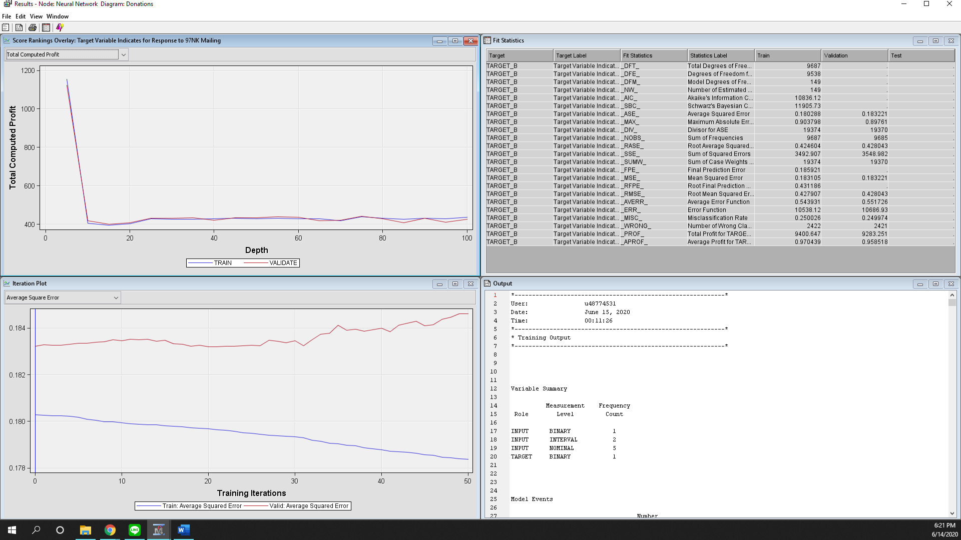

For this assignment we were needed to run and compare two models together the logistics regression model and the neural networking model. Last assignment we studied and implemented three different decision tree models: Gradient Boosting, Decision Tree and Interactive Decision Tree so it was good to see how the process to implement these two other models differed from the previous decision tree models.
The first step was to add Impute node to our control mode that would look for missing variables and replace them. I learned that with decision trees missing values do that cause any problems as you can use splitting rules to select other variable values when there are missing values, however with regression neural network models the will ignore any entry that is missing a value with could reduce the size of the data set which weakens the predictive accuracy of the model.
Next we added a transform node to diagram the purpose of these node allows us stabilize variance, remove nonlinearity, improve additivity and counter non-normality. We transform data in order to create models that are better fits.
The first model I ran for this assignment was the regression node after running both the impute missing values and transformation input values. From here I learned that we can explore function to look at the trained variables in the properties filed in order to look at variables and view histograms of selected variables. From there I would run the node and analyze the result screen and see how well the logistical regression model fit.
The last model I ran for this assignment was the neural network node where I ensured that the direction connections is on and that the number of hidden units is five. After running the this node we wer able to from the results screen that the Logistics Regression model was a better fit the Neural Netowork which was surpising to me.

