Module 2: Critical Thinking – Option 1
Ty Cook
Colorado State University – Global Campus
Module 2: Critical Thinking – Option 1
Figure 1
Complete Diagram Workspace
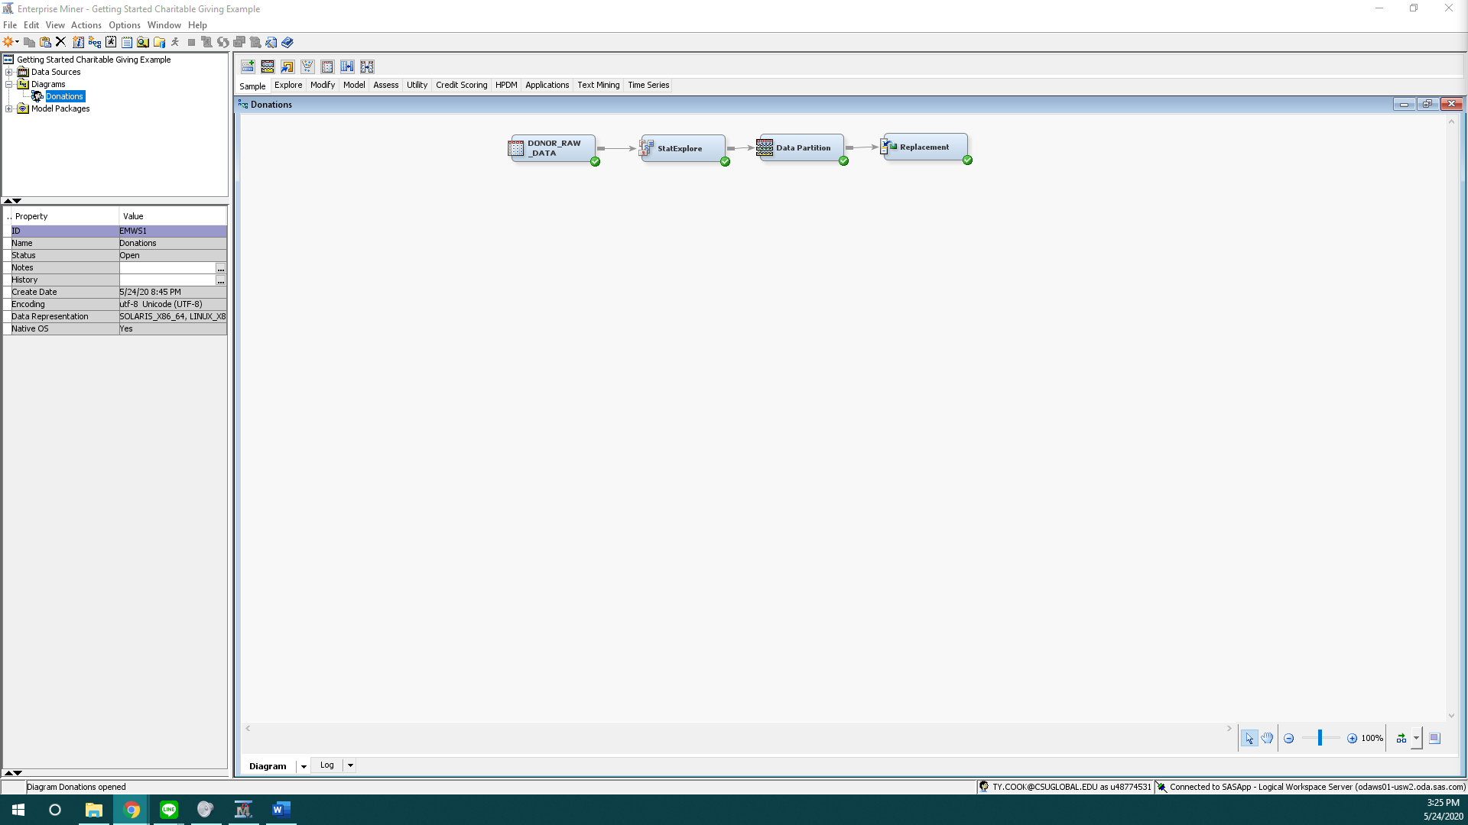
Note. Screenshot showing the complete diagram workspace after following both videos

Figure 2
Donor Diagram Node with results and properties
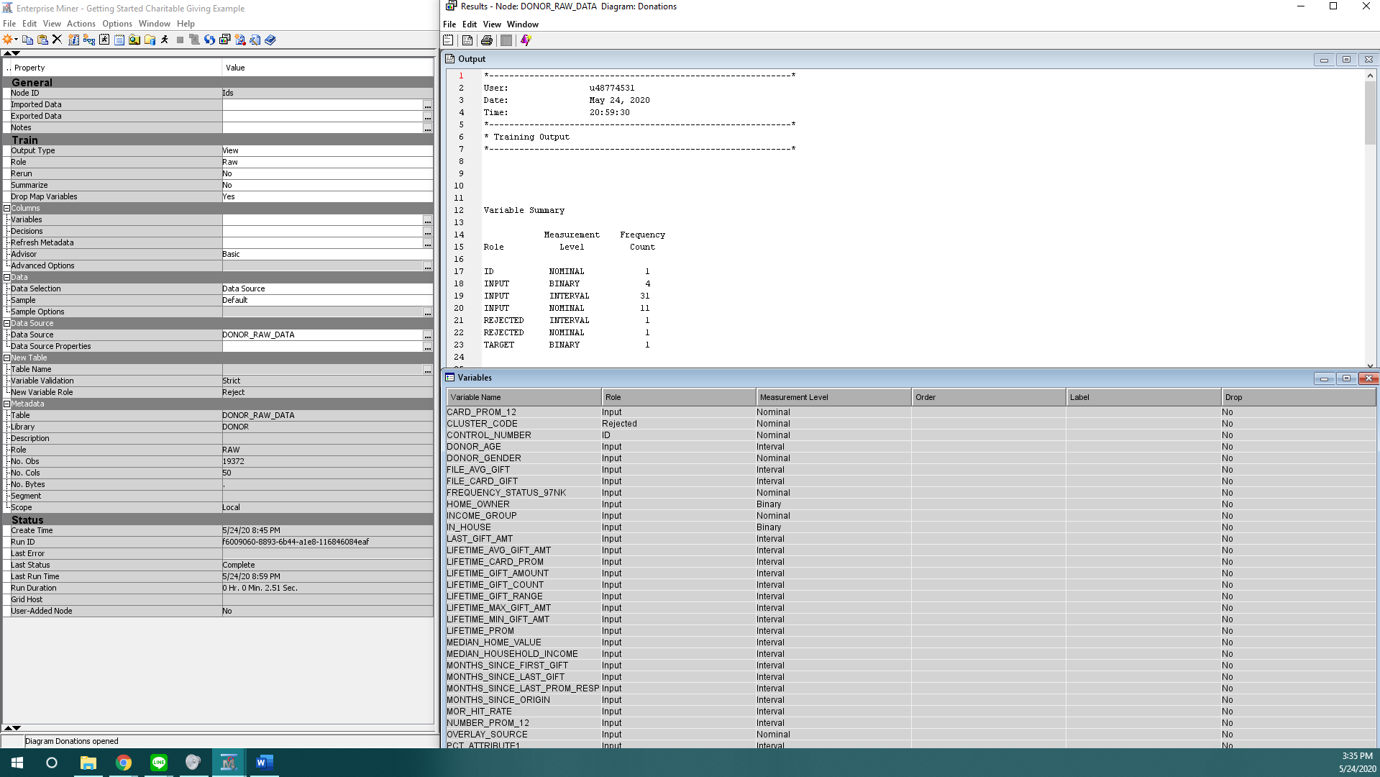
Note. Donor Diagram Node with results and properties

Figure 3
StatExplore node results and property window displayed
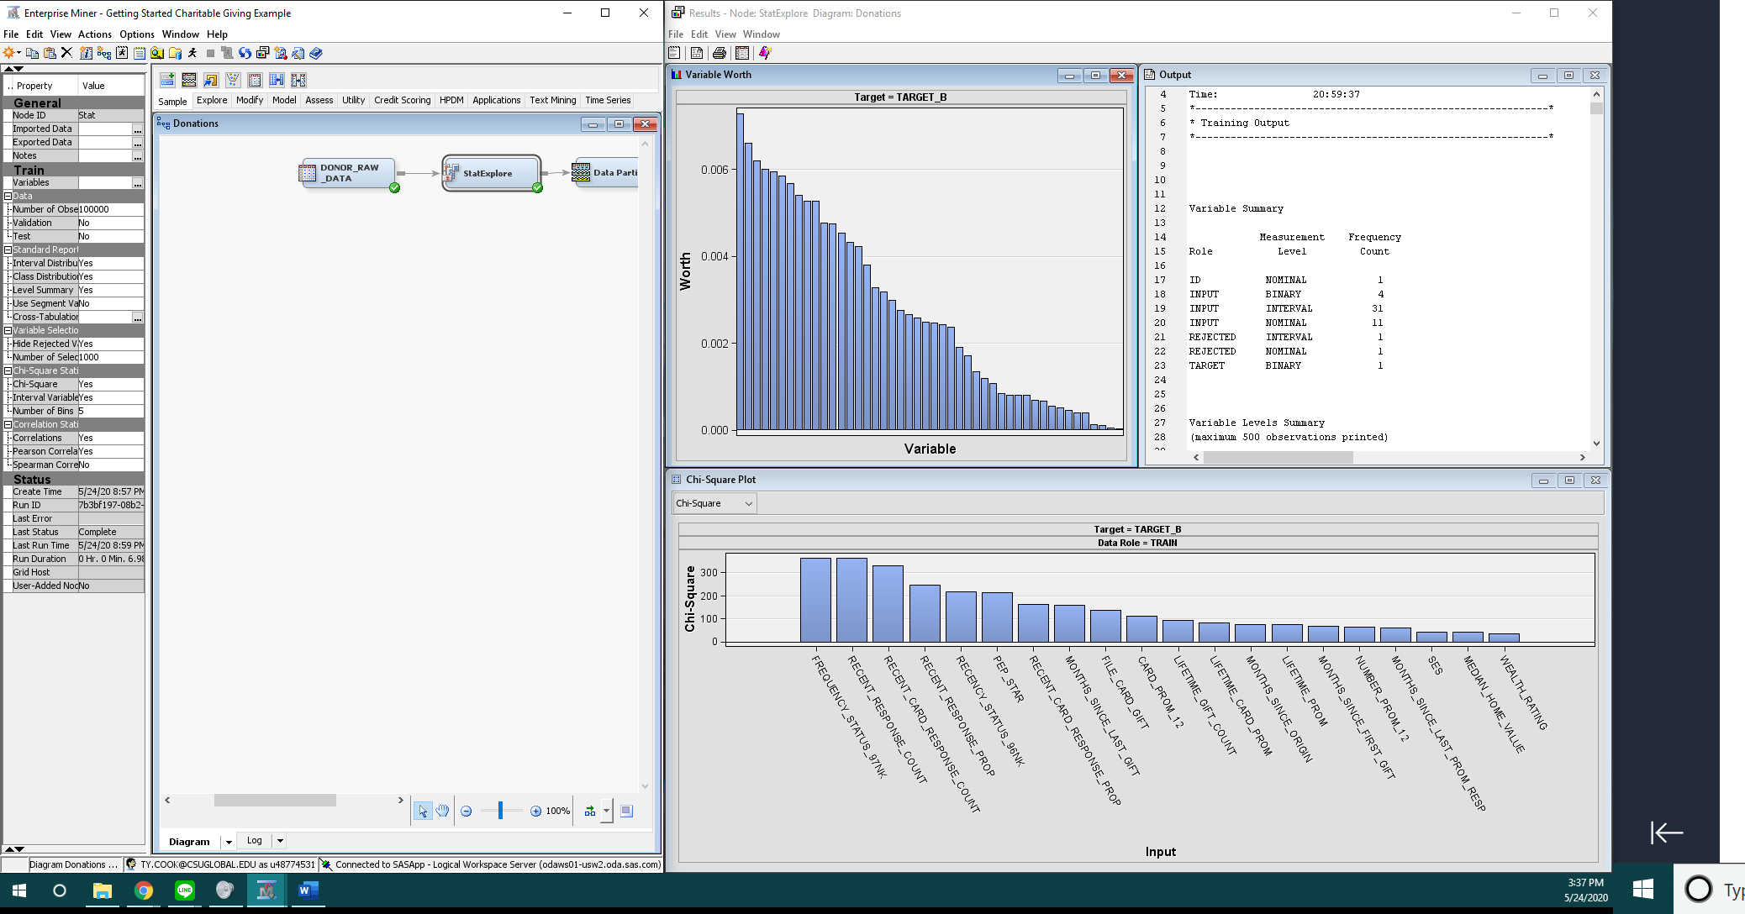
Note. StatExplore node results and property window displayed

Figure 5
Data Partition node results and property window displayed
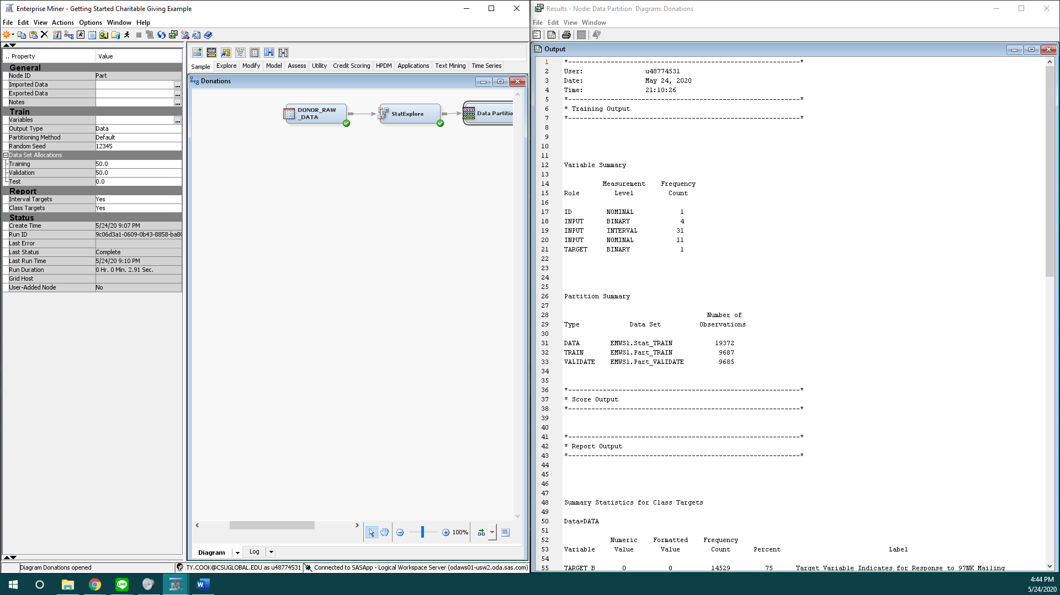
Note. Data Partition node results and property window displayed

Figure 6
Replacement node results and property window displayed
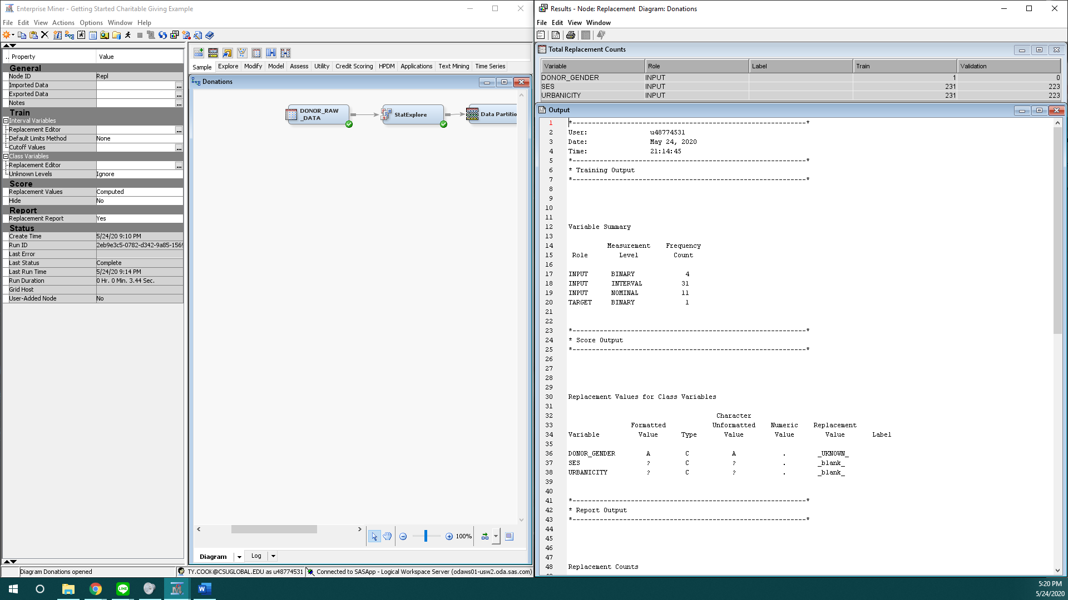
Note. Data Partition node results and property window displayed

Summary
SAS Enterprise Miner is a completely new concept to me, while I have used the SAS University Edition in a previous course MIS500 this would be the first time that I will have used SAS Enterprise Miner. While going through the tutorial videos I was amazed to see how little syntax was needed to be used in comparision to what I’m use to from my previous experience with the RStudio IDE from my last class, I was not use to such a graphical IDE that SAS entprise miner turned out to be. In SAS Enterprise Miner it would of taken be several lines of code in R to perform the same function.
I found it very easy to create a new project import the data set and create a diagram by following the tutorial videos. Like I said in the previous paragraph the visual asepct of the diagram is what was interesting to be and what I learned the most from while performing this crtical thinking assignment. It was very interesting to be how easy is was to select a node function on the diagram and easily input your properties from either a dropdown or text field and then be able to easily apply it to your data set by connectioning the node to your data set both graphically and as a command of the data.
One thing of note I noticed howver is the video had another window that would pop up in order to see the results of the data set, not window popped up for me and I had to manually click to see the results of the data. But it was interesting to see the data partiton and replacement functions and how easy it was to perform these functions in comparsion to R Syntax. It was also a surprise to me how useful the replacement function was from R it was simple to understand and perform from a data exploration scenario.
All in all SAS Enterpise Miner was a surprise to me and I was very pleased to learn what I did from it this week and look forward into learning even more from this IDE.

