Module 1: Critical Thinking – Option 1
Ty Cook
Colorado State University – Global Campus
Module 1: Critical Thinking – Option 1
Figure 1. SAS Account registration and creation
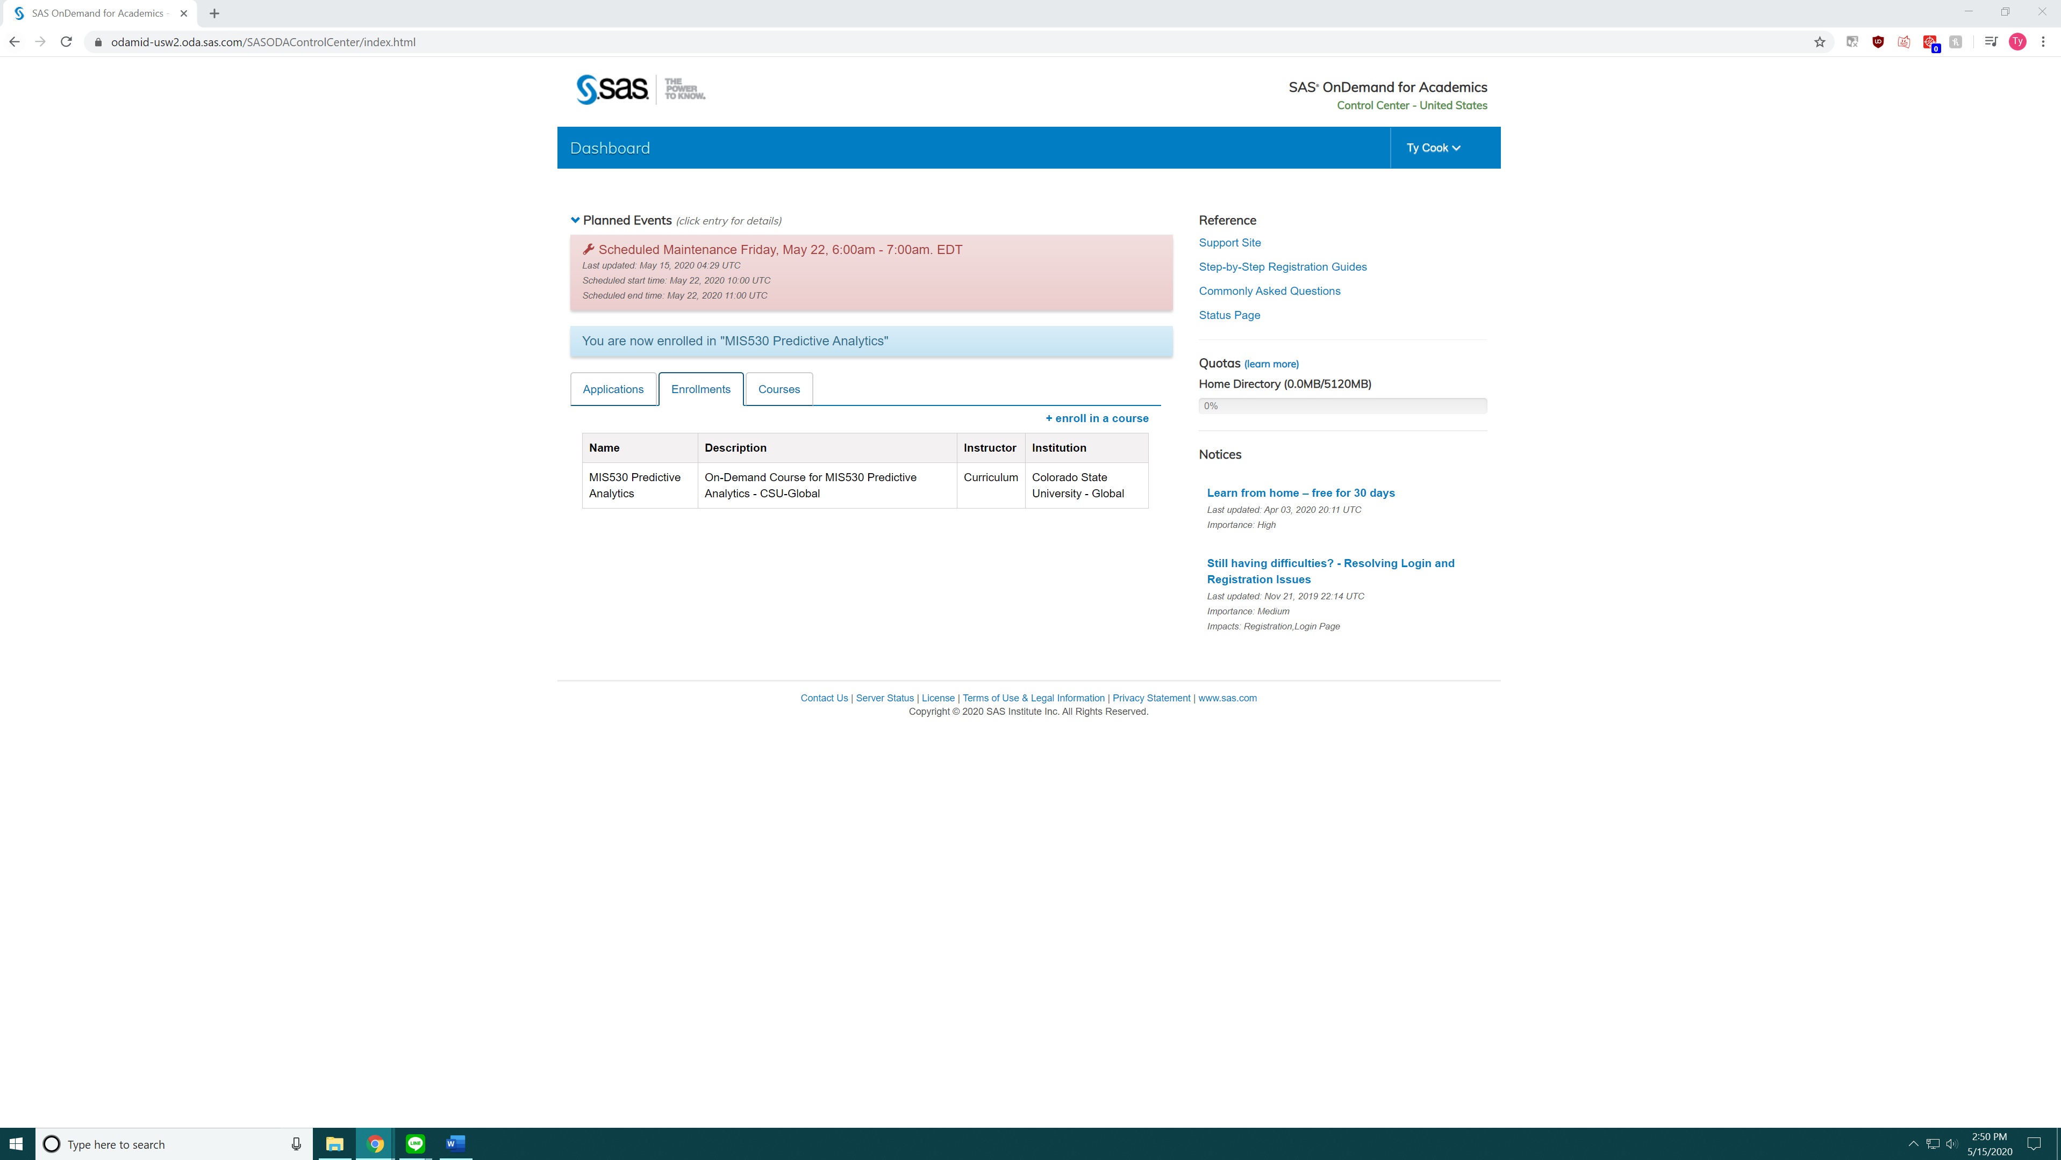
Figure 2. SAS Enterprise Miner Control Center
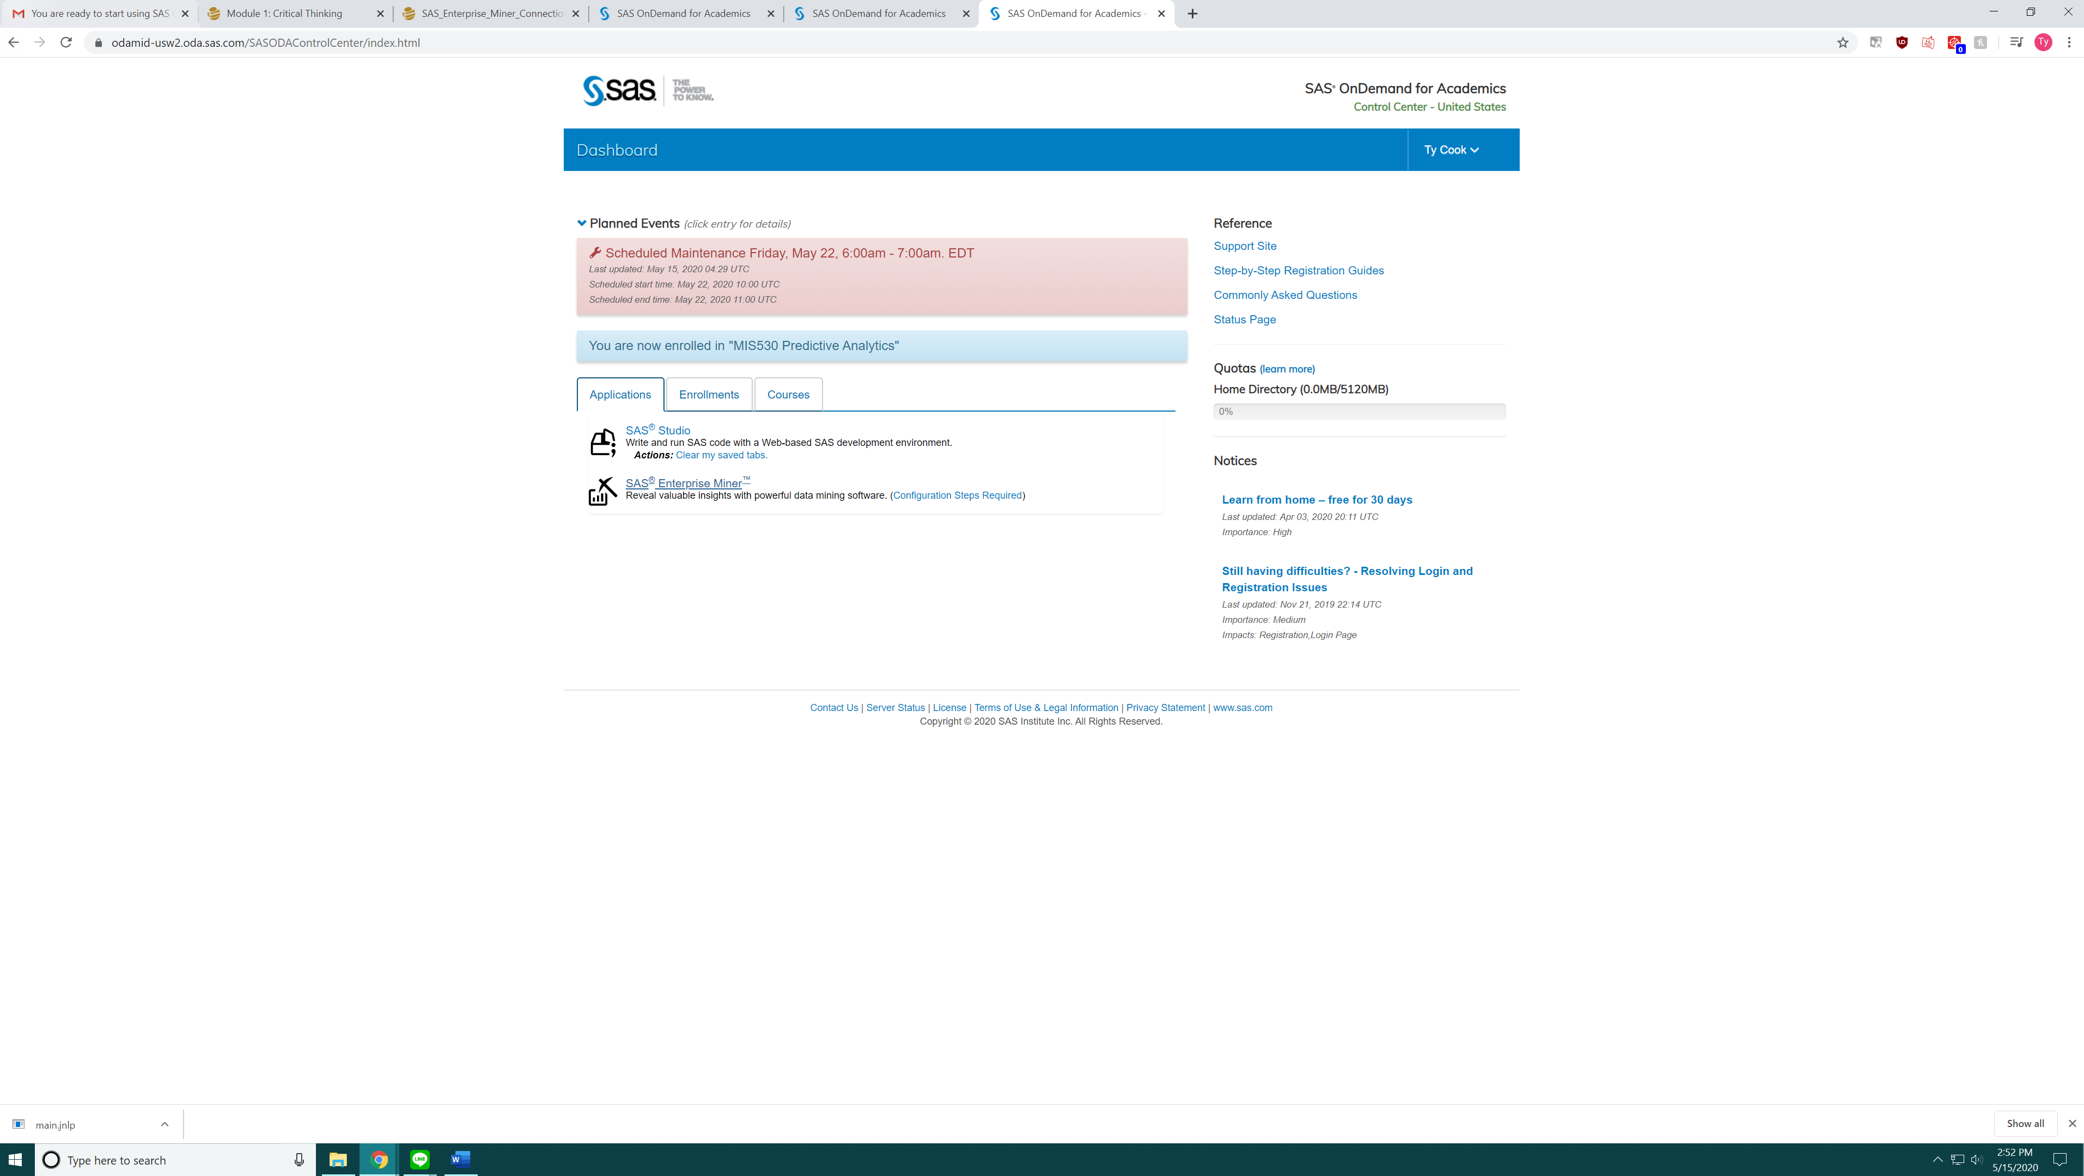

Figure 3. SAS Miner Unable to launch application error message
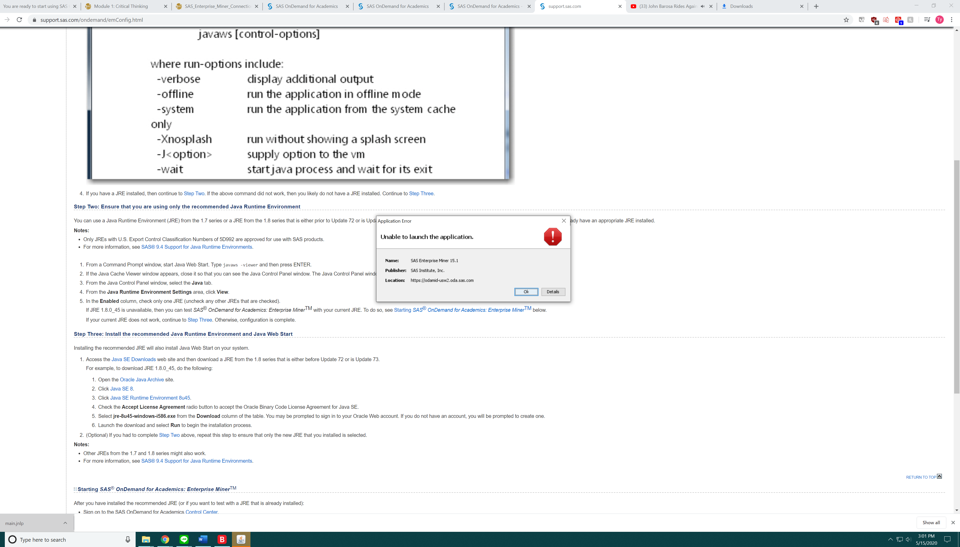
Figure 4. Java SE version check
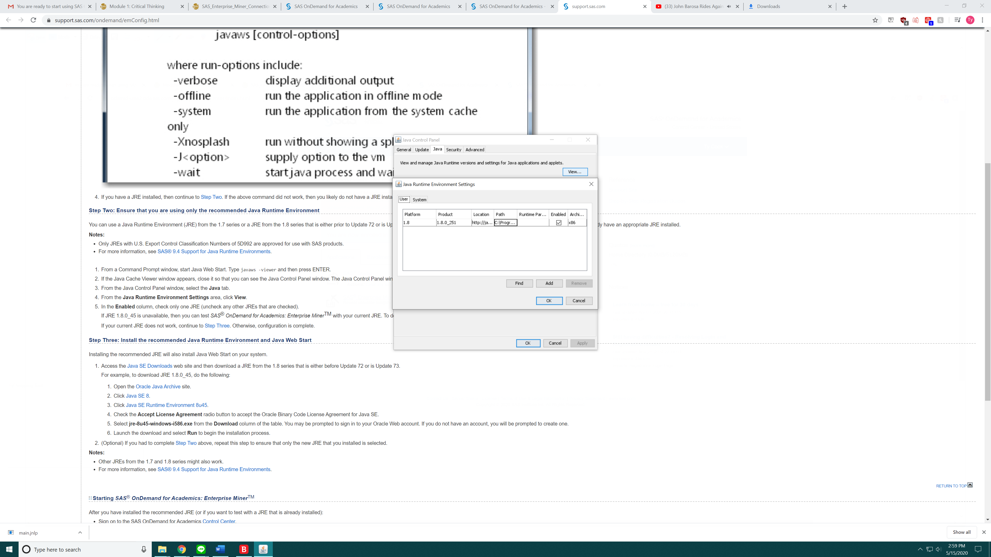

Figure 5. SAS Knowledge Base Article# 61038
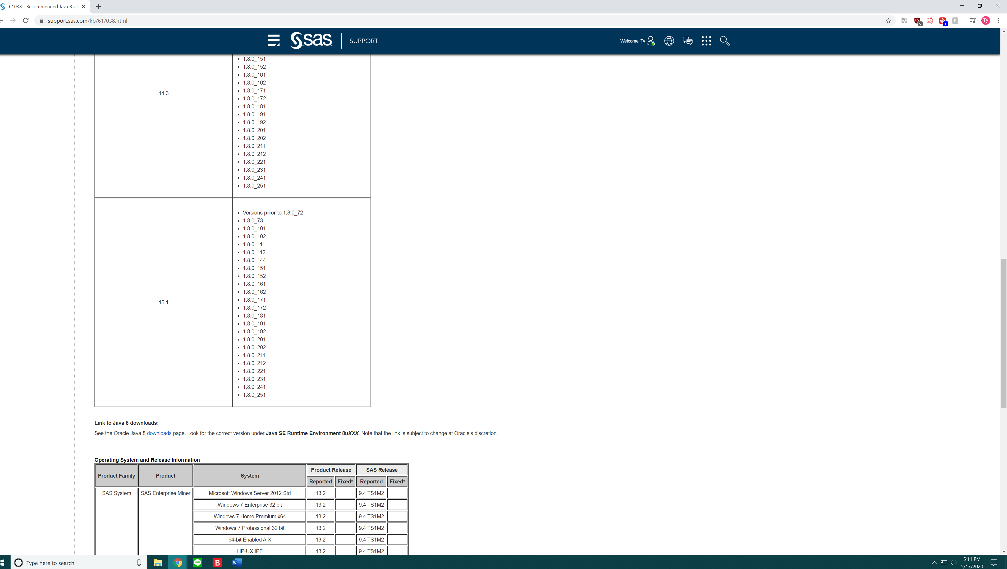
Figure 6. SAS Enterprise Miner
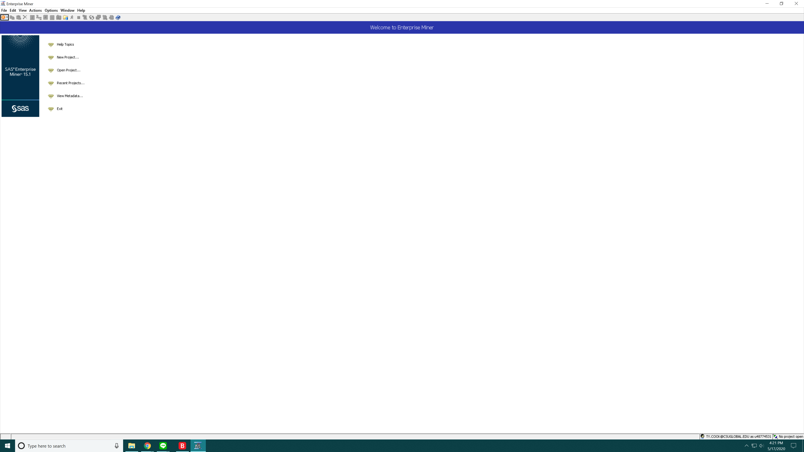

1. The first step was to go through the account creation and registration process following the SAS enterprise miner connection instructions provided in first module. Figure 1 is results of following these steps by getting my acount created and course registered
2.Next step was to download the SAS Enterprise Miner main.jnlp file from the control center.
3. Is where I would run into my first issue with the installing of the miner I would receive an error message saying that the application was unable to launch and was cancelled as the apllication could not load resources.
4. Next step for me was to look the configration information on the control panel portal. From reading the information going through the troubleshooting information I determined I was running Java 1.8.0.251 which doing a search appeared to be the most up date verision and looking at the the chart on support article 61038 should be a valid verision to run the enterprise miner.
5. I was then led to believe that the article was wrong and that I would need to downgrade the Java in order to allow the program to run. So I followed the instructions and downloaded JRE 1.8.0_45 and uninstalled the current verision I had installed in order and cleared the Java cache.
6. This did not solve my issue as I received the same error message as before with the 45 runtime enviroment.
7. I ended up doing some more research and determined that previous enviroment should have no problem running the miner and that I should not be receiving this error, so as a last ditch effort I reinstalled the 251 verision and was able to get the miner working as indicated by Figure 6. My assumption is that was corrupt file somwhere within the Java SE during my origional install. As I disovered there is not a lot of troubleshooting information available for the SAS Miner other than comparing assuming it’s a Java issue.

