一、表单&列表菜单开发
1、设计表单
①系统设计》表单设计器
在表单设计器中，您可以在左侧选择不同的元素来设计自己的业务属性
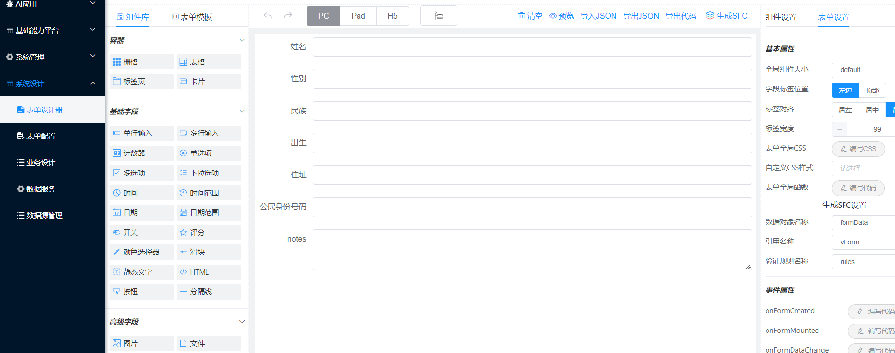

②在标签属性上输入业务属性标签名称
唯一名称：必须为英文字母，对应数据库表字段
标签：业务属性名称，

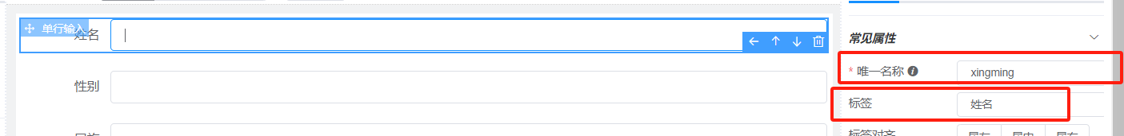

③表单设计完成后，点击右上角的按钮“导出JSON”，复制出来所有代码
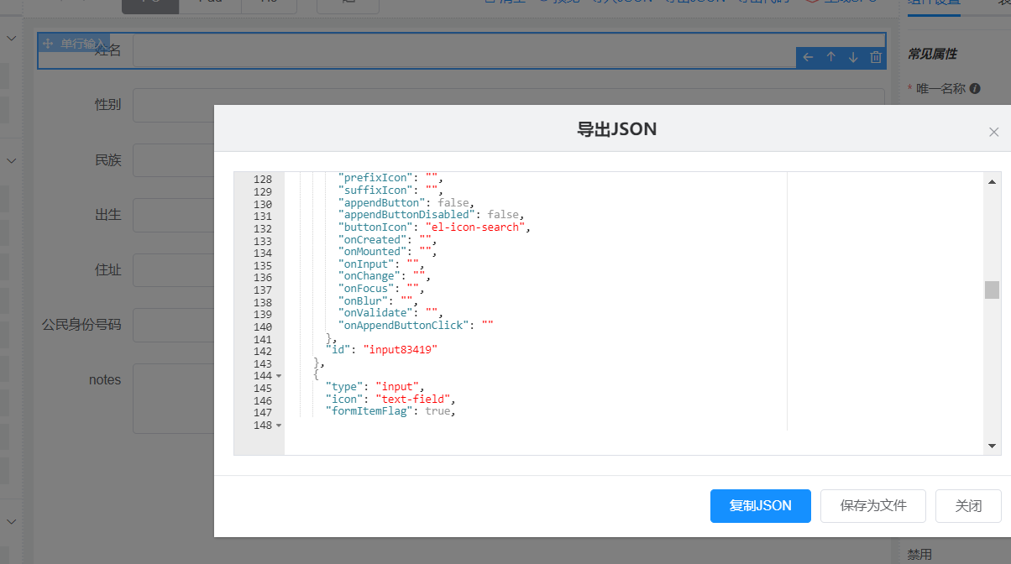
示例：
{
"widgetList": [
{
"type": "input",
"icon": "text-field",
"formItemFlag": true,
"options": {
"name": "xingming",
"label": "姓名",
"labelAlign": "",
"type": "text",
"defaultValue": "",
"placeholder": "",
"columnWidth": "200px",
"size": "",
"labelWidth": null,
"labelHidden": false,
"readonly": false,
"disabled": false,
"hidden": false,
"clearable": true,
"showPassword": false,
"required": false,
"requiredHint": "",
"validation": "",
"validationHint": "",
"customClass": [],
"labelIconClass": null,
"labelIconPosition": "rear",
"labelTooltip": null,
"minLength": null,
"maxLength": null,
"showWordLimit": false,
"prefixIcon": "",
"suffixIcon": "",
"appendButton": false,
"appendButtonDisabled": false,
"buttonIcon": "el-icon-search",
"onCreated": "",
"onMounted": "",
"onInput": "",
"onChange": "",
"onFocus": "",
"onBlur": "",
"onValidate": "",
"onAppendButtonClick": ""
},
"id": "input102810"
},
{
"type": "input",
"icon": "text-field",
"formItemFlag": true,
"options": {
"name": "xingbie",
"label": "性别",
"labelAlign": "",
"type": "text",
"defaultValue": "",
"placeholder": "",
"columnWidth": "200px",
"size": "",
"labelWidth": null,
"labelHidden": false,
"readonly": false,
"disabled": false,
"hidden": false,
"clearable": true,
"showPassword": false,
"required": false,
"requiredHint": "",
"validation": "",
"validationHint": "",
"customClass": "",
"labelIconClass": null,
"labelIconPosition": "rear",
"labelTooltip": null,
"minLength": null,
"maxLength": null,
"showWordLimit": false,
"prefixIcon": "",
"suffixIcon": "",
"appendButton": false,
"appendButtonDisabled": false,
"buttonIcon": "el-icon-search",
"onCreated": "",
"onMounted": "",
"onInput": "",
"onChange": "",
"onFocus": "",
"onBlur": "",
"onValidate": "",
"onAppendButtonClick": ""
},
"id": "input97169"
},
{
"type": "input",
"icon": "text-field",
"formItemFlag": true,
"options": {
"name": "minzu",
"label": "民族",
"labelAlign": "",
"type": "text",
"defaultValue": "",
"placeholder": "",
"columnWidth": "200px",
"size": "",
"labelWidth": null,
"labelHidden": false,
"readonly": false,
"disabled": false,
"hidden": false,
"clearable": true,
"showPassword": false,
"required": false,
"requiredHint": "",
"validation": "",
"validationHint": "",
"customClass": "",
"labelIconClass": null,
"labelIconPosition": "rear",
"labelTooltip": null,
"minLength": null,
"maxLength": null,
"showWordLimit": false,
"prefixIcon": "",
"suffixIcon": "",
"appendButton": false,
"appendButtonDisabled": false,
"buttonIcon": "el-icon-search",
"onCreated": "",
"onMounted": "",
"onInput": "",
"onChange": "",
"onFocus": "",
"onBlur": "",
"onValidate": "",
"onAppendButtonClick": ""
},
"id": "input83419"
},
{
"type": "input",
"icon": "text-field",
"formItemFlag": true,
"options": {
"name": "chushen",
"label": "出生",
"labelAlign": "",
"type": "text",
"defaultValue": "",
"placeholder": "",
"columnWidth": "200px",
"size": "",
"labelWidth": null,
"labelHidden": false,
"readonly": false,
"disabled": false,
"hidden": false,
"clearable": true,
"showPassword": false,
"required": false,
"requiredHint": "",
"validation": "",
"validationHint": "",
"customClass": "",
"labelIconClass": null,
"labelIconPosition": "rear",
"labelTooltip": null,
"minLength": null,
"maxLength": null,
"showWordLimit": false,
"prefixIcon": "",
"suffixIcon": "",
"appendButton": false,
"appendButtonDisabled": false,
"buttonIcon": "el-icon-search",
"onCreated": "",
"onMounted": "",
"onInput": "",
"onChange": "",
"onFocus": "",
"onBlur": "",
"onValidate": "",
"onAppendButtonClick": ""
},
"id": "input34026"
},
{
"type": "input",
"icon": "text-field",
"formItemFlag": true,
"options": {
"name": "zhuzhi",
"label": "住址",
"labelAlign": "",
"type": "text",
"defaultValue": "",
"placeholder": "",
"columnWidth": "200px",
"size": "",
"labelWidth": null,
"labelHidden": false,
"readonly": false,
"disabled": false,
"hidden": false,
"clearable": true,
"showPassword": false,
"required": false,
"requiredHint": "",
"validation": "",
"validationHint": "",
"customClass": "",
"labelIconClass": null,
"labelIconPosition": "rear",
"labelTooltip": null,
"minLength": null,
"maxLength": null,
"showWordLimit": false,
"prefixIcon": "",
"suffixIcon": "",
"appendButton": false,
"appendButtonDisabled": false,
"buttonIcon": "el-icon-search",
"onCreated": "",
"onMounted": "",
"onInput": "",
"onChange": "",
"onFocus": "",
"onBlur": "",
"onValidate": "",
"onAppendButtonClick": ""
},
"id": "input100320"
},
{
"type": "input",
"icon": "text-field",
"formItemFlag": true,
"options": {
"name": "card",
"label": "公民身份号码",
"labelAlign": "",
"type": "text",
"defaultValue": "",
"placeholder": "",
"columnWidth": "200px",
"size": "",
"labelWidth": null,
"labelHidden": false,
"readonly": false,
"disabled": false,
"hidden": false,
"clearable": true,
"showPassword": false,
"required": false,
"requiredHint": "",
"validation": "",
"validationHint": "",
"customClass": "",
"labelIconClass": null,
"labelIconPosition": "rear",
"labelTooltip": null,
"minLength": null,
"maxLength": null,
"showWordLimit": false,
"prefixIcon": "",
"suffixIcon": "",
"appendButton": false,
"appendButtonDisabled": false,
"buttonIcon": "el-icon-search",
"onCreated": "",
"onMounted": "",
"onInput": "",
"onChange": "",
"onFocus": "",
"onBlur": "",
"onValidate": "",
"onAppendButtonClick": ""
},
"id": "input113833"
},
{
"type": "textarea",
"icon": "textarea-field",
"formItemFlag": true,
"options": {
"name": "notes",
"label": "notes",
"labelAlign": "",
"rows": 3,
"defaultValue": "",
"placeholder": "",
"columnWidth": "200px",
"size": "",
"labelWidth": null,
"labelHidden": false,
"readonly": false,
"disabled": false,
"hidden": false,
"required": false,
"requiredHint": "",
"validation": "",
"validationHint": "",
"customClass": "",
"labelIconClass": null,
"labelIconPosition": "rear",
"labelTooltip": null,
"minLength": null,
"maxLength": null,
"showWordLimit": false,
"onCreated": "",
"onMounted": "",
"onInput": "",
"onChange": "",
"onFocus": "",
"onBlur": "",
"onValidate": ""
},
"id": "textarea44402"
}
],
"formConfig": {
"modelName": "formData",
"refName": "vForm",
"rulesName": "rules",
"labelWidth": 99,
"labelPosition": "left",
"size": "",
"labelAlign": "label-right-align",
"cssCode": "",
"customClass": "",
"functions": "",
"layoutType": "PC",
"onFormCreated": "",
"onFormMounted": "",
"onFormDataChange": "",
"jsonVersion": 3,
"onFormValidate": ""
}
}

2、配置表单
①菜单路径
系统设计》表单配置
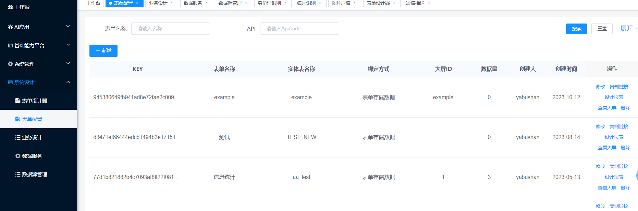
②新增表单
点击新增按钮，弹出页面，填写如下信息：
表单名称：填写中文业务名称
实体名称：填写英文业务名称
表单(复制表单设计器中的json)： 将步骤1中得到的代码复制进去
如下图:点击确定，即可完成表单的设计
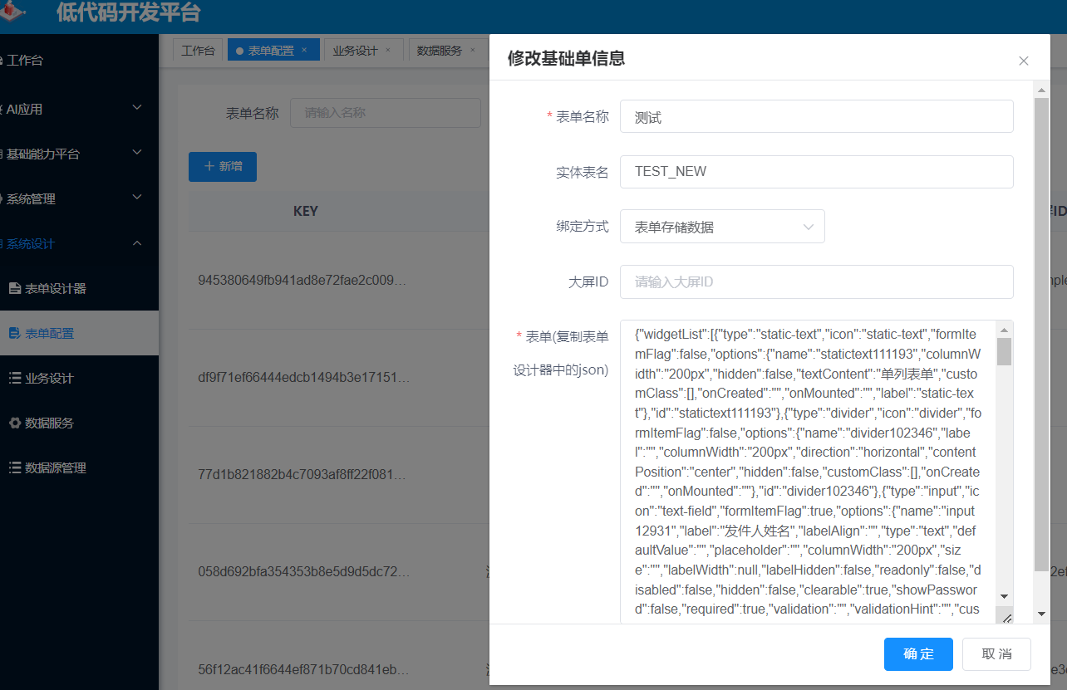

③查看表单
点击列表中操作列的“复制链接”，打开浏览器新页面可查看设计的表单信息

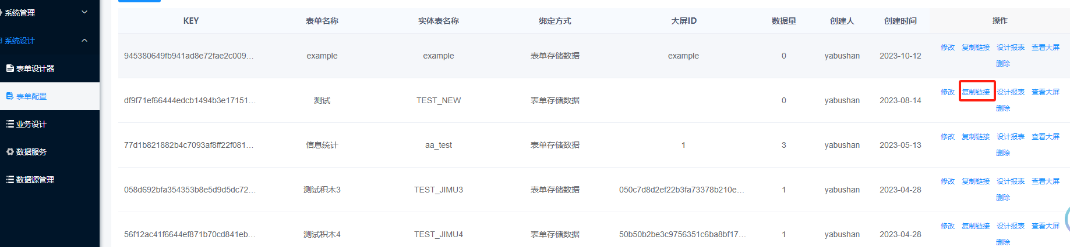
查看表单信息
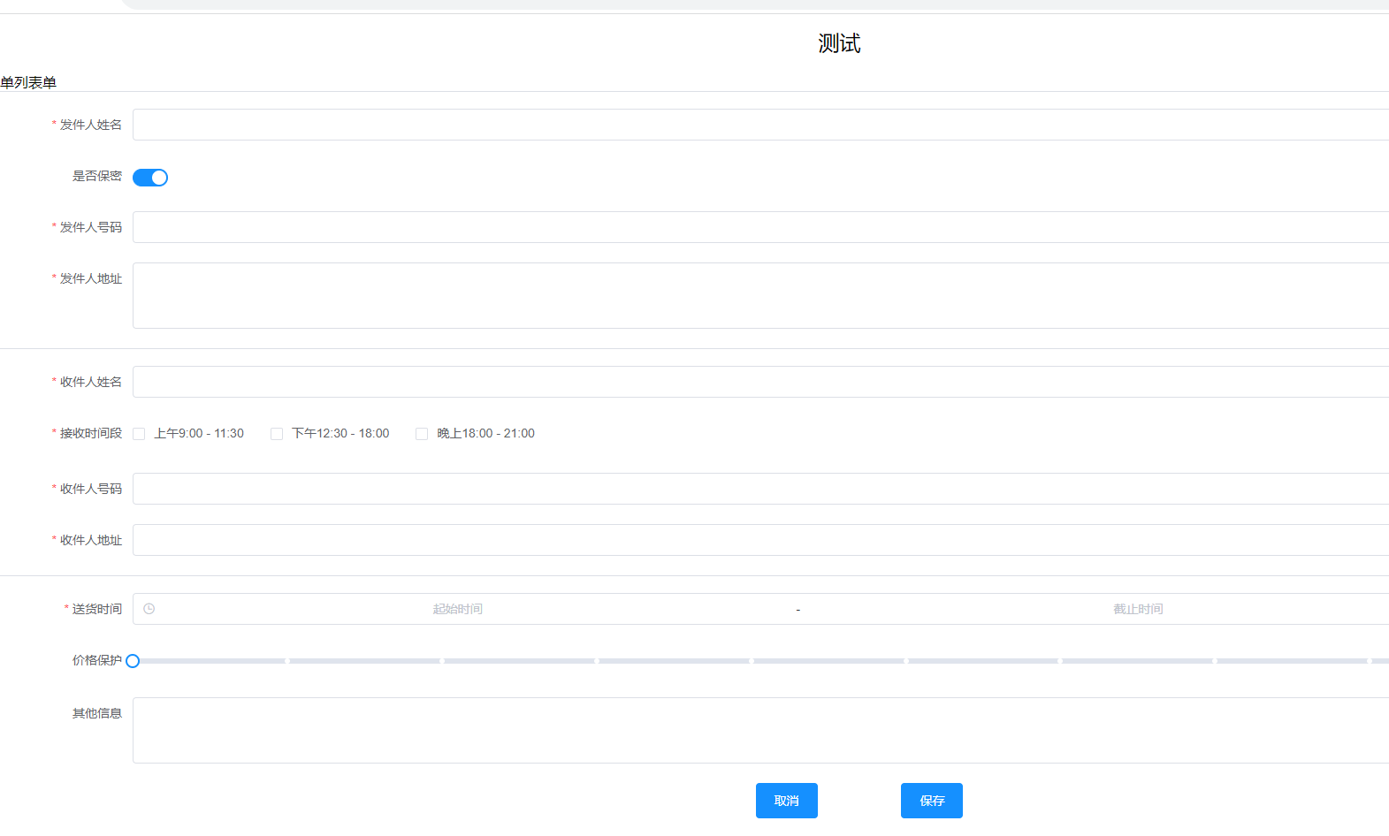
3、设计列表
3.1系统设计》业务设计
点击新增按钮，弹出页面，填写如下信息：
列表名称：该业务列表的中文名称
表单配置主键：步骤2中得到的表单KEY
列表头展示字段：配置列表需要显示的属性【详细配置介绍看3.4章节】

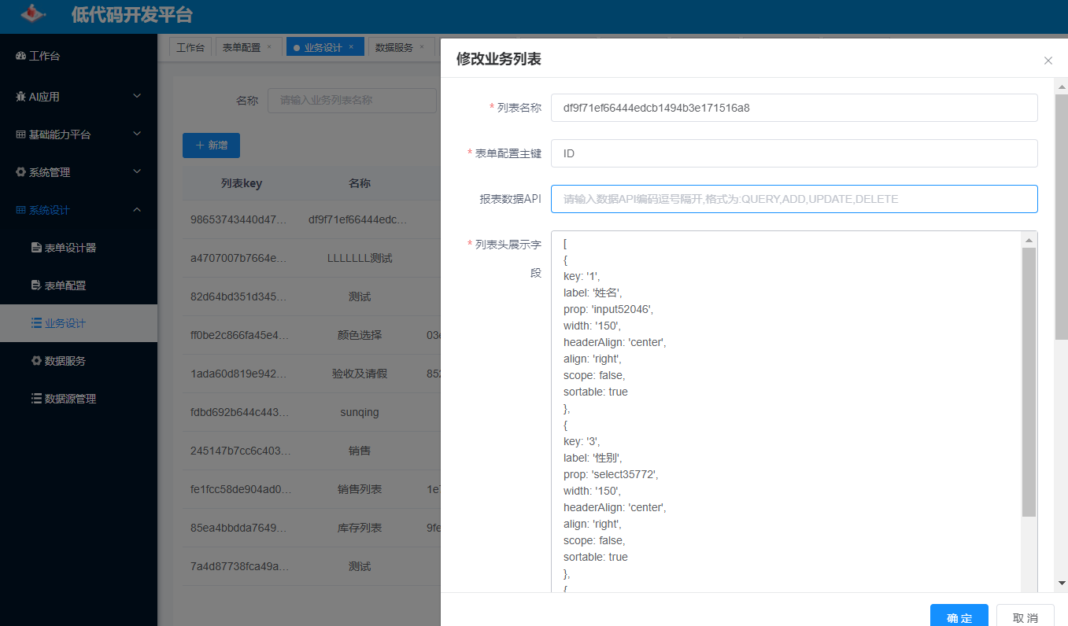
配置按钮权限，点击确定即可完成业务列表的设计
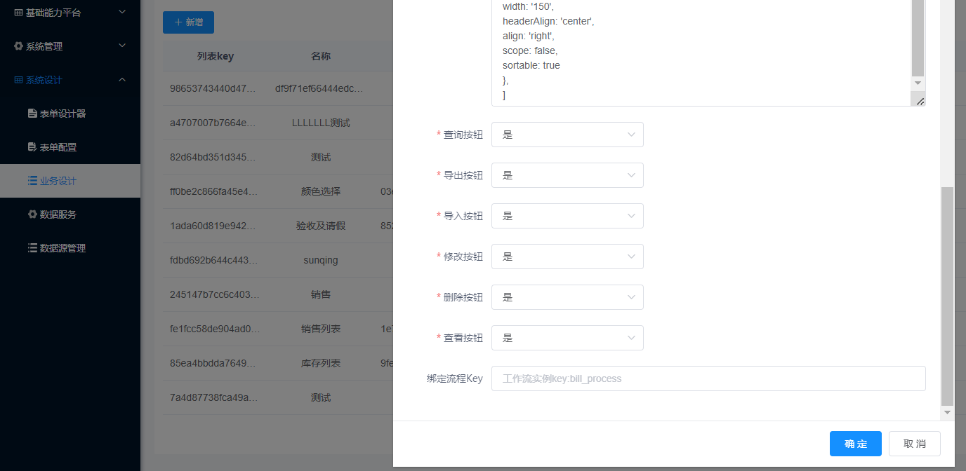
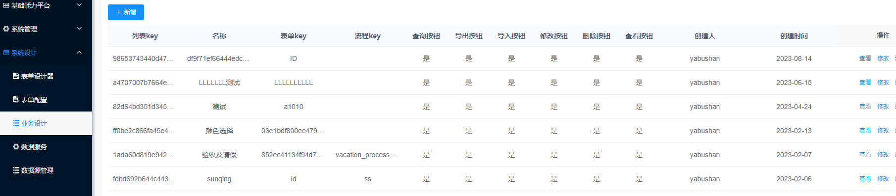
3.2 记录表单key主键和列表key主键
步骤3.1完成后，可在列表看到新增成功的字段的列表ID属性和表单属性，将该2个属性按照以下格式组装，后续在菜单配置中会用到：
listid:列表ID
formId：表单
{"listid":"3f52acc4afba46f08073fa235bc05302","formId":"f5888e79c3f547578b921e313a40e4e1"}
3.3 列表头展示字段配置解释
列表头字段的展示是为了展示业务属性，帮助用户更好的查看和分析数据，建议将表单1得到的代码字段进行全量展示。
在配置列表头字段前需要先得到3.1中得到的代码属性： "name": "input99197", "label": "姓名",与列表头的label和prop进行对应

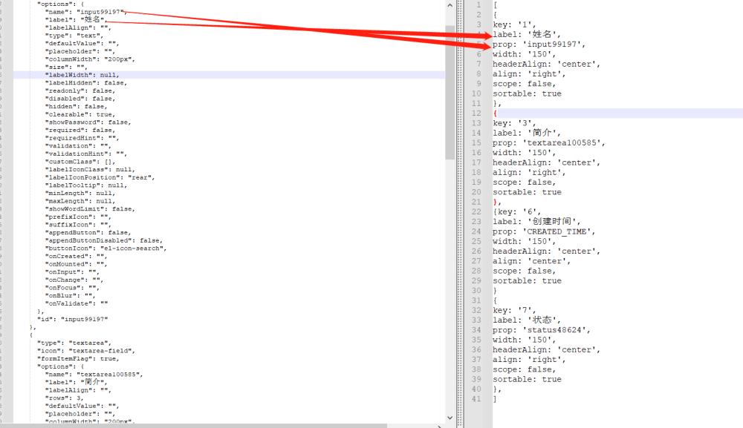
3.4.1 得到的列表头
[
{
key: '1',
label: '姓名',
prop: 'input52046',
width: '150',
headerAlign: 'center',
align: 'right',
scope: false,
sortable: true
},
{
key: '3',
label: '性别',
prop: 'select35772',
width: '150',
headerAlign: 'center',
align: 'right',
scope: false,
sortable: true
},
{key: '6',
label: '创建时间',
prop: 'CREATED_TIME',
width: '150',
headerAlign: 'center',
align: 'center',
scope: false,
sortable: true
}
]
3.4.2 列表头各属性解释
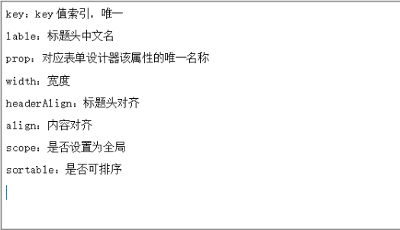
3.4.3 系统默认列表头属性
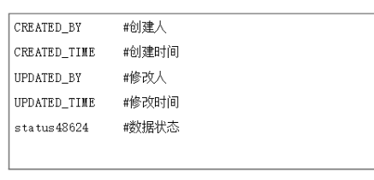
3.4.4 多重表头配置
[{
key: '1',
label: '日期',
prop: 'date',
width: '100',
headerAlign: 'center',
align: 'center',
scope: false,
sortable: true
},

{
key: '3',
label: '分析情况',
prop: 'analysis',
width: '100',
headerAlign: 'center',
propChildren: [{
key: '31',
label: '同比',
prop: 'TB',
width: '100',
headerAlign: 'center',
align: 'center',
scope: true,
sortable: true
},
{
key: '32',
label: '环比',
prop: 'HB',
width: '100',
headerAlign: 'center',
align: 'center',
scope: true,
sortable: true
},]
},
{
key: '4',
label: '金额',
prop: 'price',
width: '100',
headerAlign: 'center',
align: 'right',
scope: false,
sortable: true
},
{
key: '5',
label: '地址',
prop: 'address',
width: '',
headerAlign: 'left',
align: 'left',
scope: false,
sortable: false
}
]

4、注册列表到菜单
4.1 系统管理》菜单管理
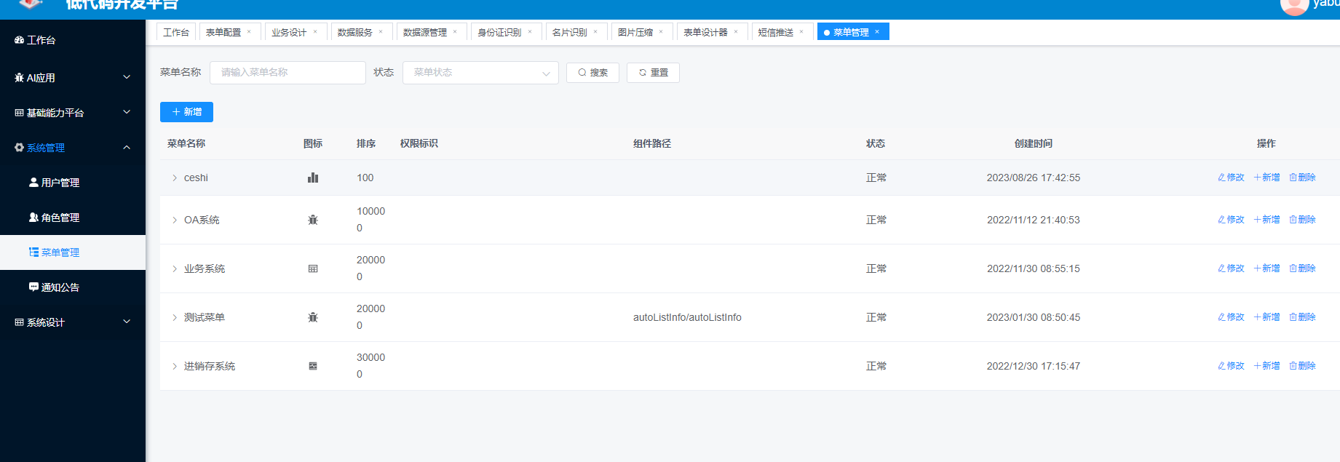
4.2 新增菜单
点击新增按钮,弹出添加菜单页面，根据业务分类挂在不上级菜单下，例如：
上级菜单：OA系统菜单类型：菜单
菜单名称：个人信息收集
显示排序：1
路由地址：xinxishouji
【二级菜单可随意字母组合；
三级菜单格式为： |listId&formid】
组件路由：autoListInfo/autoListInfo
【二级地址默认为：autoListInfo/autoListInfo
三级地址默认为：autoListInfo/child/autoListInfo】

点击确定即可完成菜单的创建
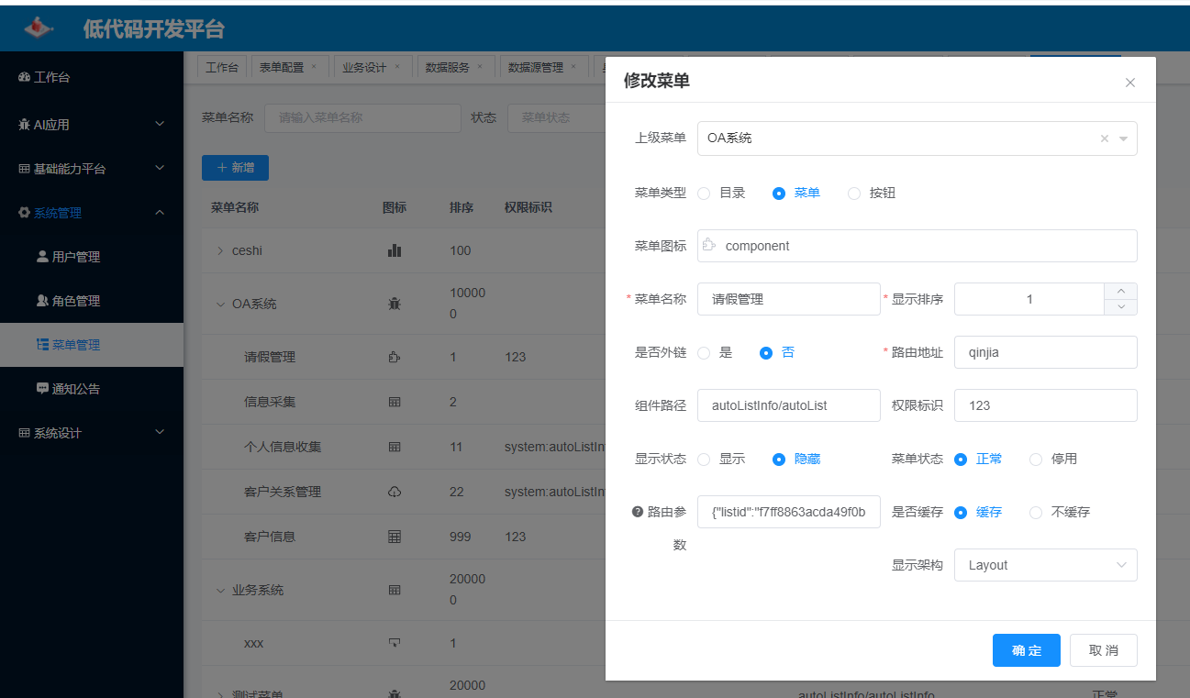

4.3路由参数设置
在步骤4.2中新增完菜单后，选择刚创建的菜单，点击修改按钮：
将3.2步骤中的代码复制到：路由参数属性中；
点击确定，完成菜单和业务的绑定。
{"listid":"91fb80a3004947cd84bf8f052390b38c","formId":"616ae76c37224f368c841426c63c0fd7"}

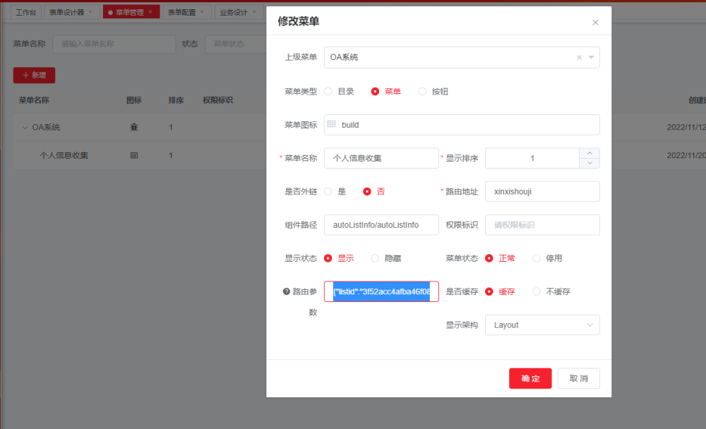

5、分配菜单权限
5.1、系统管理》角色管理
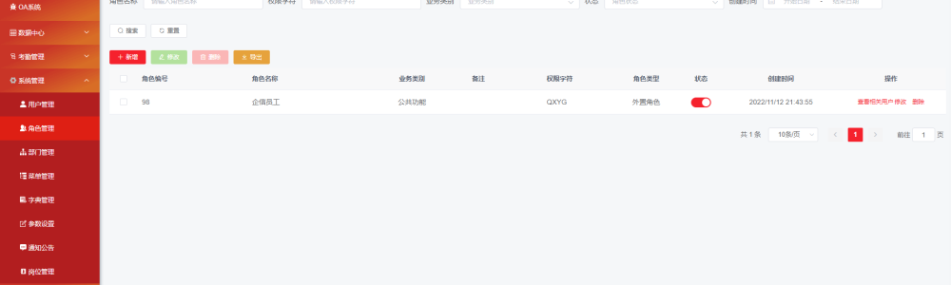

在5.1步骤中可以看到系统上现有角色，可将刚创建的菜单分配给到不通的角色下，拥有该角色的人员即可看到该菜单。
勾选个人信息收集，点击确定完成菜单和角色的授权

