Project 2 Report

Jingyang Guo, Yifan Wang, Anthony Colas, FNU Ronald Wilson

**1.Results**

*1.1 Accuracies*

|  |  |  |
| --- | --- | --- |
| RVM | SVM | GPR |
| 93% | 95.22% | 96.22% |

*\*best results using 5-fold cross-validation*

*1.2 Overall confusion matrices*

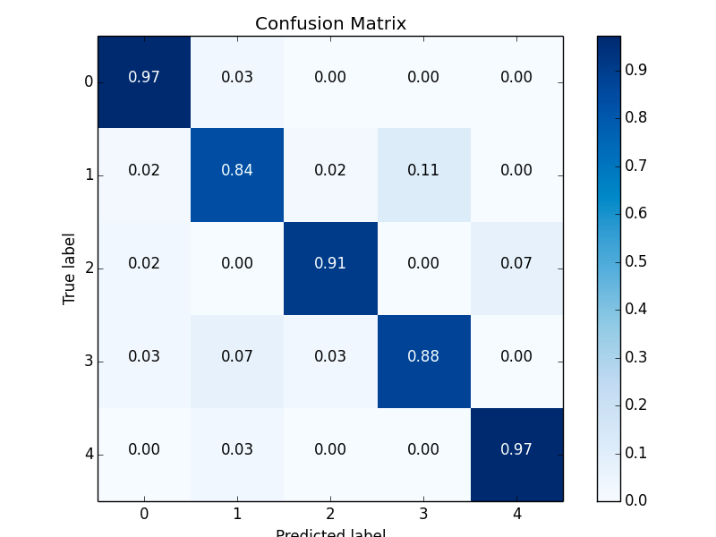

Figure 1: RVM Confusion Matrix

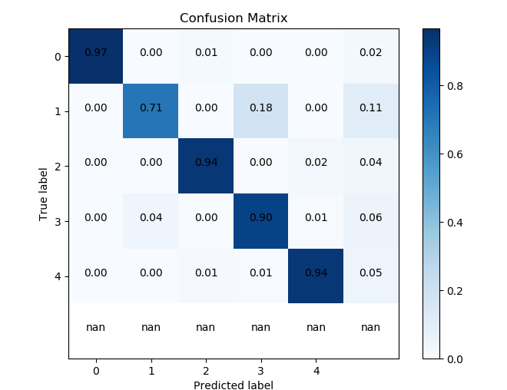

Figure 2: SVM Confusion Matrix

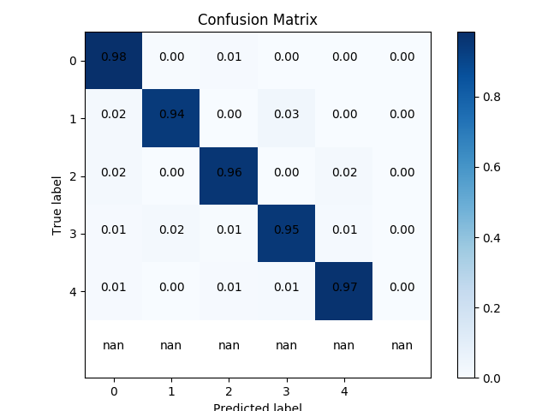

Figure 3: GPR Confusion Matrix

*1.3 Number of vectors*

|  |  |  |  |  |  |
| --- | --- | --- | --- | --- | --- |
|  | Fold 1 | Fold 2 | Fold 3 | Fold 4 | Fold 5 |
| RVM | 800 | 800 | 800 | 800 | 800 |
| SVM | 1029 | 1039 | 1017 | 1020 | 1025 |

**2. Observations**

*2.1 Relevance Vector Machines (RVM)*

RVM calculates Hessian requiring O(N^3) computation ,thereby, slowing down the training phase. Therefore, the amount of data was randomly downsampled from 25,000 samples to 2,000 samples. RVMs provide probabilistic predictions and can be easily extended to multiple-classes but their accuracy may be affected by downsampling. We are also training using a reduced number of iterations compared to SVM and GPR. Hence, the degradation in performance.

*2.2 Support Vector Machines (SVM)*

There are 2 factors affecting performance. If gamma is large, there will be more support vectors so that it will be easy to overfit. The second is the number of training iterations. In our experiments, SVM converges fast. Around 100 to 300 iterations are enough. If we iterate too many times, there will be overfitting. Performance of SVM will be excellent without overfitting. Accuracy of each validation fold is over 94% and quite close to each other, which means not only does SVM have good accuracy but also great stability.

*2.3 Gaussian Process Regression (GPR)*

G.P. Classifier in sklearn can’t return probabilities using all-pairs method, so we trained one classifier with one_vs_rest method for each pair of classes, and worked out the all-pairs results manually. About the probability that one isn’t from any class, intuitively, the closer other probabilities are, the more likely one come from new class. To introduce a reasonable new probability value, denote standard deviation of the probabilities of current classes with std_dev, then the new probability should be p = exp(-std_dev). This function satisfies such fact: when std_dev = 0, p = 1; when std_dev -> ∞, p = 0. This is a reasonable property. However std_dev are tiny, making p too high, so we multiplied it by #Classes * 10, because intuitively the more known classes, the less likely a sample comes from an unknown class.