CloudFlare

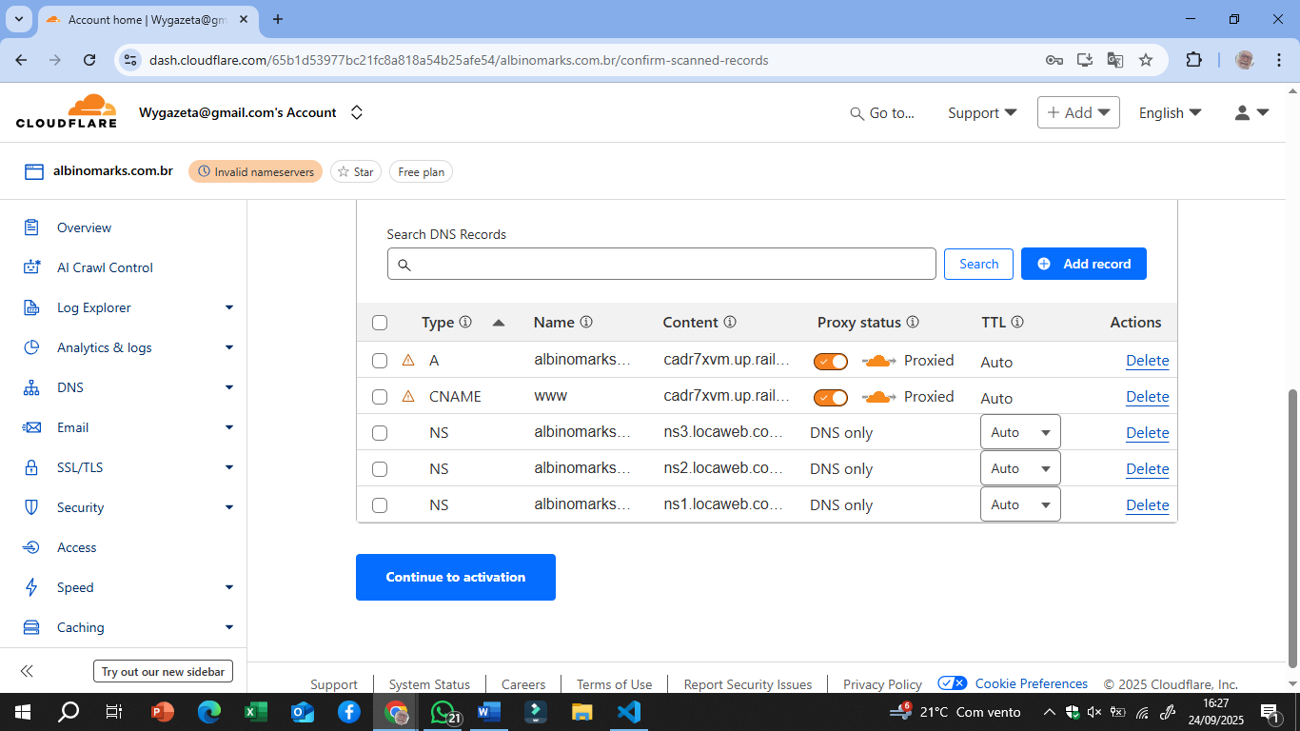
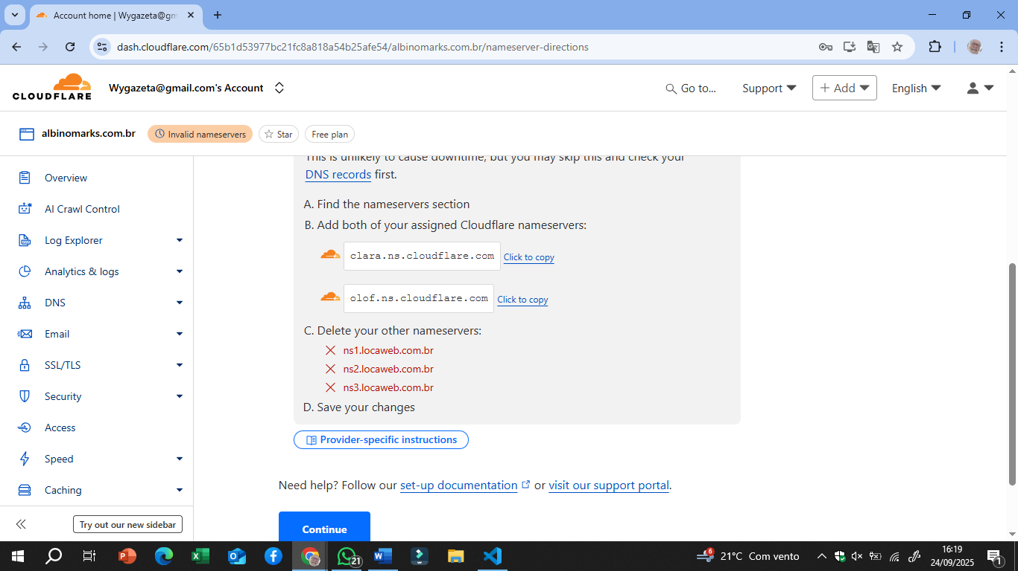
clara.ns.cloudflare.com
olof.ns.cloudflare.com

Last step: Update your nameservers to activate Cloudflare
This is the last step to allow Cloudflare to speed up and protect your web traffic.
- Log into your DNS provider (most likely your registrar)
Find your registrar on ICANN Lookup
If you purchased your domain through a reseller (e.g., Squarespace) or use a separate DNS provider, log into that account instead.
- Make sure DNSSEC is off
Find and turn off the DNS security (DNSSEC) setting if it is on. You can re-enable it later through Cloudflare.
- Replace your current nameservers with Cloudflare nameservers
This is unlikely to cause downtime, but you may skip this and check your DNS records first.
  - Find the nameservers section
  - Add both of your assigned Cloudflare nameservers:
clara.ns.cloudflare.com
Click to copy
olof.ns.cloudflare.com
Click to copy
  - Delete your other nameservers:
ns1.locaweb.com.br
ns2.locaweb.com.br
ns3.locaweb.com.br
  - Save your changes

