3 Late-Delivery Risk Classification (T1)
This section develops and evaluates a classifier that estimates, at the moment an order is placed, the probability that it will be delivered late. Because operational responses such as upgrading the shipping mode or revising the promised delivery date are only feasible before dispatch, the model is restricted to information available at order placement. Four supervised learning algorithms of increasing complexity were compared against a naive benchmark on a chronological hold-out design. The selected XGBoost model attains a test ROC-AUC of 0.777 and a late-class recall of 0.774. The analysis further shows that predictive performance is bounded by the information content of pre-shipment features rather than by model capacity: shipping mode, together with the order hour for Same Day orders, accounts for almost all of the available signal.

3.1 Problem Definition and Success Criteria
The prediction target is the binary variable Late_delivery_risk (1 = late, 0 = not late), and the unit of prediction is the order (Order Id), so that one score is produced per order. The model is intended for real-time inference immediately after order placement. In line with the project proposal, two success criteria were set for a recent, untouched hold-out period: a ROC-AUC of at least 0.80, measuring the ability to rank late orders above on-time orders, and a recall of at least 0.75 for the late class, ensuring that most late orders are flagged for intervention. Precision, F1-score and the confusion matrix are reported as supplementary measures of the cost of false alarms.

3.2 Modelling Dataset

3.2.1 Order-Level Aggregation
The modelling dataset was derived from the cleaned item-level file produced during data preparation (180,519 order items). Items were aggregated to 65,752 orders by Order Id. Order attributes such as order date, shipping mode, market, region, payment type, customer segment and the target are constant within every order, so the aggregation involves no loss of information; basket-level measures (quantities, sales, discounts and department mix) were summed or counted across items. The resulting order-level table was reconciled order by order with the order-level file produced during data preparation, and all values agreed.

3.2.2 Treatment of Canceled Orders
All 2,855 orders with the delivery status Shipping canceled carry the label 0, although for 1,650 of them the recorded shipping time exceeds the scheduled time. The label of these orders therefore reflects cancellation rather than punctual delivery. Including them would teach the model that cancellation implies on-time delivery, so they were excluded from training and evaluation and examined separately (Section 3.6.1). Table 3.1 shows that the exclusion raises the late rate from 54.8% to 57.3%; the latter is the relevant baseline for all subsequent results.
Table 3.1 Composition of the modelling sample
Sample | Orders | Late | Not late | Late rate
All orders | 65,752 | 36,048 | 29,704 | 54.8%
Modelling sample (canceled orders excluded) | 62,897 | 36,048 | 26,849 | 57.3%

3.2.3 Leakage Control and Feature Set
Data leakage occurs when a model is trained on information that would not be available at the time of prediction, which inflates offline performance but fails in deployment. Each candidate field was therefore assessed against the question of whether its value exists at order placement. Table 3.2 summarises the excluded fields. Fields in the first group encode the outcome directly: for delivered orders, the label coincides in every case with the condition that actual shipping days exceed scheduled days, and the delivery status maps one-to-one onto the label. The order status is a snapshot taken when the data were extracted and changes during the life cycle of an order. The profit fields describe a financial outcome whose availability at order placement is undefined; Section 3.6.2 confirms empirically that their exclusion sacrifices no predictive signal. In addition, Order Id is retained only as an identifier, and the scheduled shipping time was dropped because it is a one-to-one recoding of the shipping mode (Standard Class 4 days, Second Class 2, First Class 1, Same Day 0).
Table 3.2 Fields excluded from the predictor set
Group | Fields | Reason for exclusion
Direct label leakage | Days for shipping (real); shipping date; Delivery Status | Known only after shipping or delivery; determine the label
Post-event status | Order Status | Changes during the order life cycle; identifies canceled orders
Realised financial outcome | Benefit per order; Order Profit Per Order; Order Item Profit Ratio | Availability at placement undefined; no predictive signal (Section 3.6.2)
The retained predictors are listed in Table 3.3. Calendar variables and discount measures are derived inside the modelling pipeline, so that the same transformation is applied consistently in training and deployment.
Table 3.3 Predictor set available at order placement
Type | Features
Categorical | Shipping mode; market; order region; payment type; customer segment
Basket | Total quantity; total sales before discount; total discount; number of items; number of distinct products and categories
Department mix | Units purchased in each of the 11 departments
Derived | Net sales; discount rate; order hour; day of week; month

3.2.4 Chronological Train–Validation–Test Split
A random split would allow the model to learn from orders placed after those it is evaluated on, which overstates performance for a system that must score future orders. The data were therefore partitioned by order date (Table 3.4). Because each row is an order, all items of an order necessarily fall into the same partition. The late rate is stable at between 57.0% and 57.6% across the three periods.
Table 3.4 Chronological partitioning of the modelling sample
Partition | Period | Orders | Late rate
Training | 1 Jan 2015 – 31 Mar 2017 | 44,883 | 57.3%
Validation | 1 Apr 2017 – 30 Sep 2017 | 9,971 | 57.0%
Test | 1 Oct 2017 – 31 Jan 2018 | 8,043 | 57.6%

3.3 Modelling Approach

3.3.1 Pipeline and Preprocessing
Each model was embedded in a single scikit-learn pipeline comprising three steps: computation of derived features; preprocessing, consisting of median imputation and standardisation for numerical variables and mode imputation with one-hot encoding for categorical variables; and the classifier. All preprocessing parameters were estimated on the training partition only, which prevents information from later periods from entering the model. Categories unseen during training are encoded as all-zero vectors, so the pipeline can score new orders without failure.
To quantify the dependence of the models on shipping mode, which emerged in the exploratory analysis as the variable most strongly associated with lateness, every algorithm was estimated on two feature sets: the Full set of Table 3.3 and a NoMode set from which shipping mode was removed.

3.3.2 Candidate Models: From Simple to Complex
Following the recommendation to include both simple and complex models for non-linear problems, four algorithms of increasing complexity were compared (Table 3.5). Logistic regression provides an interpretable linear baseline. A CART decision tree captures threshold rules and interactions in a readable form. A random forest averages many de-correlated trees grown on bootstrap samples, reducing variance. XGBoost builds trees sequentially, each correcting the residual errors of its predecessors, and is widely regarded as one of the strongest learners for tabular data. A naive benchmark, which scores each order by the training-period late rate of its shipping mode, defines the minimum performance that any model must exceed.

3.3.3 Hyper-parameter Tuning
Hyper-parameters were tuned by grid search, fitting each configuration on the training partition and evaluating its ROC-AUC on the validation partition. The search spaces are given in Table 3.5; in total, 128 configurations were evaluated across the two feature sets.
Table 3.5 Candidate models and hyper-parameter search spaces
Model | Complexity | Search space
Logistic regression | Simple, linear | C ∈ {0.001, 0.01, 0.1, 1, 10}
CART decision tree | Simple, non-linear | Maximum depth ∈ {3, 5, 8, 12, unlimited}; minimum leaf size ∈ {20, 100, 500}
Random forest | Complex, bagging ensemble | Maximum depth ∈ {8, 16, unlimited}; minimum leaf size ∈ {10, 50, 200}; features per split ∈ {√p, 0.5p}; number of trees ∈ {100, 300, 600}
XGBoost | Complex, boosting ensemble | Number of trees ∈ {200, 500}; maximum depth ∈ {3, 5, 7}; learning rate ∈ {0.03, 0.1}; minimum child weight ∈ {1, 20}; row and column subsampling 0.8

3.3.4 Model Selection and Threshold Rules
Model selection and threshold choice relied exclusively on the validation partition, and both rules were fixed before the test partition was examined. The final model is the Full-feature candidate with the highest validation ROC-AUC; where several candidates lie within 0.005 of the best value, the one with the highest precision at a recall of at least 0.75 is preferred, reflecting the operational cost of false alarms. The alert threshold is the value that maximises validation precision subject to a validation recall of at least 0.75, which aligns the operating point directly with the recall criterion of Section 3.1.
The selected model was not refitted on the combined training and validation data. Scores of Standard Class orders lie close to the threshold, so refitting shifts many of them across it and invalidates the threshold chosen on validation. The model evaluated on the test partition is therefore exactly the model delivered for deployment.

3.4 Results

3.4.1 Validation Comparison
Table 3.6 reports validation performance at the threshold chosen for each model. With the Full feature set, all tree-based models clearly outperform both the benchmark and logistic regression, and the decision tree (0.7767), XGBoost (0.7766) and random forest (0.7755) are separated by less than 0.0012 in ROC-AUC. Without shipping mode, every algorithm collapses to a ROC-AUC between 0.523 and 0.527, barely above random ranking. Under the selection rule, XGBoost was chosen because it achieves the highest precision (0.707) at the required recall; the decision tree, whose coarse leaf-level scores cannot place a threshold close to a recall of 0.75, offers a markedly lower precision of 0.618. The margin of XGBoost over the random forest (0.0009 in precision) is negligible, and both would be defensible choices. The resulting alert threshold is 0.406.
Table 3.6 Validation performance of the tuned candidate models
Model | Feature set | ROC-AUC | Recall | Precision | F1
Mode-only benchmark | — | 0.742 | 1.000 | 0.570 | 0.726
Logistic regression | Full | 0.749 | 0.750 | 0.673 | 0.709
CART decision tree | Full | 0.777 | 0.911 | 0.618 | 0.737
Random forest | Full | 0.775 | 0.750 | 0.706 | 0.728
XGBoost (selected) | Full | 0.777 | 0.751 | 0.707 | 0.728
Logistic regression | NoMode | 0.526 | 0.750 | 0.580 | 0.654
CART decision tree | NoMode | 0.523 | 1.000 | 0.570 | 0.726
Random forest | NoMode | 0.527 | 0.753 | 0.584 | 0.658
XGBoost | NoMode | 0.524 | 0.756 | 0.581 | 0.657

3.4.2 Test-Set Performance of the Final Model
The selected model was evaluated once on the test partition (Table 3.7 and Figure 3.1). It achieves a ROC-AUC of 0.777, a recall of 0.774 and a precision of 0.696, flagging 64.1% of orders. Relative to the benchmark, which must flag every order to reach a comparable recall, the model raises precision by 12.0 percentage points. Validation and test ROC-AUC are identical, indicating that the model has not overfitted the validation period. On the test partition the model correctly flagged 3,590 late orders and missed 1,046, while raising 1,568 false alarms against 1,839 correctly cleared on-time orders.
Table 3.7 Test-set performance of the final model and reference models
Metric | XGBoost (final) | Mode-only benchmark | Best NoMode model
ROC-AUC | 0.777 | 0.745 | 0.532
Late-class recall | 0.774 | 1.000 | 0.739
Precision | 0.696 | 0.576 | 0.585
F1-score | 0.733 | 0.731 | 0.653
Share of orders flagged | 64.1% | 100.0% | 72.8%
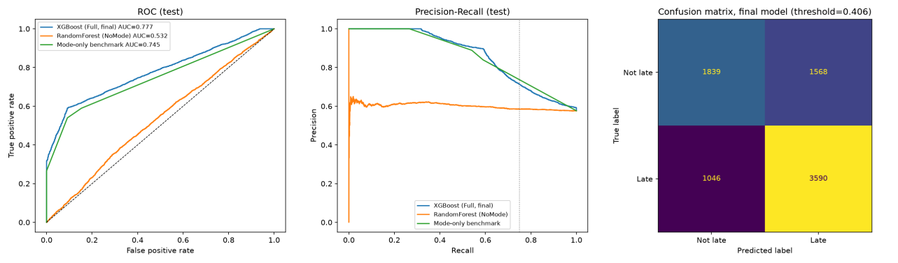
Figure 3.1 ROC curves (left), precision–recall curves (centre) and confusion matrix of the final model (right) on the test partition

3.4.3 Simple versus Complex Models
To assess whether additional model complexity is justified, all tuned candidates were also scored on the test partition after the final model and threshold had been frozen; these figures were not used for selection. Table 3.8 and Figure 3.2 lead to two conclusions. First, a non-linear model is necessary: logistic regression (test ROC-AUC 0.753) is clearly inferior to the tree-based models because it cannot represent the threshold rule for Same Day orders described in Section 3.5.2. Second, complexity beyond a single tree yields no measurable benefit: the decision tree, random forest and XGBoost differ by less than 0.002 and all coincide with a five-cell lookup table based only on shipping mode and the Same Day order hour. The limiting factor is therefore the information contained in pre-shipment features, not the capacity of the learning algorithm. XGBoost is retained for its superior precision at the required recall, while the decision tree remains a transparent alternative with equivalent ranking performance.
Table 3.8 Performance of simple and complex models (Full feature set)
Model | Complexity | Validation ROC-AUC | Test ROC-AUC | Test recall | Test precision
Mode-only benchmark | Benchmark | 0.742 | 0.745 | 1.000 | 0.576
Logistic regression | Simple, linear | 0.749 | 0.753 | 0.772 | 0.671
CART decision tree | Simple, non-linear | 0.777 | 0.776 | 0.976 | 0.600
Random forest | Complex, bagging | 0.775 | 0.777 | 0.807 | 0.673
XGBoost | Complex, boosting | 0.777 | 0.777 | 0.774 | 0.696
Five-cell lookup (reference) | — | — | 0.776 | — | —
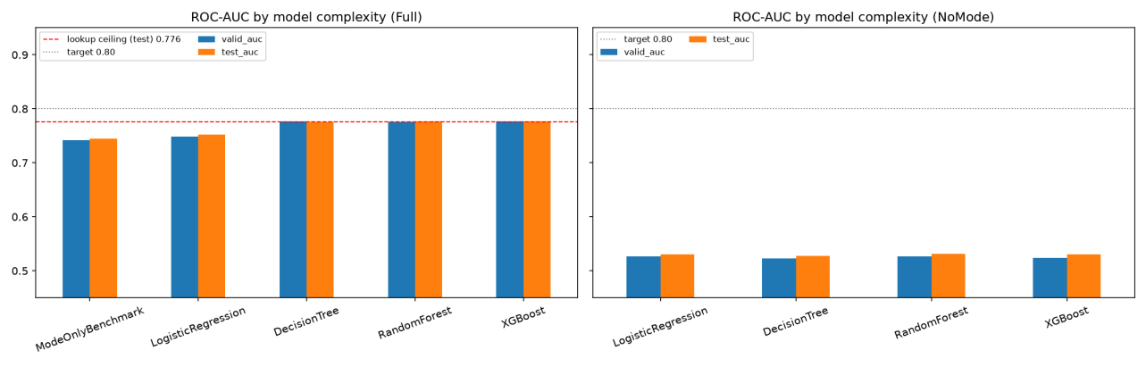
Figure 3.2 ROC-AUC by model complexity with (left) and without (right) shipping mode; the dashed line marks the five-cell lookup ceiling

3.4.4 Alert Thresholds under Limited Capacity
Where intervention capacity is constrained, the model can be operated by flagging a fixed share of the highest-risk orders instead of applying a probability threshold. Table 3.9 shows that the top 20% of orders are late in 98.4% of cases and the top 30% in 92.1% of cases, which supports a tiered policy: automatic action for the highest-risk orders and manual review for the next band. Flagging 60% of orders reproduces approximately the recall target of 0.75.
Table 3.9 Recall and precision when flagging the riskiest share of test orders
Share of orders flagged | Orders flagged | Recall | Precision
10% | 804 | 0.173 | 1.000
20% | 1,609 | 0.341 | 0.984
30% | 2,413 | 0.480 | 0.921
40% | 3,217 | 0.604 | 0.870
50% | 4,022 | 0.675 | 0.778
60% | 4,826 | 0.746 | 0.717
70% | 5,630 | 0.811 | 0.668
80% | 6,434 | 0.879 | 0.633

3.4.5 Assessment against Success Criteria
Table 3.10 compares the test results with the criteria defined in Section 3.1. The recall criterion is met. The ROC-AUC criterion is not met, and the analysis in Section 3.5.2 indicates that it cannot be met with the available features, since a model using only shipping mode and the Same Day order hour already reaches the practical ceiling of approximately 0.776.
Table 3.10 Assessment of the final model against the success criteria
Criterion | Target | Test result | Assessment
ROC-AUC | ≥ 0.80 | 0.777 | Not met
Late-class recall | ≥ 0.75 | 0.774 | Met

3.5 Model Interpretation and Error Analysis

3.5.1 Feature Importance
Permutation importance, defined as the decrease in test ROC-AUC when the values of a feature are randomly shuffled, shows that shipping mode dominates the final model with a decrease of 0.262 (Figure 3.3). The order date ranks second (0.046), and its contribution operates through the order hour. Every other feature contributes 0.0013 or less. The coefficients of the logistic regression baseline corroborate this pattern, with the four largest coefficients all belonging to shipping-mode categories and First Class having the strongest positive effect.
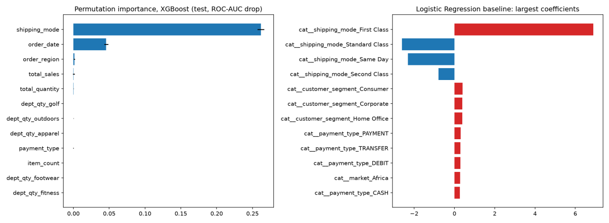
Figure 3.3 Permutation importance in the final XGBoost model (left) and largest logistic regression coefficients (right)

3.5.2 Shipping Mode as the Dominant Driver
Table 3.11 decomposes the behaviour of the final model by shipping mode. First Class orders are scheduled for one day but always take two, and are therefore always late. Second Class orders are late in 80.0% of cases. Same Day orders follow a strict cut-off: orders placed at or after 12:00 are always late, whereas earlier orders are never late, and the model separates them perfectly. Within Second Class and Standard Class, however, actual shipping times are distributed almost uniformly between two and six days, and the model’s within-mode ROC-AUC is 0.50, equivalent to random ranking. Consequently, all 1,046 missed late orders and 1,256 of the 1,568 false alarms on the test partition occur among Standard Class orders. A lookup table containing the training-period late rates of the five cells defined by shipping mode and the Same Day cut-off attains a test ROC-AUC of 0.776, identical to that of the final model, which establishes the practical ceiling for the available features. These relationships are associative; the data do not demonstrate that changing the shipping mode of an order would prevent its late delivery.
Table 3.11 Behaviour of the final model by shipping mode
Shipping mode | Share of orders | Late rate | Test behaviour of the final model
First Class | 15.3% | 100.0% | All orders flagged; no errors
Second Class | 19.5% | 80.0% | All orders flagged; within-mode ROC-AUC 0.50
Same Day | 5.4% | 48.4% | Perfect separation by the 12:00 cut-off; within-mode ROC-AUC 1.00
Standard Class | 59.8% | 39.8% | Within-mode ROC-AUC 0.50; source of all missed late orders

3.5.3 Errors by Market and Department
Figure 3.4 presents recall, precision and false-positive rate on the test partition by shipping mode, market and main department. Performance in Europe (recall 0.788, precision 0.693) and Pacific Asia (recall 0.768, precision 0.698) is almost identical. Differences between departments, for example a recall of 0.63 for Fan Shop compared with 0.92 for Outdoors, largely reflect differences in the shipping-mode composition of each department rather than an independent department effect. Owing to the temporal structure of the data, the test partition contains orders from only two markets; this limitation is discussed in Section 3.7.
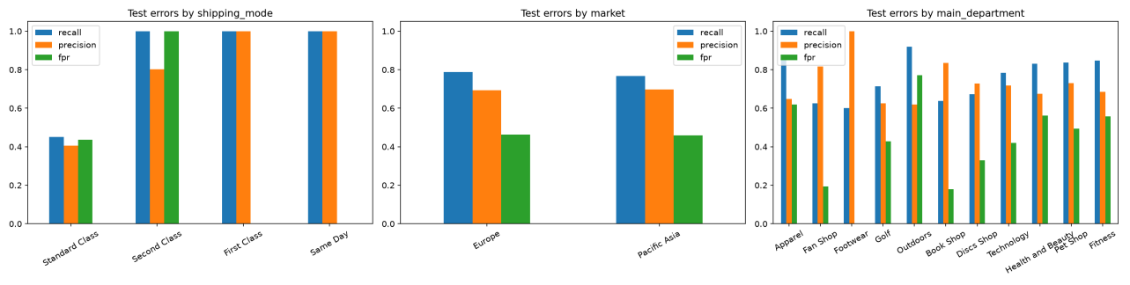
Figure 3.4 Test-set recall, precision and false-positive rate by shipping mode, market and main department

3.6 Supplementary Analyses

3.6.1 Canceled Orders
The 2,855 canceled orders comprise 1,367 orders with the status CANCELED and 1,488 with the status SUSPECTED_FRAUD. All of them were paid by bank transfer: 15.8% of transfer-paid orders were canceled, compared with none of the orders paid by cash, debit card or other methods. Their distribution across shipping modes, markets and customer segments otherwise mirrors that of delivered orders. When scored by the final model, canceled orders receive a mean risk of 0.58 and 62% of them would be flagged, so the late-delivery model does not discriminate cancellations. The identification of cancellations or fraud would require a separate model with a distinct target.

3.6.2 Exclusion of Profit Fields
Because the profit fields were excluded on grounds of availability rather than on empirical evidence, an additional test examined whether their exclusion sacrifices predictive signal. The three fields carry a single piece of information: Benefit per order equals Order Profit Per Order in every row, and equals Order Item Profit Ratio multiplied by the order item total, subject to rounding of the ratio to two decimals. Five order-level features were constructed from them, namely total profit, profit ratio, mean and minimum item profit ratio, and the share of loss-making items. Individually, their ROC-AUC ranges from 0.497 to 0.509 across the three partitions, and the direction of association reverses between the training and test periods, indicating the absence of a stable relationship with lateness.
Table 3.12 compares models with and without the profit features. With the tuned hyper-parameters, the features do not improve validation performance and significantly reduce the test ROC-AUC of the final XGBoost model, whose 95% bootstrap confidence interval for the difference lies entirely below zero. When the random forest and XGBoost were re-tuned with the profit features included, the best validation ROC-AUC was 0.7766, compared with 0.7767 without them. A deeper XGBoost configuration gains approximately 0.005 on the test partition only, but this difference is not statistically significant and, being invisible on validation, cannot legitimately inform model selection. The profit fields were therefore excluded from the final model.
Table 3.12 Effect of adding profit features (paired bootstrap with 1,000 resamples)
Setting | Model | Validation ROC-AUC (without → with) | Test ROC-AUC (without → with) | 95% CI of test difference
Tuned parameters | Logistic regression | 0.749 → 0.749 | 0.753 → 0.753 | [−0.001, +0.001]
Tuned parameters | CART decision tree | 0.777 → 0.773 | 0.776 → 0.774 | [−0.007, +0.004]
Tuned parameters | Random forest | 0.775 → 0.773 | 0.777 → 0.780 | [−0.001, +0.007]
Tuned parameters | XGBoost | 0.777 → 0.770 | 0.777 → 0.773 | [−0.007, −0.001]
Re-tuned with profit | Random forest | 0.773 → 0.774 | 0.778 → 0.781 | [−0.002, +0.007]
Re-tuned with profit | XGBoost | 0.773 → 0.777 | 0.779 → 0.784 | [−0.000, +0.009]

3.7 Limitations and Implications
Several limitations qualify these findings. First, markets appear in the data in blocks of consecutive months: the validation partition contains only LATAM and Europe, and the test partition only Europe and Pacific Asia. From October 2017 onwards, moreover, almost every order contains a single product. The test results therefore do not cover Africa, USCA or LATAM, and they reflect a basket structure that differs from earlier periods. Second, several deterministic regularities, namely the invariable lateness of First Class orders, the exact noon cut-off for Same Day orders and the near-uniform distribution of shipping times within modes, suggest that the dataset may have been generated synthetically; these patterns should be re-validated on operational data before deployment. Third, the alert threshold is tied to the fitted model, so any retraining on more recent data must be accompanied by a renewed threshold selection on a later hold-out period. Finally, the analysis is associative and does not establish that modifying the shipping mode would reduce lateness.
The results nevertheless carry clear implications. The model is suitable as a pre-dispatch screening tool, either with the validation-based threshold or with a capacity-based rule, under which the riskiest 20–30% of orders are late in more than 92% of cases. Since lateness is concentrated in specific shipping modes, revising the service promises themselves is likely to reduce late deliveries more than further model refinement: First Class orders never meet their one-day schedule, Second Class orders are late in four out of five cases, and Same Day delivery should not be promised for orders placed after noon. Such changes should be evaluated in a controlled pilot, given the associative nature of the evidence. Finally, exceeding the ROC-AUC target would require new information available at order placement, such as warehouse workload, stock location, carrier capacity and delivery distance, which could explain the variation in lateness within Standard and Second Class that the current features cannot capture.

